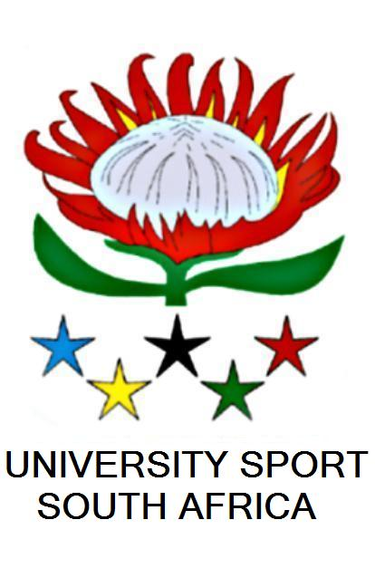
UNIVERSITY SPORT SOUTH AFRICA
NETBALL
Chairperson Secretary
Melinda Goosen Annelie Swarts
melinda.goosen@nmmu.ac.za swartsa@cput.ac.za
041 504 4224 (w) 021 460 3740 (w)
076 396 2121 (c) 082 886 7441 (c)

16 July 2012

Dear Netball Affiliates

USSA NETBALL CHAMPIONSHIPS RESULTS 2012

Super League:
- University of Pretoria (TUKS)
- University of Free State (KOVSIES)
- University of Johannesburg
- North West University – Potchefstroom
- University of Stellenbosch (MATIES)
- Nelson Mandela Metropolitan University

Premier League:
- Cape Peninsula University of Technology - Cape Town
- Thswane University of Technology - Pretoria
- VUT Vanderbijl Park
- University of Cape Town
- Wits University
- Durban University of Technology

B Section:
- University of Namibia
- North West University – Vaal
- Central University of Technology
- UKZN – Westville
- Cape Peninsula University of Technology – Bellville
- University of Limpopo – Turfloop
- MUT
- WSU – Ibika
- University of Venda
- WSU – Buffalo

C Section:
- University of the Western Cape
- North West University Mafikeng
- Tshwane University of Technology – Polokwane
- Tshwane University of Technology – Emal.
- University of Fort Hare
- University of Zululand
- WSU Mthatha
- University of Limpopo – Medunsa
- Tshwane university of Technology – Shoshanguve
- NC FET
- VUT Ekur.
- CIDA
- NC NIHE

Regards
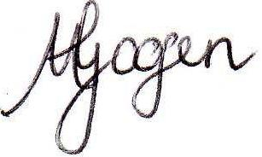
Melinda Goosen
Chairperson
USSA Netball

