Spirituality for Social Cohesion and Democracy Conference
Venue University of Pretoria
Date : 14th and 15th November 2013
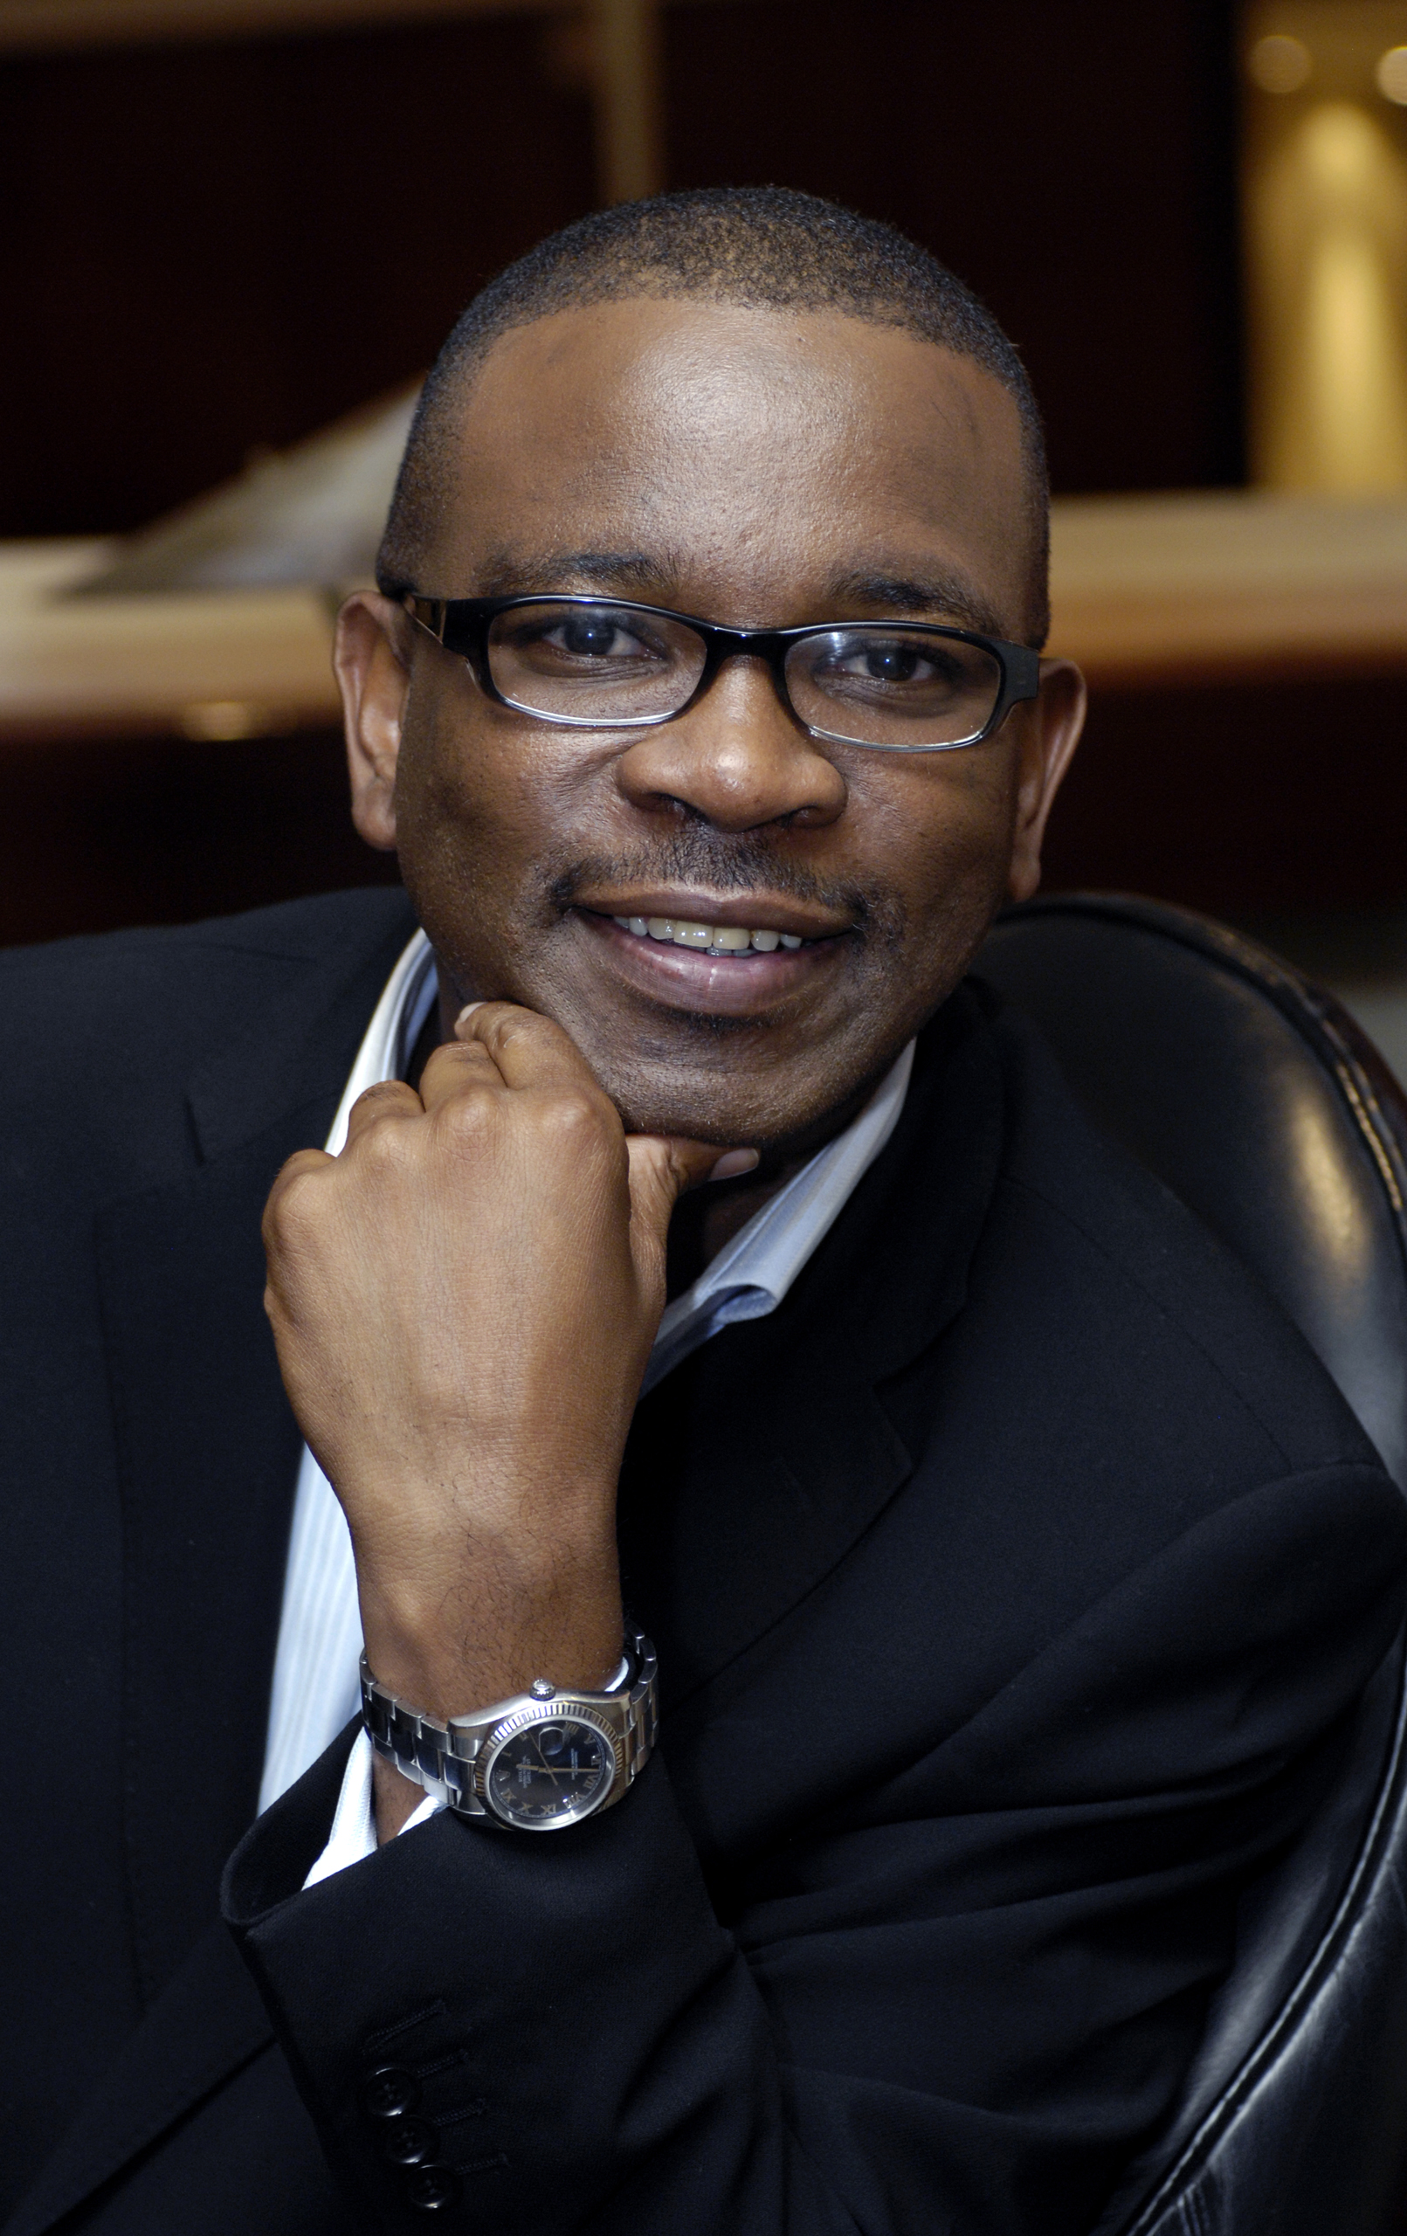
Biography - Xolela Mangcu

Xolela Mangcu is Associate Professor of Sociology at the University of Cape Town, and a non-resident W.E.B Du Bois Fellow at Harvard University.
He is the author and co-author of seven books, including the recently published, Biko: A Biography (Tafelberg, 2012), To the Brink: The State of Democracy in South Africa (UKZN Press 2008), and The Democratic Moment (Jacana Press 2009) and the Meaning of Mandela (essays by Wole Soyinka, Cornel West, Henry Louis Gates Jr.), (HSRC Press, 2005). His next book is titled Harold Washington and the Rise of Barack Obama.
Mangcu was previously a columnist for the Business Day, the Weekender and the Sunday Independent, and currently writes a bi-weekly column for the Sowetan. He was also the Founder of the Platform for Public Deliberation and Founding Executive Director of the Steve Biko Foundation.
He has held fellowships at the Brookings Institution, Harvard University, the Massachusetts Institute of Technology, the Rockefeller Foundation
Mangcu obtained his Ph.D. in City and Regional Planning from Cornell University. He also holds MSc in (Development Planning) and BA ( Sociology) degrees from Wits University.
The Sunday Times has described him as “possibly the most prolific public intellectual in South Africa.”

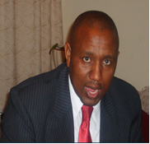

Dr. Sibusiso Masondo's research and teaching is focused, broadly speaking, around African Religion, culture and philosophy. More specifically, Dr Masondo is concerned with African Religion, African Christianity and indigenous meaning systems, African Indigenous Churches, African intellectual history, and comparative religion. For his doctorate, he did a comparative study of two churches in the same vicinity in Guguletu, Cape Town. In the research done among the two churches, one conventionally classified as African indigenous and the other classified as mainline, two models of conversion emerged, the crisis model at St John’s and the growth model at the Reformed Presbyterian Church (RPCSA). His current research focus is on the African and Christian origins of Nazareth Baptist Church worship practices. Latest publication is “The Crisis Model for Managing Change in African Christianity: The Story of St John’s Apostolic Church”. Exchange, 42 (2013): 157-174.

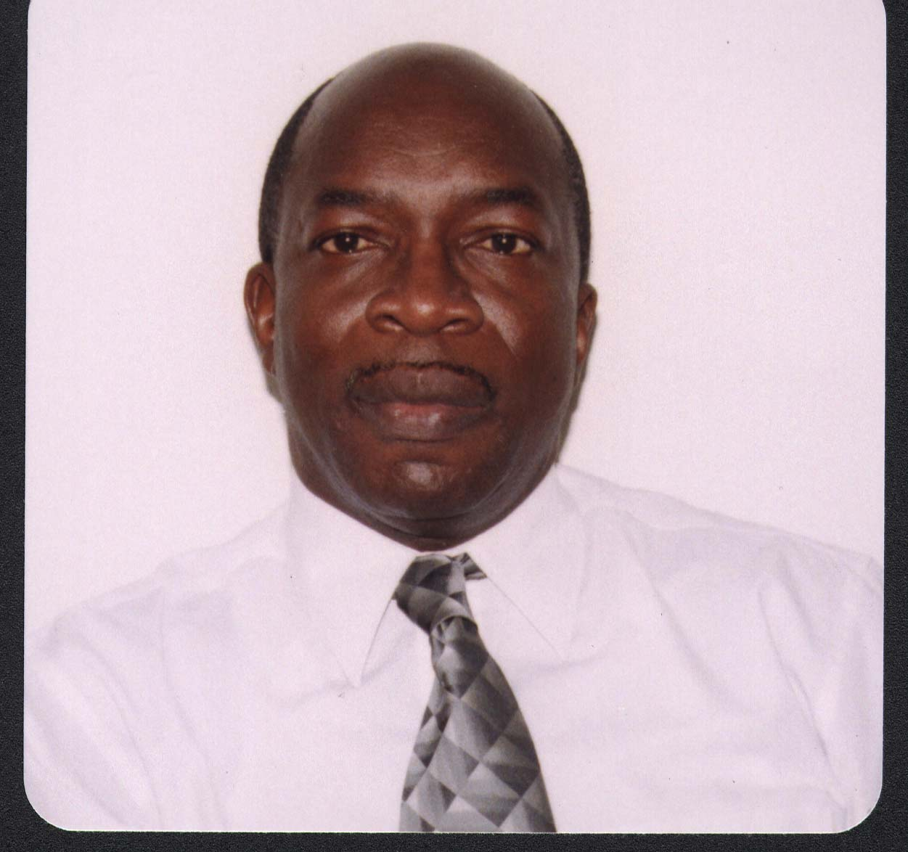
Dr. Roderick Hewitt is Academic Leader for Theology and Ethics and Programme Director for Systematic Theology at the School of Religion, Philosophy and Classics (SRPC) at the University of Zwa Zulu Natal. He lectures in Missiology, Ecumenism and African Theologies in the Diaspora. Before taking up his appointment, he lectured at the International University of the Caribbean and the United Theological College of the West Indies/University of the West Indies. He has held a number of leadership positions in ecumenical organisations. He served as the Vice President for the Jamaica Council of Churches, Co-moderator for the Mission in Unity project of the World Alliance of Reformed Churches and currently serves as a member of the WCC AGAPE Reference Group. Dr Hewitt has served two terms as Moderator of Synod of The United Church in Jamaica and the Cayman Islands and as Moderator of The Council for World Mission. He also served as Chairman of the Board of Governors for Knox Community College. Dr. Hewitt was educated at Knox College, the United Theological College of the West Indies (Diploma in Ministerial Studies), University of the West Indies (BA Hons), University of London (Kings College) MPhil, and University of London (Kings College) PhD. To his credit he has several publications. These include: Transforming Leadership, CWM Publishers, London 1996; Dialogue for Disciples 1990; Equipping Local Congregations in Mission 1992 and Post Colonial Mission: Power and Partnership in World Christianity (2011) that he co-edited with Desmond van der Water and four other scholars; His most recent text ‘Church and Culture: An Anglo-Caribbean experience in Hybridity and Contradiction’ will be published by Cluster Publications in 2012. He has also written many articles on Mission, Leadership Development and Theological Education that have been published in international journals. He is married to Wilhelmina and they have one daughter, Rochelle and two sons, Machel and Michael.

