Post Graduate School of Agriculture and Rural Development
and
Public Policy and Governance Platform

Brown Bag seminar series invitation
SPECIAL SESSION

Dear All,

You are invited to attend the Post Graduate School of Agriculture and Rural Development and the Public Policy and Governance Platform’s Brown Bag seminar presentation on:

“Governing development in Africa – The role of the State in Economic transformation”

LAUNCH OF
ECA's 2011 Economic Report on Africa

by UN Economic Commission for Africa (UNECA), African Union Commission & SA National Treasury

Date: 27 May 2011
Time: 12:30-14:30
Venue: PGSARD boardroom, IT Building room 3-19

May you please RSVP by Friday, 20 May 2011.

Regards,

Thinah Moyo
University of Pretoria
Post Graduate School of Agriculture and Rural Development
IT Building, Room 3-23
Tel: 012 420 4561
Fax: 086 658 5187 / 012 420 4111
E-mail: thinah.moyo@up.ac.za

Faculty of Natural and Agricultural Sciences
Postgraduate School of Agriculture & Rural Development

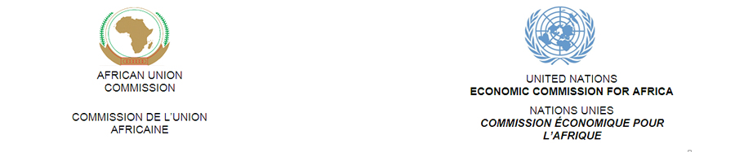
Brown Bag seminar series programme

Date | Presenter | Tentative title / subject
May 24, 2011 | Dr Langelihle Simela (NERPO) | Livestock in Rural Development
May 27, 2011 | National Treasury, African Union Commission & UN Economic Commission for Africa (UNECA) | ECA's 2011 Economic Report on Africa  Governing development in Africa – The role of the State in Economic transformation
June 28*, 2011 | Dr Inga Jacobs (CSIR) | Coordination of Water Use Entitlements and Land Use Rights
July 12, 2011 | UN Special Rapporteur on Food Security | *
July 28, 2011 | Leilaine Williams (CASE) | Women, land and customary law
Aug 02, 2011 | Clementine Remy & Alice Clerc | Understanding the rural reality in the Madibeng Municipality (North-West Province)
Aug 25 or 30*, 2011 | Mvula Trust | *
September 2011
October 2011
November 2011
* To be confirmed

Objective and call for presentations:
The objective of the Post Graduate School of Agriculture and Rural Development and the Public Policy and Governance Platform’s Brown Bag seminar is to enhance debate on issues related to rural and agricultural development. Presentations include policy documents, final and intermediary research findings, discussion papers, etc. It is open to all stakeholders, as participants as well as presenters. If you would be willing to present your work for debate, please contact Thinah Moyo (thinah.moyo@up.ac.za).

