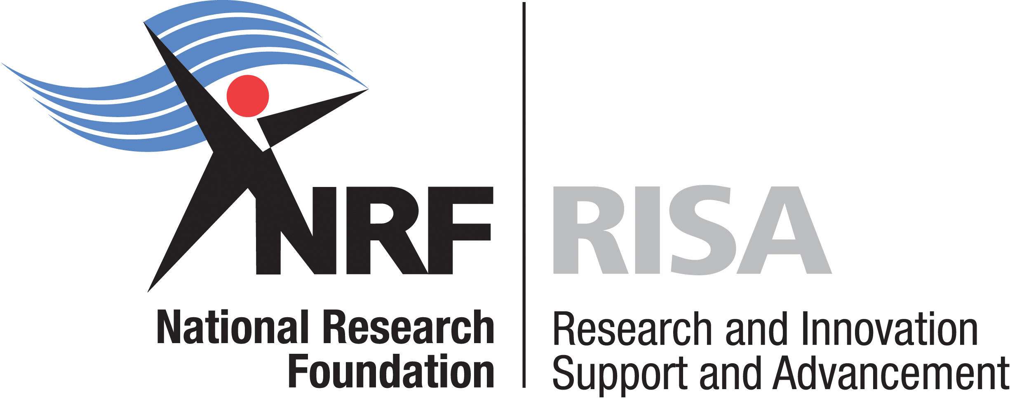

VRIJE UNIVERSITY AMSTERDAM-NRFDESMOND TUTU DOCTORAL SCHOLARSHIP

CALL FOR APPLICATIONS

Vrije University (VU) Amsterdam has established the Desmond Tutu Programme in honour of Archbishop Emeritus Desmond M. Tutu, and its main focus is on the theme Youth, Sports and Reconciliation. The programme aims to strengthen the co-operation between VU Amsterdam and South African Higher Education Institutions. In honour of the contribution by Archbishop Emeritus Tutu as a public leader, a special scholarship has been introduced to support a doctoral student to carry out research on the role played by the Archbishop Desmond Tutu as priest, pastor and global leader.

We invite South African students to apply for this special VU Amsterdam–NRF Desmond Tutu Doctoral scholarship. The format for the doctoral studies will be a sandwich programme in which the successful applicant will:
- Register and obtain their research doctoral degree from VU Amsterdam;
- Be jointly supervised by academic researchers at VU Amsterdam and a South African Higher Education Institution;
- If required, complete required coursework for doctoral studies both in South Africa and in the Netherlands;
- Spend between one (1) and two (2) months per year over a period of four (4) years at VU Amsterdam to undertake course and thesis related work; and
- Carry out their research in South Africa.

The application form can be found on the NRF website: www.nrf.ac.za and the guidelines provide further information. Complete applications are due on Monday, 28 March 2011.

VU UNIVERSITY AMSTERDAM-NRF
DESMOND TUTU DOCTORAL PROGRAMME
Research Project:

Desmond Tutu: The making of a public church leader and theologian

The recent retirement of Archbishop Desmond Tutu from public life is a fitting opportunity to look back at his public life. In his case the reception of the Nobel Peace Price in 1984 for his contribution to peace in South Africa, was not the end but just a moment of recognition of his life long commitment to issues of peace, reconciliation and justice. Later on he would play a decisive role as Chair of the Truth and Reconciliation Commission and he continues to act as the Chair of the Elders. At the same time his central public identity was that of a priest and bishop, a church leader. His outreach was far beyond the scope of religion, but whether he addressed a religious or a secular public, his Christian theological sources were always present. And his deepest motivations are fuelled by a life of prayer.

This PhD research will address the question of how a church leader has become a moral global leader sharing the gifts of the wisdom and spirituality of a specific religious tradition with a global audience. The study will focus on the role played by his calling to be a priest and pastor, to the elements of the Christian traditions that he brought into public life, and on his spirituality. How have they contributed to the making of this public church leader and theologian? The study will analyse his public message on the basis of an in-depth research of his sermons, addresses and books, and will include interviews. The answers to this research will contribute to the understanding of what is needed for religions to offer a credible contribution to global issues of peace, reconciliation and justice.

VU UNIVERSITY AMSTERDAM-NRF
DESMOND TUTU DOCTORAL PROGRAMME
GUIDELINES

1. Required qualifications:

Individuals with a relevant research Master’s degree or in the process of completing requirements for such a degree may apply. However, applicants must have successfully completed a Master’s degree to be admitted into the programme.

2. Funding:

The VU Amsterdam-NRF Desmond Tutu Doctoral Programme provides funding for up to four (4) years of study, depending on satisfactory progress each year. The doctoral scholarship will cover:
- Two economy return flights from South Africa to Amsterdam per year;
- Accommodation and living allowance in Amsterdam (for up to two one-month visits each year); and
- A scholarship to the value of R70 000 each year toward doctoral study costs in South Africa.
In addition to the above, a contribution toward the public doctoral dissertation defense costs will be provided.

3. Citizenship and residency status:

Applicants must be South African citizens or permanent residents.

4. Commencement of studies:

Successful applicants in this cycle may commence with their doctoral studies any time from September 2011 or within the VU Amsterdam 2011/12 academic year.

5. Dependants:

The NRF and VU Amsterdam are not responsible for dependants accompanying a scholarship holder to Amsterdam.

6. Application forms:

Application forms are available from the NRF website: www.nrf.ac.za

7. Closing date for applications:

The closing date for applications and all required documents (applications, copies of transcripts and certificates, and reference letters) is Monday, 28 March 2011.

No requests for extension will be considered.

8. Selection procedures:

All applications will be reviewed by a selection committee and short-listed candidates will be invited for telephonic interviews or face-to-face interviews. Where applicable, the NRF will arrange and cover travel costs for short-listed candidates.

9. Format of application and required documentation:

Completed typed applications must include the following documents:

- Application form;

- Certified copy of South African Identity Document;

- Certified copy of academic transcripts ;

- Certified copies of all degree certificate; and

- Two letters of reference.

Incomplete applications will not be considered.

10. Queries:

For further information and other matters in relation to this programme, please contact Ms Danielle Nel at telephone number 012 481 4191 or by e-mail to danielle.nel@nrf.ac.za.

