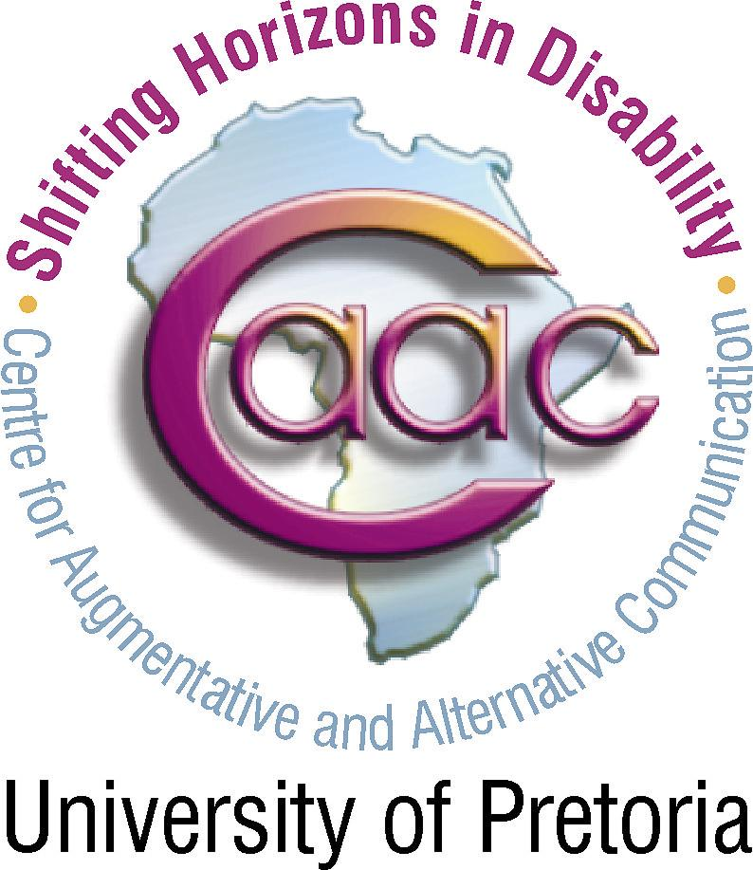
PRADER-WILLI SYNDROME ASSOCIATION (SA)
Registration Form: 28 August 2010
Linda Thornton Workshop 28 Augustus 2010
“Understanding the person – understanding the syndrome”
The PWSA (SA) in co-operation with the Centre of Augmentative and
Alternative Communication at the University of Pretoria, present a workshop on the Prader-Willi syndrome from a parent perspective.

DATE | Saturday, 28 August 2010
VENUE | Ear Institute, 1240 Webb Street, Queenswood, Pretoria.
MAP | Directions will be forwarded with confirmation of registration.
TIME | 08:30 for 09:00 until 16:30
COST | R200.00 per person for early registration before 23 July, 2010.  Late registration R250.00 per person, only accepted until 12 August 2010 due to catering requirements.

Your contact information:
(Please complete one registration form per person)

Initials |  |  | Title |  | Prof | Dr | Mr | Mrs | Ms
Name
Surname
Address
 |  |  |  | Postal Code
Tel |  |  |  | Fax
Cell number
Email
What is your relationship to person with PWS? |  | Parent/ family/ teacher/ doctor/ carer/ other?
Name of school, institution, organisation?
For professionals: Your HPCSA Number #

Registration fee includes early coffee,  tea-time refreshments during break and lunch.  Your registration will be confirmed.  Cancellation of registration not refundable.  This workshop is CPD accredited. | Information for name tag:
  Title
  Name
  Surname

Payment details:
We appreciate direct deposits or payment through Internet Banking.
Reference on payment slip:
Total amount paid:
R

Initials and surname, institution/school/organisation/town/city
PRADER-WILLI SYNDROME ASSOCIATION (SA)
ABSA BROOKLYN, PRETORIA. Branch number 632005
Savings account 11 364 1800

Please return your registration form and proof of payment before 23 July, 2010
Receipt will be given at the workshop on 28 August 2010.

