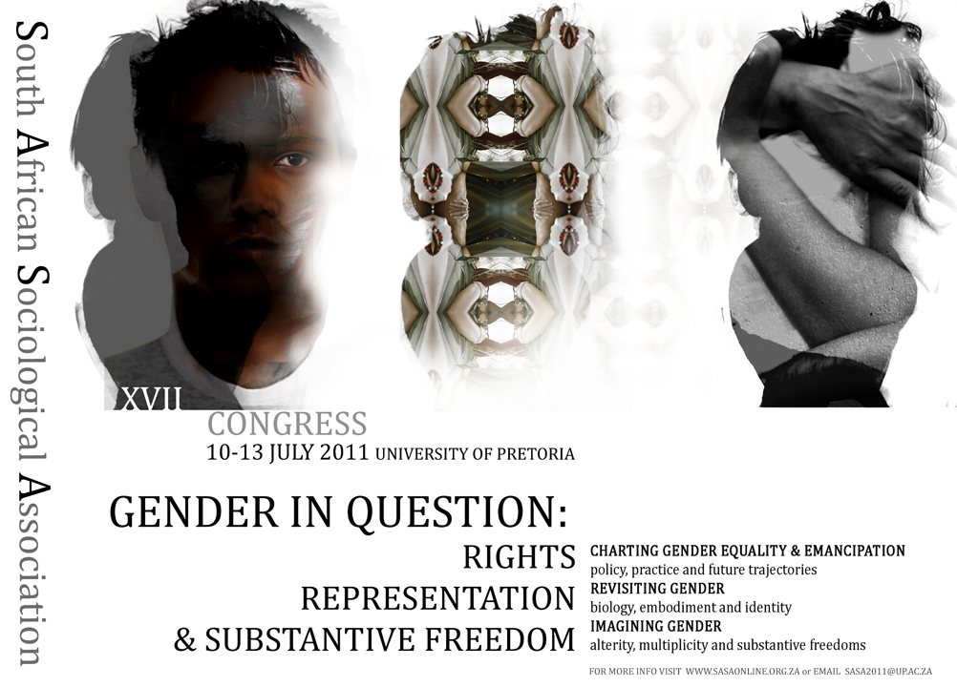

XVII SASA Congress
UNIVERSITY OF PRETORIA
10 – 13 July, 2011
Congress Venue:
Humanities Building
University of Pretoria Campus
Lynnwood Road and Roper Street
City of Tshwane Metropolitan Municipality
South Africa


SOUTH AFRICAN SOCIOLOGICAL ASSOCIATION

CALL FOR PAPERS (Thematic & General sociological abstracts)

Gender in Question: Rights, representation and substantive freedom
- Charting gender equality and emancipation: Policy, practice and future trajectories
- Revisiting gender: Biology, embodiment, and identity
- Imagining gender: Alterity, multiplicity and substantive freedom

Steeped in an emancipatory rights regime, the post-apartheid order held a promise of gender equality, which was hard won. On this promise, it has delivered, albeit ambiguously and only partially. Significantly, the new gender dispensation was ushered in together with an imperative to redress racial inequalities and recognise the right to diverse sexualities. This conjunction has been central to the way in which ‘gender’ and gender emancipation have been understood and shaped in post-apartheid South Africa.

The progress made in dismantling apartheid’s formal gender apparatus has been extraordinary. Nonetheless, the gap between the language of the law and vernacular practice; between political prerogative and talk on the street, between parliamentary proclamation or court victory and democratic consolidation invites questions about the depth of the gains and the foundations of power on which the advances women made rest.

Even gains made are not without contradictions and unintended consequences. Those with higher levels of cultural, economic, social and symbolic capital have benefited disproportionately. Whilst the representation of women seems to be less stereotypical than before, gaps, silences and new distortions in representation – in its double sense – need to be examined alongside more recalcitrant modes of representation. Against this background, what shape does a feminist project take now? What is the current state of women’s movements in South Africa? What new cultures and cults of femininity are emerging? Where are the public spaces in which lesbian, gay, bisexual, transgender and intersex (LGBTi) cultures and identities are being rendered visible and part of the mainstream? Where LGBTi have become visible, have these cultures and practices made gender identities more fluid? How does race and socio-economic status interlink with gender and sexual orientation and what intersectional identities are possible? How has women’s and LGBTi organisations linked up with other social struggles, such as campaigns against poverty and for access to land?

So far, South Africa has defied the standard coupling of nationalism with specific forms of gender repression and erasure. But to what extent does a political system based on proportional representation veil that women’s political power is not secured by deep democratic practice? Is the manner in which the language of culture and an appeal to its logic are surfacing in public discourse an indication of some unease and even outright discontent with the post-apartheid gender regime? How are anxieties about the past, in particular the question of race and its relation to inequality, reflected in the national question? How do these unresolved tensions spill over into struggles around gender, sexual and class identities and relations? What are the consequences of the sharp contrast between South Africa’s gender rights regime and those of many neighbouring countries?

South Africa’s stark inequalities and tenuous welfare provision also place constraints on the assertion of women’s rights. Does women’s access to pension and children’s grants and their improved position in the labour market place them at risk anew of predatory relationships and intimate violence because of their perceived role in eroding men’s power and as gatekeepers of resources? How do we explain the disturbing and extraordinary levels of rape and increasing reports of violence perpetrated against lesbians?

Conversely, how do shifts that have taken place in gender regimes over the past fifteen years affect men? What repertoires of male domination have remained intact in a discursive context of gender equality? What new possibilities and positive assertions of being a man have opened up? What do discourses and practices around fatherhood, marriage and civil unions, and the payment of bride wealth tell us about contemporary understandings of the family form and gender roles?

Internationally and locally, the theoretical articulation between gender, the body, sex and sexuality opens a messy if also very productive terrain for social enquiry and political mobilisation. How and in what ways does a focus on the body and the performative aspects of gender make possible a new scholarly field focusing on political identities, aesthetics, desires, and eroticisms attached to gendered subject positions and politics? Yet, understandings of gender and the body simply as social constructs seem to be inadequate. What are the challenges sociologists face in engaging the growing scholarship, in biology and genetics, that foregrounds the body in explaining human behaviour?

Finally, what is thrown up when we place gender in question and do so against the background of the shifting landscape of post-apartheid South Africa, with its possibilities and its undercurrents? A neat insulation of gender struggles from other social struggles and the idea of women’s issues as a singular reality have been challenged by black and third world feminisms, and more recently by queer theorists. What is the explanatory power in South Africa of intersectionality, not as new identity theory jargon, but as a vital way of making current and specific inequalities more visible and therefore available for analysis and intervention? What is at stake and at risk in the clustering for the purpose of social analysis or social and political mobilisation particular kinds of social attributes? Moreover, what are ongoing and specific gender struggles? How do these link to other social struggles more broadly and what are the limits of identity politics? How may this kind of analysis cast light on the present social order in South Africa and the region, as well as on multiple modernities?

We invite you to submit an abstract for XVIII SASA Congress. Papers that approach the thematic from a wide range of perspectives are welcome. We also welcome general sociological papers. The working groups in which papers may be presented are listed below.

Congress Venue
Humanities Building, University of Pretoria, City of Tshwane Metropolitan Municipality, South Africa

Date
July 10 – 13, 2011

Host Institution
University of Pretoria

Abstract Deadline (Thematic & general sociological abstracts)
Abstracts should be submitted online at http://www.sasaonline.org.za not later than March 31st 2011. On submitting your abstract, you will be asked to select the working group in which you would like present your paper:

THEMATIC WORKING GROUPS
Crime, violence and security | Development
Economic and industrial sociology | Environment and natural resources
Family and population studies | Gender studies
Health | Higher education and science studies
Lesbian, gay and queer studies | Media, culture and society
Methodology and social theory | Political sociology and law
Race, ethnicity and class | Religion
Rural sociology | Social movements and popular protest
Sport, leisure and society | Urban sociology

Information and general enquiries
For general enquiries contact sasa2011@up.ac.za or visit www.sasaonline.org.za for further information. Contact details for working group convenors are available at: http://www.sasaonline.org.za/working-groups.html
Prospective sponsors of plenary sessions, working group convenors as well as organisations wishing to support or participate in the congress in other ways should contact the LOC Chair, Charles Puttergill (sasa2011@up.ac.za).

