

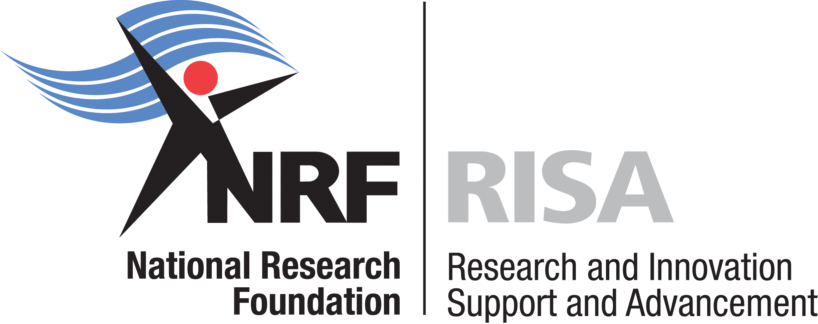

COMMUNIQUÉ ON THE AFRICAN ORIGINS PLATFORM OPEN CALL
FOR INTERIM FUNDING IN 2011
(February-31 March 2011)

The African Origins Platform (AOP) was originally established as a research programme aimed at integrating and coordinating scientific research conducted in South Africa. Over a three year period, from 2008-2010, a number of research projects and postgraduate students were successfully funded in the programme, thereby, addressing two fundamental requirements of the AOP: human resource development and knowledge generation.

During 2009 and 2010, the DST embarked on a consultative policy development process for Archaeology and Palaeontology, which when promulgated, will result in the realization of a national renewed vision for the sector.

While the policy process is underway in 2011, the Department of Science and Technology has concomitantly allocated interim funding for one year during the transition period which will result in a revised offering of funding support under the rubric of the African Origins Platform.

This call document details the three discrete funding categories earmarked for support by the DST interim funding strategy:

- Support for research costs and associated student bursaries;
- Support for research equipment; and
- Support for technical skills

Applicants have the opportunity to apply for funding support in all or one of these three funding categories.

The African Origins Platform Open Call for Funding for 2011 is an interim funding opportunity, and offers only one year of bridging funds (12 months from date of award).

Student bursaries will be funded for the commensurate duration of support as commitments and will be honoured beyond the one year period, in respect of Masters and Doctoral support.

Researchers are invited to submit applications to this call, in accordance with the strategy and eligibility criteria, as set out in the attached call guide.

CALL OPENS: February 2011
CALL CLOSES: 31 March 2011

GRANT AWARD NOTIFICATION: By May 2011

Any queries on the call can be directed to:

Candice Steele (candice@nrf.ac.za)
Lebusa Monyooe (lebusa@nrf.ac.za)

The NRF looks forward to receiving your application

Source: Technical Skills Call Guide 2010

