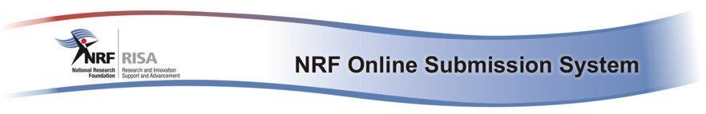

**Table of Contents**

**NRF ONLINE SUBMISSION SYSTEM**

Guidelines and instructions

for the approval of research output

records

**Please note that all research output records need to be processed prior to applying to certain Calls**

February 2012

A. BACKGROUND INFORMATION 3

B. INFORMATION ABOUT THE NRF ONLINE SUBMISSION SYSTEM 3

**Support Desk** 3

**Landing Page** 4

**Additional important information** 4

C. HOW TO PROCESS RESEARCH OUTPUT RECORDS 5

**NRF ONLINE SUBMISSION SYSTEM**

Guidelines and instructions for the approval of research outputrecords

***Important notes***

**Please note that all research output records need to be processed prior to applying to certain Calls.**

This document is divided into three main sections:

A. Background information

B. Information about the NRF Online Submission System

C. How to process research output records

# A. BACKGROUND INFORMATION

As part of the project to develop the new system, the NRFengaged with the RIMS project team to ensure that the data requested as part of the CV module was in line with the InfoEd solution to ensure that the two systems “talk” to each other. In the future, this will alleviate any dual capturing of CV data. It should be noted that more detailed fields have been added to the research output sections on the new NRF Online Submission System. A clean-up exercise was undertaken by the NRF to split the content of the existing *‘free text’* on the current NRF Online System into the detailed fields on the new system. This data was then imported into the new system.

**As a result of this exercise, the NRF requires that each user validate that their data to ensure that it has been properly cleaned.** In order to do this, functionality has been provided to view both the cleaned data as well as the original data on the current NRF Online System.

# B. INFORMATION ABOUT THE NRF ONLINE SUBMISSION SYSTEM

## **Support Desk**

Should you experience any problems, please click on the ‘Support’link in the top right-hand corner of all screens. You will then have the option to search through the Frequently Asked Questions. Should you not find information relevant to your query, please click on the Support button and capture the relevant information. Once you click on Send, a call will be logged with the NRF Support Desk.  The Support Desk can alternatively be contacted by telephone (**012 481-4202**) or by e-mail (**supportdesk@nrf.ac.za**), and is available from**Mondays to Fridays from 08:00 to 16:30**.

## 

## **Landing Page**

Once you have logged in and entered the system, the screen which appears is the Landing page (see diagram below).

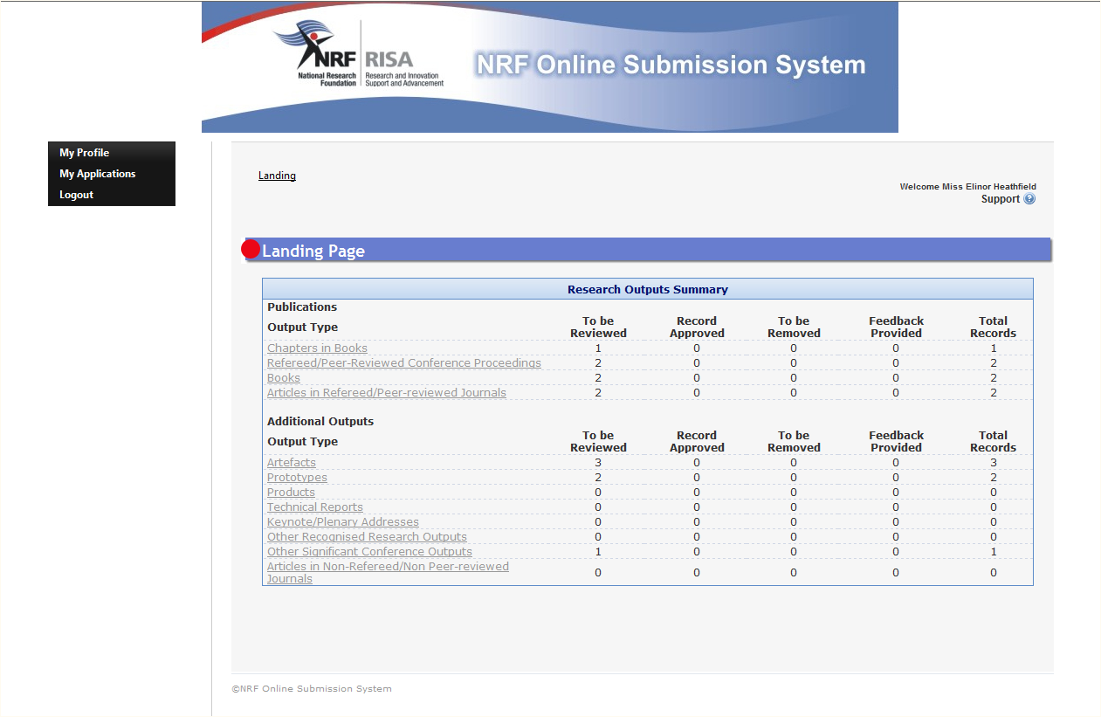

The menu on the left-hand side allows for navigating to personal information (My Profile) and applications (My Applications).

The Research Outputs Summary comprises of:

* A list of all the various research output types that existed on the old NRF Online system. Each output type is a hyperlink which, when clicked, will navigate to the relevant section of the CV where records can be reviewed and processed.
* An indication of how many records, per output type, need to be reviewed/validated (To be Reviewed).
* An indication of how many records, per output type, have been reviewed and approved as correctly cleaned up (Record Approved).
* An indication of how many records, per output type, have been flagged as no longer relevant to the CV (To be Removed).
* An indication of how many records, per output type, have been flagged due to feedback being sent back to the NRF (Feedback Provided).
* The total number of records per output type (Total Records).

## **Additionalimportant information**

* Selected sections of information **already** captured in additional CV sectionson the old NRF Online system (not relevant to users registering on the system for the first time) haveautomatically been migrated to the new system. Please check all the data fields of the migrated information for correctness and completeness. Should any data be missing out of any of the sections, due to new fields for example, the sections will display as “Incomplete” on the Edit Application menu when an application is created for a Call. Please update these fields in order to update the status of the section to ‘”Complete”.
* In order to navigate through the system, various options have been provided:
  + The menu on the left can be used;
  + Each page has a breadcrumb which provides links back to each previous page that has been navigated through to get to the current page or—in hierarchical site structures—the parent pages of the current one.
  + Clicking on a Return to Menu button will return to the menu the section is listed on.
* If there is no activity on a page for 10 minutes, a warning will appear informing that the system will timeout if there is no activity for a further 10 minutes.

# C. HOW TO PROCESS RESEARCH OUTPUT RECORDS

This section provides guidelines on using the functionality for reviewing and/or approving cleaned-upresearch output records.

* Click on the relevant Output Type hyperlink (for example, Chapters in Books) where there are records to be reviewed.
* When the relevant screen loads, click on the icon under the heading **Cleaned-up research output records from NRF Online.** This will expand the panel to show all the cleaned-up records under that research output type.



* In order to view the cleaned-up data for a record, click on the icon next to the relevant record. This will display the new fields with the cleaned-up data. Some of the fields will not be populated as these are additional fields for which there was no data on the old NRF Online system.



* In order to compare the cleaned-up data with the original old NRF Online data, a link has been provided to display the original record.
* Once the cleaned-up data has been reviewed, click on Save. This will mark the record as approved and it will be moved to the top grid on the screen. If further editing needs to be done on the record, it can be done from the top grid.
* In order to flag a record to be removed from the list, click on the icon next to the relevant record. Provide relevant feedback in the Feedback to NRF block and select To be Removed from the Status drop-down list. This will mark the record in yellow on the grid.



* In order to provide feedback to the NRF, click on the icon next to the relevant record. Provide relevant feedback in the Feedback to NRF block and select Feedback Provided from the Status drop-down list. This will mark the record in red on the grid.



* On the Feedback screen, both the cleaned-up data and old NRF Online data can be viewed by clicking on the relevant link.
* As part of an application for a Call, the relevant research output section will only be marked as “Complete” once all research output records have been processed. If the records are not processed, an application will not be marked as complete and it will not be possible to submit the application to the relevant institution.