

Directions to the Centre for AAC

1. Coming from Johannesburg (southern direction)

Drive on the M1 (North), which becomes the N1 (North) passing the Buccleuch interchange towards Pretoria. Pass the Brakfontein / Rooihuiskraal offramp, while keeping to the left. Take the next split indicating Krugersdorp / Polokwane. Remain right onto the Polokwane (N1) highway. Do not take the N14. Pass John Voster, Botha, R21, Rigel, Garsfontein and Atterbury offramps. Turn left into Lynnwood Road. Continue straight in Lynnwood Road, pass 9 sets of robots. At the 10th robot turn right into the main gate of the University.

2. Coming from Polokwane (northern direction)

Drive on the N1 towards Johannesburg passing the N4 interchange. Soon after, look out for the Lynnwood Road offramp. At the T-junction turn right into Meiring Naude road and again right at the next robot (Lynnwood Road). Proceed straight in Lynnwood Road. Pass 9 sets of robots. At the 10th robot turn right into the main gate of the University.

3. Coming from the Johannesburg International Airport

Take the R21 to Pretoria. After the Irene / Nellmapius off ramp, take the next off ramp indicating Krugersdorp / Polokwane (N1). Proceed in the Polokwane direction (north) passing the Rigel, Garsfontein and Atterbury off ramps. Soon after Atterbury take the Lynnwood off ramp. Turn left into Lynnwood Road. Continue straight in Lynnwood Road. Pass 9 sets of robots. At the 10th robot turn right into the main gate of the University.

4. Getting to the Centre for Augmentative and Alternative Communication (CAAC)

Once you are at the main gates (corner of Lynnwood and Roper Road). Park your car outside the University grounds. Walk through the main gates. Turn left and we are in the red Brick Building next to the old Victorian Building (Kaya Rosa) on the left. Ring bell at the big glass door for reception.

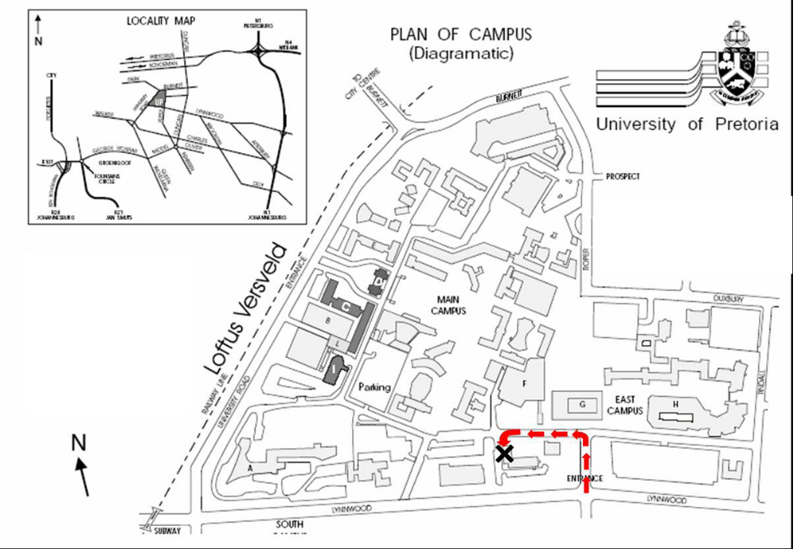

Our telephone number: (012) 420 2001
Our fax. number: 086 719 2666

