REPORT: VISIT TO THE U.S. – Prof Rika Joubert and Jean van Rooyen

12 OCTOBER 2009 – 6 NOVEMBER 2009

Purpose of the visit

The MED(Leadership) programme of the Department of Education Management and Policy Studies has been on offer for five years. It includes four modules on aspects of education leadership, education law, education finances and human resource management in education. In South Africa there are a limited number of universities that offer similar programmes. Therefore, there is a need for partnerships and international research opportunies in these fields to ensure that this programme is comparable with similar programmes offered in the world.

In the U.S., education law courses form part of most masters’ programmes for school principals. There is a dire need to find out more about the composition of the curriculum for education leadership programmes, the content of the courses, the presentation of the content, the assessment of the students at masters level. One of the challenges we face in the MEd(Leadership) programme is the supervision of our students’ research. Most importantly we need to establish research partnerships with experts in the fields of education leadership, and education law.

Institutions visited
12-16 October 2009 –– Cleveland State University in Cleveland, Ohio – host, Prof Ralph Mawdsley
Both Prof Joubert and Mr Van Rooyen presented lectures to the principals in the Education Leadership masters’ programme. Prof Joubert presented classes in Education law and attended Sport Law classes. Mr. Van Rooyen attended classes for school principals in Financial Management offered by Dr David Kowalski.
17-21 October 2009 – University of Kentucky in Lexington, Kentucky- host, Prof Lars Björk

Prof Lars Bjork is the Head of Department and responsible for teaching leadership in postgraduate programmes. We met with Prof Tricia Browne-Ferrigio who coordinates the post graduate programmes and heads their department’s research.
We had individual interviews with all staff members involved in the Education Leadership post graduate programmes.
We presented a lecture to the all faculty members working in education.

We met with the Dean Mary John O’Hair who has visited UP twice.
A 35 Minute video interview with Prof Justin Bathon who teaches Education Law. This video was posted on the website www.edjurist.com. This is the blog used by Justin Bathon to teach Education law to post graduate students at the University of Kentucky.

22-24 October 2009 – attended the Education Law Association (ELA) annual conference in Louisville, Kenctuky to present papers.
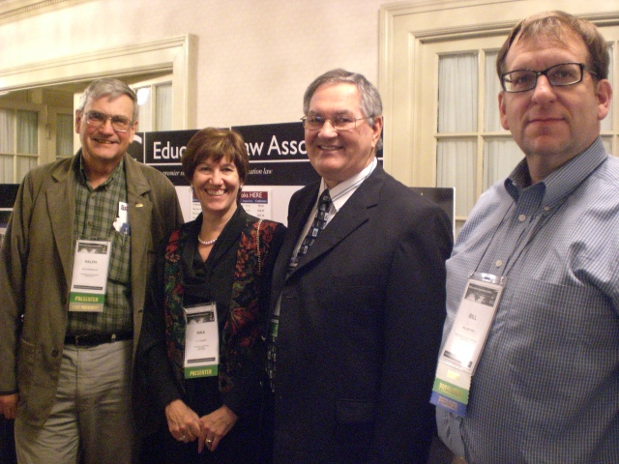
Prof R Mawdsley, Rika, Jean and Bill Thro

Prof Joubert presented a paper titled; Balancing culture, beliefs and human dignity and uphold a disciplined environment in schools in South Africa.
Jean van Rooyen’s paper was titled: Free education and no fee schools in South Africa – A contradiction in terms?

25-30 October 2009 – Virginia Polytechnic Institute and State University, in Blacksburg, Virginia – host, Prof David Alexander
Prof Rika Joubert and Mr. Jean van Rooyen presented lectures to the school principals in the masters’ programme in their postgraduate centre in Roanoke.
Prof Joubert had long discussions with Prof David Alexander on the teaching of Education law. Prof Alexander’s well-known textbook is used by more than 10 000 students in the U.S every year. He gave us copies of this book, his workbooks and CD with typical questions and answers in Education Law.

We attended a video proposal defence of a PhD student and obtained valuable information about the supervision of PhD students.

We also had in depth discussions with Proff Richard Salmon (one of the leading figures in the management of educational finances in the USA), Wayne Trip (Leadership) and Lewis Wasserman (Education Law).

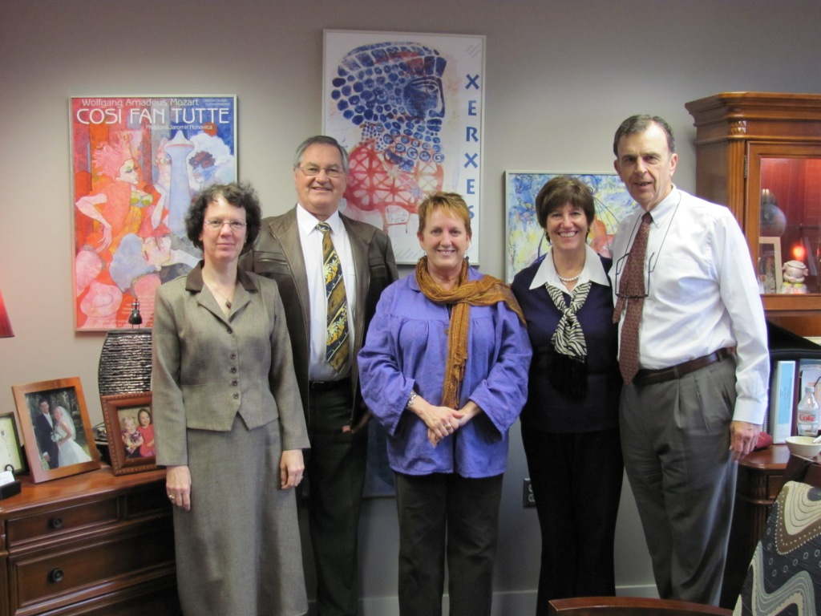
Meeting with the Dean and Deputy Dean of Virginia.Tech. Host Prof David Alexander on the right

Below: Mr Jean van Rooyen teaching at Virginia Tech
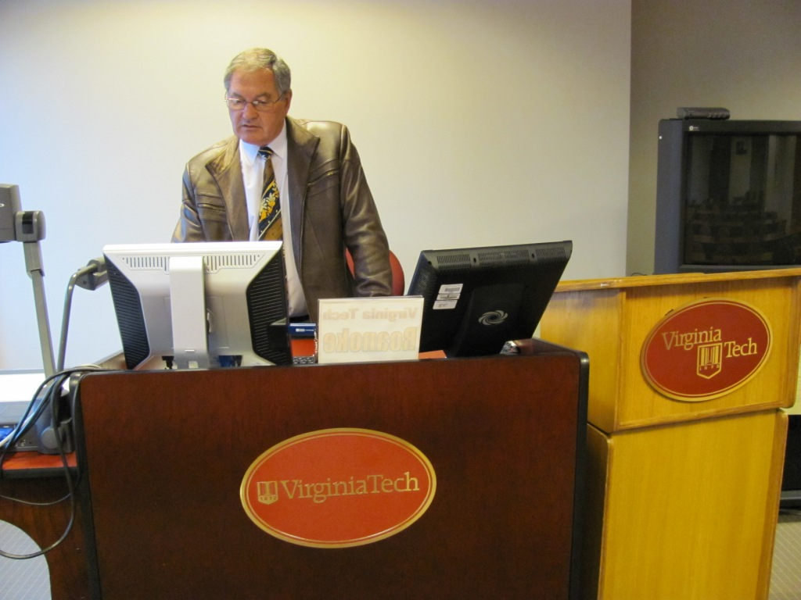

1-4 November 2009 – Christopher Newport University in Yorktown, Virginia – host, Mr Bill Thro
Mr Bill Thro the University Counsel and professor teaching education Law invited us to attend various classes in education law. We presented lectures to his education law class and to a political science class.

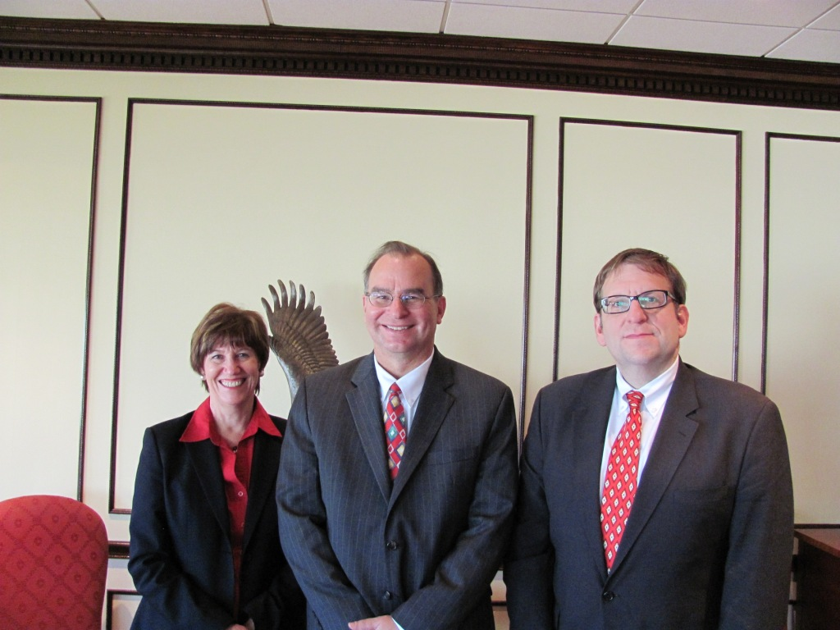
We met with the Provost, Dr Mark Padilla ( Centre). On the left is Prof Rika Joubert and on the right is Mr Bill Thro

5 November 2009 – Old Dominium University in Norfolk, Virginia – host, Prof William Owens
Our host Prof Bill Owens is the Head of Department and a well known author of Education leadership books. We received valuable information about the structure, content and assessment of their masters programmes in Education Leadership.

