## Pretoria: Science Review Session Held at Mae Jemison

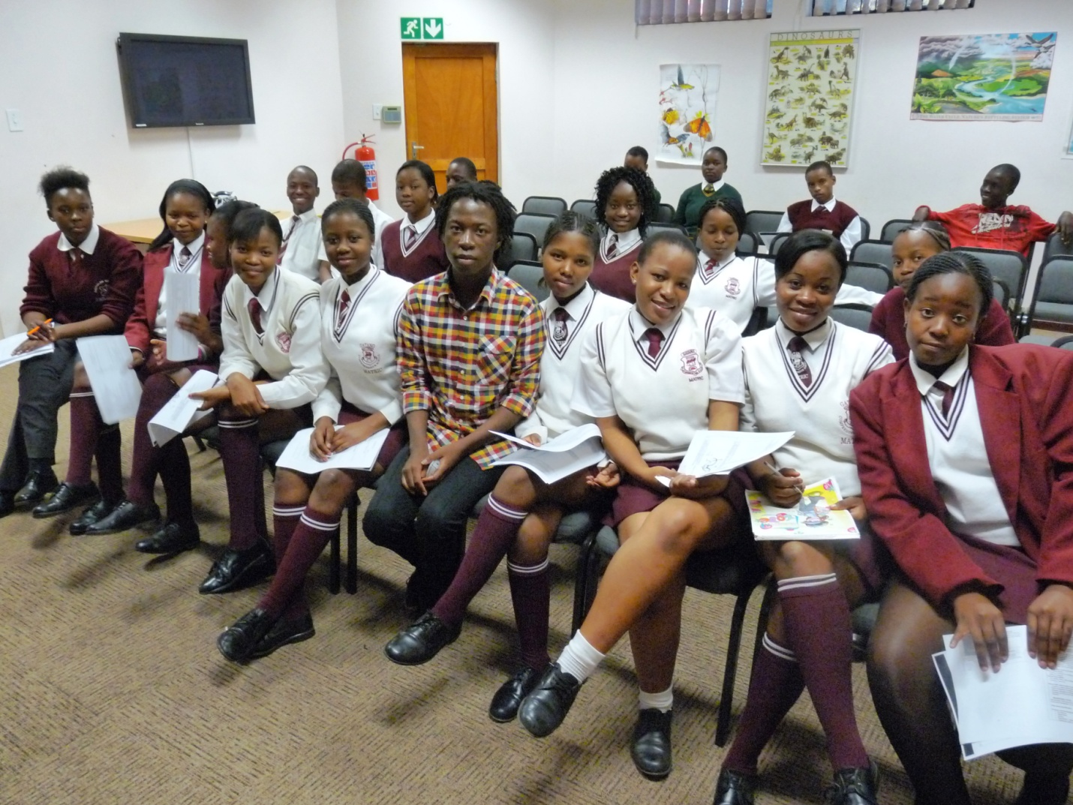

Students worked hard to review the subject of Plant Reproduction for an upcoming Life Sciences exam, with UP student teacher Koketso Sehlapelo (center).

On Monday, May 17 at the Mae Jemison U.S. Science Reading Room, students gathered for extra help to prepare for upcoming exams in Life Sciences. Koketso Sehlapelo, who is studying education at the University of Pretoria, led the review session on the subject of Plant Reproduction. Koketso volunteers at Mae Jemison in order to receive credit for field work toward his education degree. It is a successful partnership under the direction of Lecturer Hanlie Dippenaar, who encourages her university students to use this community engagement to improve their own English language proficiency and communication skills as future teachers in South Africa.

The 30 students who attended reported that the session was very helpful in broadening their understanding of the subject. The results of this program will be clear when students receive their marks after the exam, and the ongoing partnership will assist in creating a stronger group of new teachers.