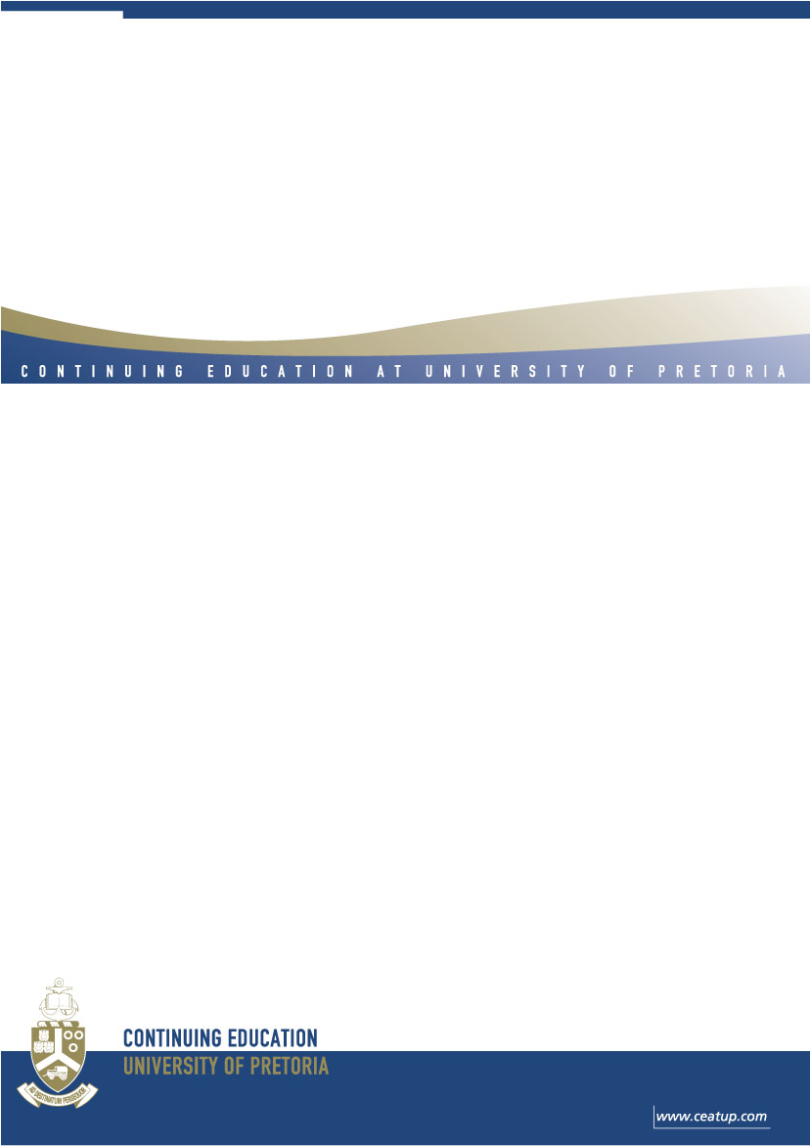

Certificate Programme in
WILDLIFE CHEMICAL IMMOBILISATION

Presented by the Department of Paraclinical Sciences, Faculty of Veterinary Science, University of Pretoria, in association with Wildlifevets.com and Veterinary Wildlife Services, SANParks

2 – 8 September 2007

,
BRIEF DESCRIPTION

This is a comprehensive hands-on course in safe and ethical methods of capturing wildlife through chemical immobilisation. Special attention is given to new preparations, new equipment, and modified techniques.

CONTENT / LEARNING OUTCOMES

After completion of this course, delegates should understand the theoretical and practical aspects of chemical immobilization in wildlife with emphasis on the following:

1. Applied physiology;
2. Pharmacological principles from injection to recovery;
3. Current and new pharmacological preparations;
4. Equipment;
5. Basic principles of immobilization;
6. Species-specific information;
7. Problems under anaesthesia;
8. Accidental human injection;
9. Confined-space darting;
10. Legal aspects of darting, keeping of records and registers.

Plenty of extra reading material and many videos are provided.

PARTICIPANTS

Veterinarians and veterinary students registered with the South African Veterinary Council, foreign veterinarians and veterinary students, and any non-South Africans with a background in wildlife.

PRESENTERS

Professor Gerry Swan, Dr Markus Hofmeyr, Dr Peter Buss, Dr Cobus Raath and Dr Leon Venter.

VENUE

The course is presented at Ngongoni Lodge near Nelspruit and at Skukuza in the Kruger National Park.

ACCREDITATION
NQF level 8, 30 CPD Points (AC/0172/07)

CERTIFICATION

Delegates will receive a certificate reflecting “successfully completed” at the end of the course, following an assessment at the end of the course.

COURSE FEE

The course fee is R9 950 for South African citizens and $1 800 for applicants outside South Africa. All course notes, meals, accommodation & transport during the course are included.

Registrations close on 27 August 2007.

REGISTRATION & ENQUIRIES

Chanine Pienaar
Tel: +27 12 420 5015
Mobile: 083 302 4274
E mail: chanine.ce@up.ac.za

ENQUIRIES REGARDING CONTENT

Dr. Leon Venter Prof Nick Kriek
Tel: +27 12 529 8034 Tel: +27 12 529 8557
Email: leon.venter@up.ac.za Email: nick.kriek@up.ac.za


(11 pt)
DURATION OF INSTRUCTION
(11pt)
The course is presented from? at the University of Pretoria.
(11 pt)
COURSE FEE
(11pt)
The fee for the course is R3 5000-00 and it includes study material and refreshments.
(11pt
ASSESSMENT
(11pt)
- Role play
- Mock trail case
(11pt)
REGISTRATION AND ENQUIRIES
(11pt)
Tumi Mathabatha
Tel: (012) 420-5015
E-mail: tumi.ce@up.ac.za
(11pt)
CONTEXTUAL ENQUIRIES
(11pt)
Dr Vera Roos
Tel: 082 925 7946)
Fax: (018) 299 1730

Hiermee die formaat wat ek voorstel vir die detail ‘look en feel’ vir E pos brosjures vir 2005
Soms is daar meer inligting – hanteer dit so stylvol moontlik. Pasop dat dit nie te lank word nie – mense lees dit dan ook nie.

Die volgende opskrifte moet in brosjures voorkom

Titelblad
BRIEF DESCRIPTION
CONTENT
PRESENTERS
LEARNING OUTCOMES
ADMISSION REQUIREMENTS
STRUCTURE & DURATION
COURSE FEE
ASSESSMENT
REGISTRATION & ENQUIRIES

Die volgorde van die opskrifte gaan afhang wat jy wil beklemtoon – mense lees die eerste bladsy eerste.

