

Researchers

**ETHICS APPLICATION & APPROVAL SYSTEM**

Post Approval Submissions

Table of Content

1. How to Login to the Ethics system 3

2. Add Post Approval Submission 4

2.1 Add submissions on Protocol not exists on the system 5

2.1.1 Submit Post Approvals to the Ethics Committee 7

2.1.2 Submit Documents to only receive an Acknowledgement Letter 8

2.2 Add more submissions on Existing Protocol 9

2.2.1 Submit Post Approvals to the Ethics Committee 10

2.2.2 Submit Documents to only receive an Acknowledgement Letter 11

3. Modify Existing Submission 12

# How to Login to the Ethics system

Login to UP Portal ([www.up.ac.za](http://www.up.ac.za)  / MyTUKS Login)

On the UP Staff Portal, UP Student Portal and UP Guest Portal, find the “Research Grants & Ethics” section.

Click on the Research Grants & Ethics link, see below:

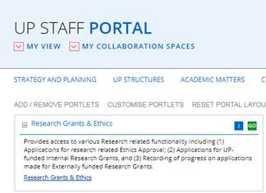

On the Homepage, click on the “Ethics Application & Approval” tile:

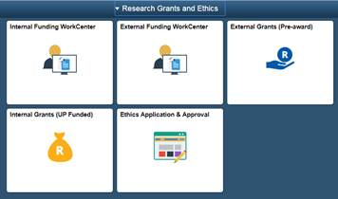

# Add Post Approval Submission

Post Approval Submissions includes:

1. Submit Post Approvals to the Ethics Committee

* Amendments
* Annual Renewals
* Serious Adverse Events
* Other Submissions
* Reports on Medication Trials (Additional to Annual Renewal)

1. Submit Documents to only receive an Acknowledgement Letter

## Add submissions on Protocol not exists on the system

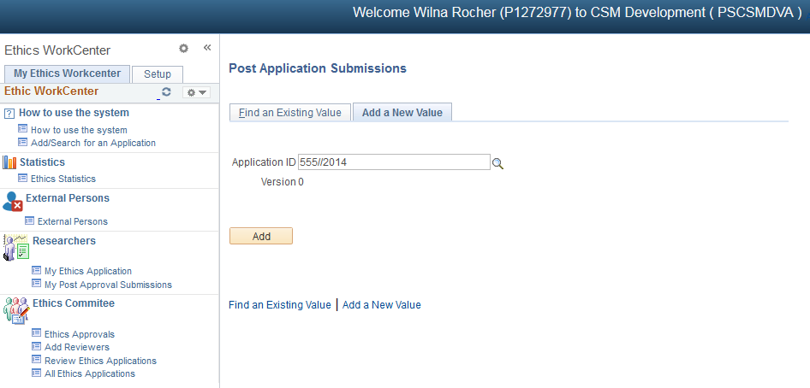

Click on “My Post Approval Submissions”

Type the Protocol number and click on the “Add” button.

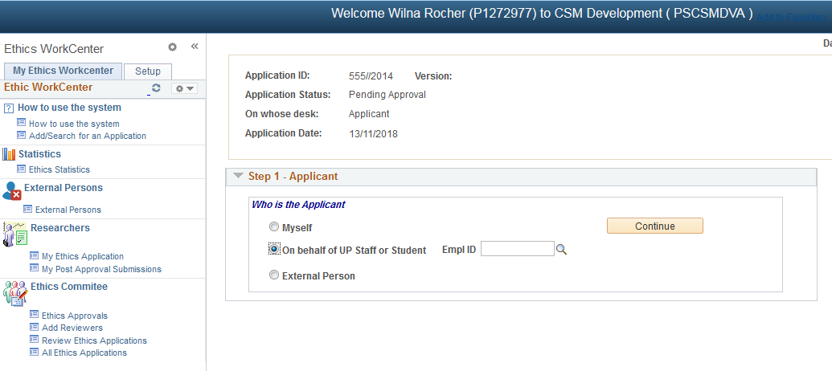

Click on “Myself” if you are the Researcher

OR

Click on “On behalf of UP Staff or Student” if you are submitting the application on behalf of a researcher. Fill in the Researcher’s Empl ID, or click on the magnifying glass to search for the Researcher.

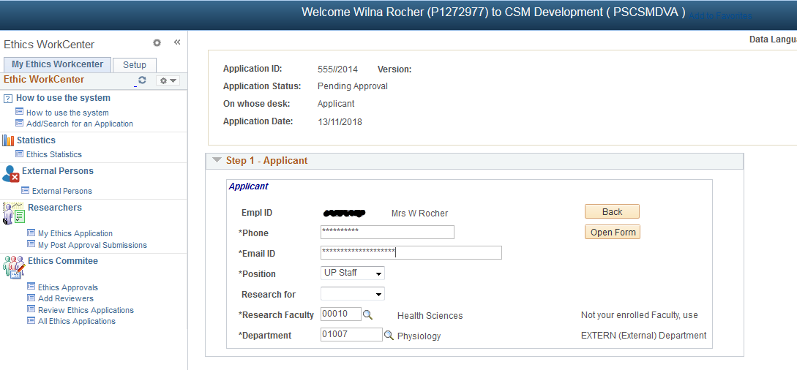

Please confirm that your information is correct, all communication will be send to this Email Address.

All fields must be completed.

Click on the “Open Form” button

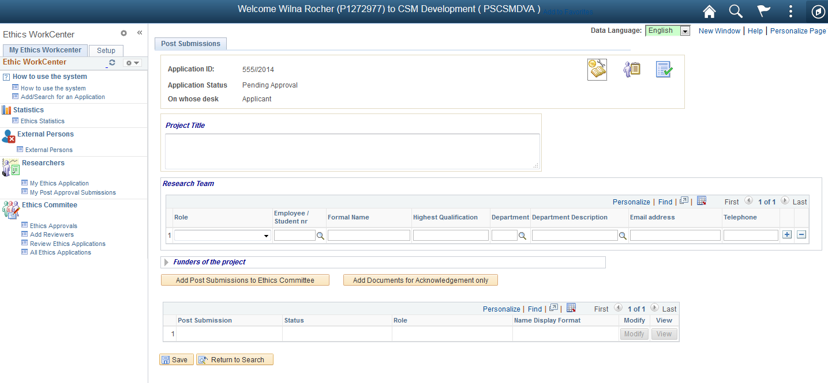

First complete the following:

1. Project Title
2. Research Team – please add:
3. Principal Investigator
4. Student Supervisor – if you are a student
5. Funders of the Project

### Submit Post Approvals to the Ethics Committee

The following submissions will be submitted to the Ethics Committee:

* Amendments
* Annual Renewals
* Serious Adverse Events
* Other Submissions
* Reports on Medication Trials (Additional to Annual Renewal)

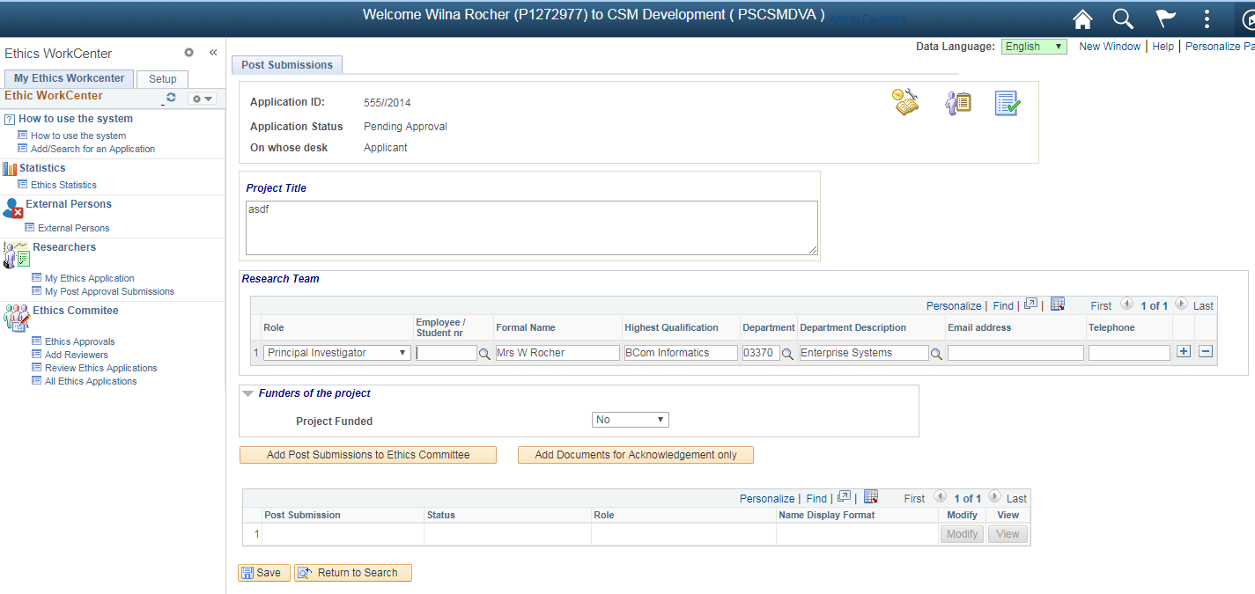

Kliek on the “Add submissions to the Ethics Committee” button

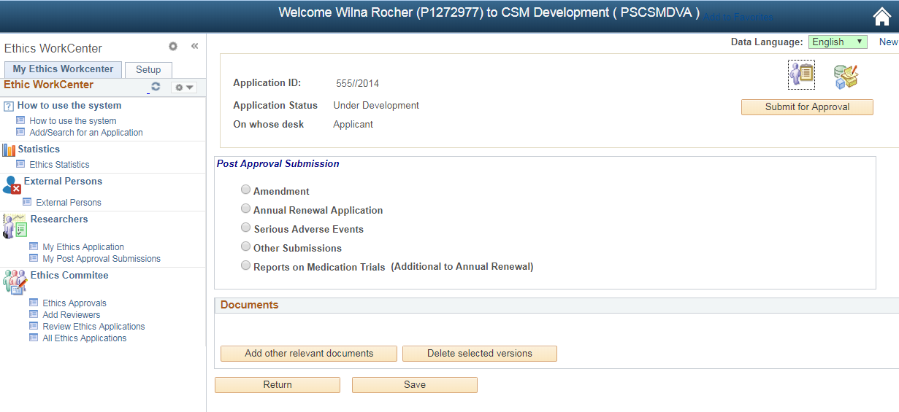

Choose one of the submissions and complete the areas that will become available on the screen.

Add the relevant documents by clicking on the “Add other relevant documents” button.

Click on the “Save” button to save your changes.

Click on the “Submit for Approval” button to submit the submission to the Ethics Committee.

Click on the “Return” button to return to the Protocol screen

### Submit Documents to only receive an Acknowledgement Letter



Click on the “Add Documents for Acknowledgement only” button.

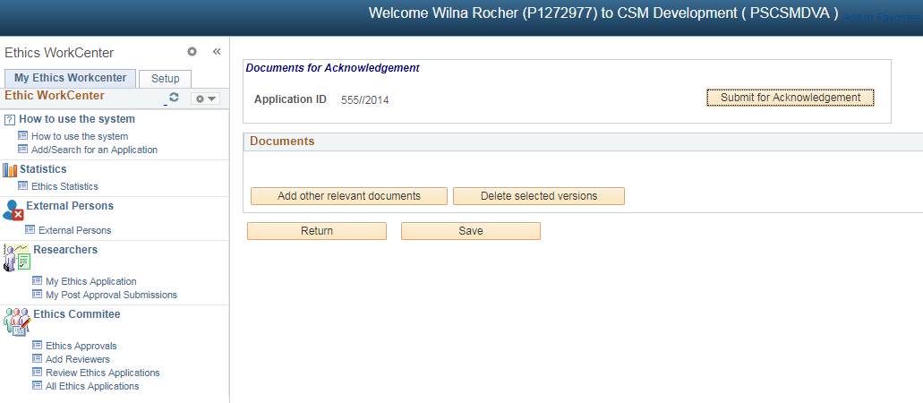

Add all documents by clicking on the “Add other relevant documents” button.

Click on the “Save” button.

Click on the “Submit for Acknowledgement” button to request an Acknowledgement Letter.

Click on the “Return” button to take you back to the Protocol screen.

## Add more submissions on Existing Protocol

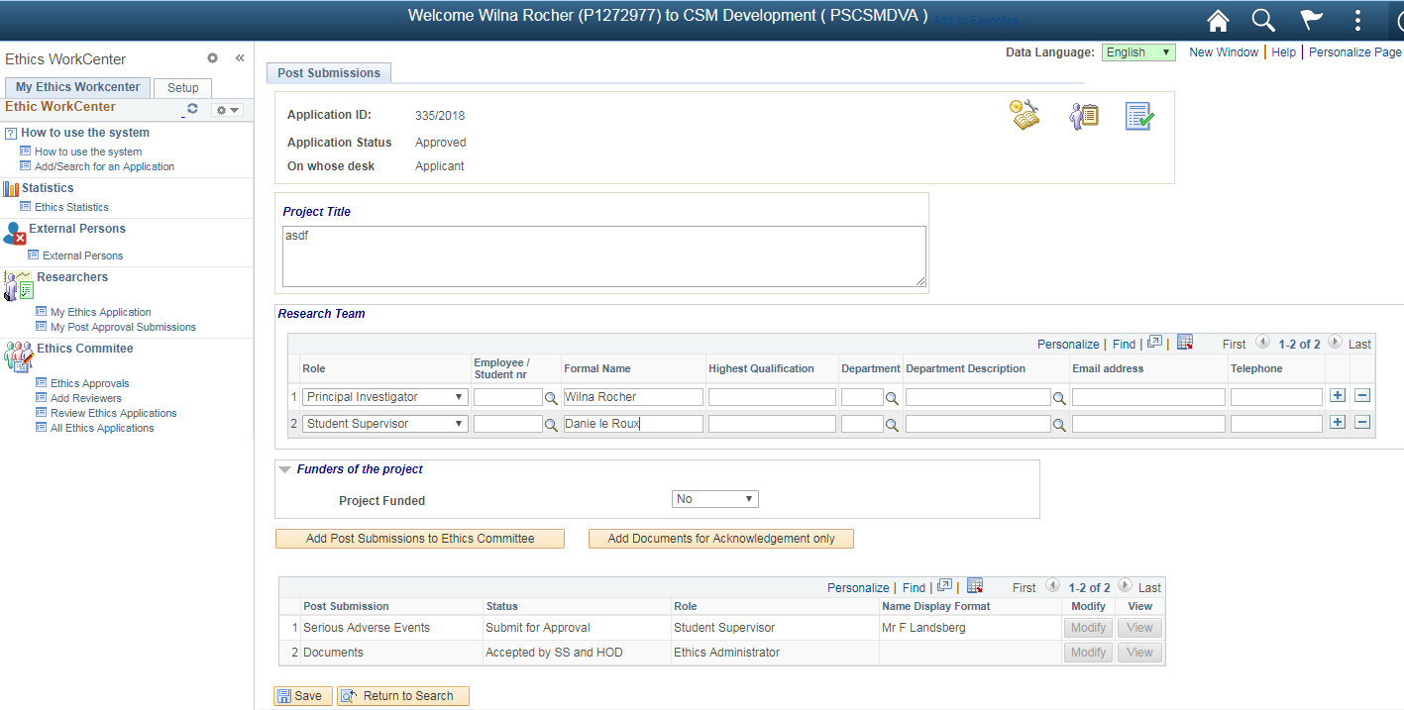

To view the Initial Protocol information, click the icons in the top right hand corner

1. Post Approval Submission – this is the page you are on.
2. Application Form – Form completed for Initial Application
3. Documents – Documents uploaded for Initial Application

### Submit Post Approvals to the Ethics Committee



To Add new submissions, click on the “Add Post Submissions to Ethics Committee” button



Choose one of the submissions and complete the areas that will become available on the screen.

Add the relevant documents by clicking on the “Add other relevant documents” button.

Click on the “Save” button to save your changes.

Click on the “Submit for Approval” button to submit the submission to the Ethics Committee.

Click on the “Return” button to return to the Protocol screen

### Submit Documents to only receive an Acknowledgement Letter



Click on the “Add Documents for Acknowledgement only” button.



Add all documents by clicking on the “Add other relevant documents” button.

Click on the “Save” button.

Click on the “Submit for Acknowledgement” button to request an Acknowledgement Letter.

Click on the “Return” button to take you back to the Protocol screen.

# Modify Existing Submission

If you save you submission, but you didn’t submit the submission to the Committee or submit the documents for acknowledgement, then you will be able to work on your submission again.

Go to “My Post Approval Submission”



Click on “Find an Existing Value” tab

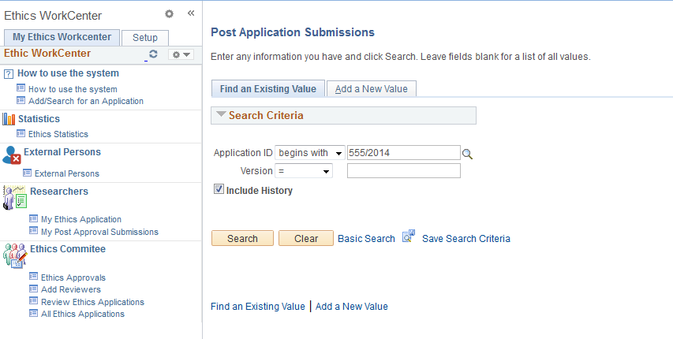

Enter the protocol number and click on the “Search” button

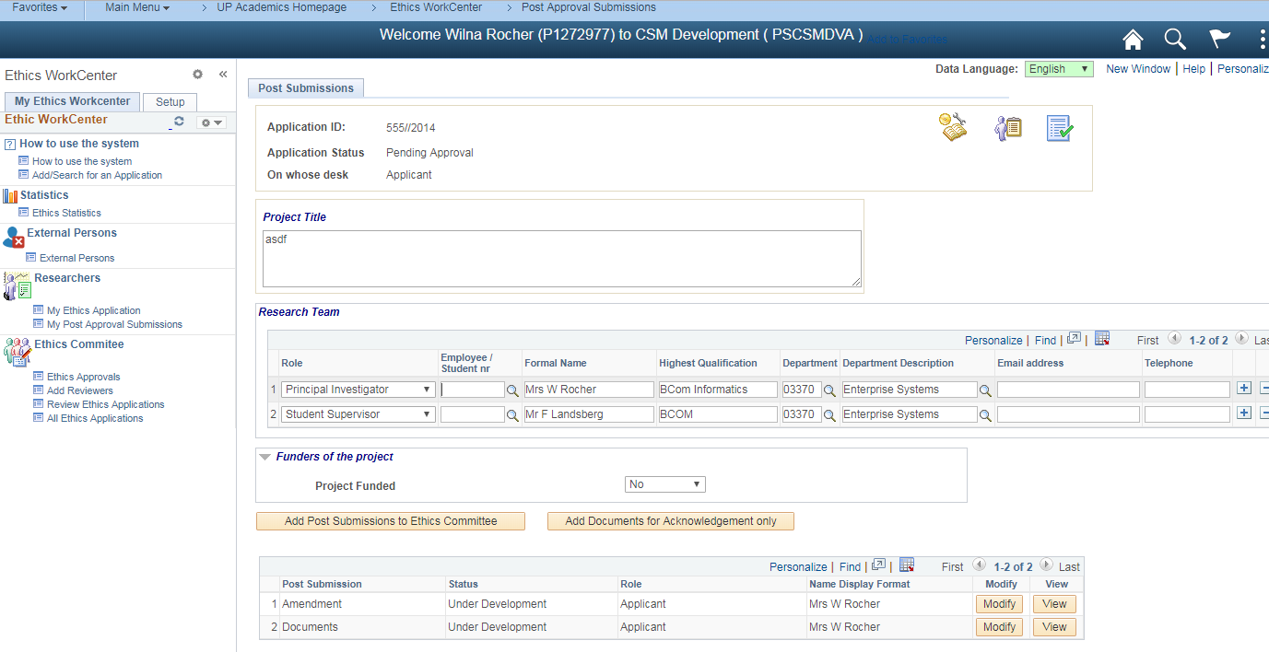

VIEW – you won’t be able to work on the submission, this is only for display purposes.

MODIFY – you can change, add, delete and submit your submission to the Ethics Committee, or submit your documents for acknowledgement.

Click on Modify to open your submission

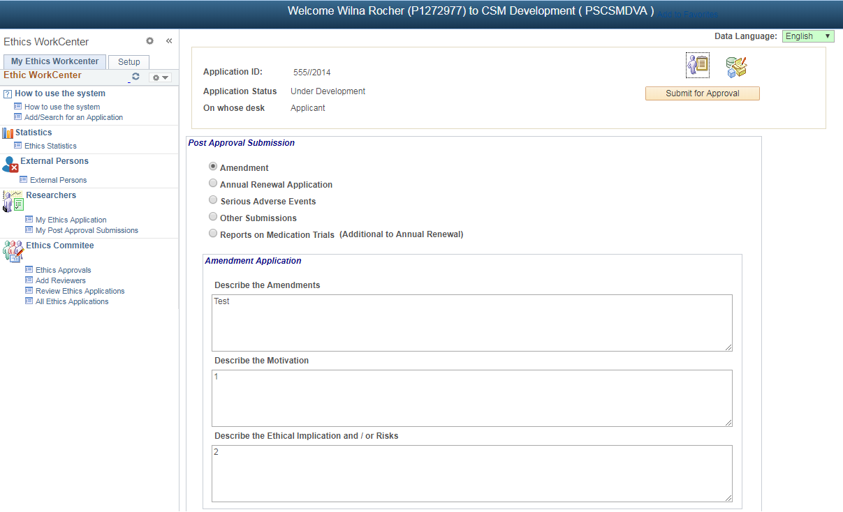

You can change and submit the submission

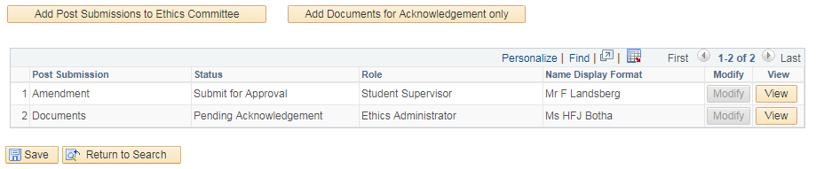

By clicking on the View button, you will be able to view your submission.

You will not be able to change (modify) the submission.

Each line will show the status, role and name of the person on whose desk the submission is.

When the submission is with a Reviewer, you won’t be able to see the name of the Reviewer.



You can add a new submission by clicking on the “Add Post Submissions to Ethics Committee” button or “Add Documents for Acknowledgement only” button.

See 2.1.1 and 2.1.2