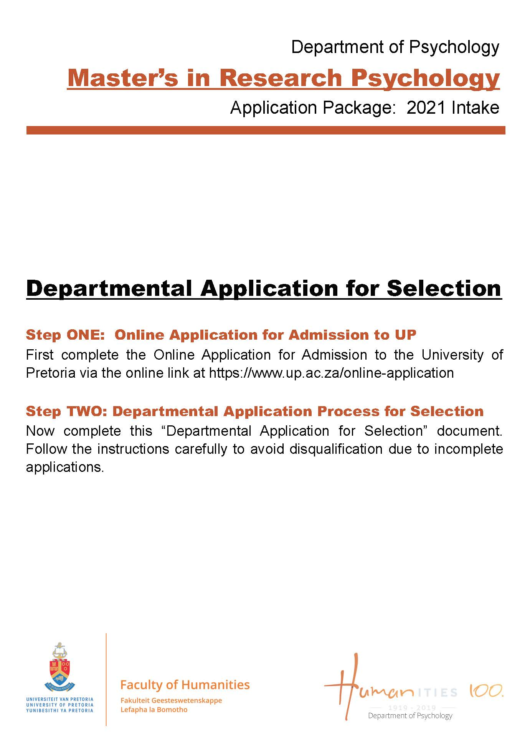

Table of Contents
The Selection Process Information 1 - 4

Compulsory Checklist 5

Departmental Application Form 6 to 9

Departmental Referee Report 10 - 11

Concept Research Proposal Guidelines ..........................................................................12 - 13

The Selection Process Information

(Read this carefully before you complete the application form to avoid disqualification)

The Selection Process for the MA Research Psychology Programme

The Department of Psychology offers the MA Research Psychology programme, which leads to registration as a Research Psychologist with the Professional Board of Psychology of the Health Professions Council of South Africa. The programme comprises one full-time academic year of study, followed by a full-time internship year, during which students also complete their mini-dissertations. Students must complete the full-time academic year before they can enter the internship.

This document provides important information about the selection process (STEPS) to applicants applying for the MA Research Psychology programme of the Department of Psychology.

OUTLINE OF THE APPLICATION & SELECTION PROCESS
The following information outlines the application and selection process to be followed when applying for the MA Research Psychology programme. Step 1 outlines the minimum academic requirements to submit an application for the MA in Research Psychology degree at the University of Pretoria. Steps 2 and 3 focus on application-related information. Steps 4 and 5 outline the selection process.

Step 1: First, the applicant must ensure they meet the minimum academic requirements to submit an application for the MA in Research Psychology at the University of Pretoria.

Step 2: Second, and only after the criteria for Step 1 are successfully met, the applicant must complete the online Application for Admission to Study process via www.up.ac.za/online-application (for unenrolled/prospective students) or the Internal Application process (for currently enrolled students) via the University of Pretoria’s Student Portal (Student Centre).

Step 3: Third, and only after Step 2 is successfully completed, can the applicant then complete the Department of Psychology Form and the Department of Psychology Referee Report Form, which together form a complete application and act as additional supplements to the University of Pretoria’s Application Forms (submitted as part of Step 2), which are specifically handled by the Department of Psychology. The Department of Psychology’s Form and Referee Report Form are, once fully completed, submitted to the Department of Psychology.

Step 4: This step entails an internal shortlisting process as part of which suitable applicants are identified and invited to participate further in the selection process.

Step 5: Shortlisted applicants are invited to participate in the selection process at the University of Pretoria.

STEPS OUTLINED

2.1 Step 1: Minimum Academic Requirements to Submit an Application for the MA in Research Psychology

The minimum academic requirements to submit an application for the MA in Research Psychology degree are based on the minimum requirements ultimately needed for admission into degree, as approved by the University of Pretoria, namely: (1) an accredited BSocSciHons in Psychology, or BA Hons in Psychology, or relevant Honours degree; and (2) a cumulative weighted average of at least 65% for said Honours degree.

In this regard, the following candidates are eligible to apply:
- Students who are currently enrolled in an Honours degree in Psychology: Students currently in progress with an Honours degree in Psychology at an accredited and recognised higher education institution should ensure: (1) that the cumulative weighted average for their undergraduate degree is no less than 70% (i.e. 70% or more); and (2) that the Honours degree for which the applicant is currently enrolled will be completed by the end of the academic year.

- Students who have completed an Honours degree in Psychology: Students who have completed an Honours degree in Psychology at an accredited and recognised higher education institution should have graduated this degree with a cumulative weighted average of no less than 65% (i.e. 65% or more).

Please Note:
- Prospective applicants should not proceed with an application if they do not meet the abovementioned minimum academic requirements for admission into the MA in Research Psychology.
- Prospective applicants should not proceed with an application if they are not a citizen of the Republic of South Africa.
- Prospective applicants should not proceed with an application if they have already applied for admission to this degree at the University of Pretoria more than twice before (i.e. three or more times).

2.2. Step 2: Online Application for Admission to the University of Pretoria

- Prospective students: It is compulsory for all prospective students to first complete the Online Application for Admission process before submitting any documents to the department. This process can only be completed online. Go to www.up.ac.za/online-application to complete the online process.

- Currently enrolled students: Currently enrolled students of the University of Pretoria need to complete the compulsory Internal Application process through their Student Centre via the student portal.

Please Note: The applicant cannot proceed to Step 3 without completing the online application for admission. Also, the completion of the online application for admission does not mean the applicant has been accepted into the MA Research Psychology degree programme.

2.3. Step 3: Department of Psychology Application forms for the MA in Research Psychology

After completing Step 2, all applicants must complete the compulsory Checklist (page 5), Supplement Form (page 6-9), the Referee Report Form (page 10-11) and the Concept Proposal (12 – 15).

Refer to the full list of compulsory documentation on the next page.

Compulsory documentation to be submitted to the department after the Online Application for Admission was submitted:
- Compulsory Checklist (page 5)
- The Departmental Application Form (typed) (page 6 to 9)
- Two Referee Reports (typed) emailed to nessa.augus@up.ac.za (page 10 to 11)
- Concept Research Proposal (typed) - Refer to point 7, page 8 of the Departmental Application Form (use the template on page 12 – 13)
- Academic Record (complete your marks on the Departmental Application Form (page 7)
- Copy of your ID
- Copy of your Matric Certificate

Once these forms are fully completed, the applicant must:
Personally deliver / courier / post the above0mentioned compulsory forms before 12h00 on 31 May 2020 to:
Ms Vanessa Augus
MA Coursework Psychology Applications Coordinator
University of Pretoria
Department of Psychology
Humanities Building, 11th Floor, Room 11-16
Corner of Lynwood Road and Roper Street
Hatfield, 0083

Please Note:
- The office hours for deliveries are from 08h00 to 15h00 (Mondays to Fridays).
- No Supplement Forms will be accepted via facsimile or email.
- Referee Report Forms will only be accepted via email (directly from the chosen Referees).
- The Department of Psychology does not accept liability for applications mislaid or undelivered through selected courier service or postal system.
- Applications which are not fully completed are considered incomplete and do not undergo further processing or consideration.
- Late applications are not processed.
- Applicant who do not meet the minimum requirements for admission in the MA in Research Psychology will not be considered for selection.

2.4. Step 4: Screening of Applicants

The screening process is internal to the Department of Psychology and, includes the MA Research Psychology Training Team. Each application is considered and any incomplete applications will be excluded from the selection process.
- The department is not responsible for applications mislaid in the post
- Late applications will not be considered

Please Note: The Department of Psychology will contact the shortlisted applicants with their invitation to participate in the selection process via email. It is the responsibility of the applicant to contact the Department of Psychology (via 012 420 2329) to determine whether their application was un/successful on 26 June 2020, between 08h00-15h00.

2.5 Step 5: The Selection Process at the University of Pretoria
For 2020, the selection process for the MA in Research Psychology is scheduled to take place from 03 - 05 August 2020, in the Department of Psychology at the University of Pretoria. Applicants who accept the offer to participate in the selection process must present themselves in person on 03 August 2020, at designated times.

The selection process is as follows:
- Day1: Individual interviews:
Candidates will be informed via email about their scheduled times

- Day2: Group activity and a written task
At the end of Day 2, all applicants are evaluated and shortlisted. Only successfully shortlisted applicants are invited to participate in the final day of selection

- Day 3: Panel interview: Candidates will be informed via email about their scheduled times.

Applicants need to be aware of the following factors which will contribute to any decisions made by the selection panel:
  - Academic performance
  - Language competency in terms of the performance required at master’s level
  - Limited space available on the programme
  - Consideration of candidates from designated groups
  - The composition of the final group selected
  - Performance on the selection tasks
  - Consideration of research competency
  - Ability to reason, argue and engage in critical thinking

Please take into consideration that it is expected from all selected candidates to be economically independent for the MA year. It is a FULL-TIME course and it is not possible for you to be in permanent, temporary or part-time employment during this period.

Please Note:
1. Please notify the Department of Psychology should you wish to withdraw from the selection process, via Ms. Vanessa Augus on nessa.augus@up.ac.za no later than 29 July 2020.
2. Applicants who accept the invitation to participate in the selection process at the University of Pretoria are expected to absorb the costs of any accommodation or travel expenses which may be incurred as a result of participation in the selection process.

Queries Regarding the Application Process can be directed to Ms. Vanessa Augus at nessa.augus@up.ac.za.

Kind regards,

Ms Sonja N Mostert
Department of Psychology
Programme Manager: MA Research Psychology

Compulsory Checklist: MA Research Psychology Programme

Go through the checklist to ensure completeness of your application form before submission. It is compulsory to attach this checklist to the FRONT of your Application Package before submitting it.

Name of Candidate: _____________________________________

Item | Have you checked the following? | Applicant: Yes / No | Office Use: Yes / No
1 | Have you made sure of the closing date of the MA Research Psychology programme? The closing date for submission is 31 May 2019 at 12h00 and no late applications will be accepted
2 | Did you complete your personal and contact information on the departmental application form? We need this to contact you via email and cell number
3 | Did you complete all sections of the departmental application form?
4 | Have you signed your departmental application form?
5 | Have you made sure of the address to which the application form must be posted? The address is on page 1 of the information letter. The Department will not be held responsible for mislaid envelopes or packages

Item | Did you include the following compulsory documents? | Applicant: Yes / No | Office Use:  Yes / No
1 | This Checklist (Compulsory)
2 | Departmental Application Form (Compulsory and Typed)
3 | Did you stick the ID/Passport Photo on the Application Form? (Compulsory)
4 | Two (2) Referee Reports (Compulsory & Typed) emailed to nessa.augus@up.ac.za by your referees (it’s your responsibility to follow up with your referees)
5 | Concept Research Proposal (Compulsory & Typed)
6 | Copy of Honours degree in psychology (If conferred already)
7 | Copy of Undergraduate degree in psychology
8 | Copy of Full Academic Record (Compulsory)
9 | Copy of Matric Certificate (Compulsory)
10 | Copy of ID (Compulsory)

Checked by: (For Office Use)

Name:
Signature:
Date:

COMPULSORY Stick ONLY ID or Passport Photo here, NO posed photos will be accepted

Departmental Application Form / Supplement Form

MA Research Psychology Programme for 2021
Closing Date: 31 May 2020

Completion of all sections of this form is COMPULSORY. A limitation of only three (3) application attempts per student is allowed; NO further applications will be considered. Non adherence to these stipulations will result in AUTOMATIC DISQUALIFICATION from the selection process! Please replace the X with your details by typing the information

INSTRUCTIONS RECAPPED:
- READ the Departmental Information Sheet before completing your application form
- Complete ALL SECTIONS by REPLACING the X with your details and / or answers by TYPING it in – delete the additional lines when done.
- ATTACH your concept proposal, two referee reports, academic record, copy of your ID, copy of your matric results to this Departmental Application Form and remember to include the ID or Passport Photo
- Deliver or Courier it to Ms Vanessa Augus (address on page 2 of this application package)

1. PERSONAL & CONTACT INFORMATION OF APPLICANT (COMPULSORY, complete in full)
Surname: | X |  |  |  |  |  |  | Title: |  | X
Names: | X |  |  |  | Race: |  |  |  | X
Date of Birth: | X |  |  |  | Relationship Status: |  |  |  | X
Identity Number: | X |  |  |  | Age in Years: |  |  |  | X
Gender (mark): | Male: | Female: Alternative: Specify:
Citizenship/Nationality: | X
UP Student No: | X |  |  | Other Student No: |  |  | X
Contact Numbers: | Cell (NB!): |  | X |  |  | Work: | X
Email Address: (NB!) | X

2. If you intend applying at any other university this year, mention these universities as well as the categories of application:
X
X

3. Have you ever submitted an application for M-selection at the University of Pretoria? If yes, for which degree programme and which year?
X
X

4. EDUCATION (Please list each 3rd year and Honours psychology module)
(This section is COMPULSORY, complete it IN ADDITION to attaching your academic record and calculate your AVERAGE in the block SUPPLIED)

4.1. EDUCATION (COMPULSORY, complete the table with your psychology and research marks, but only calculate the average using your psychology marks)

Undergraduate Qualification | Institution Where Obtained | Year Obtained | Psychology  Module Name | Final Module  Result in Percentage  (compulsory)
X
X
X
X
X
X
X
X
 |  |  | Average of Psychology Marks Only

4.1.1. Honours Psychology Modules
(This section MUST be completed in full AND calculate your AVERAGE in the block SUPPLIED)

Honours  Qualification | Institution Where Obtained | Year Obtained | Honours  Module Name | Final Module  Result in Percentage  (compulsory)
X
X
X
X
X
X
X
X
 |  |  | Average:

4.2. Previous scholarships or bursaries received:
X
X
X

4.3. Other qualifications obtained:
X
X
X

- RELEVANT WORK OR VOLUNTEER EXPERIENCE
(List ALL work / volunteer experience, insert more lines if needed and delete open lines when done)

Employer | Position | Years Employed | Details of Duties
X
X
X
X
X
X
X
X

5.1. Other appropriate experience (Mention any other relevant experience, which you consider to have made a meaningful contribution to your development):
X
X
X

5.2. Positions of leadership and other achievements:
X
X
X

- HEALTH – (COMPULSORY)
Are there any personal factors or circumstances which may reasonably have a bearing on your suitability to be trained as a psychologist, or which may otherwise reasonably be seen to render you unsuitable for the profession of research practice?

Type your answer to the above questions below:
X
X
X

7. ASSIGNMENT (Typed and Not Handwritten)
On separate sheets of paper - NO more than FIVE TYPED pages complete the following with your name and surname at the top of the page and attach it to the application form (maximum of five TYPED pages, NO hand written assignments will be accepted)

Write a concept research proposal on a research topic of your choice, following the template available on pp 15-16 of this application package.

8. REFERENCES
Select two referees who are able to comment on your suitability as a candidate for the programme. Supply each with a Referee Form via email. Please ensure that your referees supply you with the confidential reports in sealed envelopes (attach these enveloped to this Departmental Application Form) or alternatively let them email it to nessa.augus@up.ac.za. (NB. Lecturers in the Department of Psychology at the University of Pretoria (specific to the degree you are applying for), family members or friends are not acceptable as referees).

8.1 Referee 1
Title, Initials & Surname
Capacity:
Institution:
E-mail address:

8.2 Referee 2
Title, Initials & Surname
Capacity:
Institution:
E-mail address:

9. DECLARATION (COMPULSORY)

I, X (name and surname) hereby declare that the information provided in the Departmental Application Form is honest and truthful, and that the assignment is my own work and that I have not withheld any information that may have an influence on my acceptance into the programme.

I also declare that I understand that the training is a fulltime two (2) year academic programme as outlined in the yearbook.

_________________ _____________
SIGNATURE DATE

Candidates need to copy and paste this one-page referee form into a new document (from the UP Logo). Then type your name and chosen programme in and email it to your referees

Departmental Referee Form:

MA Research Psychology

Dear Referee,

The above-mentioned candidate nominated you as a referee in an application for admission to the MA Research Psychology programme at the University of Pretoria. We assume that the candidate approached you in this respect. The application form, submitted by the candidate, provides limited information. It is in this respect that your input may provide the Selection Committee with valuable information concerning the applicant. Will you please, with your insight and knowledge of the candidate, answer the following questions as extensively as possible? Please answer the questions as honestly and fairly as possible in order to afford the Department of Psychology the opportunity to screen the Applicant’s suitability for further participation in the selection process and potential as a future research psychologist.

- Personal Information about Applicant:
Name and Surname:

- Information about Referee:
Title, Name and Surname:
Occupation:
Position:
Contact Number:
In what capacity have you known the Applicant?
For how long have you known the Applicant?
When last did you have contact with the Applicant?
Signature of Referee:

- Does this Applicant have personal characteristics suitable for training as a Research Psychologist? Please tick the applicable characteristics as indicated below.

Characteristic | Yes | No | Unable to comment
Trustworthiness
Integrity
Reliability
Emotional stability
Assertiveness
Self-reliance
Maturity
Flexible/Adaptability
Time management skills
Ability to cope under pressure
Capacity to work in groups
Openness to diversity and social justice

Additional Comments:

- Does this Applicant have the academic ability suitable for training as a Research Psychologist?

Characteristic | Yes | No | Unable to comment
Problem solving and questioning skills
Expressive ability
Verbal and written ability
Research and Innovation skills
Critical thinking
Communication skills
Hardworking
Ability to meet deadlines
Logical reasoning and Clarity of thought

Additional Comments:

- How would you evaluate this Applicant’s overall suitability for training as a Research Psychologist?

Exceptional
Above Average
Average
Below Average
Poor
Unable to comment

Additional Comments:

This Referee Report Form must be emailed directly to Ms Vanessa Augus (nessa.augus@up.ac.za) before 31 May2020.

Concept Research Proposal for Master’s Studies
(Typed)

COVER PAGE
Complete this cover page, then attach your concept proposal, according to the guidelines provided below.

NAME OF APPLICANT
Name and Surname: X

TITLE

Proposed title: X

Brief statement of research question
State your research question in one sentence
X

In one sentence, explain what you intend to do in your research.
X

STRUCTURE OF THE CONCEPT PROPOSAL
Write a concept research proposal of maximum 5 pages for your topic. Follow the referencing techniques and other technical requirements and style guidelines of the most recent edition of the Publication Manual of the American Psychological Association (APA).

INCLUDE THE FOLLOWING IN YOUR PROPOSAL

Research problem
Provide a description of the research problem (i.e. what do you want to find out or investigate? Which problem/s do you want to address?).

Literature review
Provide a brief overview of the most important literature relevant to the research (Who has done similar work?).

Justification, aim and objectives
Describe why the research problem is important, i.e. why do you want to do the research? What benefits could arise from the research at a theoretical and/or practical level? Also, include in this section the aim(s) and objectives of your research.

Theoretical and/or paradigmatic point of departure
Briefly state the theoretical or paradigmatic point of departure of the study and indicate how this would be suitable to the topic. Consider a conceptual framework that would make the research question and methodology be better understood (What are the assumptions that you are making?).

Proposed research methodology
Provide a brief description of the proposed research methodology. How are you going to do the research? For example, will you be using a quantitative or a qualitative design? Will the study be literature based or empirical? How will data or information be gathered and analysed or interpreted? Who will participate in the study and how will they be selected (the sample)?

Ethical considerations
Mention any ethical issues arising from your study and state briefly how they may be dealt with.

Preliminary table of contents of the dissertation / thesis
List possible chapters to be included.

Reference list

Follow the most recent APA guidelines.

