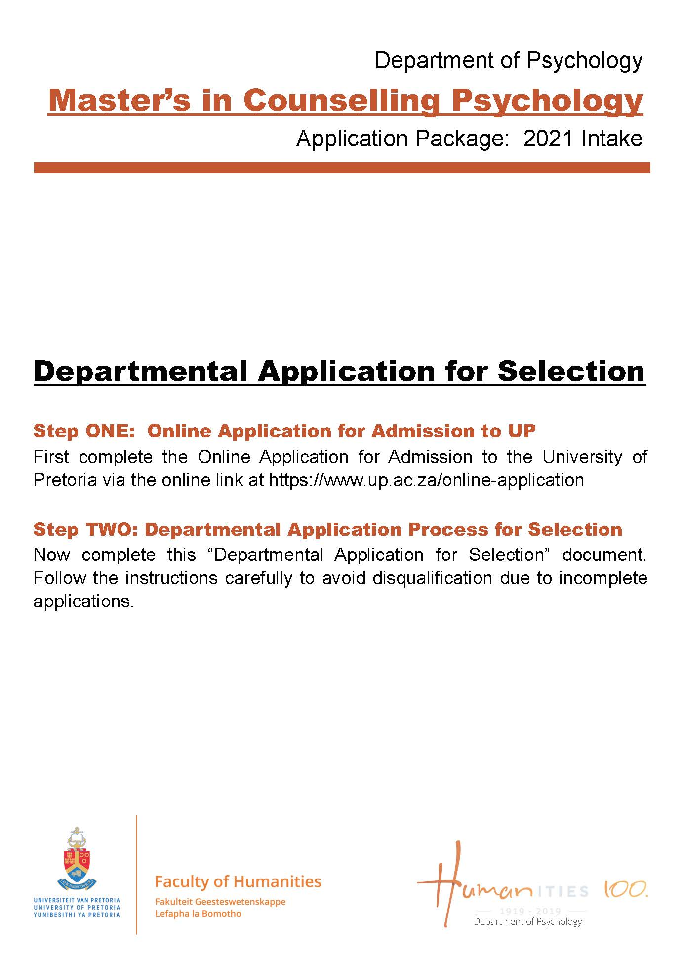

Table of Contents
Selection Process Information 1 to 2

Departmental Application Form (MA Counselling Psychology) 3 to 5

Departmental Referee Report 6 to 7

Selection Process Information

Read this carefully before you complete the application form

The Selection Process for MA Counselling Psychology Programme

The Department of Psychology offers the MA Counselling Psychology programme, which leads to registration as a Counselling Psychologist with the Professional Board of Psychology of the Health Professions Council of South Africa. The programme comprises of one full-time academic year of study, followed by a full-time internship year, during which students also complete their mini-dissertations. Students must complete the full-time academic year before they can enter the internship.

Please take into consideration that it is expected from all selected candidates to be economically independent for the MA programme. It is a FULL-TIME course and it is not possible for you to be in permanent, temporary or part-time employment during this period.

The selection process is divided into three steps

Step ONE: Online Application for Admission
- It is compulsory for all prospective students to first complete the Online Application for Admission process before submitting any documents to the department. This process is online only and can be completed on www.up.ac.za/online-application
- Currently enrolled students of the University of Pretoria need to complete the compulsory Internal Application process through their Student Centre via the student portal.

Step TWO: Departmental Application Process
All applicants should submit the compulsory, correctly completed departmental application form as mentioned below in point 1:

- 1. Compulsory documentation to be submitted to the department after the Application for Admission was submitted via www.up.ac.za/online-application:
    - The Departmental Application Form (typed) - page 3 to 4
    - Two Referee Reports emailed directly by the referee to nessa.augus@up.ac.za - page 5-6
    - Essay (typed) – see page 4

2. Personally, deliver or courier (DHL, SkyNet etc.) your completed documents before or on 12:00, 31 May 2020 to:
Mrs Vanessa Augus
The MA Application Coordinator
University of Pretoria, Department of Psychology
Humanities Building, 11th Floor, Room 11 – 16
Corner Lynnwood Road & Roper Street
Hatfield, Pretoria, 0083

3. Please take note of the submission information
- The office hours for deliveries are from 08:00 to 15:00 (Mondays to Fridays)
- NO Application Forms will be accepted via facsimile or email
- ONLY referee reports will be accepted via email (directly from the chosen referees)
- Only applicants with an overall minimum average of 70% for their Honours modules will be accepted into the MA Counselling Psychology programme
- The department is not responsible for applications mislaid in the postal service.
- Late applications will not be considered
- A limitation of only two application attempts for the MA Counselling programme per student is allowed

Step THREE: Shortlisting for Selection process

1. Paper Screening:
The selection panel screens all applications with an overall minimum average of 70% or more for their Honours and Undergraduate Psychology modules. Applicants whose marks are below 70% will be excluded. A limited number of candidates will be shortlisted.

2. Invitation to selection week:
Applicants who have been shortlisted are invited to participate in the selection week, 11 August – 14 August 2020. Those invited will take part in various activities and interviews. Participants have to be available for all four days but will be informed if their presence will be required on the following day, at the end of each day.

The department will contact the shortlisted candidates with their selection interview times via email; however, it is the responsibility of the candidate to contact the department on 22 July 2020 (via 012 420 2329) to determine whether he/she had been invited to participate.

Should you for any reason decide to withdraw from the selection process after having submitted your application, please inform the Department of Psychology immediately via nessa.augus@up.ac.za

3. The following criteria will contribute to any decisions made by the selection panel:
  - Academic performance
  - Language competency in terms of the performance required at master’s level
  - Limited space available on the programme
  - Consideration of candidates from designated groups
  - The composition of the final group selected
  - Performance on the selection tasks
  - Consideration of previous life experience
  - Ability to reason, argue and engage in critical and reflexive thinking

Kind regards,

Professor Terri Bakker
Programme Manager: MA Counselling Psychology
Department of Psychology

COMPULSORY Stick ONLY ID or Passport Photo here, NO posed photos will be accepted

Departmental Application Form

Application for Selection into the MA Counselling Psychology Programme for 2021
Closing Date: 31 May 2020

Completion of all sections of this form is COMPULSORY.
If you have applied for this programme before, please note that a limitation of only two application attempts for the MA Counselling programme per student is allowed; no further applications will be considered.

1. PERSONAL & CONTACT INFORMATION OF APPLICANT
Surname: | X |  |  |  |  |  | Title: |  | X
Names: | X |  |  | Race: |  |  |  | X
Date of Birth: | X |  |  | Disability Status: |  |  |  | X
Identity Number: | X |  |  | Age in Years: |  |  |  | X
Gender (mark): | Male: |  | Female: Alternative: ____________________________
Citizenship/Nationality: | X
Contact Numbers: | Cell: | X |  |  | Work: | X
Email Address: | X

- LANGUAGE PROFICIENCY:
List languages you know and tick if you can speak/read/write each:

Language | Speak | Read | Write

- PREVIOUS AND CURRENT APPLICATIONS
If you intend applying at any other university this year, mention these universities as well as the categories of application:
X
X
X

Have you ever submitted an application for M-selection at the University of Pretoria? If yes, for which degree programme and which year?
X
X
X

- RELEVANT WORK OR VOLUNTEER EXPERIENCE
(List ALL work / volunteer experience, insert more lines if needed and delete open lines when done)

Employer | Position | Dates Employed  (From x to x) | Details of Duties
X
X
X
X
X
X
X
X
X
X

Other appropriate experience (Mention any other relevant experience, which you consider to have made a meaningful contribution to your development):
X
X

5. HEALTH
Have you at any time in the past been treated, or are you currently being treated, for any psychiatric condition? If your response to the above is in the affirmative, kindly provide brief but pertinent details.

Are there any personal factors or circumstances which may reasonably have a bearing on your suitability to be trained as psychologist, or which may otherwise reasonably be seen to render you unsuitable for the profession of counselling practice?

Type your answer to the above questions below:
X
X

6. ESSAY (Typed)
On separate sheets of paper - NO more than TWO TYPED pages, complete the following with your name and surname at the top of the page and attach it to the application form.

Write a short essay on your life history in which you reflect on how your life history has influenced your decision to apply for selection in counselling psychology.

7. REFERENCES
Select two referees who are able to comment on your suitability as a candidate for the programme. Supply each with a Referee Form via email. Please ensure that your referees email it themselves directly to nessa.augus@up.ac.za. NB. Lecturers in the Department of Psychology at the University of Pretoria (specific to the degree you are applying for), family members or friends are not acceptable as referees.

7.1 Referee 1
Title, Initials & Surname
Capacity:
Institution:
E-mail address:

7.2 Referee 2
Title, Initials & Surname
Capacity:
Institution:
E-mail address:

8. DECLARATION

I, X (name and surname) hereby declare that the information provided in the Departmental Application Form is honest and truthful, and that the assignment is my own work and that I have not withheld any information that may have an influence on my acceptance into the programme.

I also declare that I understand that the training is a full time two (2) year academic programme as outlined in the yearbook.

________________________ _______________
SIGNATURE DATE

Candidates need to copy and paste this one-page referee form into a new document (from the UP Logo). Then type your name and chosen programme in and email it to your referees

Departmental Referee Form:

MA Counselling Psychology

Dear Referee,

Thank you for taking the time to complete this Referee Report Form. Please answer the following questions as honestly and fairly as possible in order to afford the Department of Psychology the best chance possible in screening the applicant’s suitability for further participation in the selection process and, beyond this, further training in Counselling Psychology.

- Personal Information about Applicant:
Name and Surname:

- Information about Referee:
Title, Name and Surname:
Occupation:
Position:
Contact Number:
In what capacity have you known the Applicant?
For how long have you known the Applicant?
When last did you have contact with the Applicant?
Signature of Referee:

- Does this applicant have the personal characteristics suitable for training as a Counselling Psychologist?
Please tick one indicator for each of the following:
Characteristic | Yes | No | Mostly | Unable to comment
Trustworthiness
Reliability
Emotional stability
Sensitivity
Assertiveness
Self-reliance
Maturity
Time management skills
Adaptability
Ability to be non-judgemental
Capacity to work with a variety of cultural groups
Openness to diversity and social justice

Additional Comments:

- Does this Applicant have the academic ability suitable for training as a Counselling Psychologist?
Please tick one indicator for each of the following:
 | Yes | No | Mostly | Unable to comment
Problem solving and questioning skills
Expressive ability
Verbal and written ability at the level of Master’s student
Research and innovation skills
Critical ability
Hardworking
Ability to meet deadlines
Logical reasoning and clarity of thought

Additional Comments:

- How would you evaluate this Applicant’s overall suitability for training as a Counselling Psychologist?
Exceptional
Above Average
Average
Below Average
Poor
Unable to comment

Additional Comments:

This Referee Report Form must be emailed directly to Ms Vanessa Augus (nessa.augus@up.ac.za) before 31 May2020.

