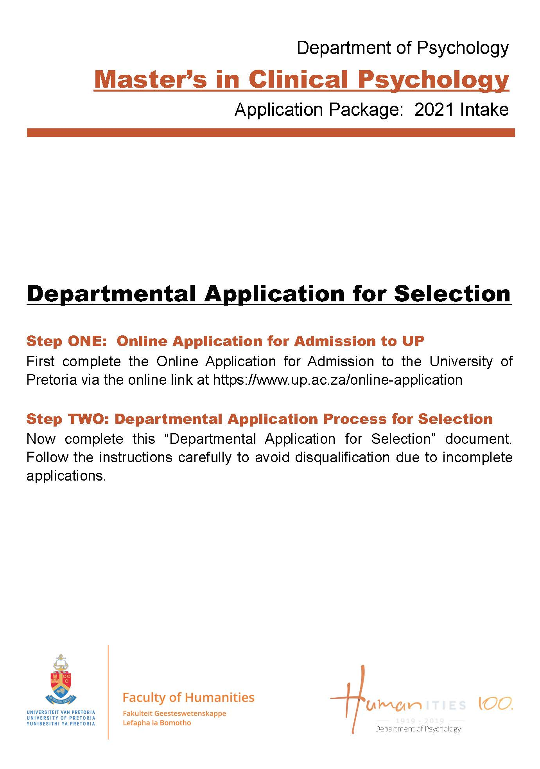

Table of Contents
- Introduction 1 - 2

- Outline of the Application & Selection Process 2 - 4

- Department of Psychology Supplement Form 5 - 6

- Department of Psychology Referee Report Form 7 - 8

***

- INTRODUCTION

Dear Applicant,

Thank you for taking an interest in applying to the Master of Arts (MA) in Clinical Psychology training programme, in the Department of Psychology at the University of Pretoria.

The MA in Clinical Psychology training programme provides integrated professional and academic training equipping a candidate to function as a Clinical Psychologist. After completion, the candidate can apply to the Professional Board for Psychology of the Health Professions Council of South Africa (HPCSA) for registration as a Clinical Psychologist. Such registration is however subject to the conditions stipulated by the Professional Board for Psychology, at the time of registration.

The MA in Clinical Psychology degree comprises one year of full-time study with 50% of the degree entailing both theoretical and practical coursework and 50% entailing a research component. The coursework component of the MA in Clinical Psychology degree provides the candidate advanced, applied, and contextual training in four core fields needed to professionally orientate the candidate towards becoming a Clinical Psychologist, namely: Psychodiagnostics; Psychotherapy Theory; Psychotherapy Practice; and Psychopathology. The research component of the MA in Clinical Psychology degree allows the candidate the opportunity to complete a mini-dissertation on an appropriate topic as approved by the Head of the Department of Psychology and the Postgraduate and Research Ethics Committee of the Faculty of Humanities. The philosophical orientation which organises and informs the educational approach and curriculum of the MA in Clinical Psychology degree is that of a Scientist-Practitioner-Activist model. In this regard, the MA in Clinical Psychology training programme aims to produce Clinical Psychologists who are capable of engaging in cutting-edge Clinical Psychological science and knowledge-production, rigorous and professional Clinical Psychological practice, as well as intensive and incisive social justice work as it relates to Clinical Psychology.

In totality, the MA in Clinical Psychology programme comprises of one year full-time academic study (Year 1), followed by a one year full-time internship in Clinical Psychology (Year 2) at a state facility accredited for intern training in Clinical Psychology, and, finally, a one year community service placement (Year 3) at a state facility accredited for community service in Clinical Psychology. The first year of academic study (Year 1) is rigours, demanding, and full-time; to this effect, all candidates are expected to be financially independent and have access to their own transport in order to meet the obligations of practical training which occurs at sites, clinics, and hospitals off the campus of the University of Pretoria. For a candidate to move from their academic study (Year 1) to their internship (Year 2), the candidate must successfully complete and pass all the modules that constitute the coursework component of the Clinical Psychology degree, and must have made substantial progress towards the completion of their mini-dissertation. For a candidate to move from their internship (Year 2) to their community service (Year 3), the candidate must have completed their mini-dissertation and successfully pass the National Board Exam in Clinical Psychology, as per HPCSA regulations.

The selection process for admission into the MA in Clinical Psychology at the University of Pretoria is highly competitive, with the Department of Psychology receiving hundreds of applications each year from around South Africa. In this regard, the academic performance and personal suitability of each application to the MA in Clinical Psychology is carefully considered and thoroughly scrutinised. With that said, it is important to remember that application to this degree does not guarantee selection, and that participation in the selection process does not guarantee acceptance into the MA in Clinical Psychology.

The policies and criteria governing the application process and selection procedures for the MA in Clinical Psychology programme are derived from the strategic mission and goals of the Department of Psychology and the University of Pretoria. Selection procedures are aligned with institutional policy and are also informed by, on one hand, historical, educational and social contexts within which the programme is based and, on the other hand, professional benchmarks and developments which allow the Department of Psychology to select the most competitive, adaptive, and suitable candidates for further training in Clinical Psychology. In this regard, the academic and institutional policy framework of the University of Pretoria is also brought to bear in an effort to meet the requirements of transformation and diversity throughout the selection process.

What follows in the remaining pages of this Application & Information Package is an outline of the application and selection process as well as the Department of Psychology’s application Supplement Form and Referee Report Form which need to completed and submitted as part of your application to the MA in Clinical Psychology. It is important that you ensure your application adheres to the requirements of the application process or it will be considered incomplete, and not undergo further processing and consideration.

The Department of Psychology wishes you the best of luck in your application to our programme.

Sincerely,

Dr Jarred H. Martin
Programme Manager: MA Clinical Psychology

***

- OUTLINE OF THE APPLICATION & SELECTION PROCESS
The following information outlines the application and selection process to be followed when applying for the MA Clinical Psychology programme. Step 1 outlines the minimum academic requirements to submit an application for the MA in Clinical Psychology degree at the University of Pretoria. Steps 2 and 3 focus on application-related information. Steps 4 and 5 outline the selection process.

Step 1: First, the applicant must ensure they meet the minimum academic requirements to submit an application for the MA in Clinical Psychology at the University of Pretoria.

Step 2: Second, and only after the criteria for Step 1 are successfully met, the applicant must complete the online Application for Admission to Study process via www.up.ac.za/online-application (for unenrolled prospective students) or the Internal Application process (for currently enrolled students) via the University of Pretoria’s online Student Centre.

Step 3: Third, and only after Step 2 is successfully completed, can the applicant then complete the Department of Psychology Supplement Form and the Department of Psychology Referee Report Form, which together form a complete application and act as additional supplements the University of Pretoria’s Application Forms (submitted as part of Step 2), which are specifically handled by the Department of Psychology and designated specifically for use by applicants to the MA in Clinical Psychology training programme. The Department of Psychology’s Supplement Form and Referee Report Form are, once fully completed, submitted to the Department of Psychology.

Step 4: This step entails an internal shortlisting process as part of which suitable applicants are identified and invited to participate further in the selection process.

Step 5: Shortlisted applicants are invited to participate in the selection process at the University of Pretoria.

2.1. Step 1
2.1.1. Step 1: Minimum Academic Requirements to Submit an Application for the MA in Clinical Psychology
The minimum academic requirements to submit an application for the MA in Clinical Psychology degree are based on the minimum requirements ultimately needed for admission into degree, as approved by the University of Pretoria, namely: (1) an accredited BSocSciHons in Psychology, or BAHons in Psychology, or relevant Honours degree; and (2) a cumulative weighted average of at least 70% for said Honours degree.

In this regard, the following candidates are eligible to apply:

- Students who are currently enrolled in an Honours degree in Psychology: Students currently in progress with an Honours degree in Psychology at an accredited and recognised higher education institution should ensure: (1) that the cumulative weighted average for their undergraduate degree is no less than 70% (i.e. 70% or more); and (2) that the Honours degree for which the applicant is currently enrolled will be completed by the end of the academic year.

- Students who have completed an Honours degree in Psychology: Students who have completed an Honours degree in Psychology at an accredited and recognised higher education institution should have graduated this degree with a cumulative weighted average of no less than 70% (i.e. 70% or more).

Please Note:
- Prospective applicants should not proceed with an application if they do not meet the abovementioned minimum academic requirements for admission into the MA in Clinical Psychology.
- Prospective applicants should not proceed with an application if they are not a citizen of the Republic of South Africa.
- Prospective applicants should not proceed with an application if they have already applied for admission to this degree at the University of Pretoria more than twice before (i.e. three or more times).

2.2. Steps 2 and 3

    - Step 2: Online Application for Admission to the University of Pretoria
- Prospective students: It is compulsory for all prospective students to first complete the Online Application for Admission process before submitting any documents to the department. This process can only be completed online. Go to www.up.ac.za/online-application to complete the online process.

- Currently enrolled students: Currently enrolled students of the University of Pretoria need to complete the compulsory Internal Application process through their Student Centre via the student portal.

Please Note: The applicant cannot proceed to Step 3 without completing the online application for admission. Also, the completion of the online application for admission does not mean the applicant has been accepted into the MA Clinical Psychology degree programme.

2.2.2. Step 3: Department of Psychology Application Process for the MA in Clinical Psychology
After completing Step 2 all applicants must complete the Department of Psychology Supplement Form (starting on page 4) and the Department of Psychology Referee Report Form (starting on page 6). Once these forms are fully completed, the applicant must:
- Personally deliver/courier/post the Supplement Form before 12h00 on 31 May 2020 to:
Ms Nessa Augus
MA Clinical Psychology Applications Coordinator
University of Pretoria
Department of Psychology
Humanities Building, 11th Floor, Room 11-14
Corner of Lynwood Road and Roper Street
Hatfield
0083

- Ensure that the designated Referees personally email the Referee Report Form before 12:00 on 31 May 2020 to Ms Nessa Augus at nessa.augus@up.a.ca.za

Please Note:
1. The office hours for deliveries are from 08h00 to 15h00 (Mondays to Fridays).
2. No Supplement Forms will be accepted via facsimile or email.
3. Referee Report Forms will only be accepted via email (directly from the chosen Referees).
4. The Department of Psychology does not accept liability for applications mislaid or undelivered through selected courier service or postal system.
5. Applications which are not fully completed are considered incomplete and do not undergo further processing or consideration.
6. Late applications are not processed.
7. Applicant who do not meet the minimum requirements for admission into the MA in Clinical Psychology will not be considered for selection.

2.3. Step 4 and 5
2.3.1. Step 4: Screening, Evaluation and Shortlisting of Applicants
The shortlisting is a process internal to the Department of Psychology and, in particular, the MA in Clinical Psychology Training Team. Each application is stringently evaluated and ranked. Thereafter only applicants who are shortlisted will be invited to participate in the selection process.

Please Note: The Department of Psychology will contact the shortlisted applicants with their invitation to participate in the selection process via email. It is the responsibility of the applicant to contact the Department of Psychology (via 012 420 2329) to determine whether their application was un/successful on 26 June 2020, between 08h00-15h00.

2.3.2. Step 5: The Selection Process at the University of Pretoria
For 2020, the selection process for the MA in Clinical Psychology is scheduled to take place from 06 July 2020 - 09 July 2020, in the Department of Psychology at the University of Pretoria. Applicants who accept the offer to participate in the selection process must present themselves in person on 06 July 2020, at designated times.

The selection process generally consists of a series of individual and group interviews, a written task, a group-based activity, and a clinical psychological case presentation on a pre-assigned case. At the end of each day of the selection process participating applicants are evaluated and shortlisted. Each applicant is emailed at the end of each day, with only the successfully shortlisted applicants invited participate in the next day of the selection process.

Further details about the selection process are provided to those applicants who are successfully shortlisted for the selection process.

Please Note:
1. Please notify the Department of Psychology should you wish to withdraw from the selection process on nessa.augus@up.ac.za no later than 29 June 2020.
2. Applicants who accept the invitation to participate in the selection process at the University of Pretoria are expected to absorb the costs of any accommodation or travel expenses which may be incurred as a result of participation in the selection process.

2.4. Queries Regarding the Application Process
The application process for the MA in Clinical Psychology is administratively coordinated by Ms Vanessa Augus. Queries regarding this process can be directed to her at nessa.augus@up.ac.za.

***

Please Paste/Fix a Colour ID/Passport Photograph Here
(This does not include posed photographs or “selfies”)

Department of Psychology Supplement Form:

Application for the MA Clinical Psychology Programme

Closing Date: 31 May 2020

Please Note: This Department of Psychology Supplement Form must have reached the Department of Psychology by the abovementioned closing date. Supplement Forms arriving after this date will not be processed.

Instructions to completing this Supplement Form:
- Before completing this Supplement Form, please ensure you have completed and submitted the University of Pretoria’s online Application for Admission to Study Form.
- Complete all sections and all fields of this Supplement Form by replacing the “X” with the required details and/or responses. Failure to do so will result in this Supplement Form not being processed.
- Attach your Personal Essay to this Supplement Form.
- Provide two appropriate Referees of your choice with the prescribed Referee Reports. Both Referee Reports should be completed electronically and emailed to Ms. Vanessa Augus (nessa.augus@up.ac.za) before the above-mentioned closing date.
- Print and deliver/courier/post this Supplement Form to Ms. Vanessa Augus (MA Clinical Psychology Applications Coordinator, University of Pretoria, Department of Psychology, Humanities Building, 11th Floor, Room 11-14, Corner of Lynwood Road and Roper Street, Hatfield, 0083).

Please Note: Failure to comply with and adhere to the abovementioned instructions will result in this Supplement Form going unprocessed, and your application to the MA Clinical Psychology Programme being designated unsuccessful.

- Personal Information of Applicant:
Surname: | X |  |  |  |  |  |  | Title: | X
Names: | X |  | Citizenship: |  | X
Race: | X |  | Date of Birth: |  | X |  | Identity Number: |  | X
Age in Years: | X | Disability Status: |  | X
Gender: | Male: | Female: | Alternative: Please describe: _____________________
Cell Phone Number: | X |  | Email Address: |  |  | X
Languages:  (Spoken fluently) | X
Languages:  (Written fluently) | X
How many times have you previously applied for this degree at the University of Pretoria?  (Please indicate your response as a number, i.e.: “0”, for no previous applications; or “1”, for 1 previous application. Your response will be ratified against the Departmental database of applications). |  |  |  |  |  |  |  |  |  | X

- Personal Health and Mental Health Declaration of the Applicant:
Have you at any time in your life consulted with a Mental Health Professional, such as, a Psychiatrist, Psychologist, or Counsellor, or are you currently consulting a Mental Health Professional, for any psychiatric, psychological, or personal condition or life difficulty? If your response to the above is in the affirmative, kindly provide brief but pertinent details below:
X

- Personal Essay by the Applicant:
On a separate sheet of paper write a Personal Essay of no more than two typed pages. The Heading for this essay should read “Personal Essay”, and it should be typed in font Times New Roman, font size 12, with 1.5 line spacing. Inability to adhere to these writing conventions will result in the Personal Essay being considered incomplete. Attach your essay to this Supplement Form. Your Personal Essay should be a brief but rich description of your life history, or particular focal aspects thereof, in which you reflect on the meaning and impact on experiences which have not only shaped who you are and your perspectives of and relations with the world, but, moreover, how these experiences have brought you to be interested in the profession of Clinical Psychology.

- References for the Applicant:
Select two Referees who are able to provide an objective evaluation of your suitability as a candidate for further training in Clinical Psychology. Supply each Referee with the prescribed Referee Report Form via email. Ensure that your Referees email their Referees Report Forms directly to Ms. Vanessa Augus (nessa.augus@up.ac.za) no later the abovementioned closing date. Please provide the biographical and contact details of your selected Referees below:
Referee 1
Title, Initials & Surname:
Capacity:
Institution:
E-mail Address:
Referee 2
Title, Initials & Surname:
Capacity:
Institution:
E-mail Address:

- Declaration by the Applicant:
I, ________________________ (Name and Surname), ___________________ (ID Number) hereby declare that the information provided in this Department of Psychology Supplement Form, as part of my application to the MA Clinical Psychology Programme at the University of Pretoria is honest and truthful and that, in all aspects of this application, all responses are my own and I have not withheld any information that may have an influence on my selection and/or acceptance into the programme.

________________________ _______________
Signature of Applicant Date Signed

***

Department of Psychology Referee Report Form:

Application for the MA Clinical Psychology Programme

Dear Referee,

Thank you for taking the time to complete this Referee Report Form. You were nominated by an Applicant to the University of Pretoria’s MA Clinical Psychology Training Programme. It is assumed that the Applicant therefore considers you to be an appropriate reference in this regard and that they obtained your consent to act as reference.

To this effect, will you please bring your insight and knowledge of the Applicant to bear in providing responses to the questions which follow. Please answer the following questions as honestly and fairly as possible in order to afford the Department of Psychology the best chance possible in screening the Applicant’s suitability for further participation in the selection process and, beyond this, further training in Clinical Psychology.

- Personal Information about Applicant:
Name and Surname:

- Information about Referee:
Title, Name and Surname:
Occupation:
Position:
Contact Number:
In what capacity have you known the Applicant?
For how long have you known the Applicant?
When last did you have contact with the Applicant?
Signature of Referee:

- Does this Applicant have the personal characteristics suitable for training as a Clinical Psychologist?
Characteristics include: Trustworthiness; Integrity; Reliability; Emotional stability; Sensitivity; Assertiveness; Self-reliance; Maturity; Time management skills; Adaptability; Ability to be non-judgemental; Capacity to work with a variety of cultural groups; and an Openness to diversity and social justice.

Yes
No
Mostly
Unable to Comment
(Please tick the appropriate indicator)

Additional Comments:

- Does this Applicant have the academic ability suitable for training as a Clinical Psychologist?
Characteristics include: Problem solving and questioning skills; Expressive ability; Verbal and written ability at the level of Masters’ student; Research and Innovation skills; Critical ability; Hardworking; Ability to meet deadlines; Logical reasoning and Clarity of thought.

Yes
No
Mostly
Unable to Comment
(Please tick the appropriate indicator)

Additional Comments:

- How would you evaluate this Applicant’s overall suitability for training as a Clinical Psychologist?

Exceptional
Above Average
Average
Below Average
Poor
Unable to comment
(Please tick the appropriate indicator)

Additional Comments:

This Referee Report Form must be emailed directly to Ms Vanessa Augus (nessa.augus@up.ac.za) before 31 May 2020.

***

