Communications & Social Media Messages:

Global Health Science and Practice Technical Exchange

(GHTechX)

April 21 - 24, 2021

GHTechX Twitter Account: @GHTechX
GHTechX Hashtag: #GHTechX21

Registration link: https://bit.ly/GHTechXregister
Virtual platform link: http://bit.ly/GHTechXplatform

MESSAGE 1:
Join us at the #GHTechX21 technical session on 21 April 2021 from 7:30 - 9:00 pm (SAST & CEST)! https://ghtechx.conference.tc/2021/events/detecting-the-high-risk-fetus-in-the-low-risk-mother-and-its-implications-mLXqVFypZLHQPGJbbEdsBG
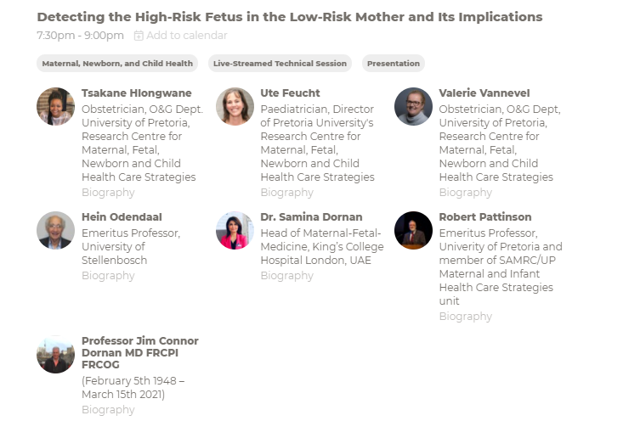

MESSAGE 2:
Join us at #GHTechX21 for the session ‘Detecting the High-Risk Fetus in the Low-Risk Mother’ and the use of UmbiflowTM! Register for free to join us for four days of #globalhealth knowledge exchange!
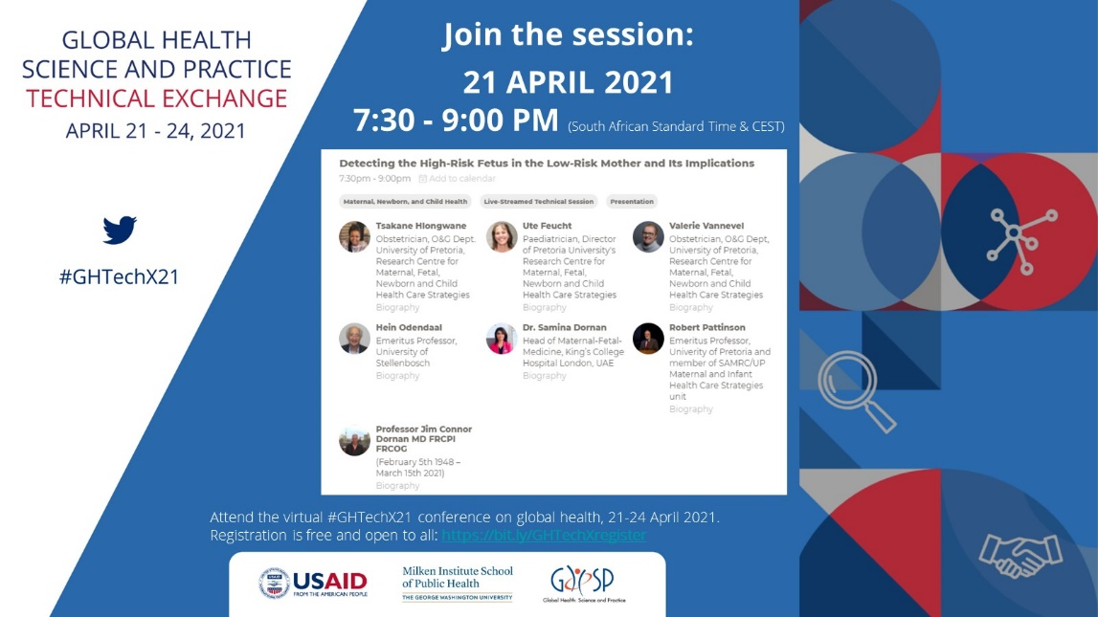
✅ Register: bit.ly/GHTechXregister
💻 Virtual Platform: bit.ly/GHTechXplatform

Flier:

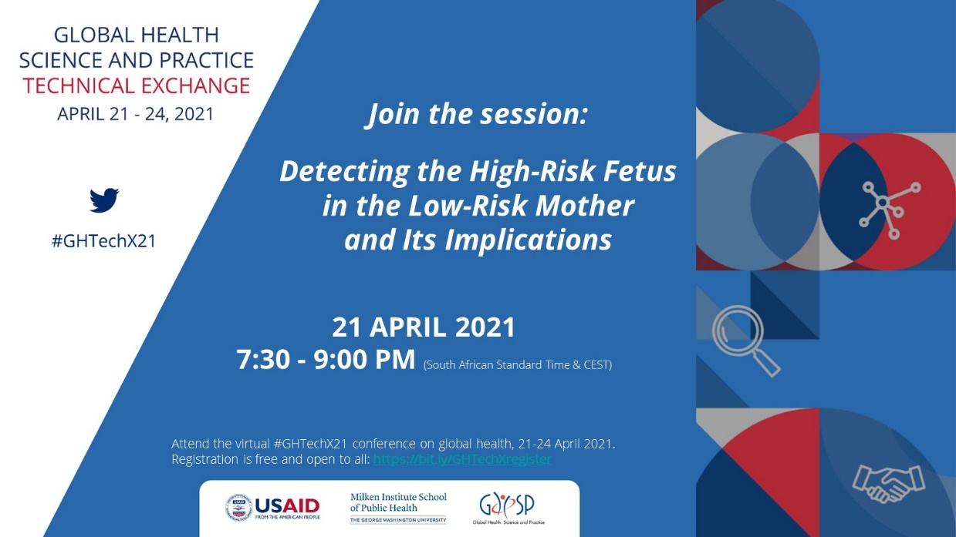

Social media message
Join us at the #GHTechX21 on 21 April 2021 from 7:30 - 9:00 pm (SAST/ CEST) for the session ‘Detecting the High-Risk Fetus in the Low-Risk Mother’ and the use of UmbiflowTM! Join the virtual #globalhealth event for four days of knowledge sharing and networking. Registration is free: https://bit.ly/GHTechXregister

Technical information on the session:

Detecting the High-Risk Fetus in the Low-Risk Mother and Its Implications
21 April 2021 | 7:30pm - 9:00pm SAST
Identifying the high-risk fetus in the low risk mother (LRM) is a neglected area of research. Fetal growth restriction (FGR), defined as failure to reach the full genetic growth potential, is a major cause of stillbirth, especially in low- and middle-income countries (LMICs), and is also very poorly detected. UmbiflowTM is an inexpensive continuous wave Doppler (CWD) apparatus that is suitable for use by all health care providers for screening low-risk pregnant populations. It can easily detect umbilical artery blood flow in the placenta, which correlates well with placental function. The session will detail the use of CWD ultrasound in LRM and report on its ability to detect FGR and by so doing prevent stillbirths and predict stunting and poor infant neurodevelopment, poor child cognitive ability and markers suggestive of poor cardiovascular function later in life. Screening with CWD ultrasound in a LRM opens the door to a step change in preventing stillbirths and a means of identifying fetuses at risk of suboptimal growth and adult diseases such as obesity, type 2 diabetes, hypertension and stroke. This will allow for appropriate interventions to be developed and implemented when it matters, i.e. in the first 1000 days.

