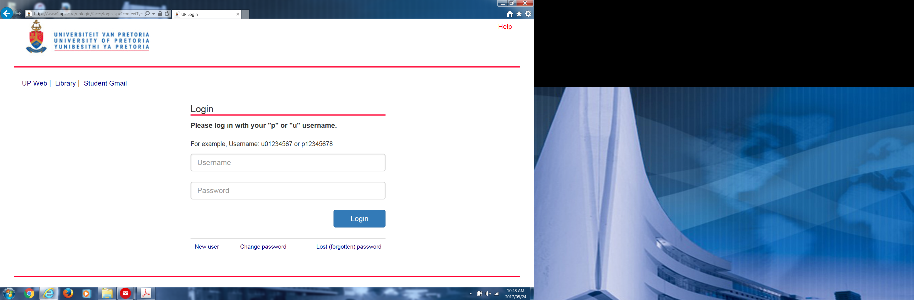
Your username is u14093112 and your password is one created by yourself.
Click on the link, “Student Center”
You will get this screen:
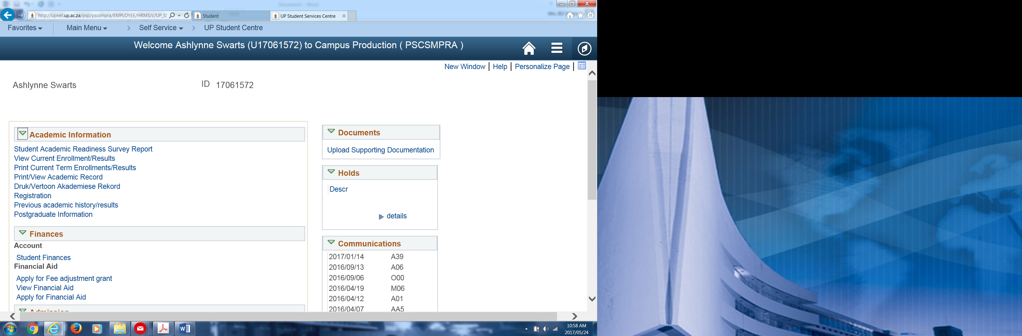
Click on “registration” and follow all the steps. After clicking on the “Confirm” button, the system will confirm that you are a registered student

