Rosemary Gray (FEEYS) has a BA and STD (UCT); BA Hons., MA cum laude and a DLitt. et Phil. (UNISA).
After 21 years at the University of Pretoria, she is Emeritus Professor in the Department of English.
She is an NRF rated researcher. Orcid ID https://orcid.org/0000-0002-6583-4319
Passionate about indigenous knowledge systems, she is an avid Anglo-Saxonist, who has specialized in Pan-African literatures in English for more than three decades. Her current primary research interest is the work of the Nigerian-born Londoner, Ben Okri.
In a coincidental celebration of her 80th birthday, her The Tough Alchemy of Ben Okri: The writer as conceptual artist has been released on Kindle and in hard copy by Bloomsbury Academic Publishers, London and New York and is available globally; it will be available as an audio book and is being translated into several global languages.
Professor Gray has published regular chapters and articles on the Okrian oeuvre, among others, in international journals and in Harvard's prestigious Analecta Husserliana for more than three decades and has a chapter in Routledge's 2021 The Literature and Art of the Niger Delta, a ground-breaking publication commissioned by the University of North Carolina.
She was awarded the Gold Medal for distinguished service to English over a lifetime in 2008 and won the Thomas Pringle award for best scholarly article in 2017. She is Managing Editor of the English Academy Review: Journal of English Studies and is Honorary Treasurer and Life Vice President of the English Academy of Southern Africa and serves on PanSALB’s National English Language Body.

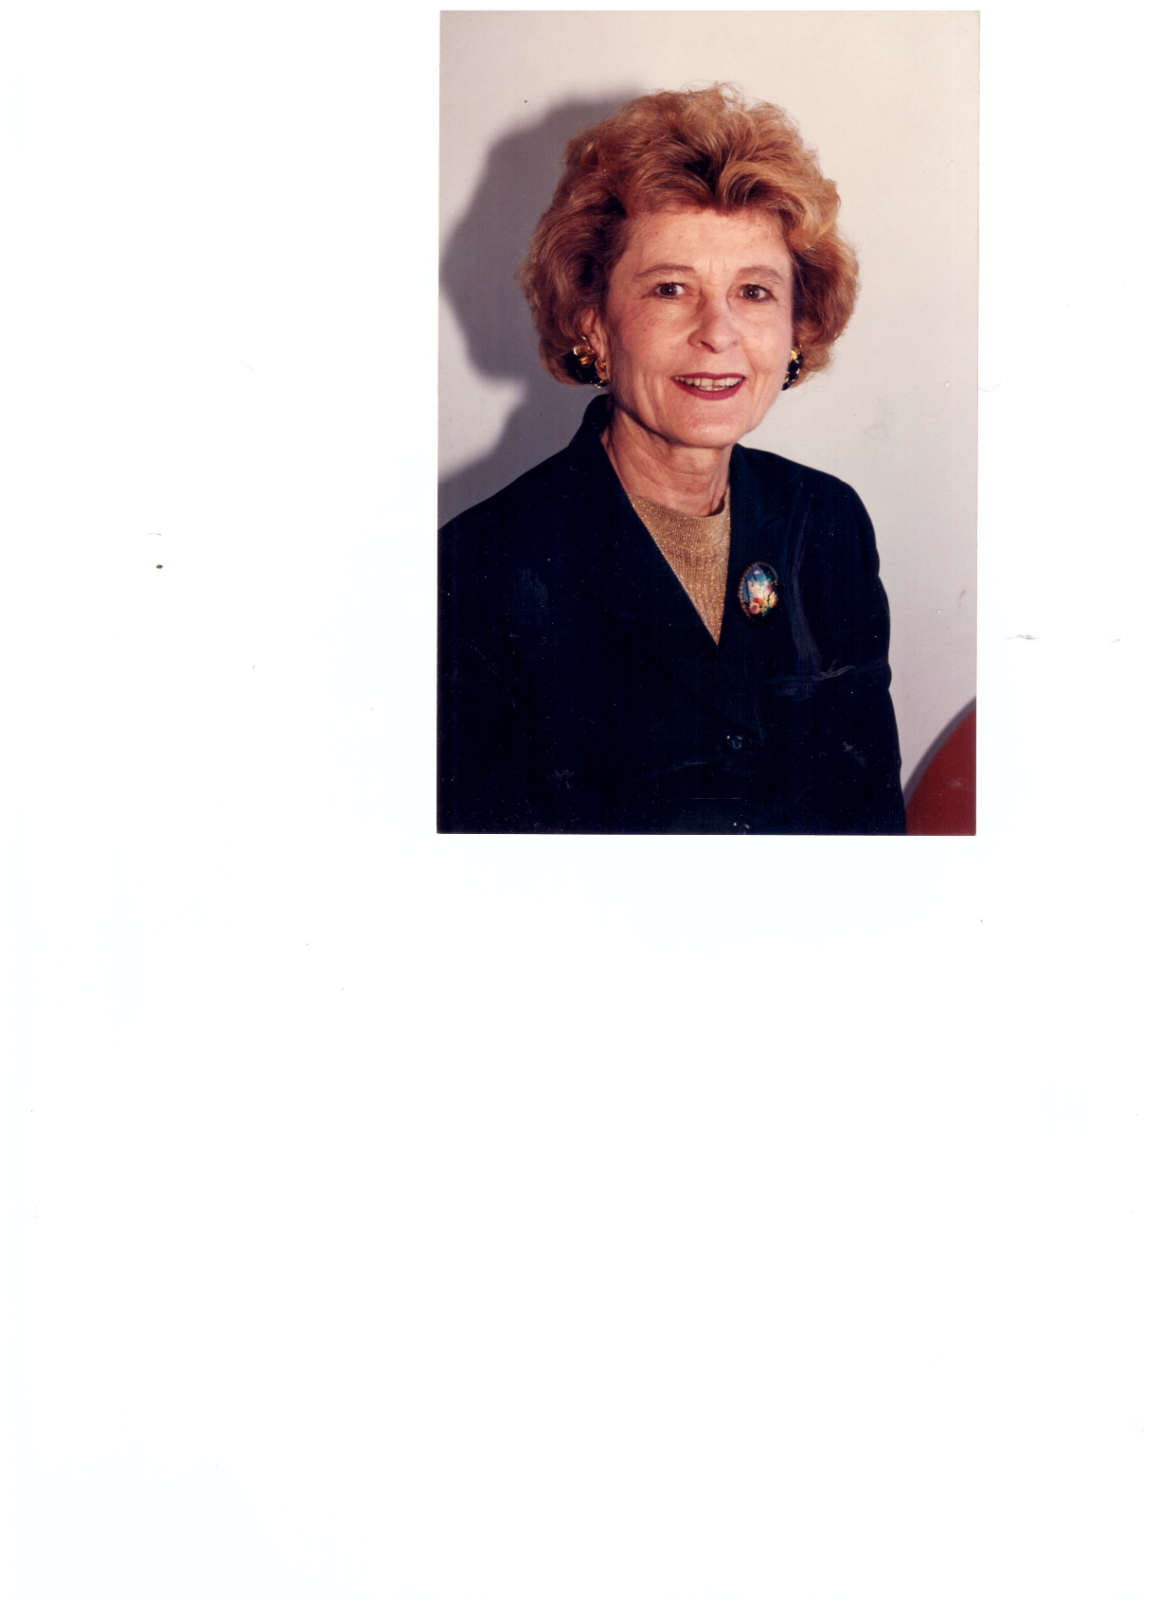

RECENT RESEARCH OUTPUT

JOURNAL CONTRIBUTIONS/Accredited articles 2016-2020
Forthcoming
Gray, Rosemary and Sopekekai Maithufi. Guest eds. 2020. “Editorial”. Journal for Literary Studies. 26 (3), September. 140pp. DHET, SCOPUS, IBSS accredited. C2

Gray, Rosemary. 2020. “Countering ‘mind-forged manacles’ in Ben Okri’s The Freedom Artist (2019): HOT consciousness”. Journal for Literary Studies. DHET, IBSS accredited ISSN 0256-4718. https://doi.org/10.1080/02564718.2020.1466446 C2

Matthew Curr and Rosemary Gray. 2020. “An Anzalduan Reading of Ben Okri’s In Arcadia”. Journal for Literary Studies. DHET, IBSS accredited ISSN 0256-4718. https://doi.org/10.1080/02564718.2020.1466446 C2

Gray, Rosemary. 2020. “Ben Okri’s ImaginNation: ‘Incandescence of the Wind’”. Scruting2, Unisa Press and Taylor & Francis.

Published
Gray, R. 2019. “Ben Okri’s Wild (2012): The Muse of Archaeology”. English in Africa 46(1): 95-110. DOI: https://dx.doi.org/10.4314/eia.v46i1.5 ISSN 0376-8902 DHET accredited.

Gray, Rosemary. 2019. “Of magic: Ben Okri’s The Mystery Feast (2015) and The Magic Lamp (2017)”. Imbizo. 10(1): 1-19. DHET. https://doi.org/10.25159/2663-6565/5580 ISSN 2078-9785. DHET accredited.

Gray, Rosemary Alice. 2019. “Ben Okri’s ‘Laughter Beneath the Bridge’: Born (Un)free”. The International Journal of Literary Humanities 17 (1): 71-81. Doi:10.18848/2327-7912/CGP/v17i01/71-81. https://doi.org/10.18848/2327-7912/CGP/v17i01/71-81. Common Ground Research Networks.

Gray, Rosemary. 2018. “Ben Okri’s Aphorisms: ‘Music on the Wings of a Soaring Bird’”. Academic Journal of Interdisciplinary Studies. July 7(2): 17-24. DOI:10.2478/ajis-2018-0042. ISSN 2281-3993. Scopus, Sciendo

Gray, Rosemary. 2018. “Redreaming ways of seeing: Ben Okri’s intuitive creativity”. Tydskrif vir Letterkunde. 55(2): 74-91. ISSN 10.47-20AM DOI:10.17159/2309-9070/tvl.v.55i2.2256 DHET, SCOPUS

Gray, R. 2018. “Ben Okri’s stoku, ‘The Standeruppers’ (2017): The frightening irony of the Anthropocene”. Journal of Literary Studies. 34(2): 1-12 DHET, IBSS ISSN 0256-4718, online ISSN 1753-5387 https://doi.org/10.1080/02564718.2018.1466446 C2

Gray, R. 2017. “Recovering our true state of being in Ben Okri’s fable, ‘The Comic Destiny’”. English Academy Review: Journal of English Studies. 34(2): 1-10 DHET, Thompson Reuters, Scopus ISSN 1013-1752. http//:wwwtandf.co.za/journals C2

Gray, R and Saha, T.S. 2017. “Fresh challenges faced on the ground by the Kingdom of the Sky: A question of peace, harmony and stability”. International Journal for African Renaissance Studies. 12(1): 90-105 DHET, Thomson Reuters, Scopus, IBSS (co-author) ISSN 1818-6874 http//:wwwtandf.co.za/journals C3

Gray, R. 2016. “Promoting the poetic cause in Ben Okri’s stokus from Tales of Freedom (2009)”. Literator – Journal of Literary Criticism, Comparative Linguistics and Literary Studies. 37(1):18-27. DHET, Thomson Reuters, Scopus ISSN: (Online) 2219-8237, (Print) 0258-2279 Websites: http://www.aosis.co.za & http://www.literator.org.za http://dx.doi.org/10.4102/lit.v37i1.1233 C3

BOOKS
Published in the last two years
Gray, Rosemary. 2020. The Tough Alchemy of Ben Okri: The writer as conceptual artist. London and New York: Bloomsbury Academic Publishers. 300 pp.

Gray, Rosemary, Martin Rupiya, Shadrack Gutto, Lesiba Teffo. Eds. 2019. A Glass Half Full or Half Empty? The challenges of political succession and elections in Africa. Johannesburg: Ssali Publishing House, 401pp.

RECENT CONTRIBUTIONS TO BOOKS
Forthcoming

Gray, Rosemary. 2021. “The Perfection of chaos: Heeding the nostalgic imperative in selected works by Ben Okri”. In The Literature and Art in the Niger Delta. Eds. Tanure Ojaide and Enajite Ojaruega. Routledge: London and New York.

Gray, Rosemary, Lisa Combrinck and Sipho Seepe. 2020. Towards an Idea of an Idea: The awkward truthtellers. Department of Arts and Culture.

Gray R. 2020. “Epistemic ecology and Ben Okri’s ‘diminishing boundaries of a shrinking world’ in ‘Heraclitus’ Golden River” from Wild (2012)”. In Eco-Phenomenology: Life. Human Life, Post-Human life in the Harmony of the Cosmos. Eds. William S Smith, Jadwiga S. Smith, Daniela Verducci. Analecta Husserliana. Springer International Publishing, 12p. ISBN 978-3-319-21791-8 (print); 978-3-319-21792-5 (online) Web of Science, Scopus

Published
Gray, R. 2018. “Sowing ‘A Quilt of Harmony’: An Eco-Phenomenological Reading of Ben Okri’s
‘“Lines in Potentis’ from Wild (2012)”. Analecta Husserliana CXXI. Eco-Phenomenology: Life, Human Life, Post-Human Life in the Harmony of the Cosmos. pp.281-290. Web of Science, Scopus. ISBN 978-3-319-21791-8 (print); 978-3-319-21792-5 (online) htps://doi.org/10.1007/978-3-319-77516-6_22.

Gray, R. 2016. “Ben Okri’s The Landscapes Within (1981): The Unfinished story”. In The cosmos and the creative imagination. Ed. A-T Tymieniecka. Analecta Husserliana 119. Switzerland: Springer International Publishing, 73-83. Web of Science. ISBN 978-3-319-21791-8 (print); 978-3-319-21792-5 (online) DOI: 10.1007/978-3-319-21792-5

Recent External examination of Master’s and doctoral dissertations and theses
2019
Deborah Kelly-Galin DLitt. et Phil. in Art History – UNISA
Topic: Dreaming, Embodiment and Perception in Narrative Arts of the Hopi people

Beverley Cornelius DPhil in English Studies – UKZN
Topic: Postcolonial nostalgia and meaning: New Perspectives on contemporary South African Writing

Angeline Debbie Haywood MA – UKZN
Topic: Dark angels: An African Womanist literary study of selected works of Chimamanda Ngozi Adiche, Warsan Shire and Beyonce Knowles-Carter

Kyle Steven Allen MA – UKZN
Topic: Witness to Everything: Representations of precarity in selected works of four South African poets
2018
Annette Greyensteyn MA – UNISA
Topic: Hans Christian Andersen’s Romantic Imagination: Exploring eighteent and nineteenth century romantic conceptualisations of imagination in selected fairy tales by Hans Christian Andersen
2017
Janet van Eeden. Doctor of Literature – University of KwaZulu-Natal
Topic: Beyond the biopic: An exploration into the nature of biography
2016
Michelle Jane Naudé MA – University of KwaZulu-Natal: Pietermaritzburg
Topic: Exploring the role of gender in the depiction of Utopia in selected novels

Oluyomi Abayomi Oduwobi Doctor of Philosophy – University of Venda
Topic: Representations of the trans-Atlantic slave trade in selected contemporary narratives

Bernice C Borain MA – University of KwaZulu-Natal: Pietermaritzburg
Topic: Charles Mungoshi’s contribution to our understanding of female tragedy in a Zimbabwean context

Samantha Schreiner MA – University of KwaZulu-Natal: Pietermaritzburg
Topic: “A hot thing”: Representations of slavery, identity, naming and mothering violence in selected Toni Morrison texts

