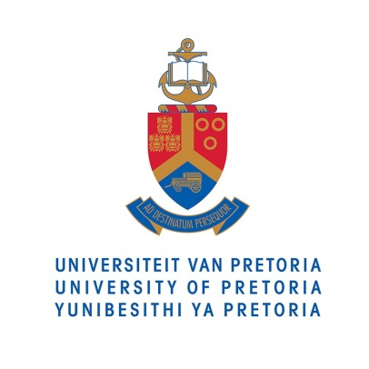
PRESS RELEASE

4 AUGUST 2015

First-in-Africa Virtual Reality Centre to
Revolutionise Mine Safety

“Within 5 years everyone will know what an ‘imagineer’ is because they will come from this university,” says Prof Ronny Webber-Youngman, Head of the Department of Mining Engineering at The University of Pretoria.

Webber-Youngman beamed like a new father as Mr Norman Mbazima, CEO of Kumba Iron Ore, officially opened the Kumba Virtual Reality Centre for mine design (VRC), as well as the new offices of the Department of Mining Engineering and the Mining Resilience Research Institute (MRRI), on 4 August 2015.

This new infrastructure, an R18.8 million investment that took three years to complete, is set to save the South African mining industry a lot of time and money, and could save lives by helping to improve health and safety, says Webber-Youngman.

At the launch, invited guests experienced the VRC’s 3-D stereoscopic theatre and its 3-D, 360 degree cylinder theatre first hand during a live demonstration. They were also given a tour of the new offices and the mine design lecture room, all of which is set to revolutionise education, research and mine design at UP.

“Our students are of the first in Africa to experience real-life incidents in a 3-D virtual mine in while sitting in a lecture room,” says Webber-Youngman, giving the example of a rock fall underground in which miners may be injured. He explains that using VR to supplement actual mine visits is much cheaper and mistakes are painless, yet the immersive nature of the simulations means the emotional effects are tangible.

“It’s very real – you feel like you’re actually at the mine,” says mining engineering student Thabile Mkhize.

Webber-Youngman says his students are more engaged in their lectures than ever before. Engineering subjects are highly scientific and often difficult for students to visualise, which is why he says the VRC will create a new generation of engineers able to imagine better solutions to real-world problems.

“I call them my ‘imagineers’,” he says.

Besides this teaching and learning drive, the MRRI will have a strong focus on research, and will generate sustainable income by offering consulting services and contract research to the mining industry.

In terms of health and safety for example, incidents involving loss of life or injury can be reconstructed using VR in order to research preventative measures. It is also possible to simulate scenarios for mine rescue teams, helping to identify risk-takers or better leaders in a virtual rather than a real mining environment.

“This virtual reality centre has the added benefit of safety; something we at Kumba take very seriously. We are very proud of the fact that we have had no loss of life for over a year now which speaks to our goal of zero harm. Nothing brings home the dangers of our profession so brutally than to lose a member of you team and then having to convey the news to his or her family,” says Mbazima.
“A virtual reality centre for the study of mine design not only creates a safe environment for study, but by mimicking reality will deliver mining engineers to the industry that are better prepared for the conditions they might face when deployed to a mine,” Mbazima adds.
In addition, mining engineers can use VR to design mines, and then test those designs in an immersive 3-D setting before actually building them. This saves both time and money.

“This all started with mining, but there are applications for the VRC from the field of medicine to the military,” says Webber-Youngman. His vision is that all UP faculties involved in mining research will become integrated with the centre, including “lawyers, medical researchers, and even the veterinary guys who look at mine rehabilitation and pastures.”

He furthermore sees VR as a key feature for UP to become a gateway into Africa in terms of mining engineering. “Whatever we develop here through research, and which has application in the industry, we can showcase and demonstrate it by putting 30 people in the cylinder. But we can also go out into Africa and show people what we’ve done using the head-mounted Oculus Rift technology as our mobile VR centre.” In that sense, he explains, the VRC cylinder at UP is essentially like a giant Oculus Rift.

Despite the advantages of this new approach to mine design, research and education, however, Webber-Youngman cautions that VR can never replace exposure to real mines. As such, actual mine visits will remain central to his department’s activities.

“What we are trying to do with the VR is simulate, as closely as possible, the real mining environment rather than an ‘ideal’ situation, because we don’t want to create an expectation that mining has no toughness and no roughness. One needs to be cautious not to over-honeymoon the idea of mining, and never underestimate the reality that goes with it.”

The construction and operation of the VRC was made possible by generous sponsorship from Kumba Iron Ore, a business unit of Anglo American, and Simulated Training Solutions has been appointed to integrate the centre’s hardware and software in order to create the simulations and visualisations.

Sound bites, video and photos available on request.

For more information or to arrange interviews, please contact:

Nicolize Mulder
Senior Media Practitioner
Department of University Relations
University of Pretoria
012 420 3023
083 709 3041
nicolize.mulder@up.ac.za

