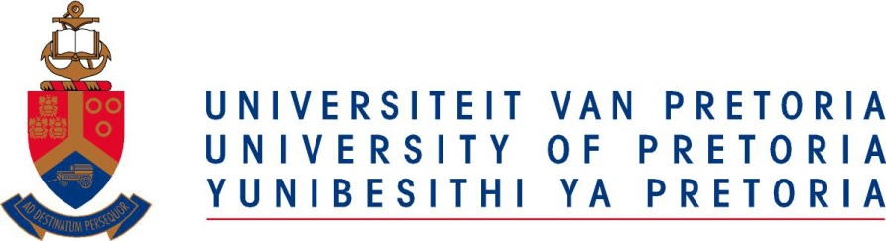

WEB ARTICLE

1 October 2014
____________________________________________________________

UP seals a partnership with the University of Stuttgart

Prof Cheryl de la Rey, Vice-Chancellor and Principal of the University of Pretoria and her counterpart from the University of Stuttgart, Germany, Prof Dr Wolfram Ressel, have signed a memorandum of understanding (MoU) between the two institutions.

The partnership entails sharing of human and material resources with the aim of promoting international understanding to contribute to the pool of global knowledge and to advance the development of our respective countries and the world.

The signing of the MoU also acknowledges research done by academics from the two institutions and the establishment of joint research programmes. There will be an exchange of academic staff and students in respect of specific research projects or courses of interest and importance.

