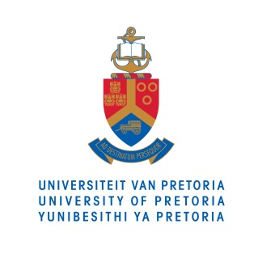
The University of Pretoria (UP), including its business school, the Gordon Institute of Business Science (GIBS), will award degrees to more than 10 400 graduates at this year’s Autumn Graduation ceremonies, starting on 14 April 2015.

A total of 134 doctorate degrees, 1 187 master’s degrees and 2 957 honours degrees are to be awarded. Five individuals, who have made notable contributions in their field of expertise, will be recognized by awarding them honorary doctorate degrees.

MEDIA RELEASE

14 APRIL 2015

A BRIGHT FUTURE FOR
concentrated solar power

Researchers at the University of Pretoria (UP)
are building a new prototype device for turning
the sun’s energy into electrical power.

According to Willem le Roux, who constructed
and tested the solar collector of the device as part of his PhD, it could one day power homes in off-the-grid and water-scarce areas of South Africa. He will receive his doctorate this month during the University’s Autumn Graduation ceremonies.

Le Roux joined UP’s Department of Aeronautical and Mechanical Engineering after developing an interest in energy and concentrated solar power (CSP) during his undergraduate studies. “The concept of getting free energy from the sun fascinated me,” he says.

This inspired his PhD project, in which he used energy from the sun to heat air, which can in turn be converted into electrical energy by a microturbine. Most of his work involved building and testing a 5m solar collector dish combined with a solar receiver.

“You can think of it as taking a lens and focusing the sun’s rays onto a small leaf,” explains le Roux. Instead of a leaf, the energy is focussed onto a solar receiver that heats air. The heated air can power what is technically known as a ‘recuperative solar thermal Brayton cycle’ – essentially a microturbine that can produce up to 5kW of power.

Le Roux says that his system provides several advantages over photovoltaic systems (solar panels) and other CSP plants, such as those being built in the Northern Cape. In comparison with solar panels, the system is more expensive but offers much greater solar-to-electrical efficiency: it boasts a conversion rate of around 30%, compared to 10-15% for solar panels.

Compared to conventional CSP plants, the advantages are found in the way this system converts solar energy to power. Whereas most CSP plants use the sun’s energy to heat either water or salts, the use of heated air means that this system can be used in regions where water scarcity is a problem.

Le Roux plans to keep working on his experimental setup, which can be found on the roof of the Engineering 2 Building at UP.

“Aiming that dish at the sun and getting rays on the solar receiver for the first time, that was significant for me,” he says.

Photos of Willem le Roux’s research is available at: https://www.dropbox.com/sh/rhtn721j85jj6ns/AABCIRfB4vIkBkevhrAs_I9va?dl=0

For more information on this study, please contact:

Willem le Roux
Department of Aeronautical and Mechanical Engineering
Faculty of Engineering, Built Environment and Information Technology
University of Pretoria
+27 12 420 3104
+27 84 581 2619

For more information on the University of Pretoria, please contact:

Nicolize Mulder
Senior Media Practitioner
Department of University Relations
University of Pretoria
+27 12 420 3023
+27 83 709 3041
nicolize.mulder@up.ac.za

