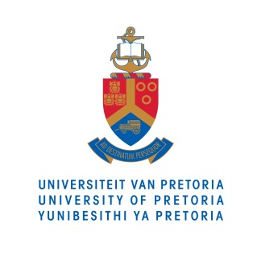
MEDIA RELEASE
THE ranks UP amongst the top global Universities

The University of Pretoria (UP) has been included in the Times Higher Education (THE) World University Rankings, it was announced today (1 October) at the University of Melbourne in Australia at the THE World Academic Summit. This places UP firmly into two global ranking systems with the other being the Quacquarelli Symonds (QS) World University Rankings.
The THE rankings are widely regarded as one of the most influential global university measures, and arguably the most widely referenced.
The UP Vice-Chancellor and Principal, Prof Cheryl de la Rey, is currently in Melbourne for the announcement. She is also participating in a panel discussion on international universities and their engagement with local communities at the summit.
A delighted Prof de la Rey said UP’s achievement in the rankings was a reflection of the progress that the University was making in actualising its vision of becoming a leading research-intensive university in Africa, and the world at large.
“The Times Higher Education World University Rankings, now in their 12th year, apply rigorous standards, using tough global benchmarks across all of a global research university’s key missions – teaching, research, knowledge transfer and international outlook. The results are trusted by students and their families, academics, university leaders and governments. For the University of Pretoria to make it into the world rankings is an outstanding achievement to be celebrated,” said Phil Baty, editor of the THE World University Rankings.
For more information on the University of Pretoria, please contact:

Anna-Retha Bouwer
Department of University Relations
University of Pretoria
Tel: 012 420 3023
Email: anna-retha.bouwer@up.ac.za

EMBARGOED UNTIL 21.00 (BST), WEDNESDAY 30 SEPTEMBER 2015

