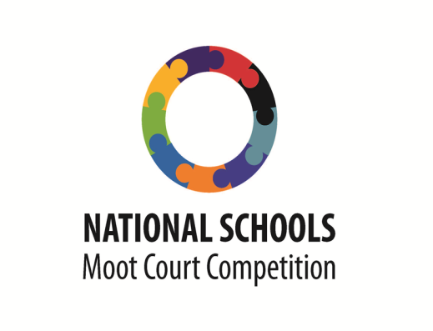
2017 Teams Qualifying to the Oral Provincial Rounds

Free State
School | Quintile | Mark
Unitas Secondary School | 5 | 87
Diamanthoogte | 1 | 87
Relekile Public Secondary School | 1 | 87
Panorama Combined School | 2 | 81
Falesizwe Senior Secondary School | 1 | 80
Edmund Rice | P | 78
St Bernard’s High School | 4 | 76
Leseding Technical Secondary School | 3 | 75
Ikanyegeng Secondary School | 2 | 74
Welkom Gimnasium | 5 | 74

North West
School | Quintile | Mark
Prestige Secondary School |  | 78
Matlaisane High School | 3 | 74
Boskuil Combined | 1 | 74
JM Ntsimi | 4 | 72
Gatelapele Secondary School | 3 | 64
Maitemogelo Secondary School | 3 | 62
Saint Annes | 4 | 59
Kgalatlowe high school | 2 | 53
Phiri Secondary School 2 | 3 | 50
Mafikeng High School |  | 50

Eastern Cape
School | Quintile | Mark
Grens High School | 5 | 91
Girl’s High School | 2 | 91
Beaconhurst High School | 5 | 90
Vela High Schools | P | 86
Stirling High School | 5 | 86
Cala Village Senior Secondary School | 3 | 84
Merrifield College | P | 83
Clarkebury Senior Secondary School | 1 | 81
Holy Corss High School | 3 | 80
VM Kwinana Senior Secondary School | 2 | 77

KwaZulu Natal
Schools | Quntile | Mark
Ohlange High School | 4 | 93
Ladysmith High School | 5 | 88
Mshweshwe High School | 3 | 88
Somfula High School | 2 | 84
Gobindlovu Combined High School | 3 | 84
*Dundee Secondary School 2 | 4 | 81
Mangwazana High School | 2 | 80
*Hafuleni Secondary School 2 | 2 | 79
*Sobantu Secondary School 1 | 3 | 79
Siyamukela High | 4 | 76

Mpumalanga
School | Quintile | Mark
Curo | P | 90
King Makhosonke II Secondary School | 1 | 67
*Acorn to Oaks High School 2 | 1 | 67
Mashishing Secondary School | 3 | 64
Lowveld High School | 4 | 57

Limpopo
School | Quintile | Mark
Ebenezer High School | 3 | 89
Marude Secondary School | 3 | 86
SJ vd Merwe THS | 4 | 78
Tshivhase Sec School | 2 | 77
Mbilwi Secondary School | 4 | 77
Mphaphuli High School | 3 | 74
*Tshebela High School 2 | 2 | 69
*Khanyisa Education Centre 1 | P | 68

Western Cape
School | Quintile | Mark
Norman Henshilwood High School | 5 | 82
Wynberg Girl's High School | 5 | 79
Kayamandi High School | 1 | 78
Hermanus | 2 | 70
Rhenish Girls’ High School | 5 | 69
Percy Mdala High | 1 | 68
Oval North 2 | 4 | 65

Northern Cape
School | Quintile | Mark
AJ Ferreira High School | 4 | 86
Concordia High School | 4 | 83
Ratang-Thuto | 2 | 80
Boresetse High School | 3 | 79
Kgomotso High School | 4 | 78
Northern Cape Agricultural High School | 5 | 74
Kenhardt High School | 2 | 73
Delportshoop High School | 3 | 70
St Boniface High School | P | 69
Hoerskool Boesmanland | 3 | 63

Gauteng
School | Quintile | Mark
Gibson Pillay Learning Academy | P | 93
Brakpan High School 1 | 5 | 90
Alexandra Secondary School | 2 | 88
Afrikaanse Hoer Seunskool 1 | 5 | 86
Minerva High School | 2 | 84
Hans Moore Hoerskool 2 | 5 | 83
MH Baloyi Secondary School | 1 | 81
Crawford College Sandton | P | 80
New Hope Secondary School | 1 | 72
Fundulwazi Secondary School | 3 | 65

*Please note that some of the schools submitted more than one team and didn't indicate team numbers so for marking purposes we assigned them. As a school is only allowed to be represented by one team we selected the highest essay mark. Below is a breakdown of learners for clarity:

KZN:
Dundee High School 2: Ngobese & Mdletshe
Sobantu Secondary 1: Ngcobo & Vellem
Hafuleni Secondary 2: Sandiswa

Mpumalanga:
Acorns to Oaks 2: Chiloane & Zitha

North West:
Phiri Secondary School 2: Nqhatsetseng

Limpopo:
Khanyise Education Centre 1: Shane
Khanyise Education Centre 3: Clyde
Tshebela: Zelda

Western Cape:
Oval North 2: Witbooi & Mufano

