Critical thinking

Purpose
This tutorial focuses on the development of a mode of thinking – about any subject, content, or problem – in which the thinker improves the quality of his or her thinking by skilfully taking charge of the structures inherent in thinking and imposing intellectual standards upon them. Most universities list critical thinking as a graduate attribute. However, although students might apply critical thinking in their university courses, they do not apply it to new contexts, particularly workplace contexts.
The nature of work – and the skills required – have been changing dramatically. With globalisation and the increased speed of business, employees at every level are facing an increasingly complex flow of information. Work settings are changing rapidly, and employees are moving into new roles, often with limited direction. Employees can no longer rely on others to make key decisions. They often must make them on their own, and quickly – and the decisions have to be good ones.
If they fall short, there may be no time to recover. Good decisions require focusing on the most relevant information, asking the right questions, and separating reliable facts from false assumptions – all elements of critical thinking. Yet too few employees possess these essential skills. A survey of HR professionals conducted by the Society for Human Resource Management (SHRM) and The Conference Board found that a full 70% of employees with a high school education were deficient in critical thinking skills. Even among employees with a four-year college education, 9% were deficient in critical thinking skills, 63% had adequate skills, and only 28% were rated excellent critical thinkers. The latest report from SHRM on The skills gap 2019 still points to critical thinking being in the category of top missing soft skills – 37% of new employees are estimated to lack skills in this area (https://www.shrm.org/hr-today/trends-and-forecasting/research-and-surveys/pages/default.aspx, Accessed 18 December 2019).
Many business leaders also come up short. Senior executive-development professionals report that the competency that next-generation leaders lack the most is strategic thinking, which hinges on critical thinking skills. Many next-generation leaders also lack the ability to create a vision or to understand the total enterprise and how the parts work together – both competencies that are closely tied to critical thinking.

Learning Outcomes
You will be able to identify your own critical thinking strengths and areas that need improvement and plan how to fill any gaps you might have.

Key Points
This tutorial explores the following topics:

Critical thinking and its importance
Critical thinking is the intellectually disciplined process of actively and skilfully conceptualising, applying, analysing, synthesising, and/ or evaluating information gathered from, or generated by, observation, experience, reflection, reasoning, or communication, as a guide to belief and action.
Everyone thinks – it is our nature to do so. But much of our thinking, left to itself, is biased, distorted, partial, uninformed or down-right prejudiced. Yet the quality of our life and that of what we produce, make, or build depends precisely on the quality of our thought. Shoddy thinking is costly, both in money and in quality of life. Excellence in thought, however, must be systematically cultivated.
A well cultivated critical thinker:
• Raises vital questions and problems, formulating them clearly and precisely;
• Gathers and assesses relevant information, using abstract ideas to interpret it effectively, comes to well-reasoned conclusions and solutions, testing them against relevant criteria and standards;
• Thinks open-mindedly within alternative systems of thought, recognising and assessing, as need be, their assumptions, implications, and practical consequences; and
• Communicates effectively with others in figuring out solutions to complex problems.
Critical thinking is, in short, self-directed, self-disciplined, self-monitored, and self-corrective thinking. It presupposes assent to rigorous standards of excellence and mindful command of their use. It entails effective communication and problem-solving abilities and a commitment to overcome our natural egocentrism and socio-centrism.
You do not need a degree to be a critical thinker. Many people who have extensive experience in the workplace have become experts in analysing situations and applying viable and innovative solutions. Some of them have forgotten what it took for them to reach that level of expertise and they often find fault with new graduates and their ability to think critically. If you are offered a mentor in the workplace, take up the offer; if not, perhaps identify someone who clearly is a critical thinker and problem solver and ask him or her to mentor you. If you are offered training, take it. If you feel you need to improve your critical thinking but no training is available, source usable courses. Work in teams where possible as multiple perspectives on a problem are better for critical thinking.
Before proceeding with this tutorial, write down your strengths in terms of critical thinking. Consult the list as you go along and refine it.

How to think critically at work
No matter what walk of life you come from, what career you are interested in pursuing or how much experience you already have, employers have all seen first-hand the importance of critical thinking skills. In fact, lacking such skills can truly make or break a person's career, as the consequences of one's inability to process and analyse information effectively can be massive.
Developing your critical thinking skills is something that takes concentrated work. It can be best to begin by exploring the definition of critical thinking and the skills it includes – once you do, you can then venture toward the crucial question at hand: How can I improve?
How implies process. What steps do we follow to apply critical thinking?
This is no easy task, which is why we aimed to help break down the basic elements of critical thinking and offer suggestions on how you can hone your skills and become a better critical thinker. Critical thinking is a skill that allows you to make logical and informed decisions to the best of your ability.
Erstad, W. (2018). Six critical thinking skills you need to master now. https://www.rasmussen.edu/student-experience/college-life/critical-thinking-skills-to-master-now/. Accessed 18 December 2019.
The author focuses on the following six skills and in each case gives hints on how to improve your skills.
- Identification
- Research
- Identifying biases
- Inference
- Determining relevance
- Curiosity
As you read, make notes under each heading. How good are you at each of these skills? Be sure to acknowledge your strengths. Which skills have you developed at university? Which skills need improvement? Can you design an action plan to improve them, with timeframes, to ensure that you do the work? Are the author’s hints on how to improve useful to you?
Erstad concludes: ‘Thinking critically is vital for anyone looking to have a successful university career and a fruitful professional life upon graduation. Your ability to objectively analyse and evaluate complex subjects and situations will always be useful. Unlock your potential by practising and refining the six critical thinking skills above’.

The RED model
Research conducted in recent years by a variety of independent academics has shown that people who score well on critical thinking assessment are also rated by their supervisors as having:
- Good analysis and problem-solving skills.
- Good judgement and decision-making.
- Good overall job performance.
- The ability to evaluate the quality of information presented.
- Creativity.
- Job knowledge.
- The potential to move up within the organisation.
Perhaps not surprisingly, independent research has also found that the higher up the ladder a position is, the more essential critical thinking becomes. People who are successful in these positions tend to be able to learn quickly, process information accurately, and apply it to decision-making. One of the most well-established research findings in industrial psychology is that cognitive ability is directly related to performance in all jobs. Critical thinking, one type of cognitive ability, is of particular importance where sophisticated decision-making and judgement are required.
It is not uncommon for organisations to ignore such research findings when they are engaged in succession planning or top-level executive searches. Organisations often assume that everyone at the highest corporate levels is bright and a ‘good thinker’, so they do not assess their candidates' critical thinking capabilities. However, a 2009 study by Ones and Dilchert found that there is variability in critical thinking ability within groups of executives (as well as among supervisors and managers). Although executives generally performed better on critical thinking tests when compared with other groups, there was a wide range of higher and lower scores. Simply put, the research found that some top executives are better at critical thinking than others – and so are likely to be more successful.
Fortunately, critical thinking can be learnt and is one of the main outcomes of an academic qualification. It is perhaps the application of the skill in different workplace contexts that is the problem. Do you think that you have learnt critical thinking skills during your degree?
The following RED Model – Recognise assumptions, Evaluate arguments, Draw conclusions – has been developed as a way to view and apply critical thinking principles when faced with a decision. (Pearsons, nd.). This model is particularly helpful in critical-thinking training programmes.
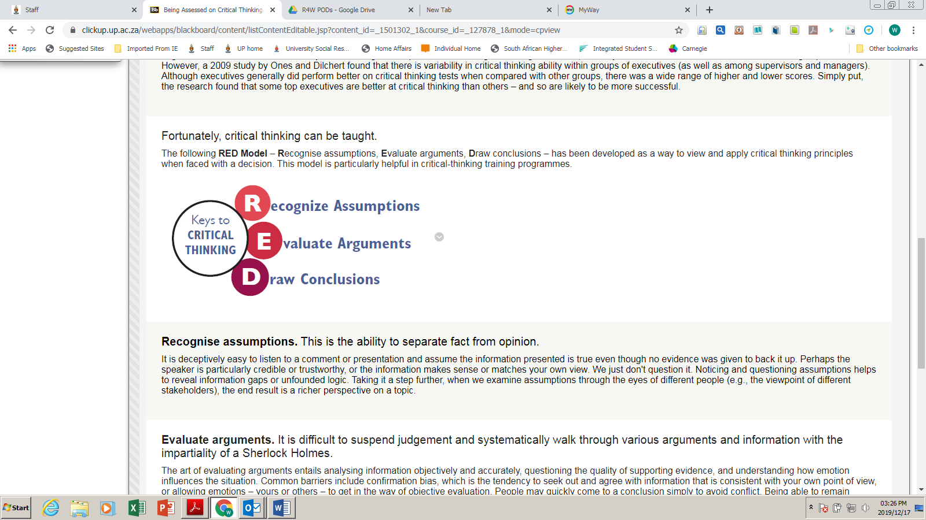
- Recognise assumptions. This is the ability to separate fact from opinion.
It is deceptively easy to listen to a comment or presentation and assume the information presented is true even though no evidence was given to back it up. Perhaps the speaker is particularly credible or trustworthy, or the information makes sense or matches your own view. We just don't question it. Noticing and questioning assumptions helps to reveal information gaps or unfounded logic. Taking it a step further, when we examine assumptions through the eyes of different people (e.g., the viewpoint of different stakeholders), the end result is a richer perspective on a topic. Perhaps you have heard people say that ‘assume’ spells make an ‘ass of u and me’.
- Evaluate arguments. It is difficult to suspend judgement and systematically walk through various arguments and information with the impartiality of a Sherlock Holmes.
The art of evaluating arguments entails analysing information objectively and accurately, questioning the quality of supporting evidence, and understanding how emotion influences the situation. Common barriers include confirmation bias, which is the tendency to seek out and agree with information that is consistent with your own point of view, or allowing emotions – yours or others – to get in the way of objective evaluation. People may quickly come to a conclusion simply to avoid conflict. Being able to remain objective and sort through the validity of different positions helps people draw more accurate conclusions.
- Draw conclusions. People who possess this skill are able to bring diverse information together to arrive at conclusions that logically follow from the available evidence, and they do not inappropriately generalise beyond the evidence.
Furthermore, they will change their position when the evidence warrants doing so. They are often characterised as having ‘good judgement’ because they typically arrive at a quality decision.
Each of these critical thinking skills fits together in a process that is both fluid and sequential. When presented with information, people typically alternate between recognising assumptions and evaluating arguments. Critical thinking is sequential in that recognising faulty assumptions or weak arguments improves the likelihood of reaching an appropriate conclusion.
You can download a free e-book on critical thinking - Better decisions. Everyday. Everywhere. Think about it! - from Pearson, the designer of the RED model, at https://downloads.pearsonassessments.com/images/assets/talentlens/CriticalThinking-eBook.pdf.

Work benefits of critical thinking
Four potential benefits
Brings new ideas
When an issue comes up in the workplace, a common reaction is to assume that it falls into a predetermined category. Critical thinking does not make any assumptions and using the process of critical thinking in the workplace removes the temptation to classify every issue automatically under something that has happened in the past. It forces employees and managers to look beyond conventional solutions and look for new ideas that can help to efficiently address problems.
Fosters teamwork
The entire workplace can get involved in the critical thinking process. The more people that are involved, the more solutions your company will come up with. A diverse workplace can benefit immensely from critical thinking. Not only does it give a reason for people of diverse backgrounds to work together on product solutions, it also encourages teamwork and gives each employee a chance to impact the future of the organisation. Critical thinking exercises promote workplace tolerance and can be used as part of diversity training.
Promotes options
One of the benefits of critical thinking is that your company can develop multiple viable solutions to the same issue. This allows your company to offer a range of solutions to clients, and it also assists in workplace innovation. Several solutions to the same problem can allow your company to develop solutions that use the resources that are available as opposed to purchasing new materials. Customers benefit from having options to choose from in solving their problem.
Uncovering spin-offs
Looking comprehensively at solving an issue brings up information that can be applied to many other situations. For example, a critical thinking exercise on how to handle a new manufacturing process may lead to ideas for other manufacturing methods. Once you get started asking questions in a critical thinking exercise for one topic, you begin to address other unresolved topics.
Examples of critical thinking in the workplace
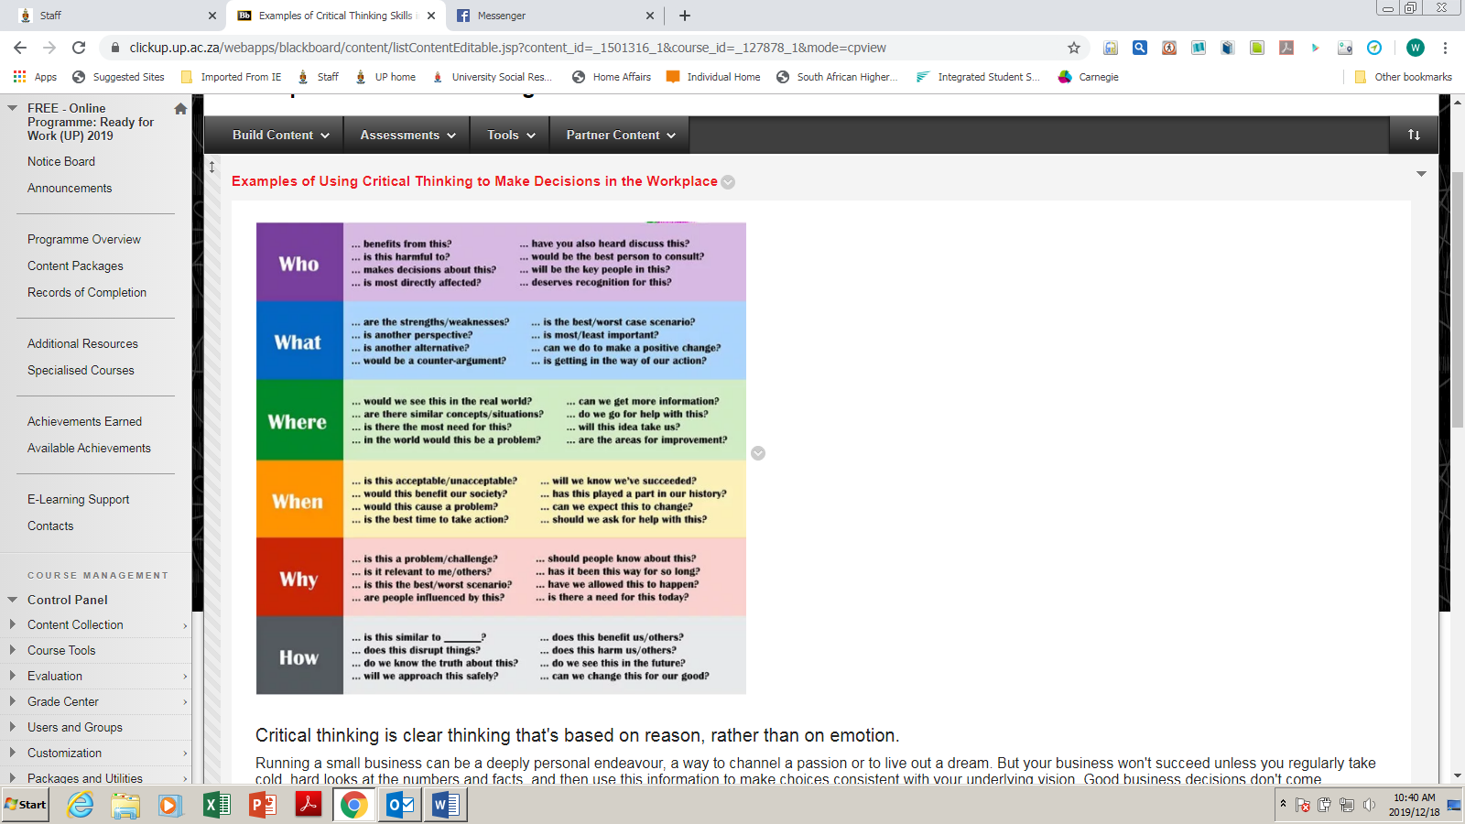
Business choices based on reason not emotion
Running a small business can be a deeply personal endeavour, a way to channel a passion or to live out a dream. But your business won't succeed unless you regularly take cold, hard looks at the numbers and facts, and then use this information to make choices consistent with your underlying vision. Good business decisions don't come exclusively from critical thinking, but critical thinking is a valuable tool, along with intuition.
Operations
The more effectively you organise your workflow, the more efficiently your work gets done and the more money your company earns. Critical thinking helps you examine processes, evaluate their efficiency and then make decisions about new systems and technologies. To think critically about operations, identify areas where you can collect and analyse data – such as the average rand value of the items your production staff makes in an hour. Use this information to pinpoint areas that can be improved. Brainstorm about solutions to remedy these inefficiencies. Then, test these solutions, gather new data, and begin your critical thinking process again.
Personnel
It can be particularly difficult to use critical thinking when making decisions about personnel, because relationships and interactions can be so complex and charged. An employee may irritate you, but that employee might still do excellent work. Or, you may truly enjoy the company of a co-worker who does sloppy, inefficient work. You can use critical thinking to separate your personal likes and dislikes from the needs of your business. Your business will benefit the most from having efficient employees. If your morale is affected by having an employee you truly dislike, you might need to use critical thinking to evaluate whether the value of that person's work is worth your discomfort and frustration, and what legal and moral options you have.
Customer service
As with personnel decisions, customer service situations often call for critical thinking in the face of an emotional response. A customer might leave an unfair, negative review on an online site, making you want to post a rude, scathing response. But doing so may cast an even more negative light on your business than the original negative review. A critical examination of the situation might lead you to wait a day to collect your thoughts, and then to respond in a measured, constructive manner. Critical thinking in customer service decisions keeps you from unnecessarily losing customers, and – in the long run – it may even improve your image.

Developing critical thinking
You leave university with critical thinking skills. Why, then, is critical thinking one of the skills employers complain that graduates lack? Take a few minutes to reflect on what your degree embedded in respect of critical thinking without providing a separate course. Do you already have some of the skills identified in this tutorial? Can you project how you might apply them in the career you have chosen? Link your thoughts to your earlier list of your strengths and to the others that you noted during this tutorial.
A useful definition of the type of critical thinking you should have developed at university level is the kind of thinking that seeks to explore questions about existing knowledge for issues that are not clearly defined and for which there are no clear-cut answers. In order to display critical thinking, you need to develop skills in:
- Interpreting: Understanding the significance of data and to clarify its meaning.
- Analysing: Breaking information down and recombining it in different ways.
- Reasoning: Creating an argument through logical steps.
- Evaluating: Judging the worth, credibility, or strength of accounts.
If employers complain that graduates do not have critical thinking skills, what are they doing about it? Anyone is capable of learning and improving critical thinking skills, but teaching your employees how to do this is not always an easy task, especially if, as a leader, you are prone to quick, thoughtless decisions. ‘The best way to encourage critical thinking is to lead by example’, Lawrence said. ‘If a CEO makes knee-jerk reactions that do not take all stakeholders into account, it will be hard to cultivate a culture of critical thinking’, Lawrence said. ‘Good thinking practices should be modelled by the senior management team’. (See reference list for one of Lawrence’s publications.)
Read the attached tips on ‘How to develop your critical thinking’ as well as the advice on ‘Five ways to improve your critical thinking skills’.
As you read, note where you already have strengths and ways in which to develop strengths that you lack or that are underdeveloped. List your strengths as you go along and keep the list handy so that you can refresh your memory if you get called to an interview. If there are areas that need development, write down an action plan to ensure that you do the work, including timeframes, costs, sources of learning/ training and so on. Remember that most subjects in the world today are covered by free Massive Open Online Courses (MOOCs) offered by some of the best universities in the world.
Critical thinking is the lifeblood of the most essential workplace skills, including problem solving, decision making, good judgement, and sound analysis. Organisations that can attract, retain, and develop the best critical thinkers have a significant and measurable competitive advantage in the business world.
Yet business suffers from a severe shortage of critical thinkers. Too few employees come to their jobs with these skills, and too few have the opportunity to develop them in the workplace. The good news, however, is that critical thinking can be taught, and applied directly to on-the-job problems and decisions. The easy-to-use RED model is a breakthrough in approaching what, until now, has been a mostly abstract and elusive concept. The RED model lays out a path for understanding how critical thinking works, and for developing each of the essential skills.
The return on investment (ROI) for critical thinking training tends to be extremely high. One company reported 17 times ROI. As a whole, participants in an onsite Critical Thinking Boot Camp workshop reported 74% of employees actually applying the new skills.
Critical thinking, perhaps more than any other business skill set, can make the difference between success and failure. Fortunately, these skills are not out of reach – they are readily available to employees at all levels. Once gained, critical thinking skills last a lifetime and become a powerful asset for organisations seeking a competitive edge.

References
Erstad, W. (2018). Six critical thinking skills you need to master now. https://www.rasmussen.edu/student-experience/college-life/critical-thinking-skills-to-master-now/. Accessed 18 December 2019.
Lawrence, J. and Chester, L. (2014). Engage the fox: A business fable about thinking critically and motivating your team. Greenleaf.
Engage the Fox is a charismatic business fable set at a newspaper run by publisher Hedgehog, and his executive team of woodland creatures. When met with a difficult decision regarding where the newspaper industry is headed, as well as pressure to give discounts to their top advertisers, Hedgehog engages consultant Thaddeus P. Fox to teach the team at The Toad Hollow Gazette how to make important decisions. By thinking critically and utilizing the different personality types present in the office, the team learns to see the big picture and tap the energy and imagination of everyone. The animals portrayed here, by their very nature, represent different aspects of the human personality as illustrated in the Myers-Briggs Type Indicator. Sensing sales manager Squirrel is adept at gathering information; feeling Animal relations director Dog is keen on seeking agreement amongst the pack; thinking finance director Owl needs to know the entirety of a situation before settling on a decision; and intuitive consultant Fox can think up an endless amount of ideas for solving problems. (Review, Amazon.com)
Ones, D.S. and Dilchert, S. (2009) How special are executives? How special should executive selection be? Observations and recommendations. Industrial and Organizational Psychology, 2 (2009), 163–170.
Pearson/ TalentLens. (nd). Better decisions. Everyday. Everywhere. Think about it! https://downloads.pearsonassessments.com/images/assets/talentlens/CriticalThinking-eBook.pdf, Accessed 18 December 2019.
Society for Human Resource Management (SHRM). (2019). The skills gap 2019. https://www.shrm.org/hr-today/trends-and-forecasting/research-and-surveys/pages/default.aspx, Accessed 18 December 2019.

Assessment
Answer the following questions based on the tutorial.

Question 1
Suppose you encounter a new problem, in work or life, and are not sure what to do. Which questions should you start to ask yourself when thinking critically?
- Which of my colleagues might know the answer so I do not waste time?
- What information about this problem do I already have?
- What does the Internet say about the topic when I google it?
- What am I trying to do: discover, prove, disprove, support or criticise?
Question 2
The RED Model outlines the following key principles of the critical thinking process:
- Realise mistakes, Evaluate alternatives, Decide on new actions.
- Read information, Evaluate information, Deliver new information.
- Recognise assumptions, Evaluate arguments, Draw conclusions.
- Read into finer details, Exercise judgement, Draw new solutions.
Question 3
Which crucial critical thinking skills are identified by Erstad?
- Identification, Research, Identifying biases, Inference, Determining Relevance and Curiosity.
- Dedication, Commitment, Idea formation, Listening, Reading, Asking.
- Examining, Questioning, Studying, Memorising, Written and Verbal Communication.
- Asking, Judging, Making conclusions, Acting on new information, Determining consequences, Deciding on quality of results.
Question 4
In order to display critical thinking, which skills do you need to develop?
- Critical path analysis: Mapping out every key task that is necessary.
- Reasoning: Arguing for and against different perspectives.
- Interpreting: Understanding the significance of data to clarify its meaning.
- Evaluating: Judging the worth, credibility or strength of accounts.
Question 5
What has recent research shown about managers’ ratings of people who score well on critical thinking?
- Managers think being critical makes for poor relationships.
- Such people perform well overall at their jobs.
- They have high tolerance of differences in the workplace.
- They rely too much on their own judgement in decision-making.
Question 6
What characteristic identifies a well-cultivated critical thinker?
- Is open-minded, recognising and assessing their assumptions, implications, and practical consequences.
- Uses abstract ideas to interpret situations so that conclusions are intellectually rigorous.
- Communicates effectively with others in figuring out solutions to complex problems.
- Raises vital questions and problems, formulating them clearly and precisely.
Question 7
What are the benefits of critical thinking in the workplace?
- Results in promotion for the individual.
- Leads to informed decision-making.
- Fosters teamwork and different perspectives.
- Brings new ideas from outside the workplace.
Question 8
Why is it so important to think critically?
- Shoddy thinking is costly as it leads to money being wasted.
- You do not want to come across as taking information for granted.
- The quality of our life and our work depends on the quality of our thoughts.
- You want to show others that you are not overly accommodating.
Question 9
How do people who think critically act?
- Work diligently to develop the intellectual virtues of integrity, humility and rationality.
- Are keenly aware of the inherently flawed nature of human thinking when left unchecked.
- Consistently attempt to live rationally, reasonably, empathically.
- Base their decisions on reason, research, evidence, reflection and consultation.
Question 10
Which of the following is a component of critical thinking?
- The habit, based on intellectual commitment, of using those skills to guide behaviour.
- The mere possession of a set of skills, because it involves the continual use of them.
- A set of generic information and belief generating and processing skills.
- The mere acquisition of information because of the way information is sought.
- The mere use of those skills (‘as an exercise’) without acceptance of their results.

MEMORANDUM
Question 1
b)
Question 2
c)
Question 3
a)
Question 4
c)
Question 5
b)
Question 6
d)
Question 7
b)
Question 8
c)
Question 9
d)
Question 10
a)

