Conditional Approvals

ETHICS APPLICATION & APPROVAL SYSTEM

Table of Content

1. How to Login to the Ethics System 3
2. Statistics Page 4
3. How to use the system 4
4. How to add a new application 5
5. Staff Setup 6
a. Add / Change staff details 6
i. Add or remove staff member 6
ii. Receive or remove e-mails 6
iii. Change the Chair, Ethics Administrator or Reviewers 7
6. Setup committee cut-off dates 8
7. Declaration setup 10
8. Add an external person (External reviewer) 11
9. Print an Agenda 13
10. View the outcome letter of an application 14
11. Approve an application 15
a. View Application Form 16
i. View Approval List / Audit Trail 16
ii. Print or Download an Application 17
b. Comments and History Page 18
i. Post a comment 19
ii. Refer application back to the applicant 20
iii. To Cancel an Application 21
iv. To set the application Ready for review 22
v. Send to Deputy Dean of Teaching and Learning 23
c. Required documents 24
12. Add reviewers 25
13. Review application on behalf of a reviewer 26
14. Set recommendation after reviewed 27
a. View Reviews of Reviewers 28
b. Set the Recommendation 29
15. View the details of all Ethics Applications for your Faculty 30

Submit documents for Conditionally Approved Applications

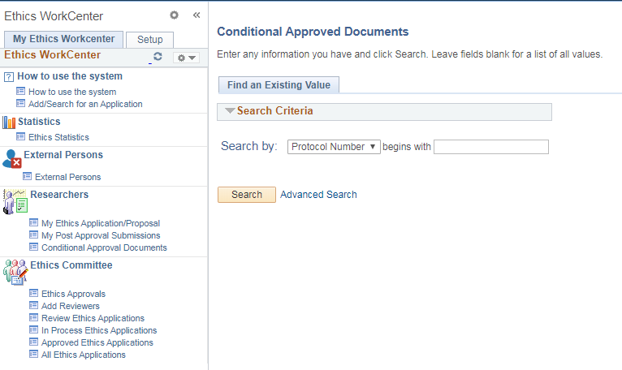
Researchers click on function Conditional Approval Documents and Search.
All the student’s Conditionally Approved Applications will be listed, or if there is only one, it will open that specific application.

Upload documents

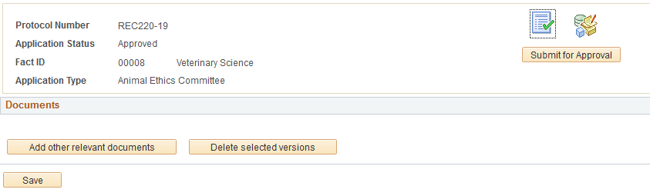
On the first icon, the documents can be uploaded, by clicking on the “Add other relevant documents” button.

Add a comment

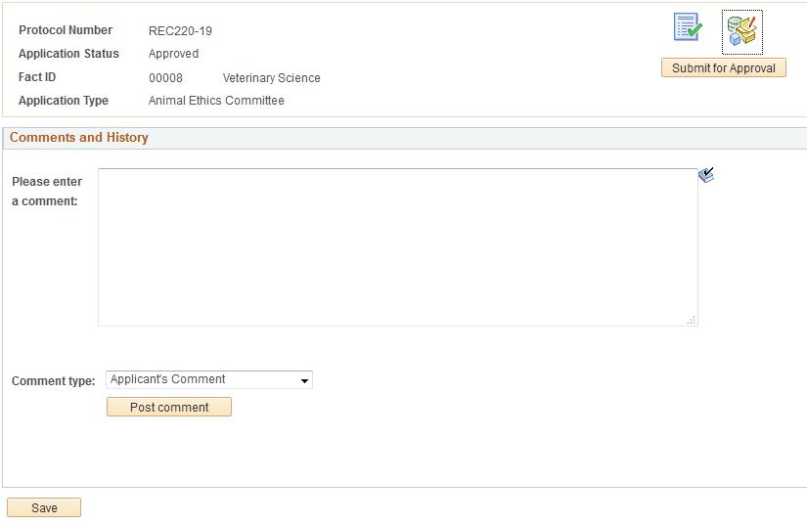
Researchers can add a comment by clicking on the 2nd icon and Post comment.
Click on “Submit for Approval” to send the request directly to the Ethics Administrator.

Ethics Administrator view documents

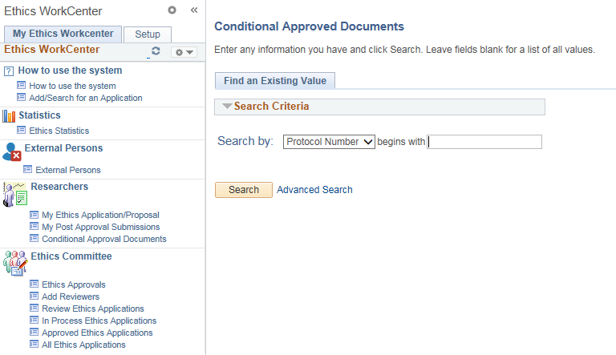
Under All Ethics Applications, please make sure which documents are required for Final Approval.
Ethics Administrators click on the same function “Conditional Approval Documents” and search.
You will receive a list of applications needing Final Approval, select one.

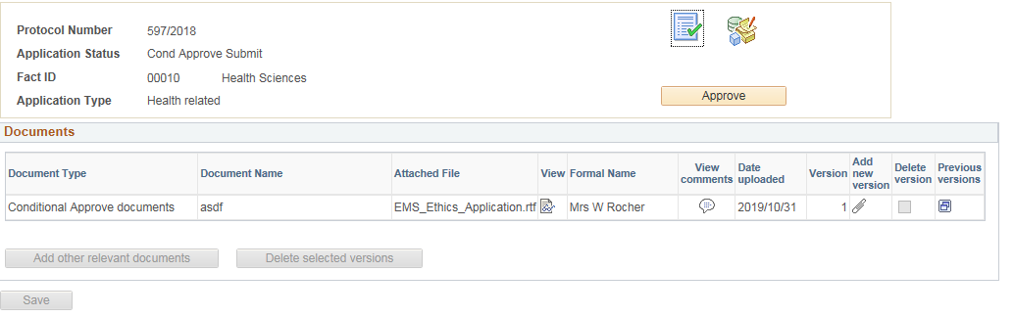
On the 1st icon, view the document.

View comments and letter, Approve

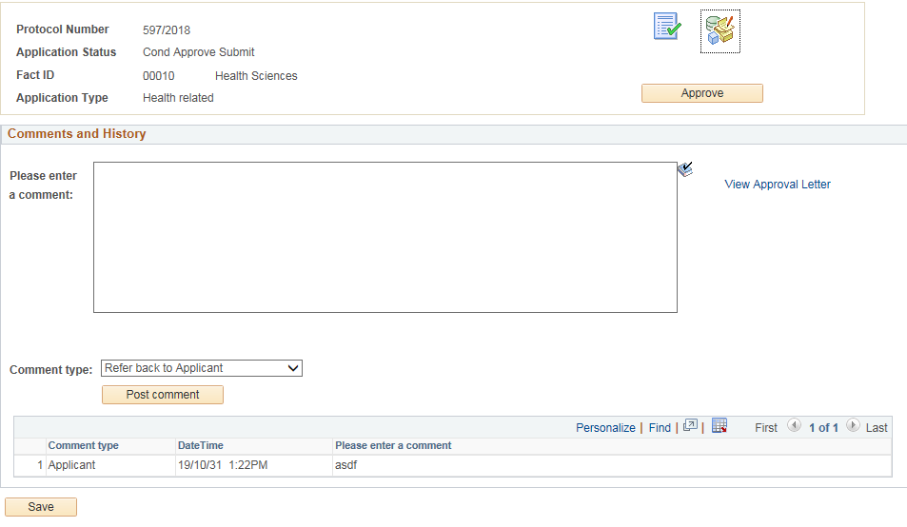

Click on the 2nd icon to:
- View the comments
- View the Final Approval Letter, by clicking on the link “View Approval Letter”
- Refer the submission back to the Researcher, if documents are still outstanding, by typing a comment and clicking on the “Post Comment” button.
- If you are happy with the documents and the letter, click on the Approve button.
When approved, the Final Approval letter will be sent to the Researcher by e-mail, and the Final Approval letter will be added to his/her Application under the Documents icon.

