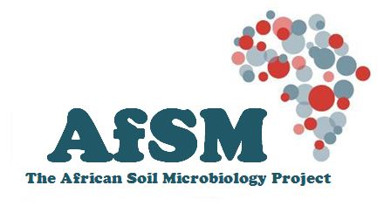

AfSM Press Release: 12 October 2016
Of all the continents, Africa faces the largest challenges concerning soil conservation and food security, in the face of increasing populations and environmental change.
Scientists from seven sub-Saharan African countries met at the University of Pretoria this week to launch the African Soil Microbiology project. This 3-year project, funded by USAID, aims to undertake a broad-scale survey of soil microbiology across the entire African continent, using the latest Next Generation DNA sequencing and computational technologies.
This unique multi-national project, the first such study to ever be undertaken in Africa at this scale, is expected to unravel the complexities of soil microbiological diversity across sub-Saharan Africa. The results of the research will contribute to our understanding of soil fertility, soil degradation and the future impacts of climate change, and important health issues such as soil-borne pathogens.
For more information, contact the project director, Prof Don Cowan, Director, Centre for Microbiology and Genomics, University of Pretoria (don.cowan@up.ac.za)

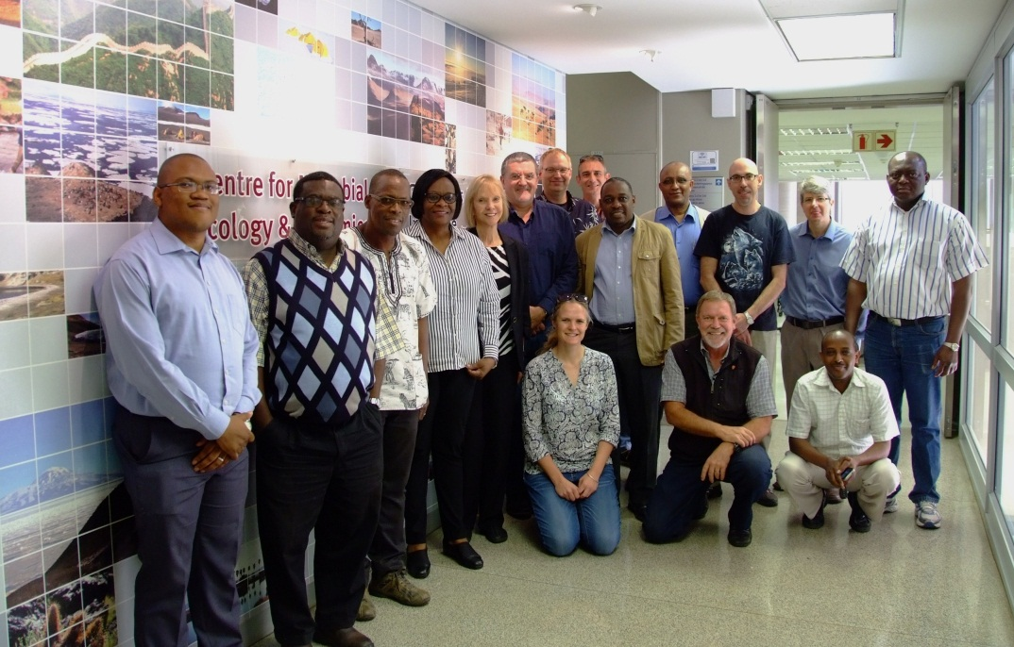
The African Soil Microbiology project team, in the CMEG laboratories at the University of Pretoria

