UP Internally Funded Calls | Staff Travel Programme
SUSTAINABLE DEVELOPMENT GOALS (SDG) focus area(s)
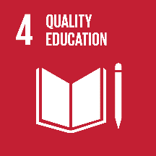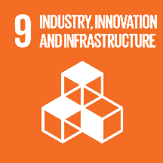

APPLICATION DEADLINE
Internal closing date
Round 1: 21 February 2020
Round 2: 22 May 2020
Round 3: 21 August 2020
BACKGROUND
The University of Pretoria (UP) has entered into a number of collaborations and cooperation agreements with international institutions, in order to promote its own internationalisation programmes. In order to stimulate collaboration, especially under the auspices of these agreements, the University provides limited funding on an annual basis for the exchange of academic staff.
Three rounds of applications are considered — in February, May, and August.

ELIGIBILITY CRITERIA
- Applications for awards must be completed in accordance with the prescribed electronic application form. The designated contact person at the Department of Research and Innovation (DRI) needs to be contacted in order to guide the applicant with the application process. All sections of the prescribed application form must be completed otherwise the application will not be considered.
- Applications must be supported by the Dean; Faculty Research Committee Chairperson or Deputy Dean: Research and Postgraduate Education and submitted via their office to DRI.
- Deadlines must be strictly adhered to as no late applications will be considered.
- Only ad-hoc applications with a strong motivation to be reviewed ad-hoc will be considered and reviewed.
- Full-time/permanent academic staff members who would like to conduct research in collaboration with, and/or undertake special training at an international institution and where the travel will enhance UP’s research profile, may apply.
- Full-time staff members of an international institution, particularly those with which the University has a cooperation agreement, who would like to conduct collaborative research at UP, may apply. The application is submitted to the Committee by the Programme/Project leader at UP.
- An application which has been submitted after the applicant has already left abroad, will not be considered as applications cannot be approved retrospectively.
- The applicant should be part of a programme of research and/or training that will be enhanced by the Staff travel abroad. Ad hoc exchanges will not receive support, unless a particularly strong motivation is provided.
- The applicant must be a proven researcher and/or have achieved success in other academic fields, or be a young staff member, at the start of their academic careers, or be from under-represented groups at the University. The exchange can be used as a development opportunity, within the framework of a research programme.
- Funds will not normally be granted only to attend conferences. Exceptions will be considered for developing researchers.
- Bursaries are allocated to individual staff members once only for a particular programme or research project. Staff members cannot reapply in the subsequent year, or apply to go to another institution in the subsequent year.

HOW TO APPLY
Please be advised that DRI has launched an online application process for UP Internal Funding Programmes. Attached are instructions pertaining to the application process.

APPLICATION DEADLINES:
Internal closing date
Round 1: 21 February 2020
Round 2: 22 May 2020
Round 3: 21 August 2020
CONTACTS FOR CALL QUERIES
Faculty Contact person
Natasha Jeftha: R4-15 HW Snyman North, Prinshof Campus, 012 319 2378, Natasha.jeftha@up.ac.za

