How to enable Flash player on Chrome

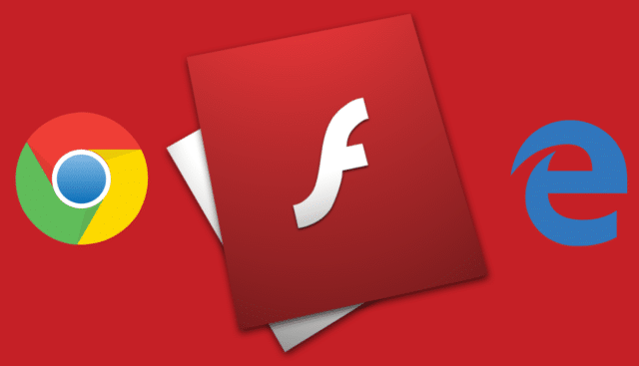

Enabling Flash on Chrome

- Logon onto ClickUp
- Go to ITS Service catalogue>
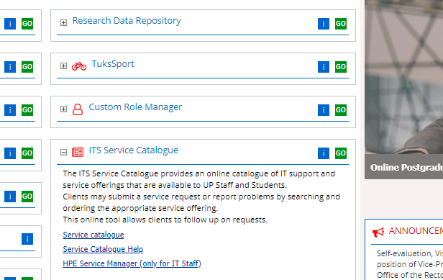

- Click on Service Catalog
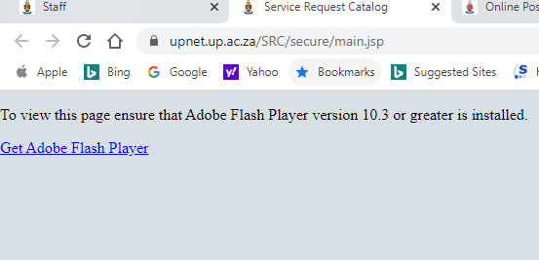

- Click on Get Adobe Flash Player , and the click on allow

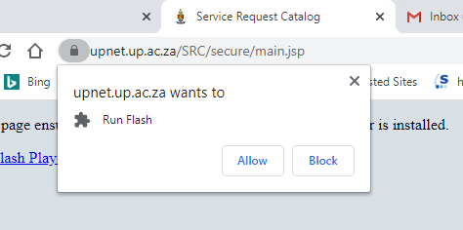

- And the window below appears and then you simply just login

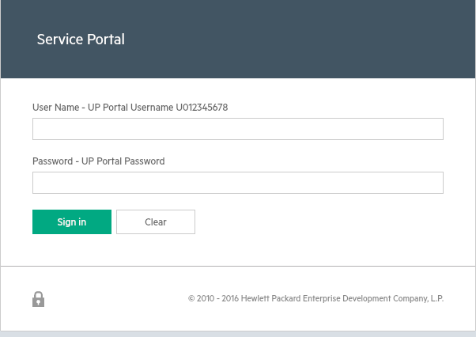

Similarly, with Microsoft Edge, follow the same procedure

