Proudly sponsored by EY

The Tax@Tuks 2022/2023 Executive Committee

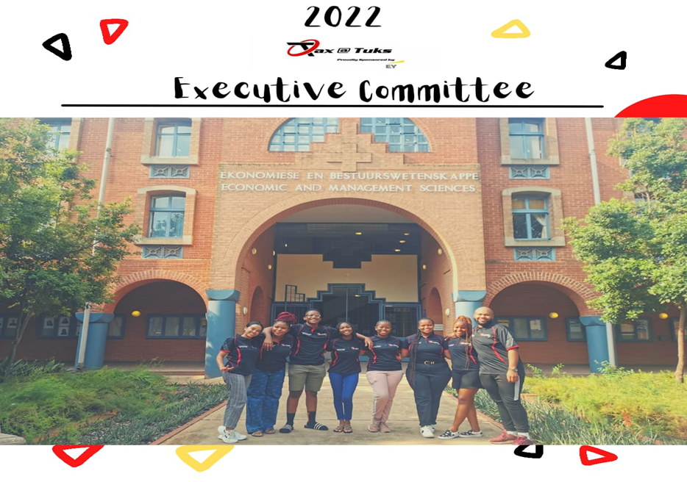

FACE TO FACE MEETING
CANCER AWARENESS
On the 29th of October the some of the Executive members of TAX@TUKS met for the first time in Hatfield, since becoming a part of the organisation. The meeting was to show support to breast cancer survivors, as well as raise awareness about breast cancer. The team however did get a chance know each other and get a better understanding on who they will be working with

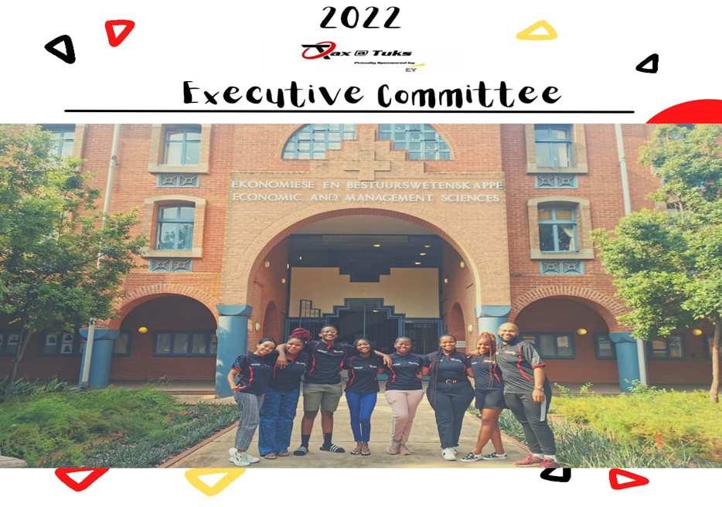
On the 24th of February 2022 the team had an opportunity to meet, hold a meeting and receive our T-shirts. It was for the very first time that all the members were available for an in-person meeting, and it was such an amazing experience to finally meet everyone. Meetings were held online to make it convenient for everyone.

PICTURE DAY
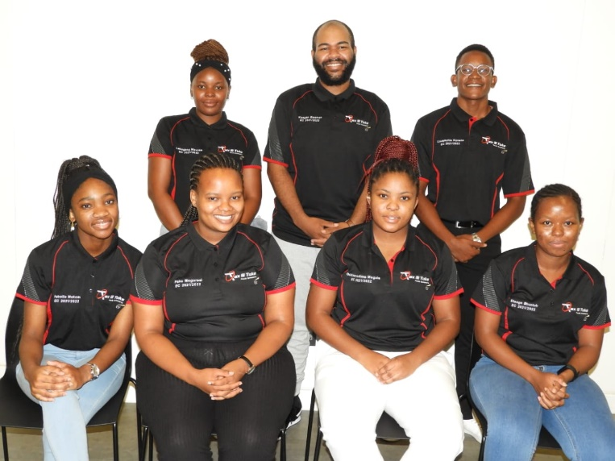
Picture day for the team during the month of March. This picture reminds us of grade 1 pictures, clean, sweet and a beautiful memory of us as a team. Individual members had their pictures taken as well and they looked as beautiful as our group picture

ANNUAL GENERAL MEETING.
On the 20th of April the Tax@Tuks team members joined other sub houses as well as the Faculty house Committee in the Thuto building. Members from different sub houses got the opportunity to know each other well and build working relationships. Commercii and sub houses got the chance to play games, and bond. There was also lunch! Sponsored by Gautrain.
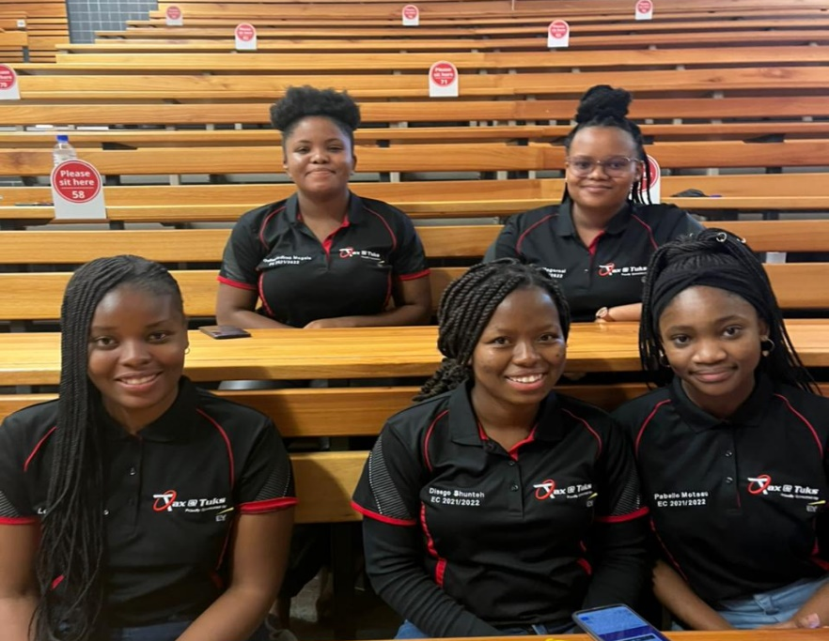
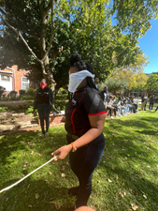
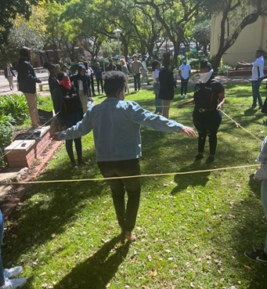
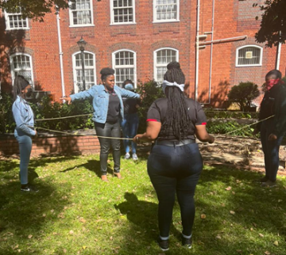

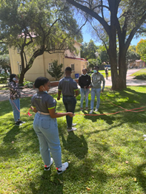
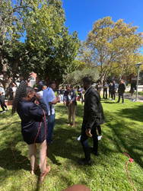
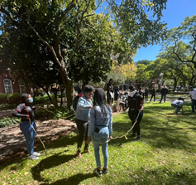

Events held thus far!!.
STATIONARY DRIVE

The team held a stationary drive that ran through the month or March to April, the drive was for a period of 3 weeks and we were able to collect a few books, pens and sharpeners. The donations are kept in the office, for the next team to add on to them if they ever to have a stationary drive during their term.
Time and stress management
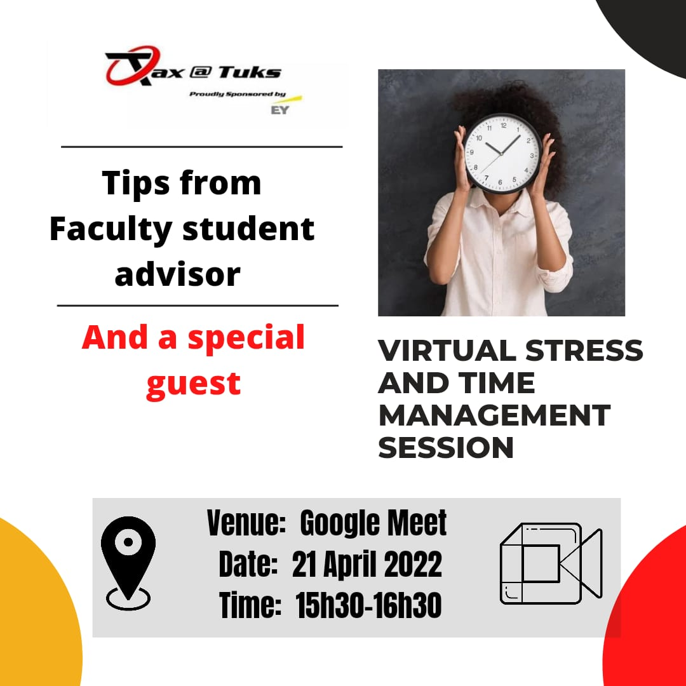
The team hosted a time and stress management event for the students. We were joined by Commercii’s head of Academics and Mentorship, Ifrah Rage as well as the EMS faculty student Advisor Miss Zinhle Sibiya.
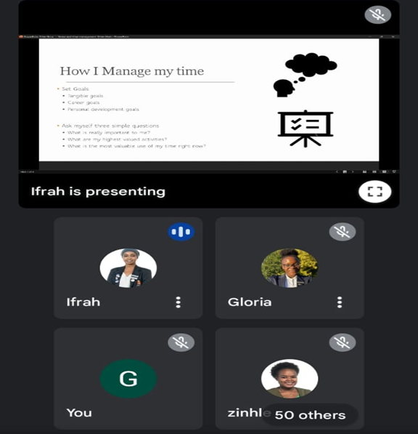

Upcoming event

Meet a tax professional
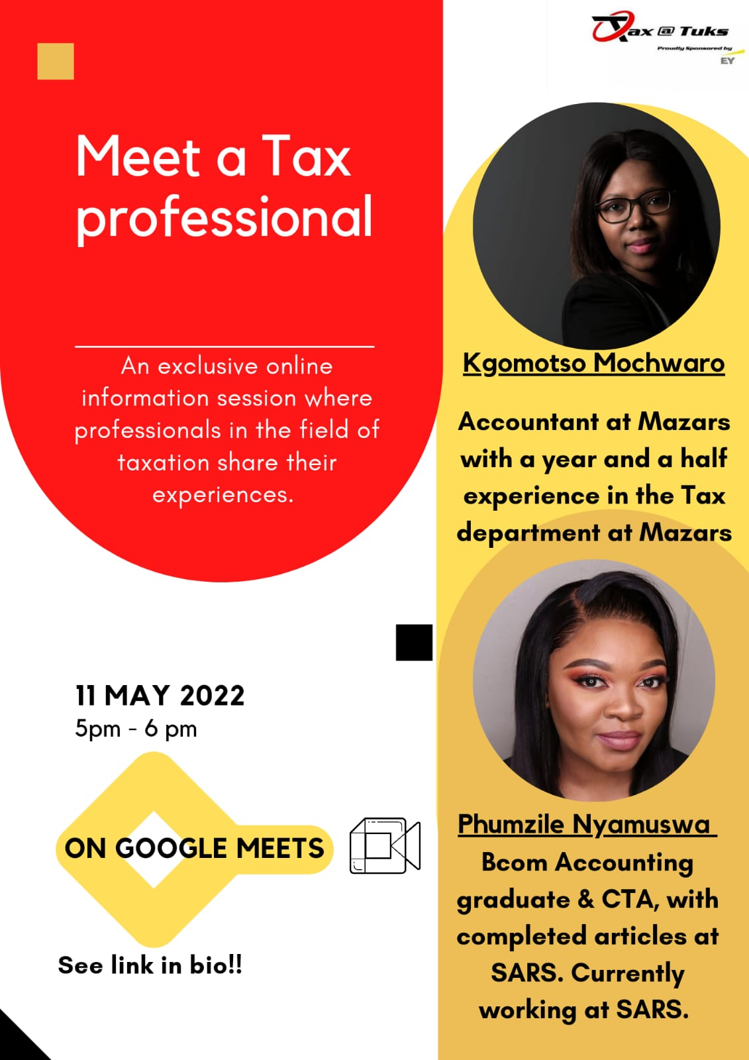

On the 11th of May, we are holding probably the most valuable session yet. Kgomotso Mochwaro and Phumzile Nyamuswa, two young tax professionals in the field of taxation will be joining us on a google meets session to share their experiences. Looking forward to see you there!!

END

