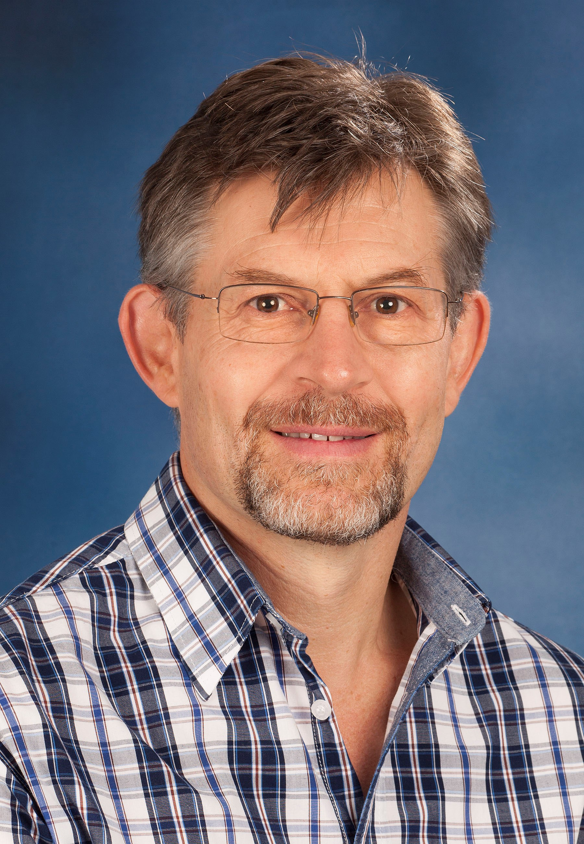
Prof. Johan P Schoeman
BVSc, MMedVet(Med), PhD, DSAM, Dipl. ECVIM
Professor: Small Animal Internal Medicine
Leader: Pathobiology Research theme
ORCID ID: 0000-0002-5057-311X

Summary CV

Prof. Johan Schoeman qualified as a veterinarian from the University of Pretoria in 1991. After spending seven years working in a veterinary mixed (small and large animal) practice in the United Kingdom, he was appointed as a lecturer at the University of Cambridge, where he completed his training for the RCVS specialist diploma in small animal medicine (DSAM). He joined the Department as a senior lecturer in 2000. In 2001, he obtained specialist qualifications in Small Animal Medicine from the RCVS (DSAM), the European College of Veterinary Internal Medicine (ECVIM) and the University of Pretoria (MMedVet). During 2004 and 2005 he was Head of Small Animal Medicine. He is a former chair of the ECVIM examination board – a body that examines and certifies specialist veterinary physicians across Europe. He has been Head of the Department of Companion Animal Clinical Studies for two terms (8 years) until October 2017. He currently leads the Faculty’s pathobiology research theme and has rekindled his passion for clinical teaching, whilst diagnosing and treating referred small animal medicine cases, especially those with cardiac and/or endocrine disease manifestations. Prof. Schoeman has successfully supervised 14 Masters and 4 PhD students, published 65 scientific papers, 10 textbook chapters, and presented over 80 international scientific, peer-reviewed congress presentations in Europe and the USA and he has delivered more than 100 regional and national CPD lectures.

Research Expertise/Interest

Prof. Schoeman has an overarching research interest in the effect of infectious organisms and inflammation on the host response, in particular the endocrine response to critical illness, which was also the topic of his PhD. Areas of study within the newly focussed pathobiology research theme will include changes in the normal physiology of animals brought about by disease and disease processes. An integral component of this theme will include disease diagnostics from clinical changes observed in the patient to diagnostic imaging perturbations, clinical pathological changes, pathological changes, molecular study of disease processes. Moreover, the theme will also involve the description of new pathological agents and/or toxins and the epidemiology of animal disease and its impact on human health.

Postgraduate Students

- PhD students
  - Dr. Pieter Defauw completed his Masters at the University of Ghent in Belgium. He is currently being co-supervised by Prof. Schoeman on the effect of canine babesiosis on kidney function, in collaboration with Prof. Sylvie Daminet of the University of Ghent in Belgium.
  - Dr. Charlie Boucher qualified as a specialist small animal surgeon from the University of Pretoria in 2017 and is currently studying for a PhD on antimicrobial resistance to antiseptics used in small animal surgery.
  - Dr. Cobus Benson is a human cardiologist who qualified from the University of Pretoria. He is currently investigating novel, non-pharmacological treatment of hypertension in a goat model, in collaboration with Prof. Greg Tintinger of the Faculty of Health Science at the University of Pretoria.

- Masters students
  - Dr Wilco Botha completed his undergraduate training at the University of Pretoria in 2013. He is currently studying the prevalence of Clostridium difficile and Salmonella spp. in canine puppies affected by parvoviral diarrhoea, in collaboration with Prof. Stan Marks of the University of California, Davis in the USA.
  - Dr. Estee van Zyl completed her undergraduate training at the University of Pretoria in 2014. She is currently working on the effect of serious injury caused by dog bite wounds on the endocrine responses of the host.
  - Dr. Chad Berman completed his undergraduate training at the University of Pretoria in 2014. He is currently studying the effects of diets with varying degrees of carbohydrate, fat and protein on the metabolic profiles of normal domestic cats in collaboration with Dr Eric Zini of the University of Zurich in Switzerland.
  - Dr. Rivona Ramnanan completed her undergraduate training at the University of Pretoria in 2017. She is currently studying the prevalence of diabetes mellitus in dogs and cats in South Africa in collaboration with Prof. Rebecka Hess of the Pennsylvania Veterinary School in Philadelphia, USA.

