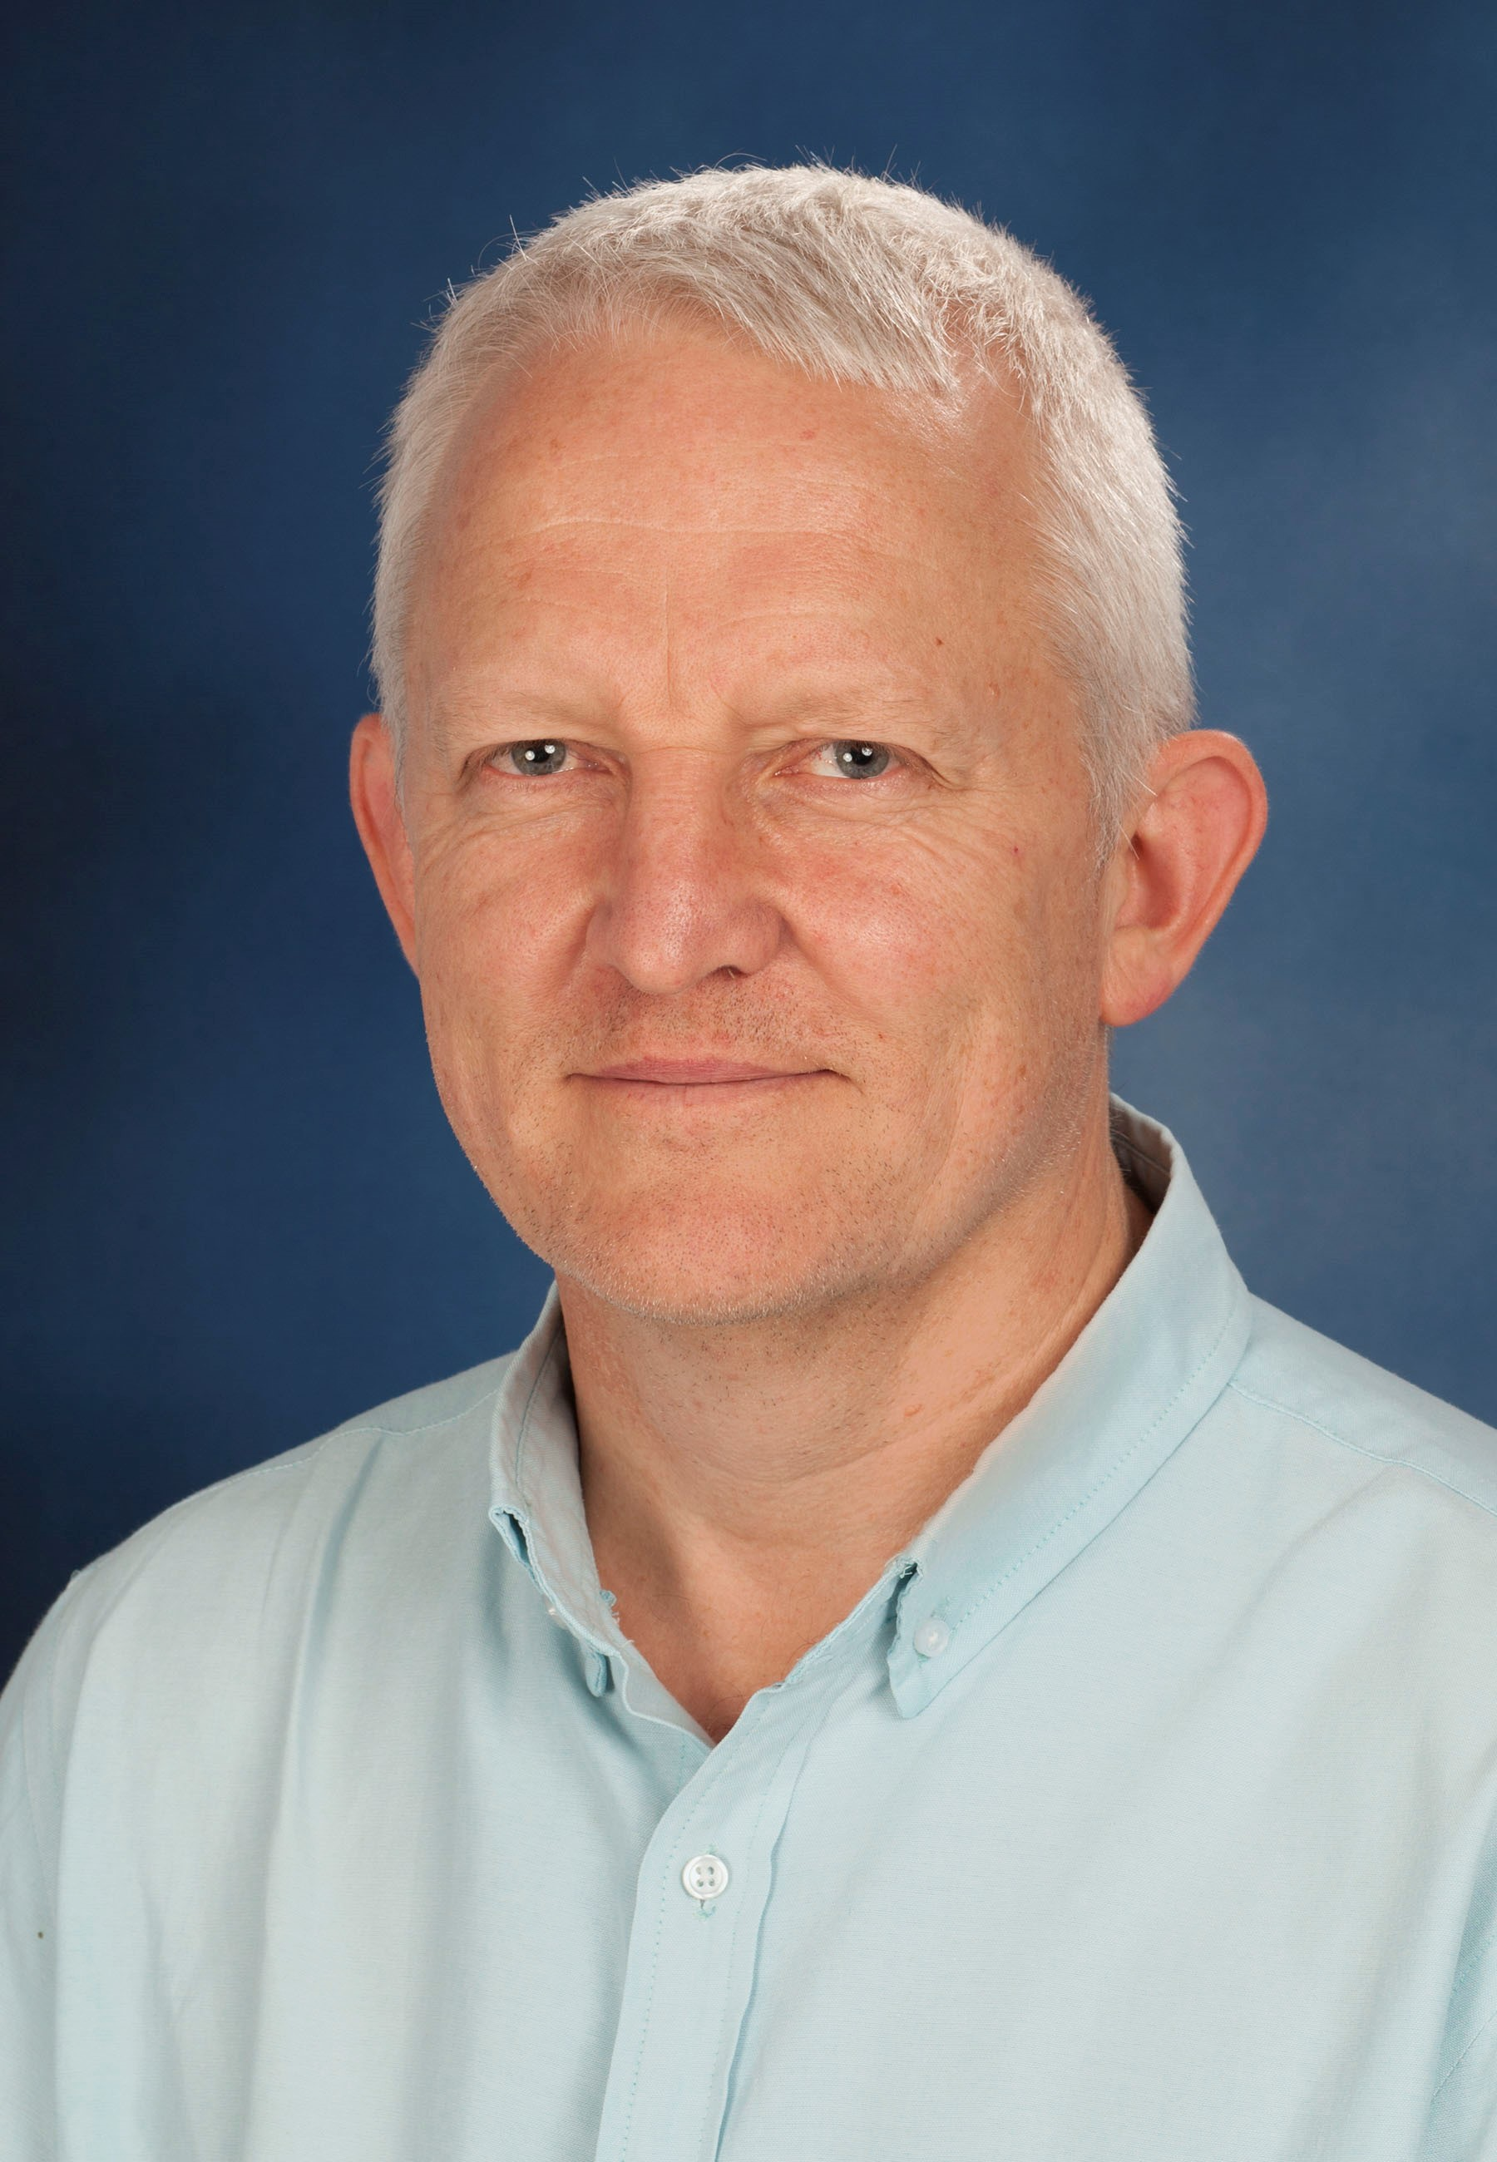
Dr. Bruce Nevill
BVSc, MMedVet(Surg)
Senior lecturer: Small animal surgery
ORCID ID:

Summary CV

Dr. Bruce Nevill completed his MMedVet specialist degree in Small Animal Surgery through the University of Pretoria. He joined the Department as a senior lecturer in 2017. Dr. Nevill particularly enjoys the interaction with final year students and helping them along the path of becoming fully fledged veterinarians.

Research Expertise/Interest

Dr. Nevill’s research interest lies in minimally invasive surgery and orthopaedic surgery in general.

Postgraduate Students

- MMedVet
- Dr. Hermien Viljoen who graduated from Onderstepoort in 2014. The aim of her project is to compare the antimicrobial efficacy of three different pre-surgical hand washing protocols used in the Onderstepoort Veterinary Academic Hospital.

