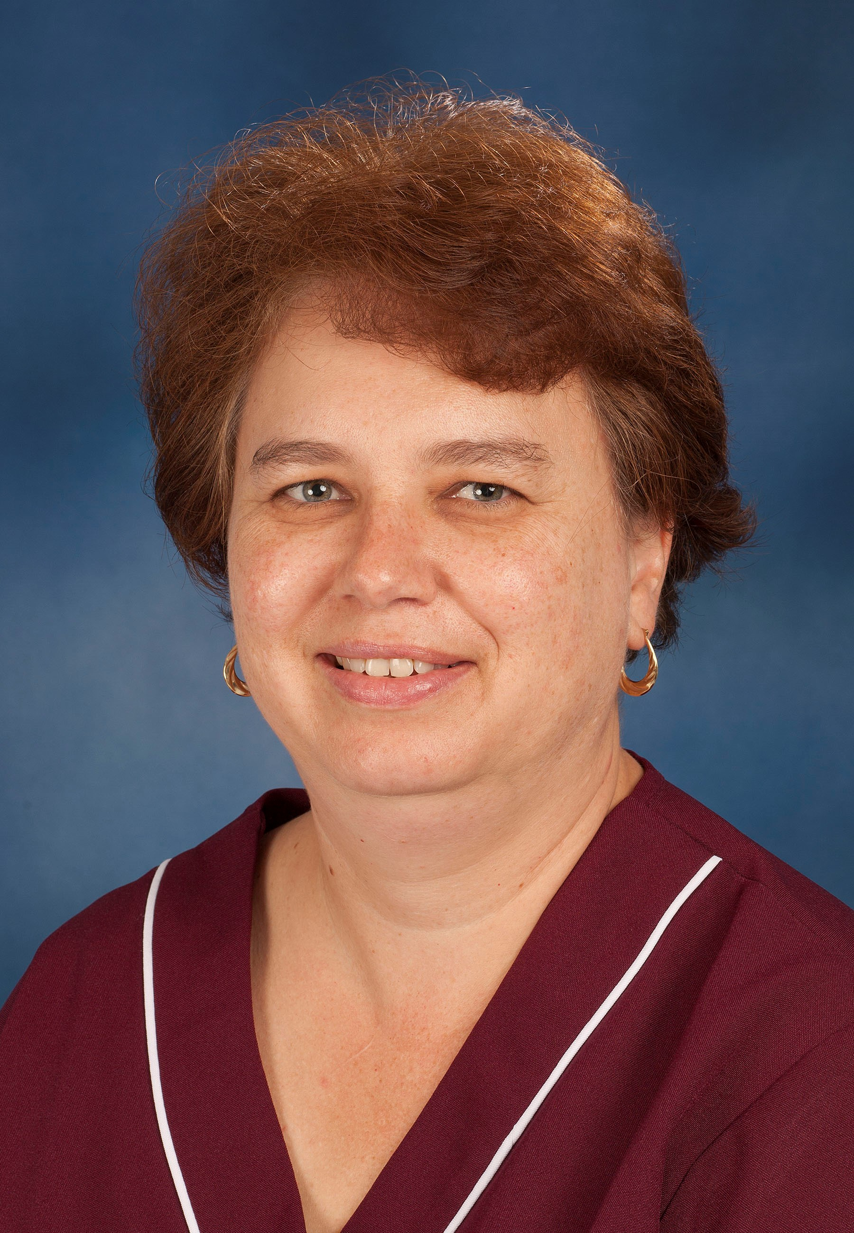
Mrs. Carien Muller
NDip Vet Tech
Control Technologist

Summary CV

Mrs. Carien Muller joined the Department in 1994 as a veterinary technologist in the Clinical Pathology laboratory. Her diagnostic laboratory functions included sample receiving and registration, haematology, haemostasis, clinical biochemistry, endocrinology and cytology preparation. Mrs. Muller was appointed as control technologist in 2011. In her capacity as control technologist the day-to-day management of the laboratory and support personnel is her responsibility. In addition she provides technical support to researchers, both internal and external, and practical training for veterinary and para-veterinary students. She also serves as the principle liaison between the laboratory and the various vendors, as well as other key stakeholders.

