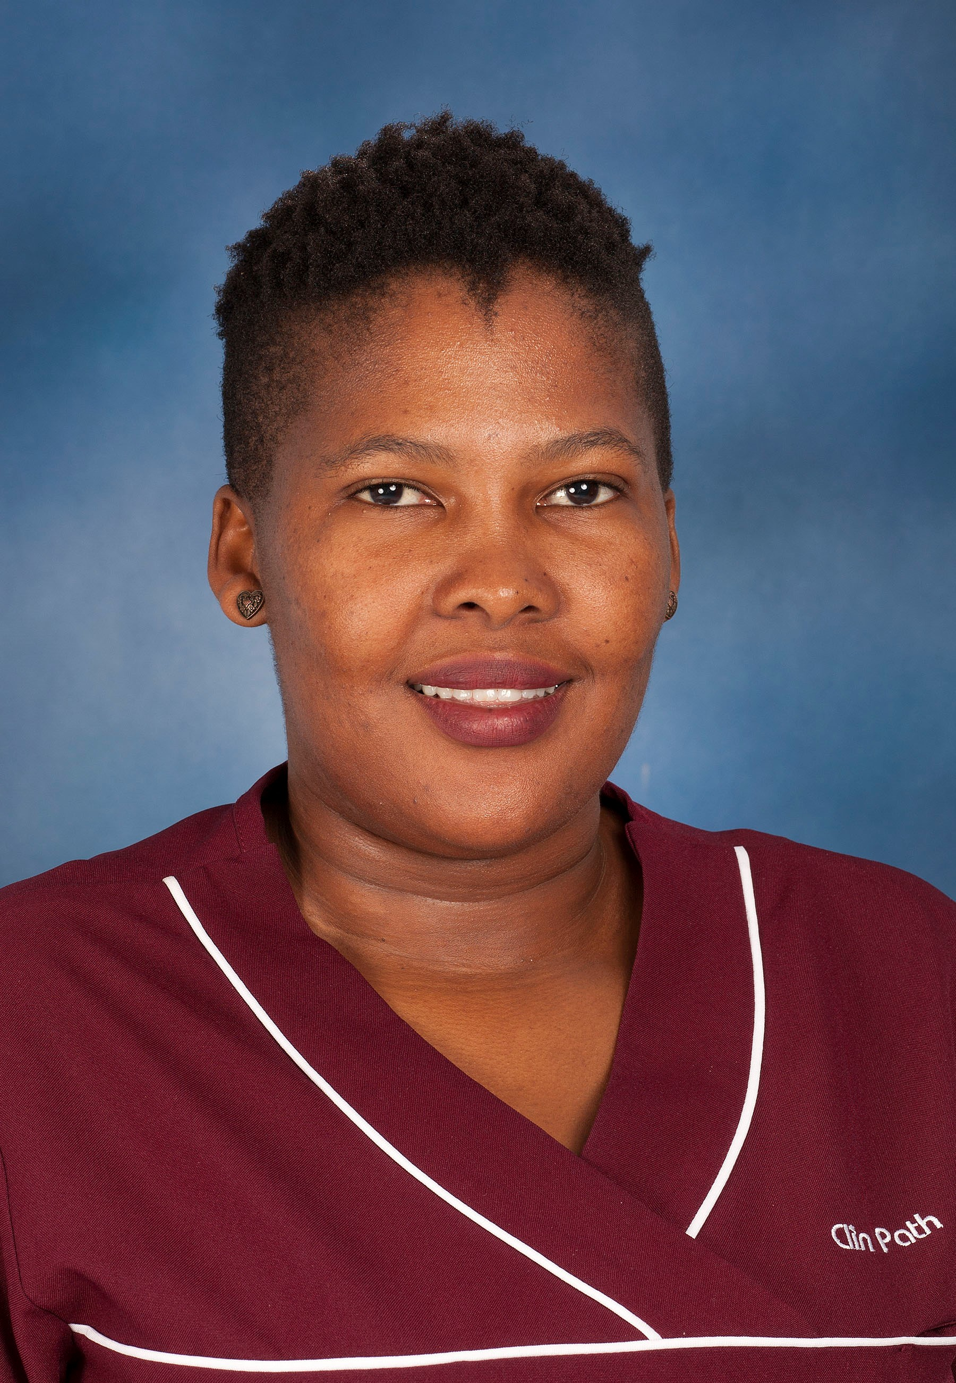
Ms. Lesego Mametse
Senior Certificate
Administrative Assistant

Summary CV

Ms. Lesego Mametse joined the Department in 2017 as an administrative assistant in the Clinical Pathology laboratory. Ms. Mametse’s duties include procurement, client accounts management and receipt of ordered products. In addition, she also assist with sample receival and registration as required.

