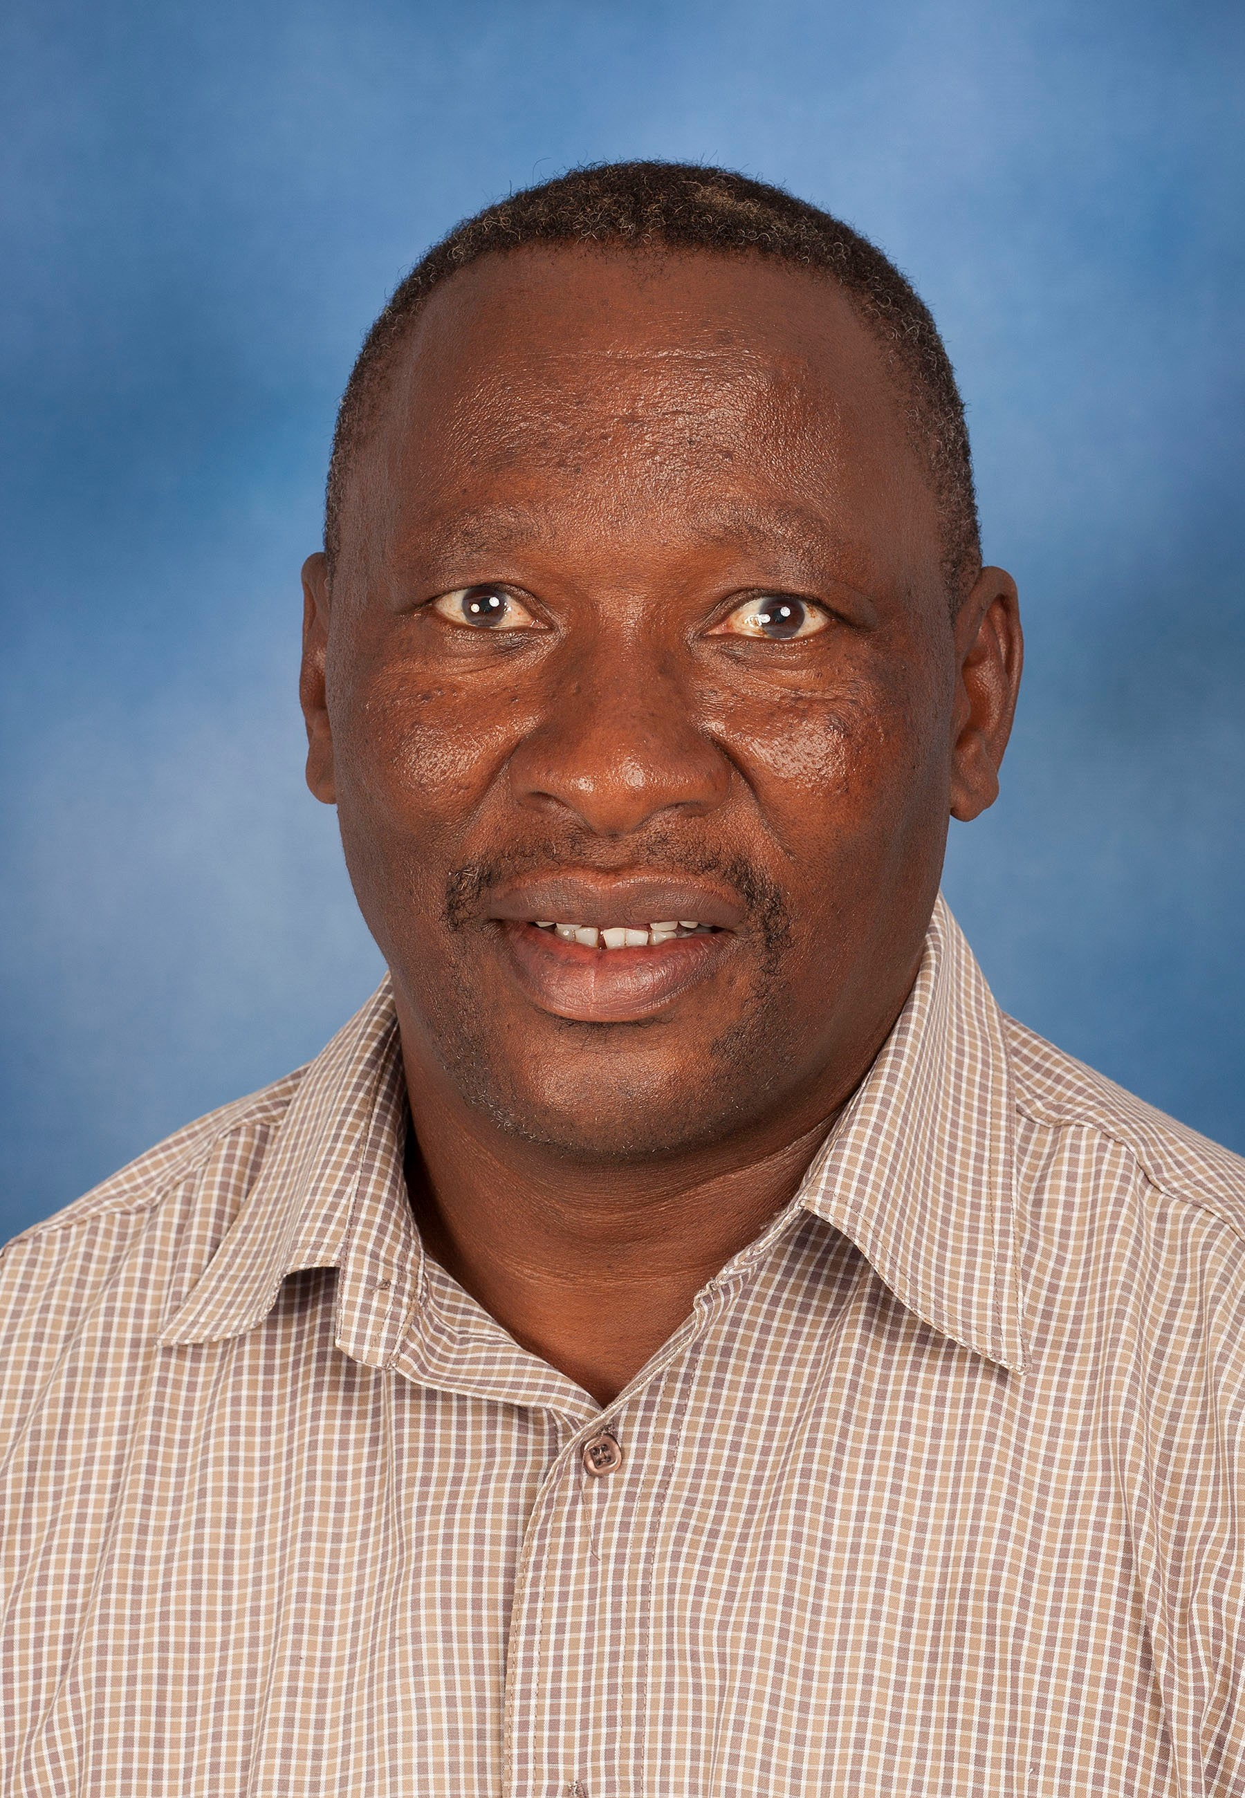
Mr. Philemon Lephotho
Junior Certificate
Senior Laboratory Assistant

Summary CV

Mr. Philemon Lephotho joined the University of Pretoria in 1993 as a security guard in the department of Security Services for a period of 6 years. Thereafter, he joined the Department in 1999 as an assistant in the Clinical Pathology laboratory. Mr. Lephotho also assists with miscellaneous functions within the Department.

