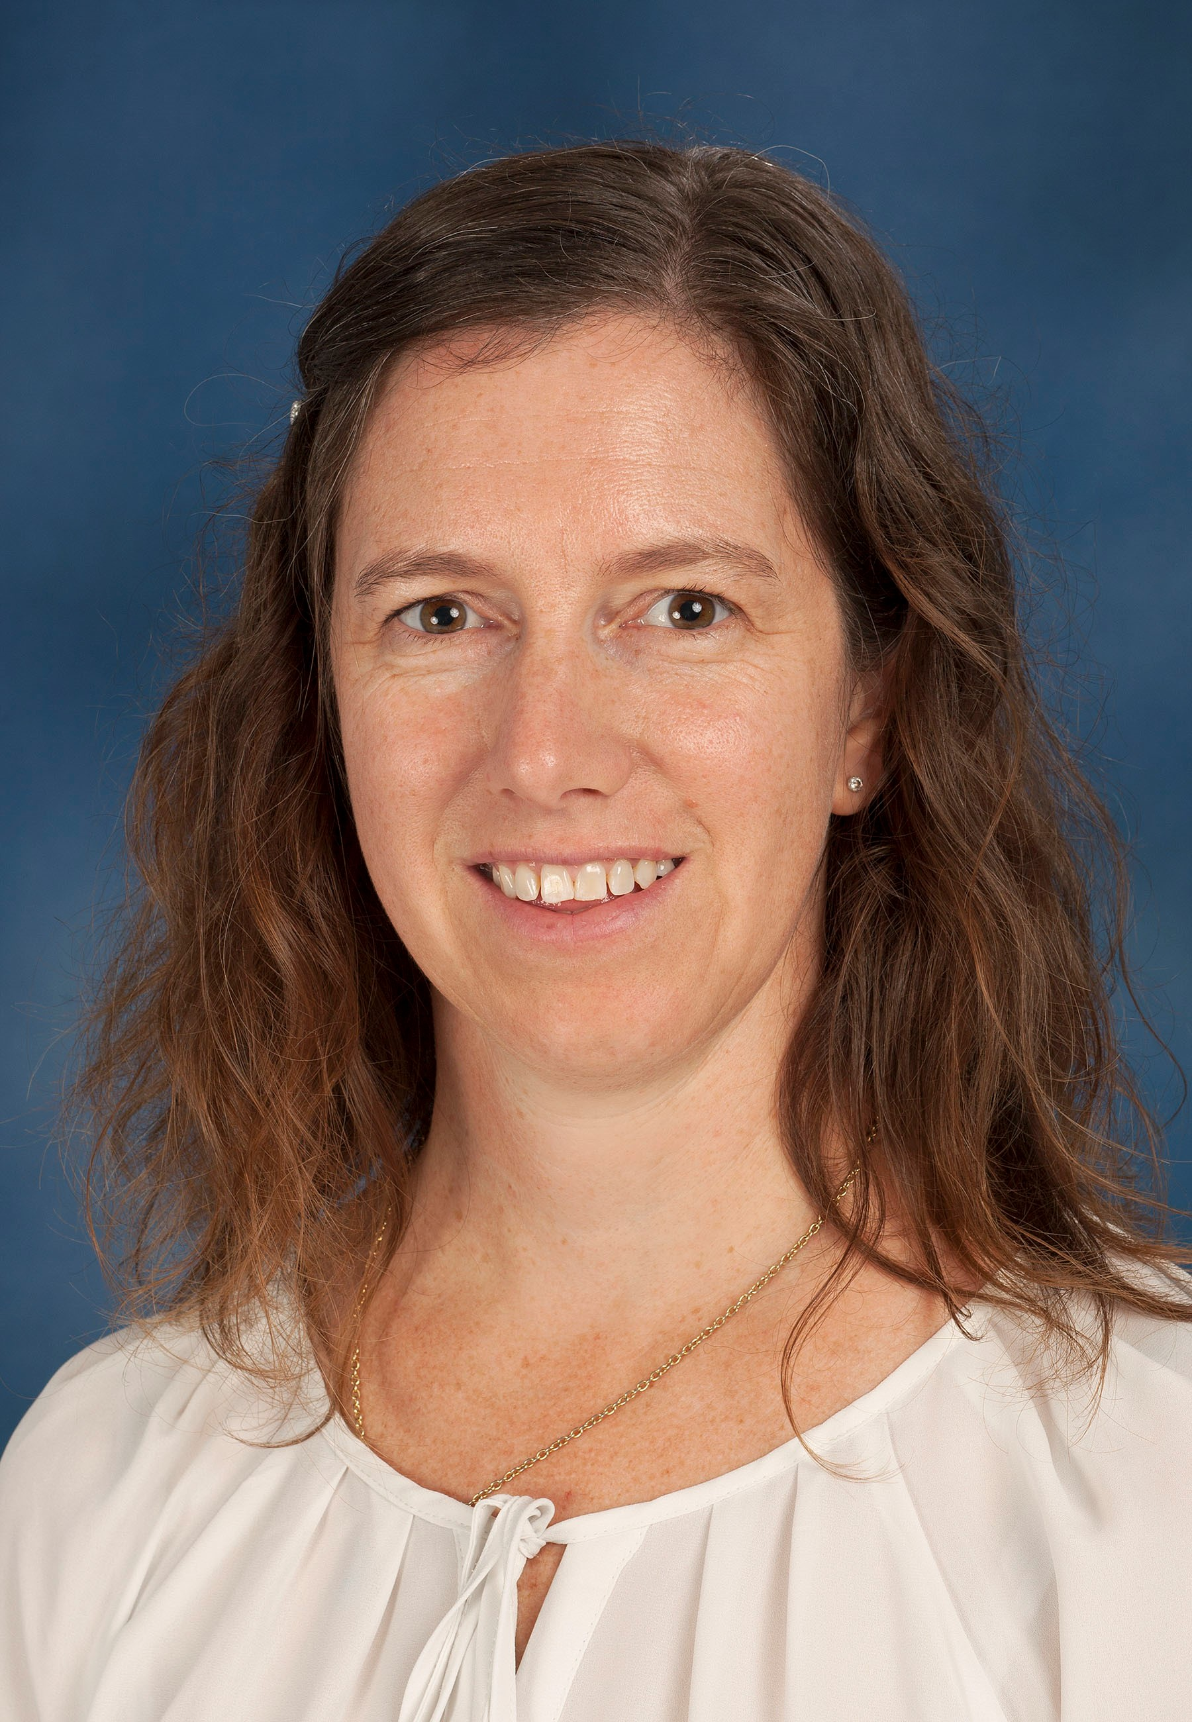
Dr. Emma Hooijberg
BVSc, GPCert(SAP), Dipl. ECVCP
Senior lecturer: Veterinary Clinical Pathology
ORCID ID: 0000-0002-4367-799X

Summary CV

Dr. Emma Hooijberg joined the Department at the end of 2014, after working and studying in Vienna, Austria, for a number of years. Dr. Hooijberg is a Diplomat of the European College of Veterinary Clinical Pathology (ECVCP) and a European and South African Specialist in Veterinary Clinical Pathology. Dr. Hooijberg is currently involved in teaching Introductory Veterinary Diagnostics in the third year and Clinical Pathology in the fourth year of the veterinary students, and Laboratory Techniques in the first year of the para-veterinary students. In addition, she teaches small groups of final year veterinary students during their final year rotation through clinical pathology. She is also involved in post-graduate training, including clinical pathology residents and is the principle supervisor of two residents enrolled in the ECVCP residency programme. Dr. Hooijberg’s research projects involve collaboration with researchers from SANParks, University of Stellenbosch and the Miami Miller School of Medicine in Florida. She currently has 13 publications in peer-reviewed journals.

Research Expertise/Interest

Dr. Hooijberg’s research interests include inflammatory markers, clinical pathology of wildlife, reference intervals and biological variation, and laboratory quality management. Her PhD research focused on clinical pathology of the white rhinoceros. She is also investigating the acute phase response and inflammatory markers in this species at present.

Postgraduate Students

- MSc
  - Dr. K Lourens is currently working on a project investigating haematology and clinical chemistry reference intervals for the Ground Pangolin.
  - Dr. Ashleigh Lemon completed her undergraduate training at the University of Pretoria in 2017. Dr. Lemon is currently working on the effects of storage time and temperature on TEG analysis in dogs and horses. The aim of the project is to determine whether prolonged storage time will affect the TEG results significantly. If not, it will make the assay more available for use by private veterinarians.
- MMedVet
  - Dr. Liesl van Rooyen completed her undergraduate training at the University of Pretoria in 2011. Dr. van Rooyen is currently working on investigating thromboelastographic platelet mapping in dogs with complicated Babesia rossi infection. The aim of this project is to investigate the role of the platelet in this disease, despite the marked thrombocytopenia observed.

