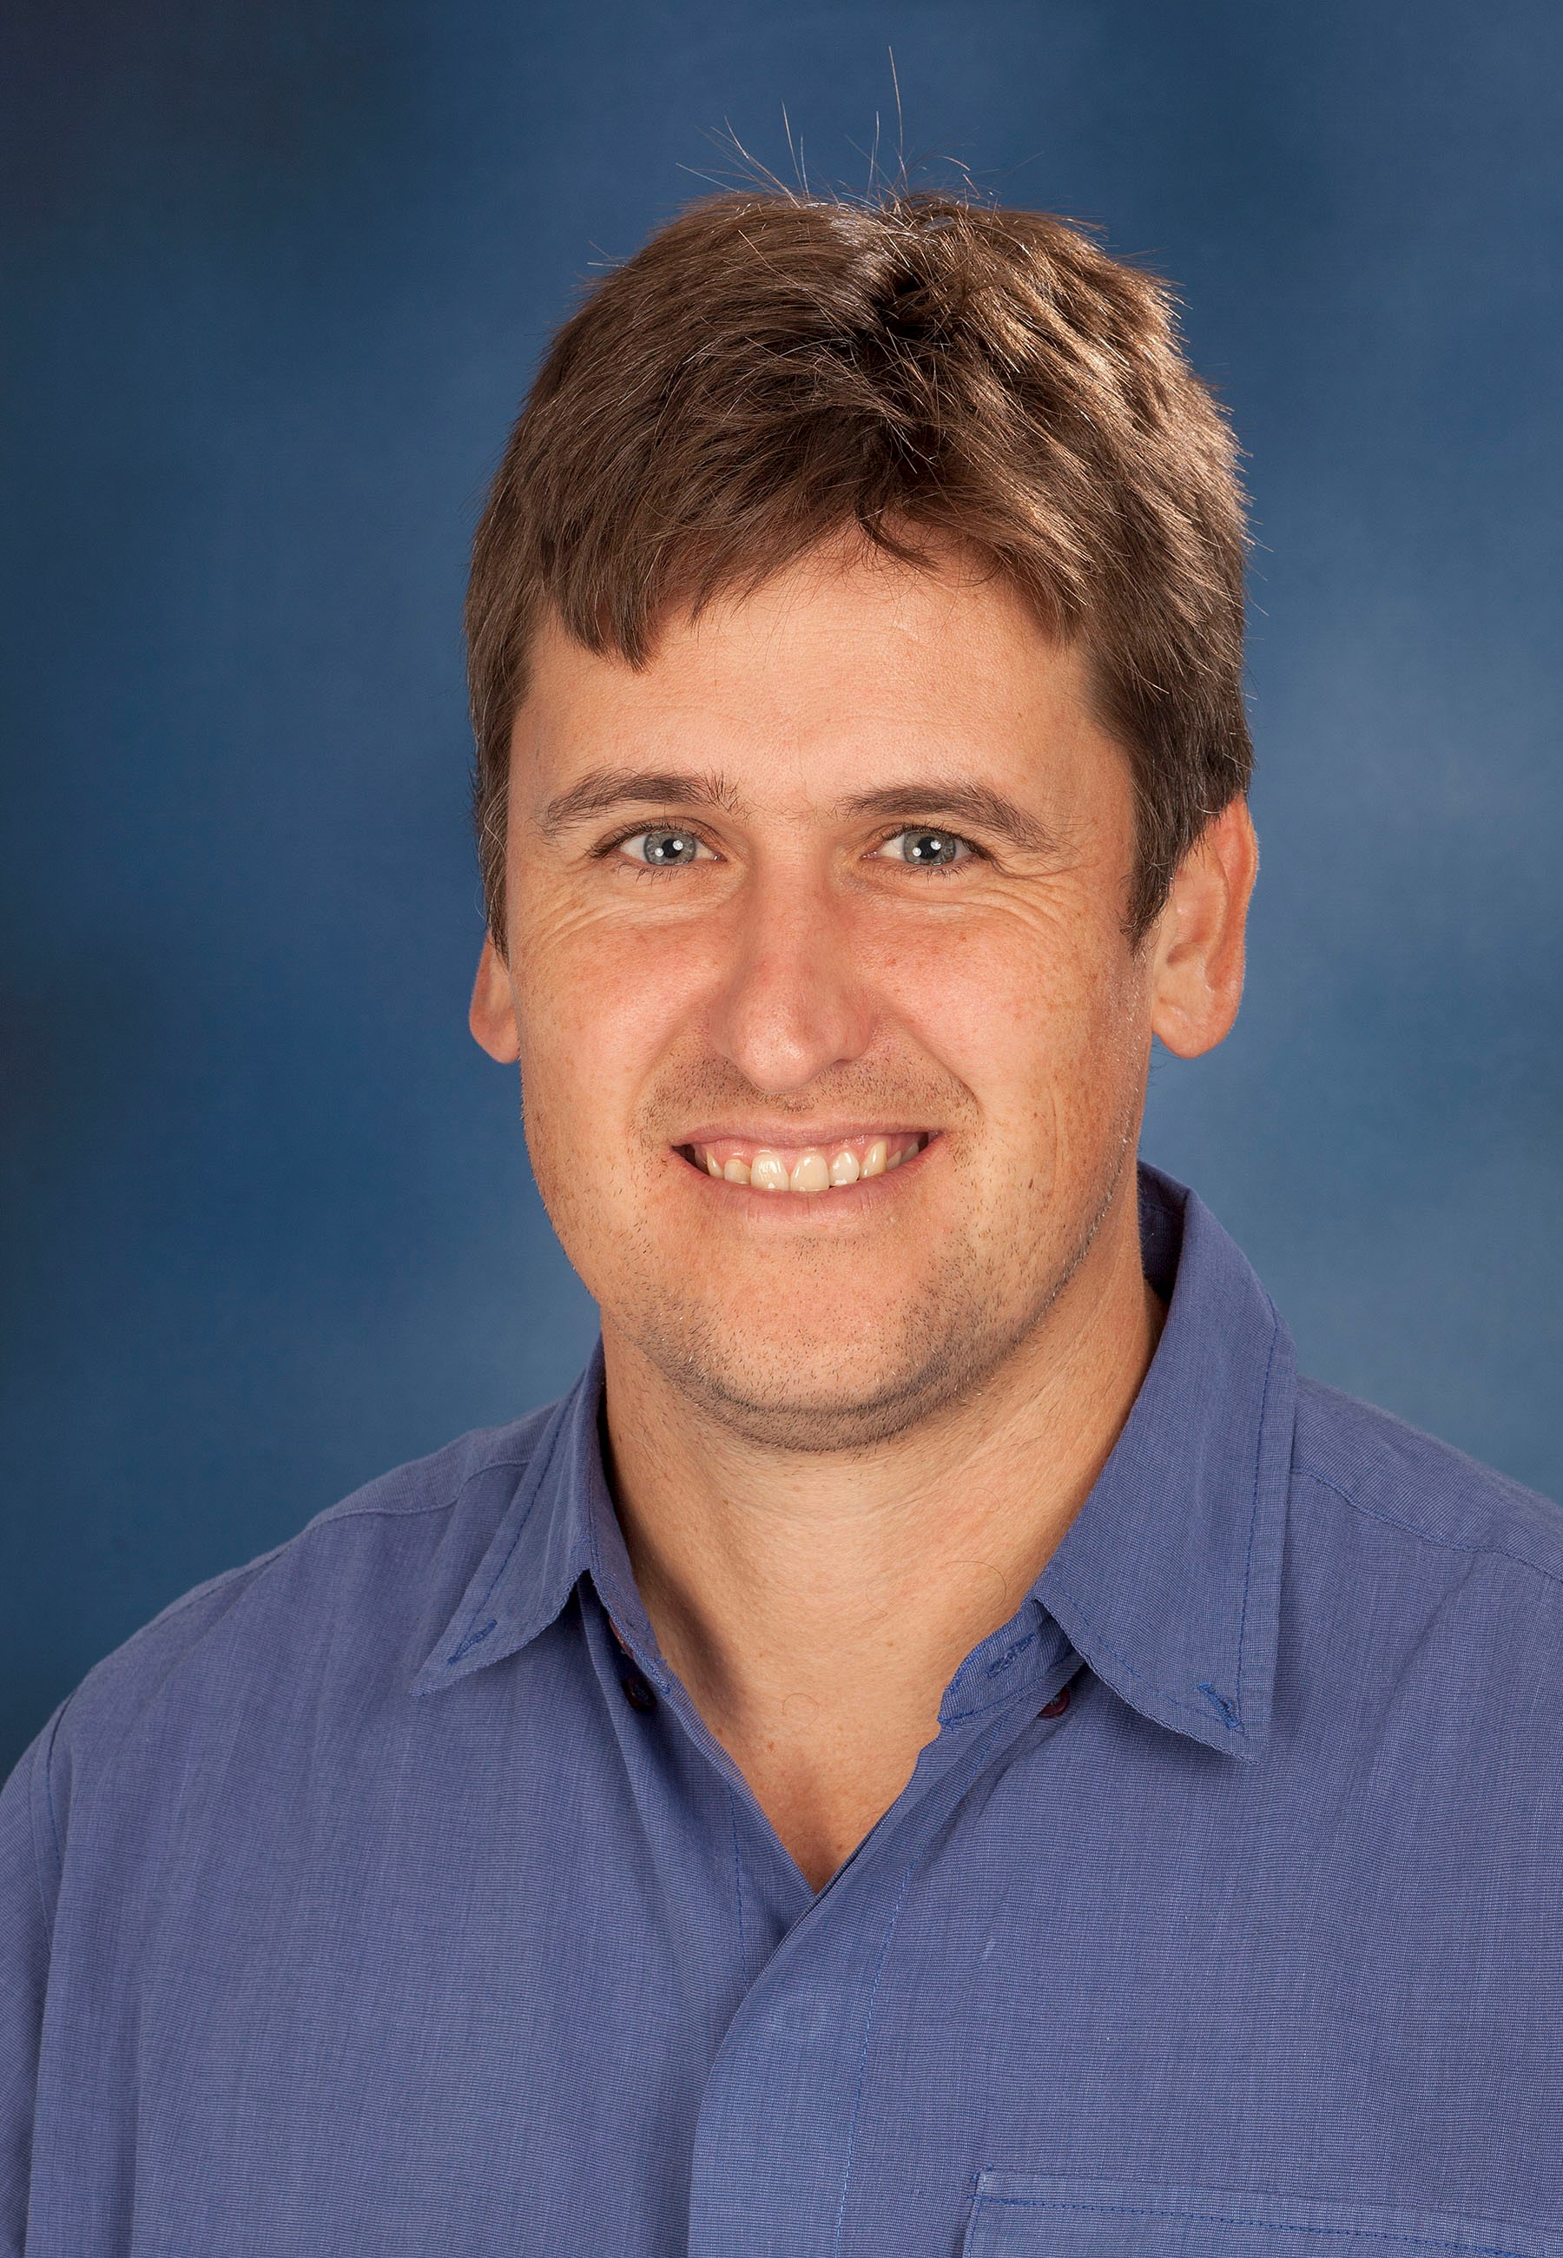
Dr. Charlie Boucher
BVSc, BVSc(Hons), MMedVet(Surg)
Lecturer: Small Animal Surgery
ORCID ID: 0000-0002-0967-1754

Summary CV

Dr. Charlie Boucher joined the Department, section of Small Animal Surgery in 2012. He lectures the veterinary nurses (theatre practice/general nursing), and the undergraduate veterinary students in their third (general surgery), fourth (neurosurgery) and final year (clinical surgery) of study. Dr. Boucher currently has four publications in peer-reviewed journals. He is the head of the Section of Small Animal Surgery in the Department of Companion Animal Clinical Studies.

Research Expertise/Interest

Dr. Boucher enjoys all aspects of small animal surgery but has a particular interest in orthopaedics and neurosurgery. He is currently busy with a research project comparing the antimicrobial efficacy of surgical antiseptics in dogs.

Postgraduate Students

- MSc
  - Dr. John Burgess completed his undergraduate training at the University of Pretoria in 2017. The aim of his project is to determine the effects that air conditioning has on the tear production of patients in the intensive care unit at the Onderstepoort Veterinary Academic Hospital.
- MMedVet
- Dr. Hermien Viljoen who graduated from Onderstepoort in 2014. The aim of her project is to compare the antimicrobial efficacy of three different pre-surgical hand washing protocols used in the Onderstepoort Veterinary Academic Hospital.

