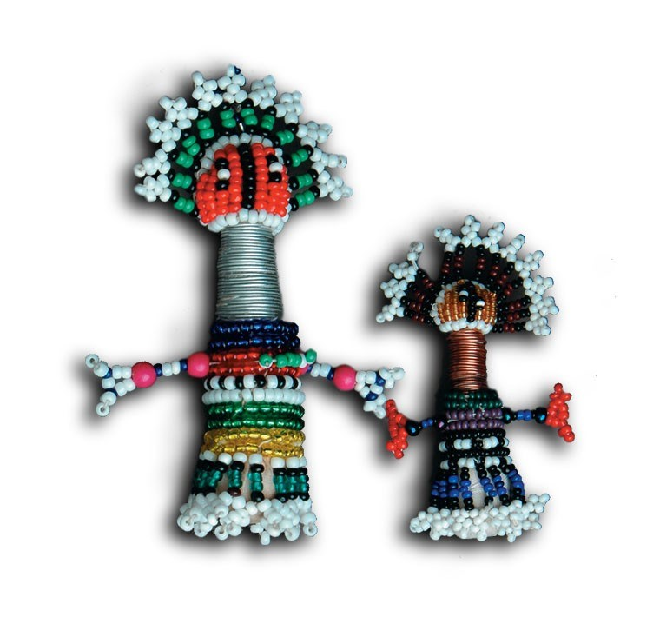
SCHOOL OF HEALTH SYSTEMS AND PUBLIC HEALTH

UNIVERSITY OF PRETORIA
Faculty of Health Sciences

DOM&H Exam Enrolment and Deregistration Form

NAME and SURNAME
STUDENT NUMBER
PROGRAMME REGISTERED FOR
(DOM&H or DOH)

Registration for examination
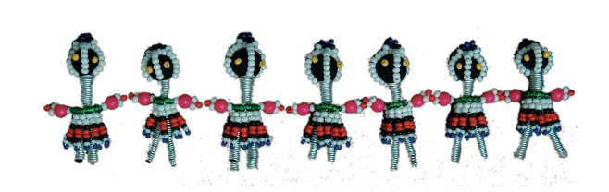
CODE |  | Date | Register (Mark X) | Deregister (Mark X)
PHM 776 (Part 1) * | Diploma in Occupational Medicine & Health Exam (Part 1)
PHM 777 (Part 2) * | Diploma in Occupational Medicine & Health Exam (Part 1)

*Please note that the entry criteria to enrol for the PHM 776 & 777 examination are the successful completion of all modules.

Students must ensure that they meet these criteria before enrolling for these exams.

I hereby confirm that I meet all the requirements for enrolment of the exam/s:

Student Signature: ____________________________ Date: _______________

Contact details in case of cancellation: _________________________________

All registrations must go through the SHSPH Student Administration Office Tel: +27 (0) 12 356 3286. Fax: +27 (0) 86 651 7529 E-mail: reuben.semenya@up.ac.za

Updated 09/11/2020

