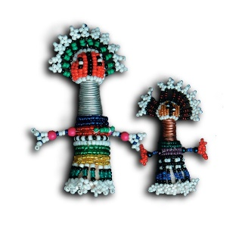

School of Health Systems and Public Health

APPLICATION FOR CPD CERTIFICATE FORM

PLEASE COMPLETE THE FORM:

PROGRAMME:
DATE OF APPLICATION:
FULL NAME:
SURNAME:
STUDENT NUMBER:
HPCSA REGISTRATION NO:
CPD DESCRIPTION:
APPLICATION FOR YEAR ☐
APPLICATION AFTER GRADUATION☐
OR BOTH ☐
EMAIL ADDRESS:
CONTACT NO:
FOR OFFICE USE ONLY:
CPD ACCREDITATION NO:
CPD TYPE:

Please note that you will apply for 30 General CPD points and an additional 30 CPD points upon completion of the programme

Please email the completed form to and/or direct any enquiries to Ms Kgomotso Modingoana (kgomotso.modingoana@up.ac.za).

You will receive a notification via e-mail once the completed forms have been sent to the HPCSA by me.

