

Researchers

**ETHICS APPLICATION & APPROVAL SYSTEM**

**Table of Content**

**1.** **How to Login to the Ethics system** 3

**2.** **How to add a new Application** 4

**3.** **Team members (Internal and External)** 7

**3.1** **External Team member** 7

**4.** **Print / Download the Application** 9

**5.** **Add a comment** 10

**6.** **Upload documents** 11

**7.** **Submit the Ethics Application** 12

**8.** **Find an existing Ethics Application** 14

**9.** **Post Approval Submissions** 15

9.1 Peoplesoft Approved Application 17

9.2 Submit a Post Approval Application 18

**10.** **Functions not available to Students** 19

# **How to Login to the Ethics system**

Login to UP Portal ([www.up.ac.za](http://www.up.ac.za)  / MyTUKS Login)

On the UP Staff Portal, UP Student Portal and UP Guest Portal, find the “Research Grants & Ethics” section.

Click on the Research Grants & Ethics link, see below:

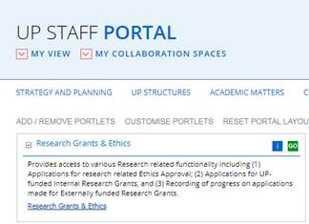

On the Homepage, click on the “Ethics Application & Approval” tile:

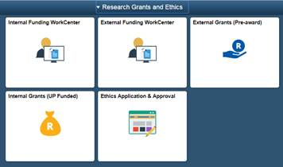

# **How to add a new Application**

Screen with navigation instructions will be displayed

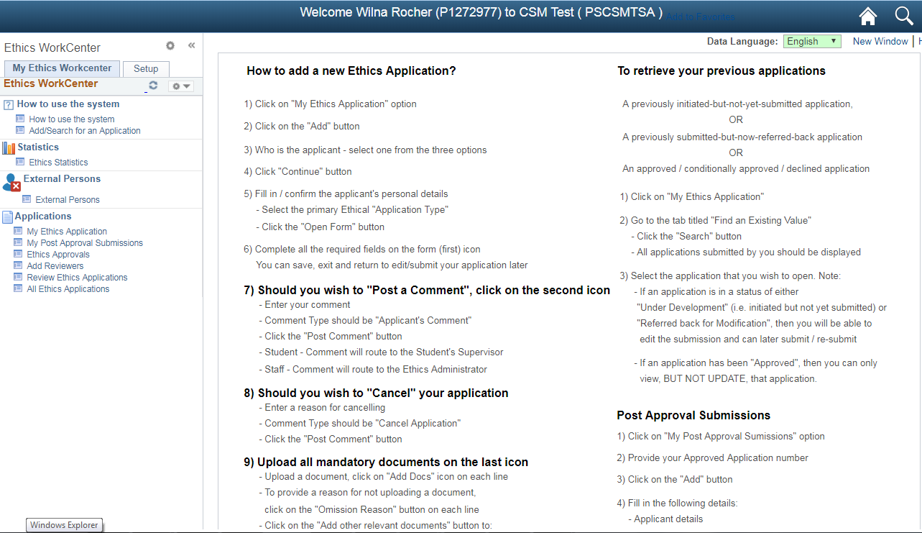

Click on the My Ethics Application link to add a new Application, click on the Add button

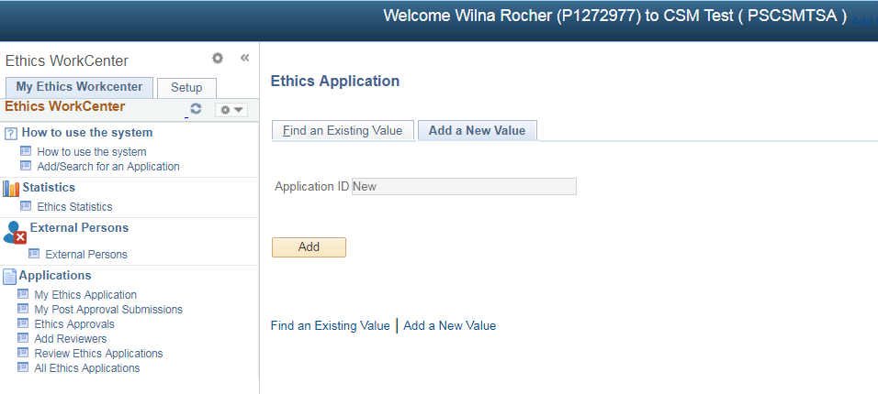

Click on Myself

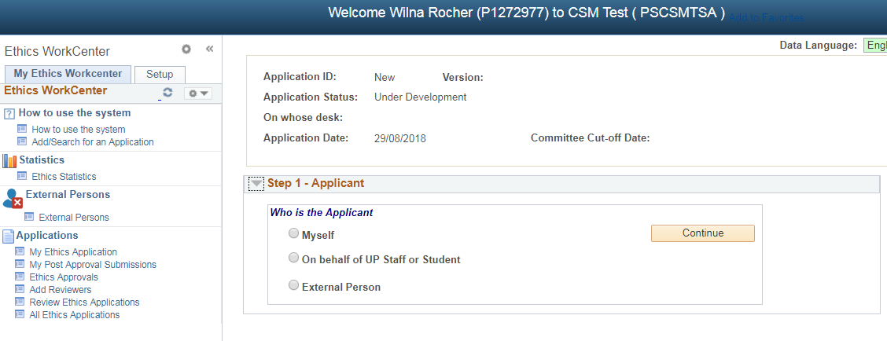

Fill in all the fields en click on Open Form

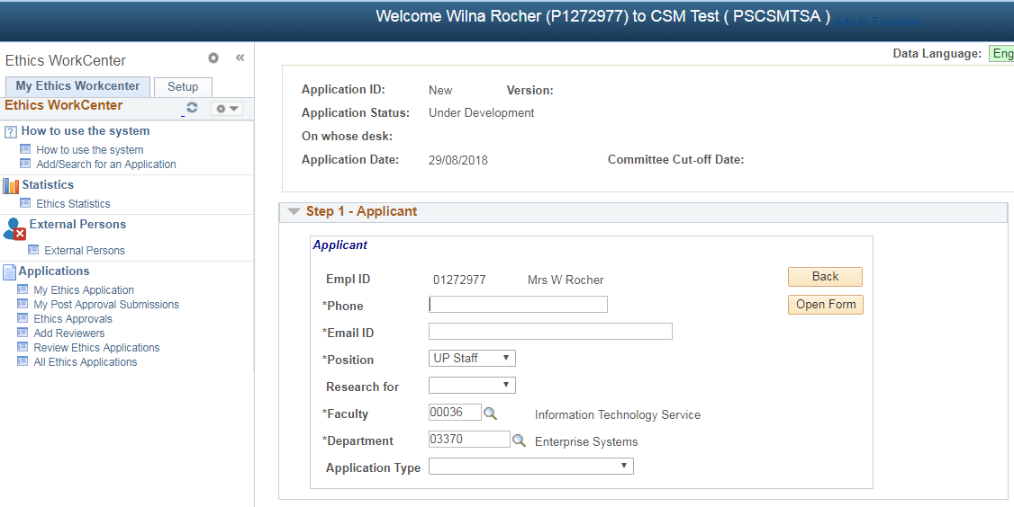

Application Type – Choose the most relevant Type:

Animal Application

Biohazard Chemical

Biohazard Organismal

External/Internal Data

Genetically Modified Organisms

Human Participants

If you want to use more than one type, you can select the other type within the Form.

The questions to look for will be:

Animal Application - Will animals be used for research or testing purposes?

Biohazard Chemical / Organismal - Does the study require the use of hazardous materials?

External/Internal Data - Will secondary data be used in this research?

GMO - Will genetically modified organisms be used in the research?

Human Participants - Will people be recruited as research participants?

An Application Form will open, please fill in all the fields.

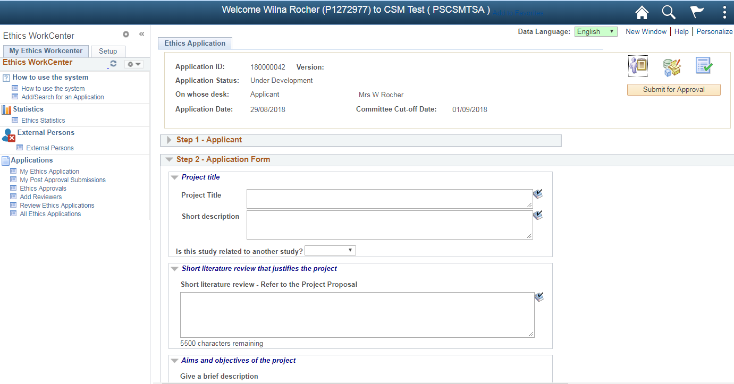

Please click on the “Save” button regularly (at the bottom of the page), to prevent the loss of data.

# **Team members (Internal and External)**

Please add all the team members, by selecting their role and search for them by clicking on the magnifying glass. Internal and External persons (please see below for External Persons).

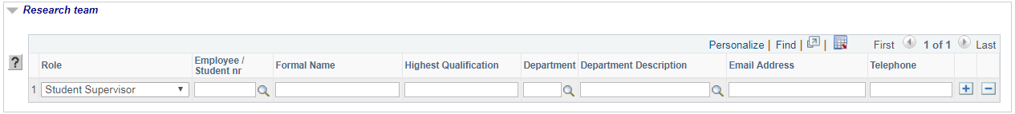

Principal Investigator – usually is the applicant himself/herself.

If you are doing this research for degree purpose – Add your student supervisor.

## **External Team member**

If the person is an **External Person**, not a student or staff from UP, register him/her at the External Person function on the left menu structure

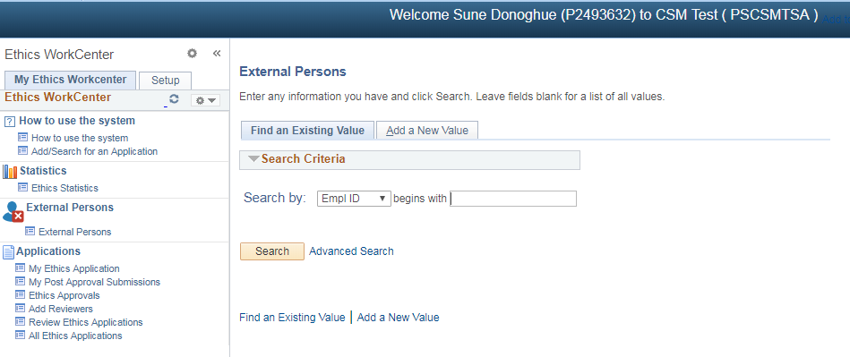

Click on **External Person**

Click the “Add a New Value” tab

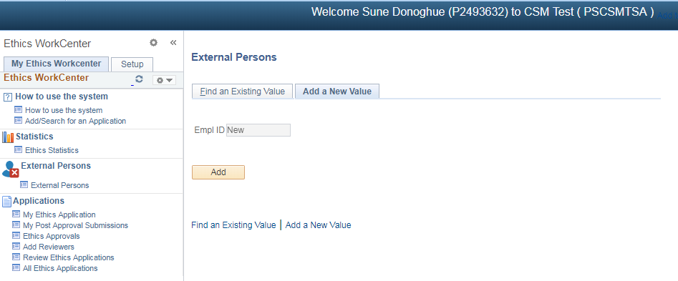

Click on **Add**

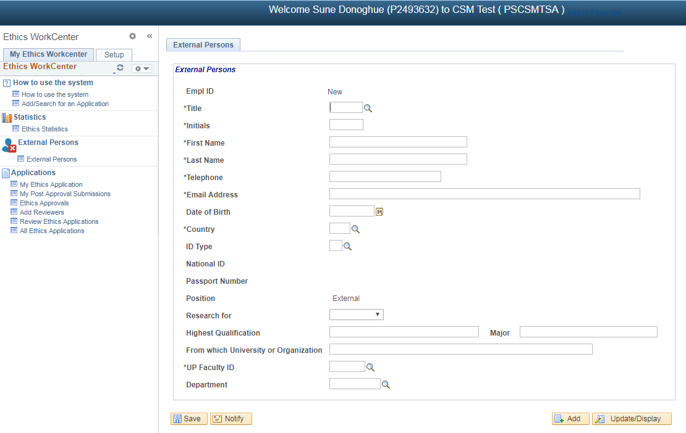

Fill in the fields

Only fields mark with an asterisk (**\*)** is mandatory.

Click on the **Save** button.

The system will generate an ID.

Login to your Ethics Application

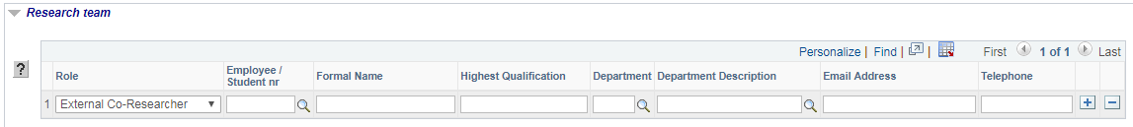

Select his “External” role and select him/her from the list by clicking on the magnifying glass or type in his system generated ID.

# **Print / Download the Application**

To print or download your application form, click on the “Print/Download” button

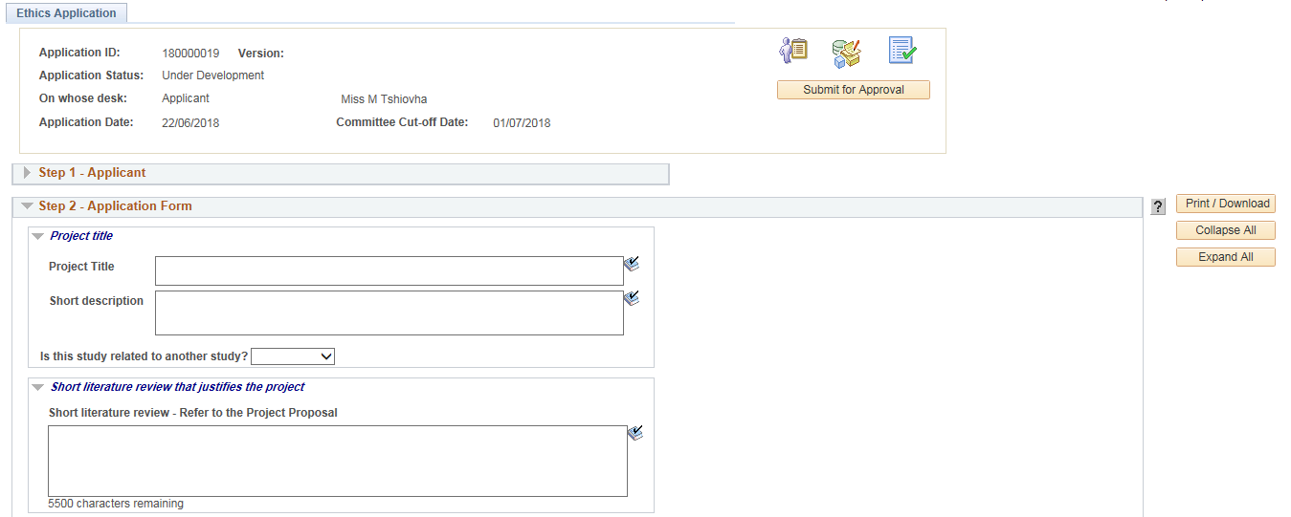

* Please make sure that the Pop-ups is not disabled.

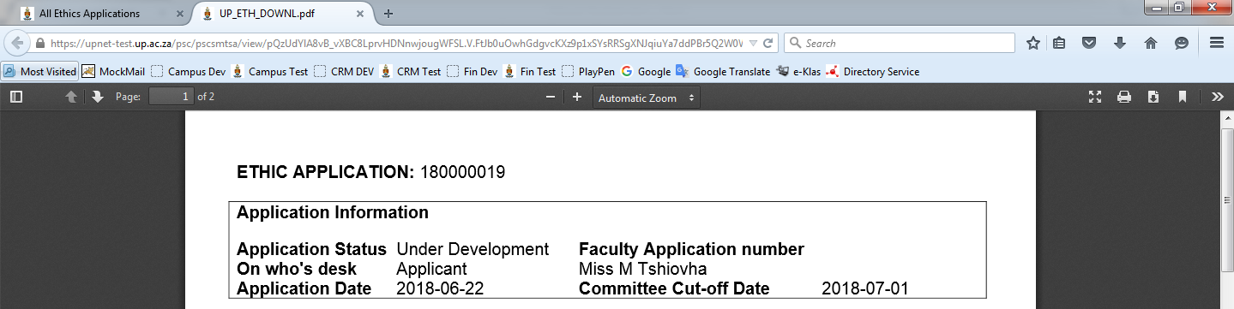

The form will open as a .pdf document.

You may print or download the form by clicking on the desired button.

# **Add a comment**

To add a comment to the Ethics Committee, click on the second tab “Comments and History”.

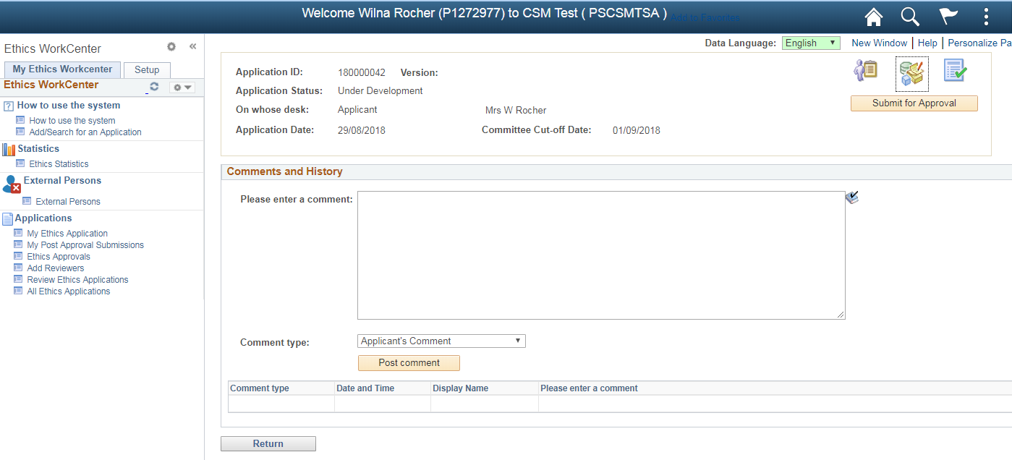

Please enter a comment – type your comment here.

Comment Type – This will be Applicant’s Comment

Click on the Post comment button

# **Upload documents**

Click on the last icon – Required documents

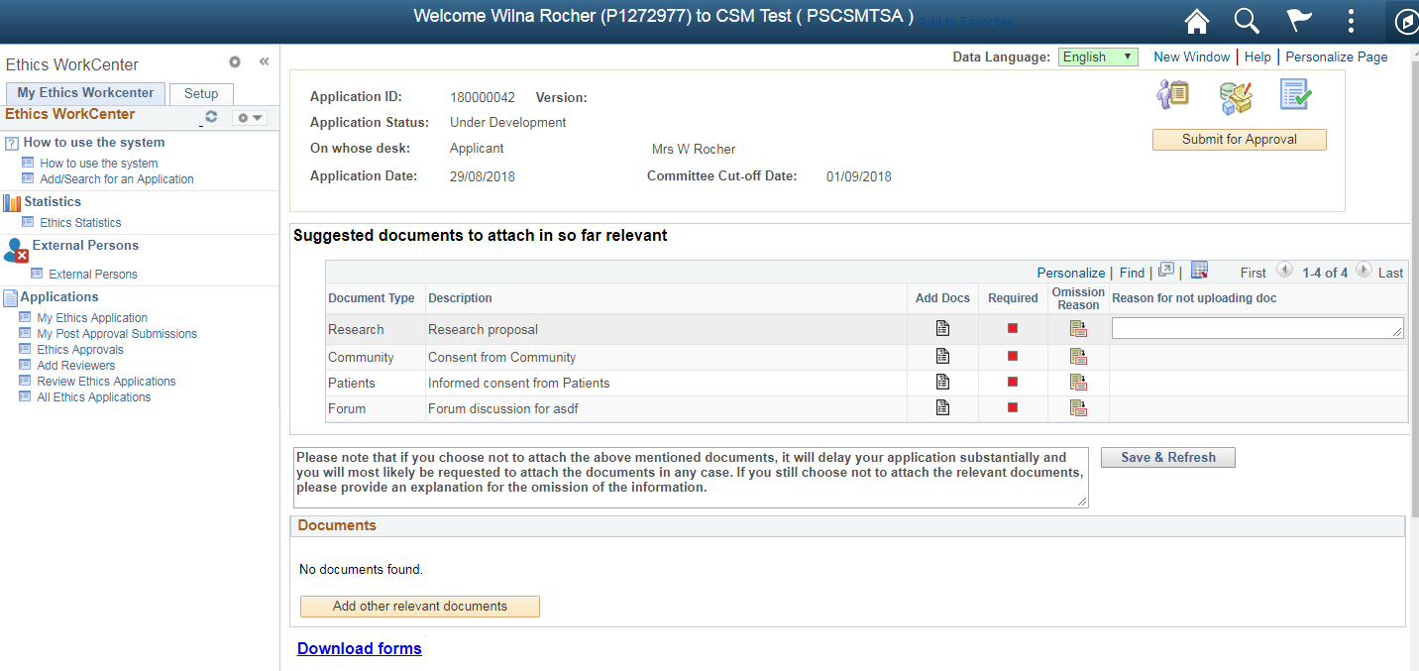

Upload each suggested document by clicking on the Add Docs icon on each line.

If you wish not to upload that document, click on the Omission Reason icon, an area will open where you can type the reason for not uploading that specific document.

The system will prevent you to submit the application, if all suggested documents was not uploaded, or giving an omission reason.

When a document has been uploaded, you can view the document at the bottom of the page

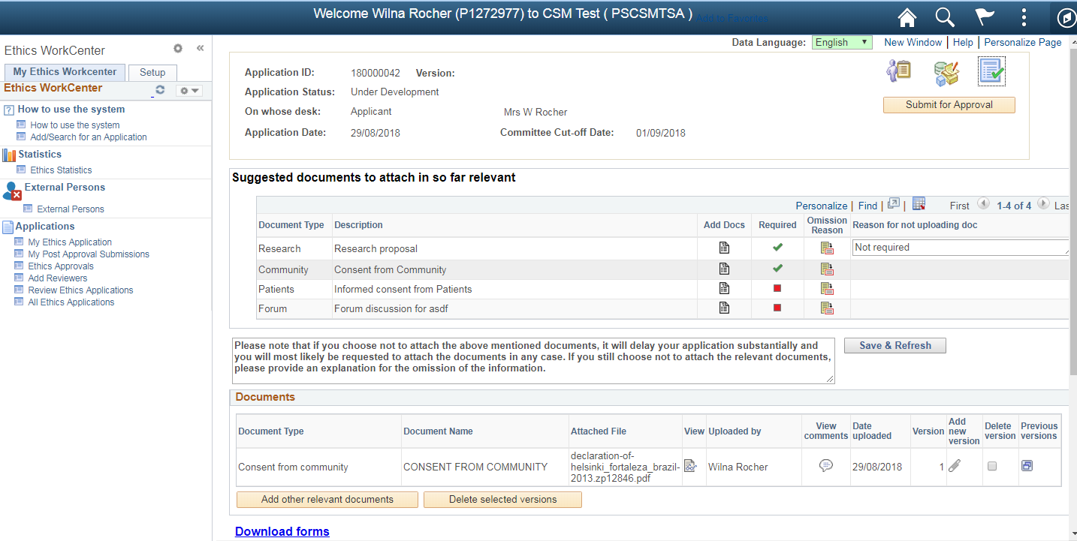

If you want to upload additional documents, not on the suggested list, please click on the “Add other relevant documents” button.

# **Submit the Ethics Application**

All Required fields should have a tick to proceed. If you enter an omission reason, click on the “Save & Refresh” button.

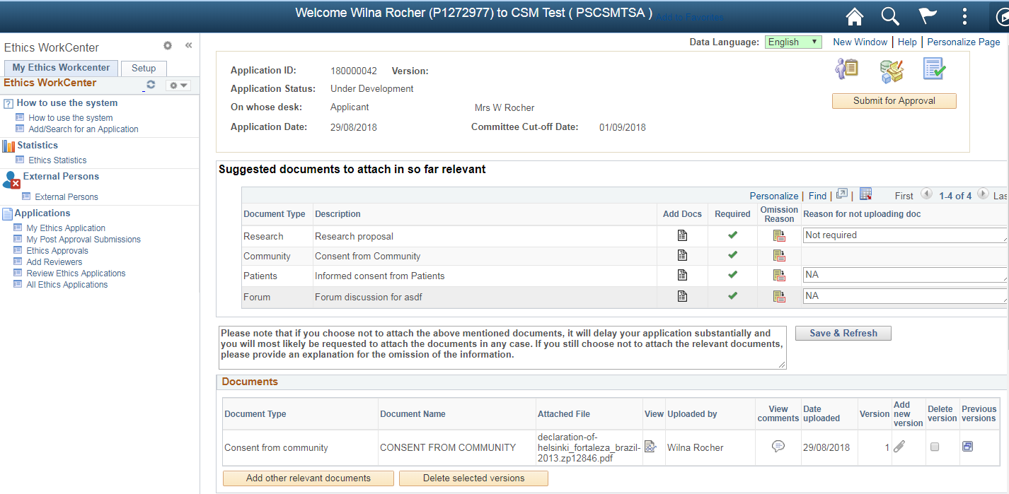

To submit the Application for Approval, click on the “Submit for Approval” button.



You will receive a message that the application has been submitted. At the top of the page you will see that the application is send to the Student Supervisor for approval.

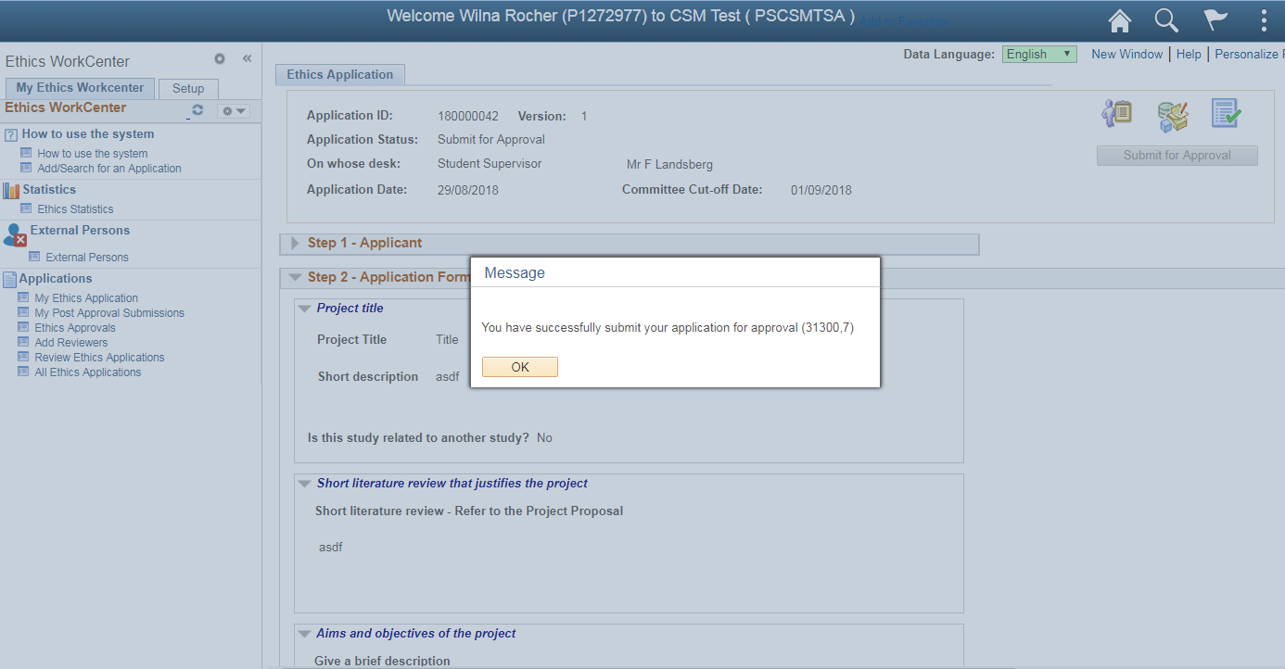

You will not be able to see your application before it has been approved / declined.

# **Find an existing Ethics Application**

You will see Applications that was:

1. Saved, but not yet submitted
2. Referred Back
3. Approved
4. Declined

Click on “My Ethics Application” and click on “Find an Existing Value” tab

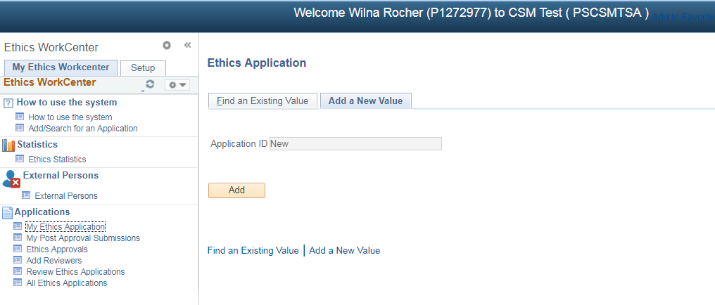

Click on the Search button and click on the Application you want to open.

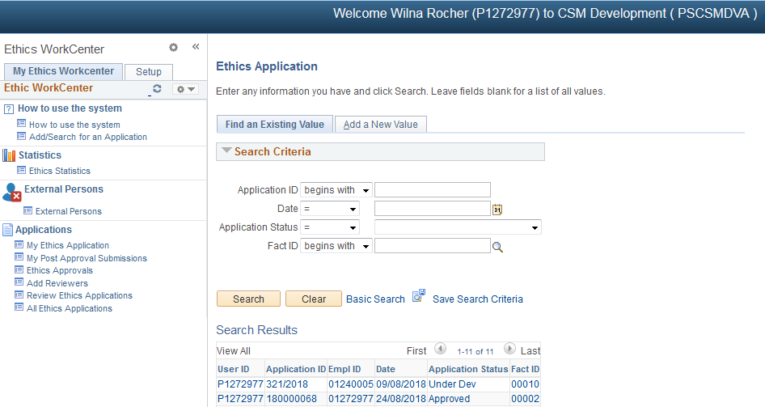

Saved and Referred Back Application – you will be able to modified the application and submit for approval.

Approved / Declined Applications – you will be able to view the application, but not modified it.

# **Post Approval Submissions**

To submit an Amendment, Annual Renewal of your approved application, SUSARS and Linelistings or Serious Adverse Events, click on the “My Post Approval Submissions” function.

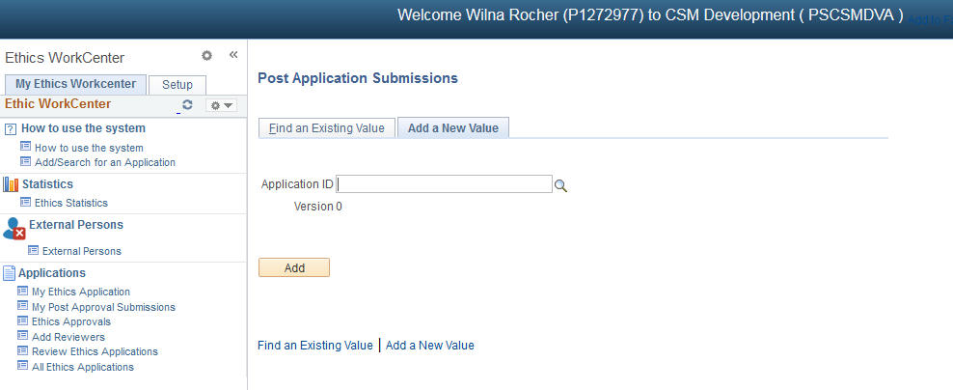

1. Insert an existing approved Application number on the Peoplesoft System, by clicking on the magnifying glass.
2. Insert an existing approved Application number that doesn’t exist on the Peoplesoft system, by typing this number in the field provided. (This can be a RIMS number or a Faculty number not on any online system).

Click on the Add button

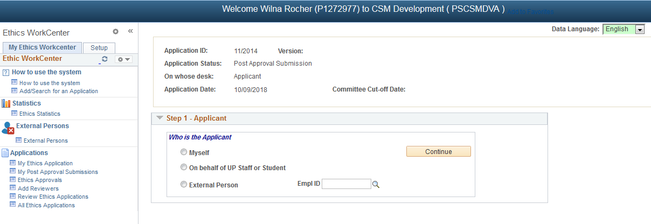

* Click on Myself if you are a UP student or Staff
* If you are an External Person and NOT an UP Student or Staff:

1. Add yourself on the External Persons function
2. Click on External Persons radio button and click on the magnifying glass
3. Click on the Continue button

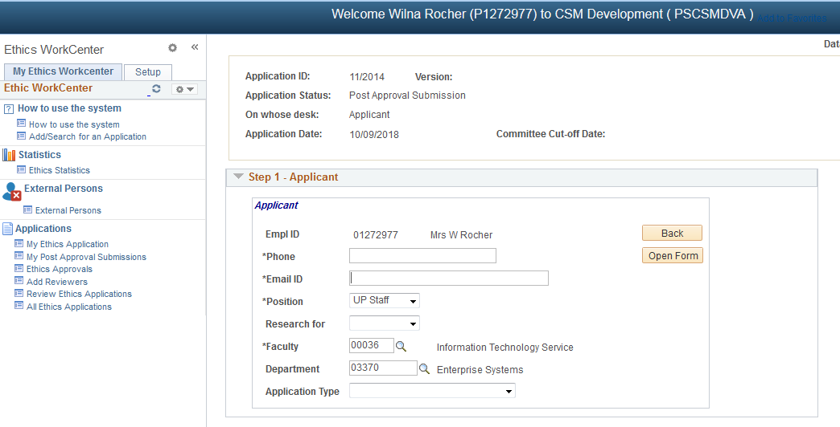

Please fill in the correct and latest information

Click on the Open Form

## Peoplesoft Approved Application

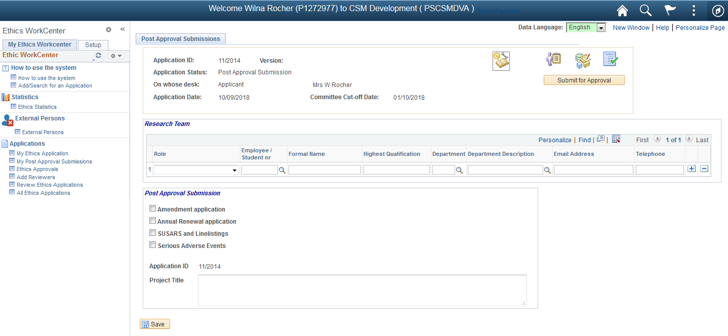

If the Application was approved on the online Peoplesoft system:

* The Team members and Project Title will be populated.
* The Approved Application can be viewed at the 2nd icon, “Application Form”.
* All comments from your Approved Application will be displayed at the 3rd icon, “Comments and History”.
* All uploaded documents is available at the last icon, “Required Documents”.

## Submit a Post Approval Application



* Provide the Principal Investigator (this is usually the Researcher [yourself])
* Provide the Student Supervisor, if this study is for a degree purpose.
* Choose what type of submission you want to do, you can do one or more at the same time:
  + Amendment
  + Annual Renewal
  + Serious Adverse Events
* If the Project Title is not populated, please provide the Title.
* Fill in all the fields on the form.

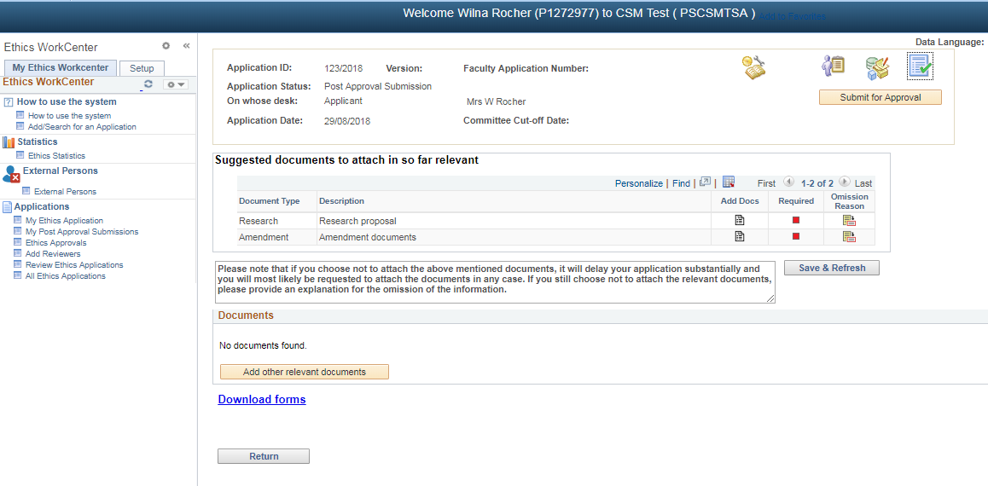

On the last “Required Documents” icon, please upload the suggested documents.

Click on the “Submit for Approval” button

# **Functions not available to Students**

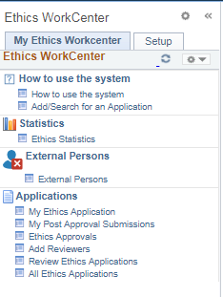

The following functions is not available to students:

Ethics Statistics

Ethics Approvals

Add Reviewers

Review Ethics Applications

All Ethics Applications

How to use the system & Add/Search for an Application – will display the same page.