

Student Supervisor

Head of Department

**ETHICS APPLICATION & APPROVAL SYSTEM**

Post Approval Submissions

Table of Content

1. Approve Post Approval Submission 3

1.1 View submission 3

1.2 View/Add comments 4

1.3 Accept for Submission 5

2. Refer the submission back to the Researcher 6

3. Cancel the submission 7

# Approve Post Approval Submission

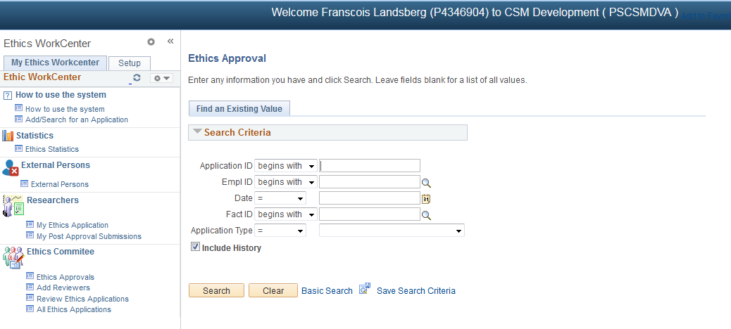

Search for submission:

1. Go to “Ethics Approvals”
2. Click on the “Search” button – this will only display the applications on your desk.

## View submission

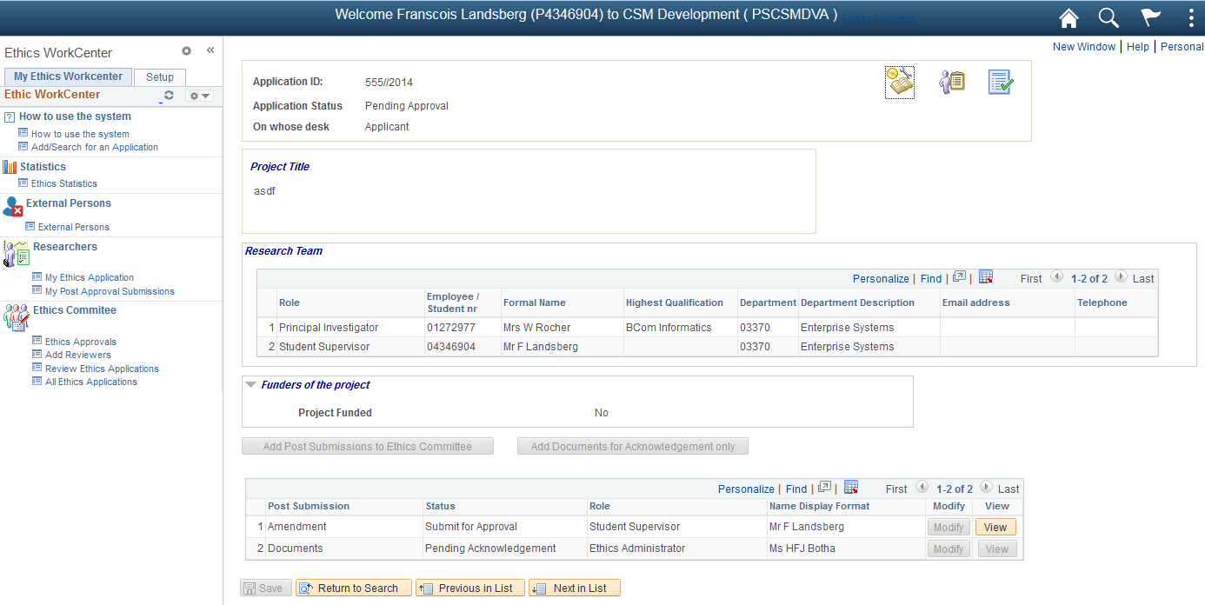

The top navigation (icons) displays the Initial Protocol information:

1. First icon “Post Approval Submission” displays the Title, Research Team and Funders of the Initial Application.
2. Second icon “Application Form” displays the Initial Application Form.
3. Third icon “Required Documents” displays the Initial Application Documents.

The Post Approval Submission will be in a column at the bottom of the page.

You will only have the option to View the submissions on your desk.

* Click on the View button

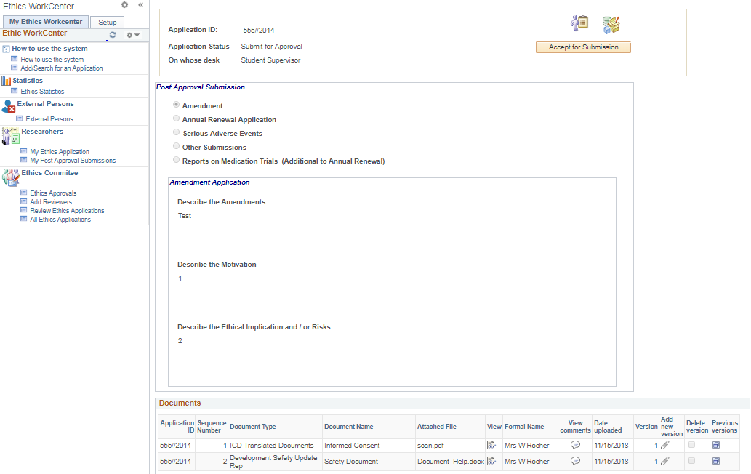

1. View Submission details
2. View documents on the same screen (Popup blocker must allow pop-ups)

## View/Add comments

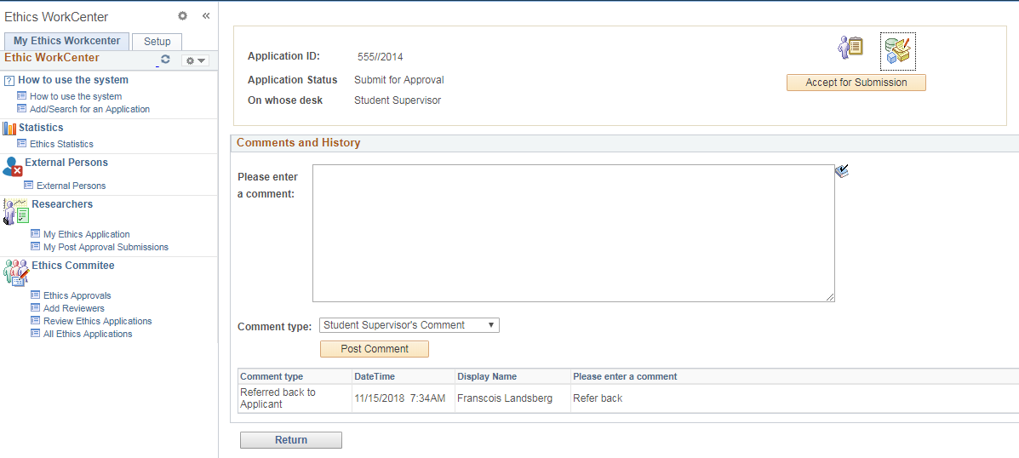

1. Type a comment for the Ethics Committee
2. Comment type: “Student Supervisor’s Comment” or “Head of Department’s Comment”
3. Click on the “Post Comment” button

## Accept for Submission

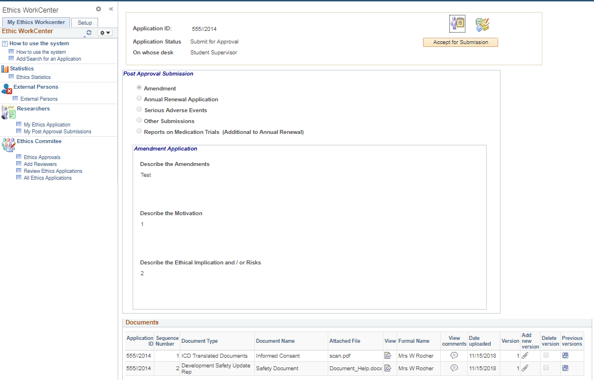

* Click on the “Accept for Submission” button to approve this application.

# Refer the submission back to the Researcher

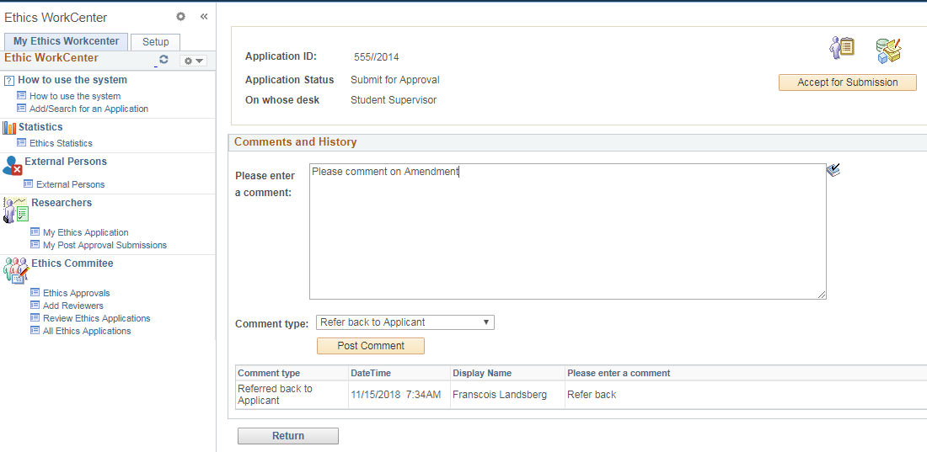

1. Type a comment for the Researcher
2. Comment type: “Refer back to Applicant”
3. Click on the “Post Comment” button

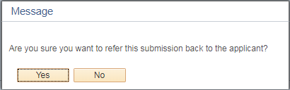

1. Click on the “Yes” button if you want to refer the submission back to the researcher.

The submission will be send back to the researcher for modifications.

# Cancel the submission

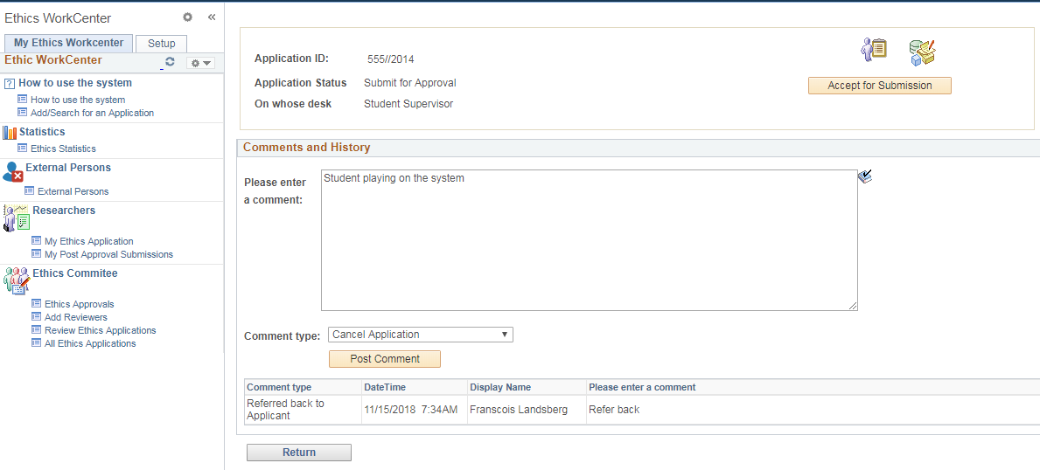

1. Type a cancel reason
2. Comment type: “Cancel Application”
3. Click on the “Post Comment” button

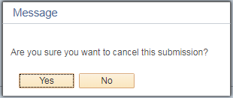

1. Click on the “Yes” button if you want to cancel the submission.

The submission is cancelled.