

Supervisor

HoD

Dept Representative

Coordinator

**ETHICS APPLICATION & APPROVAL SYSTEM**

**Table of Content**

1. How to Login to the Ethics System 3

2. View an application to approve 4

a. View Application Form 5

b. Print / Download the Application Form 6

c. View Comments 6

d. View Documents for this application 7

3. To Refer an Application back to the applicant 8

4. To Add a Comment to the Ethics Committee 9

5. To Approve an Application 9

# How to Login to the Ethics System

Login to UP Portal ([www.up.ac.za](http://www.up.ac.za)  / MyTUKS Login)

On the UP Staff Portal, UP Student Portal and UP Guest Portal, find the “Research Grants & Ethics” section.

Click on the Research Grants & Ethics link, see below:

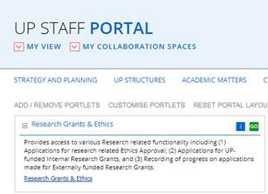

On the Homepage, click on the “Ethics Application & Approval” tile:

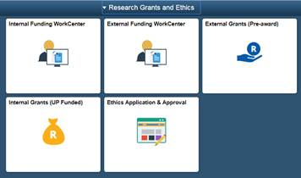

# View an application to approve

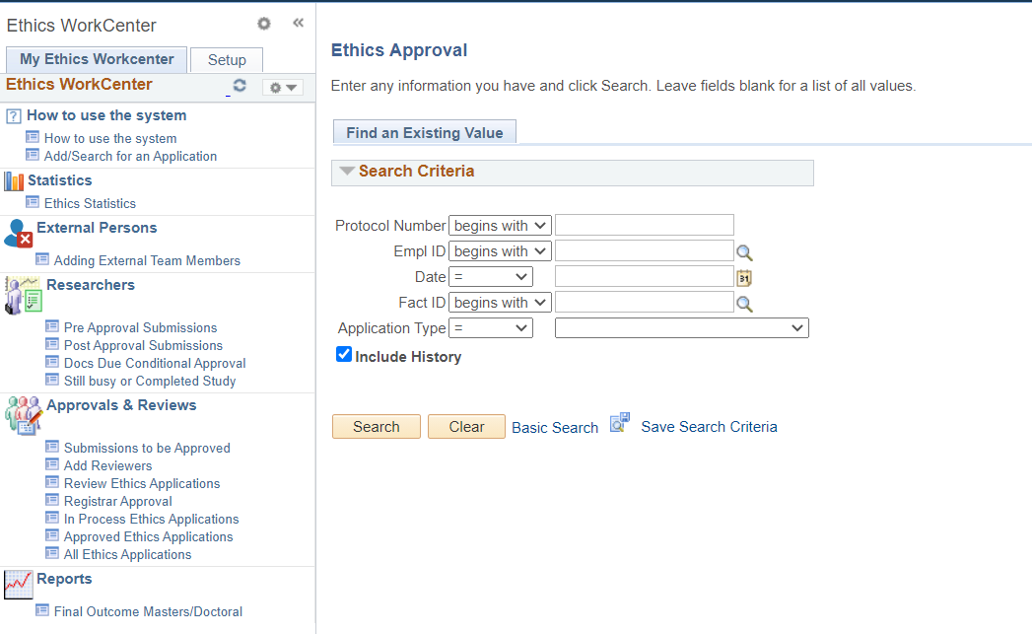

* Click on Submissions to be Approved
* Click on the Search button
* If only one application, it will open the application
* If more than one application, a list of all applications need approval will display.
* Select one by one and approve

## View Application Form

The application form will open, scroll down to view the application

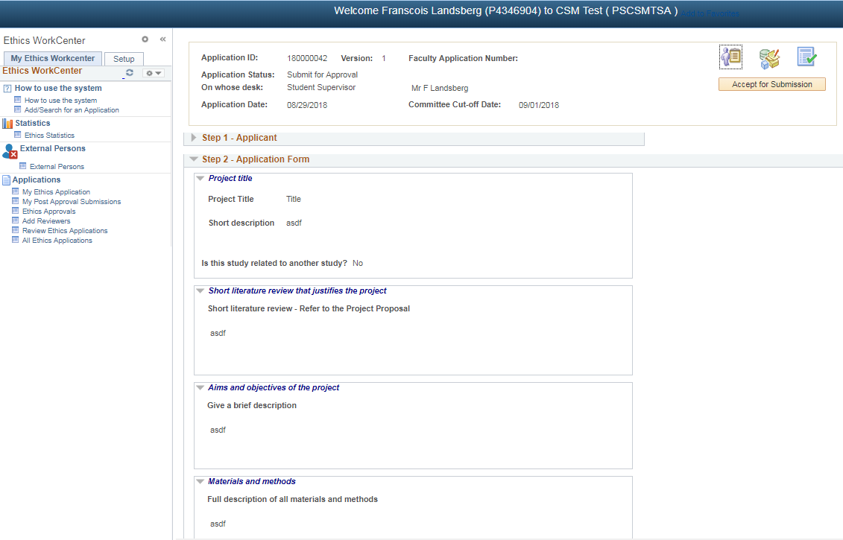

## Print / Download the Application Form

To print or download your application form, click on the “Print/Download” button

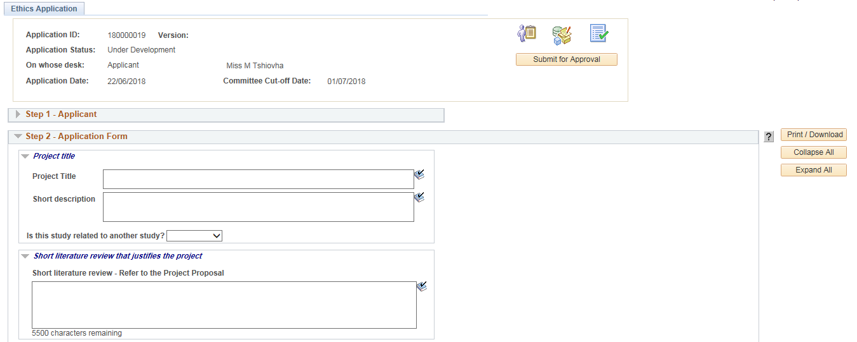

* Please make sure that the Pop-ups are not disabled.

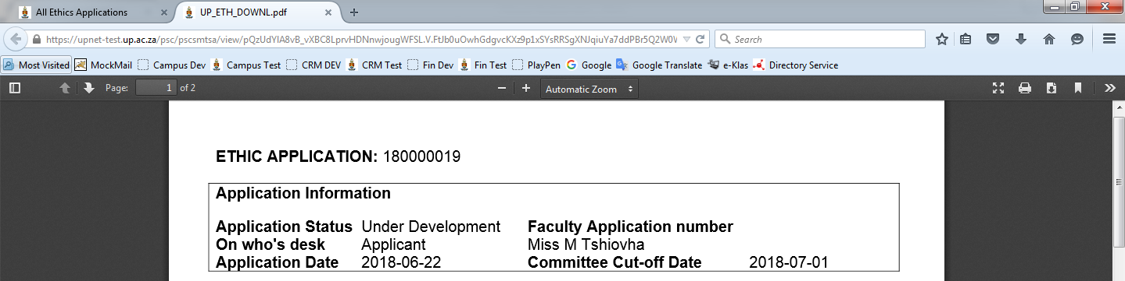

The form will open as a .pdf document.

You may print or download the form by clicking on the desired button.

## View Comments

Click on the 2nd icon to view the Comments and History.

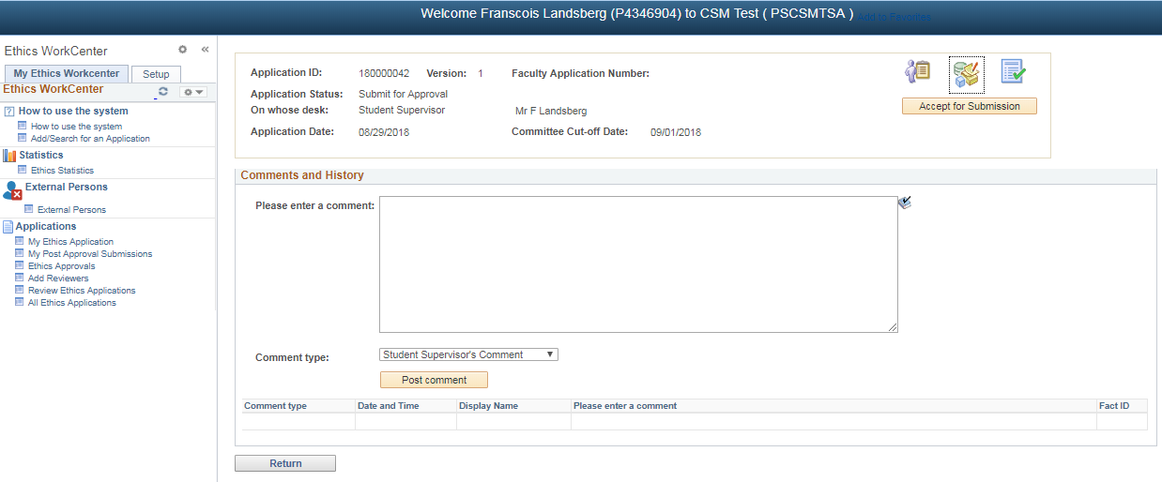

## View Documents for this application

Click on the 3rd icon to view the documents

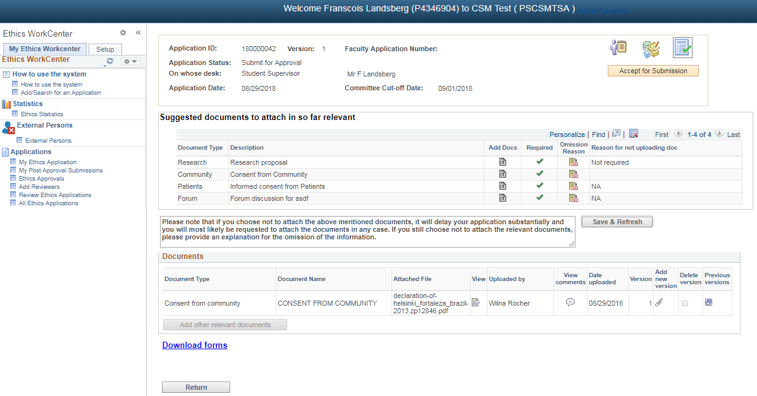

Click on the View icon on the document line to view the specific document

# To Refer an Application back to the applicant

Click on the 2nd icon – Comments and History

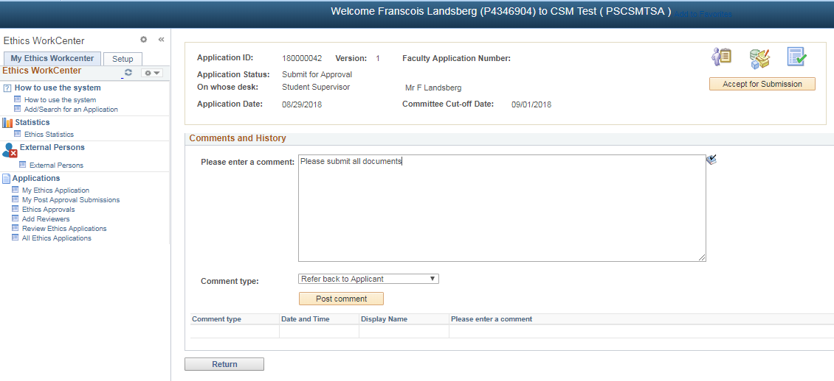

Please make sure that the form was filled in correctly and that all documents was uploaded. If not, please refer the application back to the applicant for modification.

* Type a comment for the applicant
* Comment type should be “**Refer back to Applicant**”
* Click on the **Post comment** button

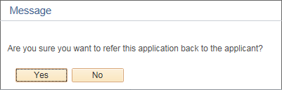

Click “Yes” – an email will be sent to the applicant and the applicant will be able to change the application form. Status will be “Referred back for Modification”.

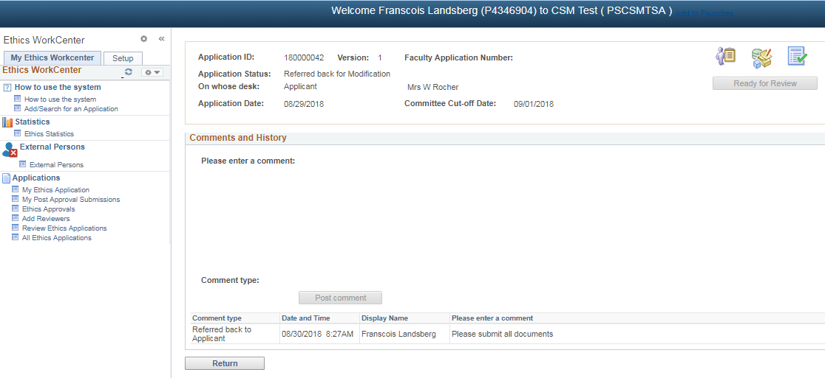

# To Add a Comment to the Ethics Committee

Click on the 2nd icon – Comments and History

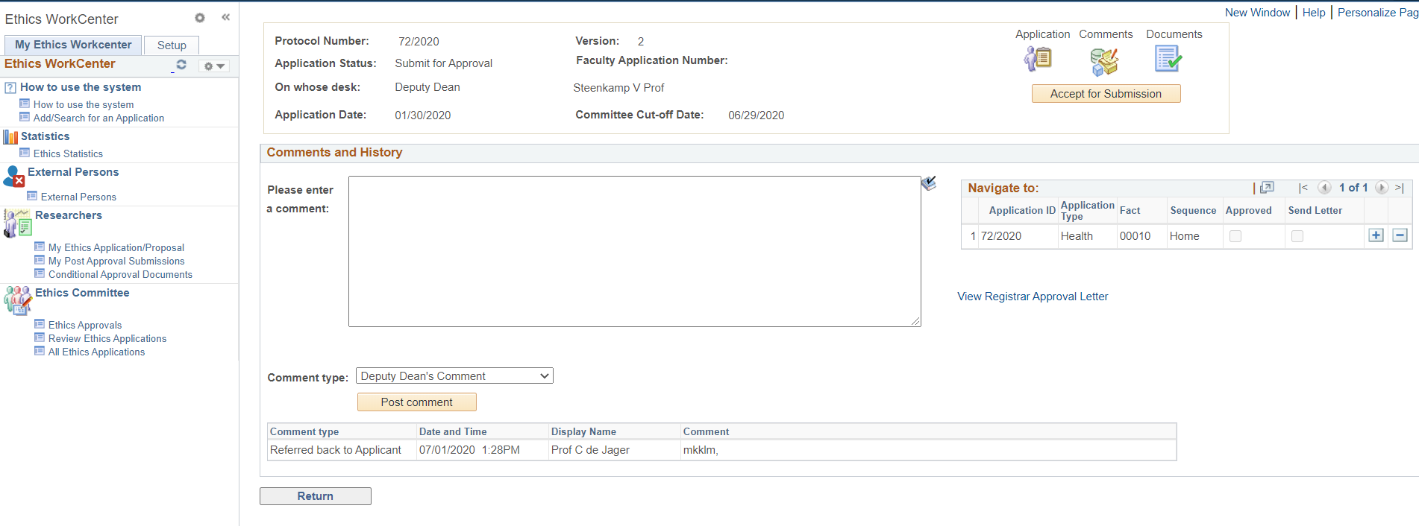

* Type a comment
* Comment type should be one of the following:

“**Supervisor’s comment**”

“**HoD’s comment**”

“**Dept Representative’s comment”**

**“Coordinator’s comment”**

* Click on the **Post comment** button

# To change from Mini-Dissertation to Full Approval Process (only for HoD’s in EBIT)

Click on the 2nd icon Comments and History

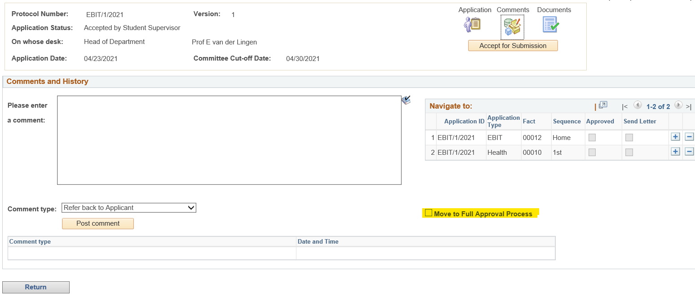

* Click in the “Move to Full Approval Process” checkbox.

# To Approve an Application

Click on the **Accept for Submission** button

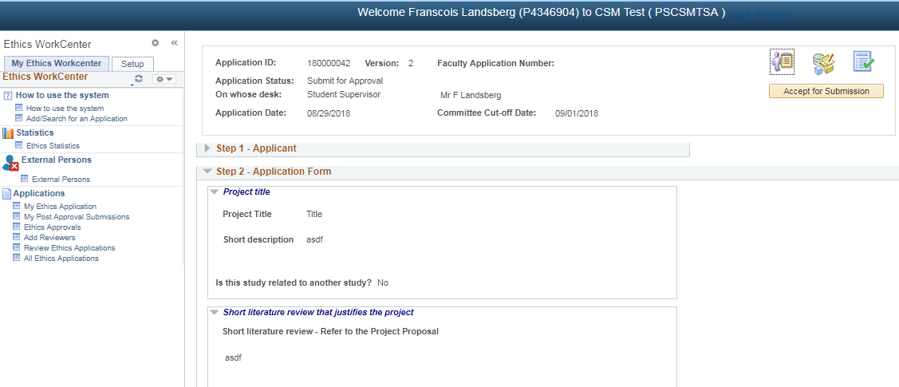

* An email will be sent to the next person for approval
* You approve the Ethics Application.