Faculty of Health Sciences
Department of Surgery
CONTROVERSIES AND PROBLEMS IN SURGERY
28TH SYMPOSIUM
03-04 OCTOBER 2025
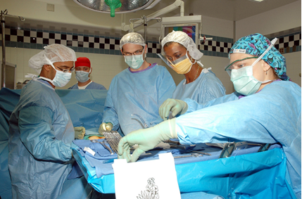

THEME: “COMMON SURGICAL CONDITIONS, WHAT IS NEW?”


MESSAGE FROM THE DEAN

Dean’s Message
It is a great honour and privilege to welcome you to the 28th Annual Controversies and Problems in Surgery Symposium 2025, hosted by the Department of Surgery in the Faculty of Health Sciences at the University of Pretoria. This symposium has grown into a flagship academic event, recognised both nationally and internationally for its scholarly rigour, clinical relevance, and enduring commitment to advancing the surgical sciences.
The very title of this symposium – Controversies and Problems in Surgery – reflects the intellectual honesty and academic courage that have defined its tradition. This gathering provides a unique platform where clinicians, researchers, and educators engage openly with complex and sometimes contentious questions, recognising that it is through debate and dialogue that the profession is able to advance.
This year’s theme, “Common Surgical Conditions, What Is New?”, is particularly fitting. As health systems evolve and new technologies emerge, common surgical conditions remain at the heart of everyday clinical practice. The programme brings together leading experts, respected colleagues, and emerging voices to explore novel approaches, assess new evidence, and reflect on the ethical, clinical, and academic implications of these developments. These discussions are not only essential for refining practice, but also for ensuring that the knowledge we generate translates into tangible improvements in patient care and outcomes.
As a Faculty, we remain deeply committed to nurturing academic excellence, fostering multidisciplinary collaboration, and producing graduates and specialists who are equipped to respond to the changing health landscape of South Africa, the continent, and the world. Symposia such as this one exemplify that mission by providing a space where knowledge is shared, networks are strengthened, and the collective pursuit of solutions is advanced.
I wish to express my sincere appreciation to the organising committee, under the leadership of the Department of Surgery, for their vision and dedication in putting together such a comprehensive and thought-provoking programme. I also extend my gratitude to our distinguished speakers for sharing their expertise, and to all delegates for their participation and commitment to academic and clinical excellence.
It is my hope that this symposium will not only be intellectually enriching, but that it will also inspire innovation, deepen professional connections, and reaffirm our shared responsibility to place patient well-being at the centre of surgical advancement.
With my very best wishes for a successful and rewarding symposium.

Professor Flavia Senkubuge
Dean: Faculty of Health Sciences
University of Pretoria

WELCOME NOTE: CONTROVERSIES 2025 BY PROFESSOR O.D. MONTWEDI

On behalf of the department of Surgery at University of Pretoria, it gives me great pleasure to welcome you to this year’s controversies in Surgery Symposium. This annual gathering has become a cornerstone in the academic calendar, bringing together both training and practicing surgeons from across South Africa to share knowledge, challenge established norms, and advance surgical practice.
This congress is not only a platform for scientific exchange but also an opportunity to strengthen the bonds within our surgical community. The diversity of perspectives represented here ensures robust debate, thoughtful reflection and most importantly, collaborative learning that will ultimately benefit our patients and healthcare system.
We extend our sincere gratitude to our sponsors whose generous support makes it possible to host a congress of this calibre. Your commitment to surgical education and advancement is deeply valued.
We wish to acknowledge the unwavering support of the department of surgery staff members, whose dedication and hard work behind the scenes ensures the smooth running of this event year after year.
To all delegates: thank you for your presence and participation. We encourage you to engage fully in the sessions, share your insights, and take this opportunity to learn from each other.
We look forward to a stimulating and rewarding congress.

PROF MONTWEDI

Thank you to our sponsors and exhibitors



DR S ISMAIL

The role of Breast Conservation Surgery (BCS) in Multifocal (MF) and Multicentric (MC) Breast Cancer

1.Introduction
MF and MC Breast Cancer(BC) has traditionally been considered a contraindication to BCS because of concerns regarding locoregional control and risk of disease recurrence leaving the default surgery i.e. the Mastectomy as being the only option ,however the evidence supporting this practice is limited. Increasingly, many breast surgeons are advocating for BCS for MF and MC in highly selected and individualised cases(1).

1.1Definitions^{(1,2)}
MF BC refers to two or more tumour foci within the same quadrant; MC refers to tumours in different quadrants of the same breast (2).Less commonly, the definition is based on the distance between the tumours, with MF tumours located within a 2-cm radius of each other (in most papers), although some papers define this as up to 5 cm, and when tumours lie beyond these distances the disease is considered to be multicentric.

In many papers, anatomical definitions can overlap, but the overriding question in considering BCS is whether it is technically feasible to safely excise the full extent of the BC while remodelling the breast in a cosmetically acceptable way. The answer is complex and will depend upon accurate interpretation of imaging and biopsies, together with the availability of oncoplastic technical skills(1).

1.2. Historical Perspective & Evolution^{(1-3,10)}
- Historically, MF/MC disease was often considered a contraindication to BCT(BCS +Whole Breast Radiation) due to elevated local recurrence (LR) risk and cosmetic concerns(3).
- Evidence supporting mastectomy predominated, but more recent data indicates that with careful case selection, BCS can be both oncologically safe and cosmetically acceptable (3).
- Early randomised controlled trials with 20 years of follow- up comparing BCT with mastectomy have confirmed non-inferior long-term survival(4). However, studies excluded tumours measuring greater than 3–4 cm, locally advanced, centrally positioned and MF/MC BC. Since these trials concluded, the practice of BCS has evolved, incorporating greater use of oncoplastic techniques. This is facilitated by the increased use of neoadjuvant treatments to downstage the primary tumour, allowing BCS when previously mastectomy would have been necessary. This has resulted in a paradigm shift away from mastectomy towards more conservative, but potentially more technically demanding surgery, with specific oncologically tailored operations allowing BCS for larger tumours(1).
- Oncoplastic techniques are now widely accepted and allow BCS for tumours that have a high tumour to breast size ratio. However, it is important to evaluate the oncological safety of extending these surgical practices to patients with MF/MC breast cancer(1).

1.3 Frequency of MC and MF tumours ^{(1,2,5,17)}
- In the meta-Analysis published by Vera -Badillo et al including 67557 patients, the rate of MCMF tumours was 9.5% (6434 patients). In the EORTC 1098122023 AMAROS trial, MF tumours of the same quadrant were included after 2008 and represented 33% of cases (342/1026)(17).
- However, the prevalence of MC/MF tumours varies from 5% to 44% in a published series depending on the definition used, the method of histological examination of mastectomy specimens and the type of imaging used for diagnosis. A higher incidence may be reported now, due to improved imaging techniques.
- Advances in imaging (e.g., MRI) have increased detection rates of MF/MC disease, though debate continues on whether this should drive more aggressive surgical approaches(1).
- Pathologically, MF BC is the result of a single tumour cell clone spreading within the ductal complex and subsequently developing disease independently at various locations. In contrast, MC BC requires the independent transformation of two separate cell groups, and is therefore less common than multifocality(1).

2. Oncological Outcomes: Recurrence & Survival^{(1,3,6-8)}
2.1 BCT in MF/MC vs Unifocal Disease
- A large study with long-term follow-up (median ~9+ years) found that MF patients treated with BCT had higher 10-year Local recurrence (LR)(6.1% vs 0.6%), Disease Free Survival (DFS)(89.3% vs 97.7%), and Overall Survival (OS) (85.8% vs 98.4%) compared to unifocal BCT patients (6).
- Another meta-analysis (2018) across ~19,000 patients found significantly higher LR in MF/MC treated with BCT vs unifocal (OR ≈2.25), but no significant LR difference between BCT and mastectomy in MF/MC cases (OR ≈1.22, NS) (7).
- Another retrospective cohort (906 patients) found similar 5-year locoregional control rates across MF/MC, and unifocal tumours—99%, 96%, and 98%, respectively (P = 0.44). MF/MC status was not an independent risk factor for recurrence (8).
- The MD Anderson Cancer Centre Group also looked at locoregional control in a separate paper where BCS was performed on 256 of the 673 patients with MF (not MC) cancer and concluded that BCS is a safe option with patients with MF BC(1,3).

2.2 BCT vs Mastectomy in MF/MC^{(1,9)}
- A recent comprehensive systematic review and meta-analysis (May 2024)confirmed that although MF/MC patients undergoing BCT had higher LR than unifocal, there was no statistically significant difference in LR when comparing BCT vs mastectomy in MF/MC patients (OR = 1.72; P = .07) (9)
- Survival outcomes post-BCT were favourable—with estimated 3, 5 and 8-year DFS of 92.4%, 88.3%, and 84.5%, and OS of 98.0%, 95.8%, and 91.8%, respectively (9).

The Following table lists studies comparing BCS Vs Mastectomy for MC /MF BC and a summary of their findings (1).

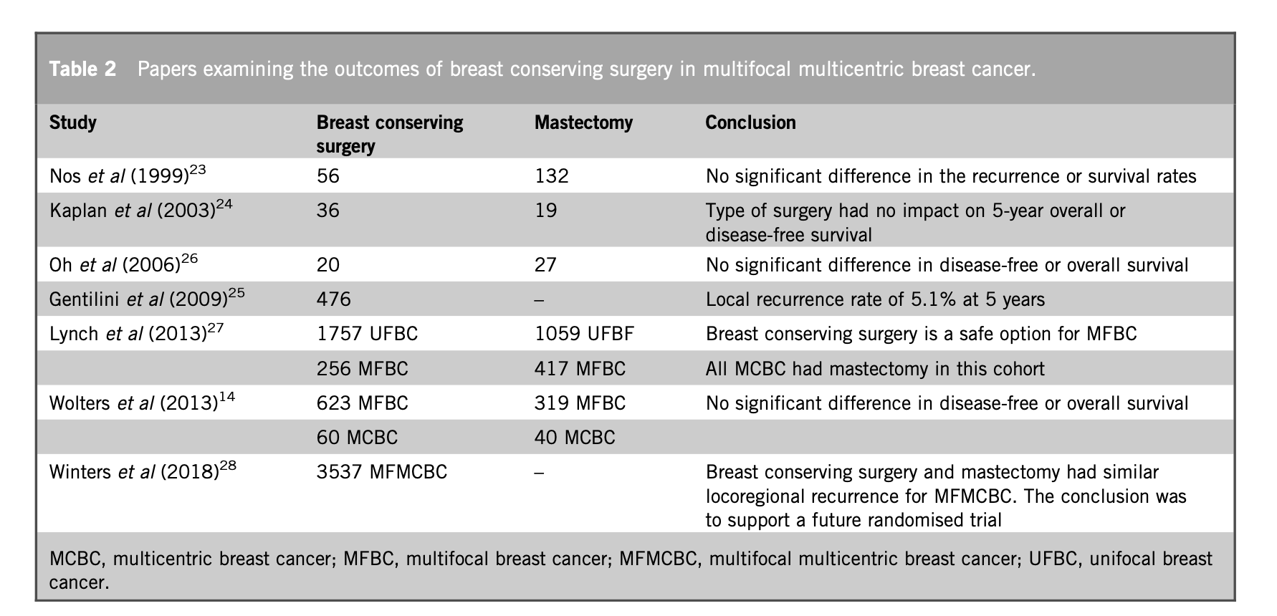

2.3 Survival⁽¹⁾
Multiple Studies show various findings . Table 1 below compares MFMC disease to unifocal disease .The table reflects these studies which are mainly heterogenous with no clear evidence that MF/MC BC impacts worse on overall survival.
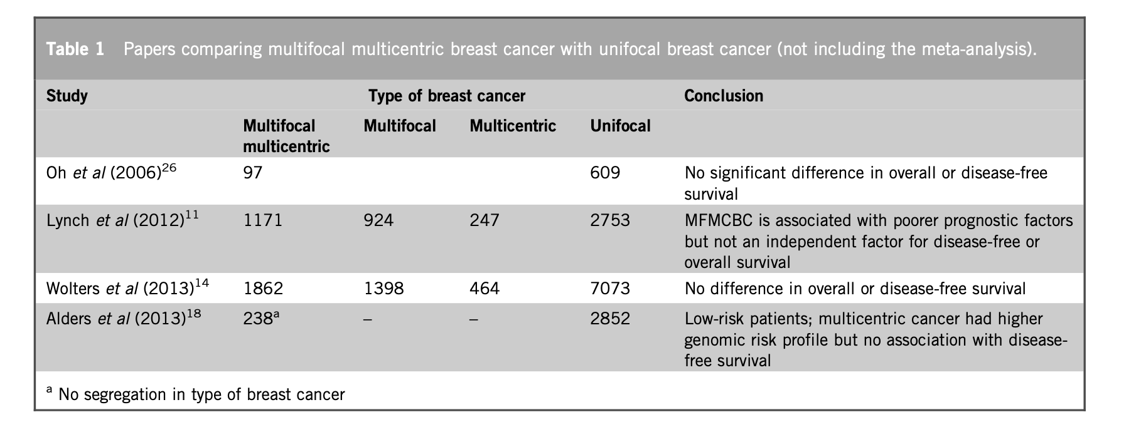
- The BRENDA study assessed survival outcomes in MF (n = 1398) and MC(n = 464) BC compared with unifocal disease (n = 7073) showing no difference in OS and DFS for patients who had BCS and mastectomy.14 Similar results were reported from the MD Anderson Cancer Centre in a cohort of 3924 patients, of whom 924 had MF and 247 MC BC. Here, the presence of MF/MC disease was associated with poor prognostic factors such as advanced disease and locoregional spread, which themselves impact on prognosis and survival. However, MF/MC BC alone were not independent factors for either BC recurrence or survival.

3. Contemporary Evidence from Prospective Trials^{(2,3)}
- The ACOSOG Z11102 (Alliance) prospective single-arm trial evaluated BCT (with radiation and site-specific boosts) in women with multiple ipsilateral breast cancers (MIBC) (typically 2–3 lesions). The 5-year LR was 3.1%, well below the predefined threshold of 8%, demonstrating oncologic efficacy (3).
- Importantly:
  - 67.6% achieved negative margins in one operation.
  - Only 7.1% required conversion to mastectomy due to persistent positive margins.
  - Cosmetic outcomes were rated “good” or “excellent” by 70.6% of patients, with only ~15% undergoing oncoplastic reconstruction (2).
- With the current advances in the diagnosis and management of BC including high quality digital imaging, targeted surgical resection, increasingly elegant pathologic assessment of margins, and continuously improving systemic therapy and radiation therapy, the LR rates in eligible women with MIBC treated with BCT are acceptably low and similar to those seen in unifocal BC supporting the use of BCT in select patients with MIBC. This broadening of indications for BCT greatly benefits this growing population of patients as BCS is associated with better patient satisfaction and potentially improved survival(3).
- At the St Gallen Consensus Conference in 2013, the view evolved: MF/ MC cancers are “relative—but not absolute”—contraindications to BCT(2).At the 15th St Gallen International Breast Cancer Conference 4 years later in 2017, the panel endorsed BCS for MC/MF BCs with the caveats that negative margins need to be obtained, adjuvant radiation needs to be given, and adequate cosmesis is achieved. The Z11102 results discussed above provide prospective evidence to support this consensus guideline.

4. Oncoplastic & “Extreme” Conservation^{(10,11,23)}
- Oncoplastic approaches now allow wider resections while preserving cosmetic integrity, extending the BCT option to more MF/MC cases (10).
- A Glasgow-based series evaluated Extreme Oncoplastic Breast Conservation Surgery (EOBCS) in MF/MC lesions (median tumour size ~55 mm). With 50 patients:
  - 5-year DFS: 91.5%
  - Cancer-specific survival: 95.7%
  - Only 12% required mastectomy after positive margins.
- These approaches are promising but need larger-scale validation(11).

5 Key Clinical Considerations^{(3,6,12,14,15)}
5.1 Patient Selection⁽⁶⁾
- Suitable candidates often but NOT limited to include:
  - Patients aged 50–69, however age is not a contraindication to this type of surgery provided there is no contraindication to adjuvant whole breast radiation and the patient is agreeable to all aspects of their management.
  - Small tumour foci
  - Absence of extensive DCIS
  - Ability to achieve negative margins and acceptable cosmesis via single specimen removal
5.2 Preoperative Assessment & Imaging^{(3,12)}
- MRI aids in detecting additional lesions but may increase mastectomy rates without clear survival benefit; its routine use requires careful discussion (2).
- MRI is not mandatory—but it is strongly recommended in specific scenarios, including MF or MC disease, to better inform surgical planning.
- The highest advantage of using MRI, it’s is high sensitivity which, in 10- 30% of patients, detects new foci of cancer not seen using other imaging tests.
- The impact of breast MRI is still debated due to its false positive rates and due to a large number of benign lesions found.
- If additional suspicious findings are identified, preoperative biopsies must be performed to limit the number of unnecessary wider excisions or mastectomies .
- Tumour localization and marking (especially in neoadjuvant settings) are critical for accurate resection planning (3).
Evidence & Guidelines⁽¹³⁻¹⁵⁾
- Cancer Care Ontario (2023)
- MRI should be considered on a case-by-case basis when additional disease extent information might influence treatment.
- Systematic Review & Meta-Analysis
- MRI uncovers additional foci in ~16% of patients.
- It leads to conversion from wide local excision to mastectomy in ~8.1%, and to more extensive surgery in ~11.3%of MF/MC cases
- Miller et. al (13) studied 81 patients undergoing pre-treatment MRI (25). In 39 patients (48,1%) there were new lesions identified, of these, 21 patients (54%) MF disease was seen, 10 (26%) had MC BC and in 8 patients, contralateral disease was found.
- Leeds (2018) -In women with MF/MC tumours:
- Without MRI: 70% had mastectomy, only 5% had BCS.
- With MRI: mastectomy dropped to 48%, and 30% underwent BCS.
- MRI enabled better correlation with histologic size and facilitated appropriate BCS decisions.

5.3 Surgical approach⁽¹⁾

There are three broad surgical approaches to BCS in MF/MC BC:
- Multiple wide local excisions: Less extensive surgery , Not the preferred option for many surgeons as many would prefer en- block resections to ensure sufficient margin clearances.

- Volume displacement -Larger Breasts; Their flexibility permits a tumour in any quadrant to be excised using a number of therapeutic mammaplasty techniques and various pedicles. Although this allows multifocal tumours to be excised, it is not always easily applicable to multicentric tumours.

- Volume replacement techniques/partial breast reconstruction, was first pioneered by Noguchi using the latissimus dorsi mini-flap. Adoption of this technique was slow but, importantly, it ushered in the development of chest wall perforator flaps. This technique can be based on a choice of perforators from the lateral chest wall or the upper abdomen and has introduced flexibility into the management of disease in patients with smaller breasts. Tumour size becomes less relevant, as the amount of recruited tissue does not depend on breast size. Tumour location may restrict this choice, although parenchymal mobilisation techniques can be incorporated in carefully selected patients. This technique can also be recommended to patients wishing to avoid breast reduction or contralateral surgery.

5.4 Margin Control & Radiotherapy^{(3,5,16,25)}
- Achieving margin-negative resection is paramount. Positive margins significantly increase recurrence risk (5).
- Radiotherapy should include tailored boosts to each lumpectomy site—though double boosts may increase toxicity (e.g., fibrosis)—requiring balance of control and side effects (3).
- Locally in our unit routine Tumour bed boosts is not standard practice , if not indicated for margin control . The fields or protocols do not change simply because the disease is MF/MC.

5.4 Multidisciplinary Decision-Making⁽³⁾
- Treatment decisions must involve radiologists, surgeons, pathologists, radiation oncologists ,clinical oncologists, and patients, weighing oncological safety and cosmetic preferences (3).

6.Future directions

6.1 The Role of Artificial Intelligence(AI) in MF/MC BC
AI technologies like TumorSight Viz and advanced 3D modelling/printing tools are pushing the boundaries of surgical precision in MF/MC BC management. By visualizing complex tumour landscapes and simulating surgical scenarios, they offer a way to plan more effectively and potentially reduce unnecessary tissue removal or mastectomy rates. That said, translation from innovation to practice depends on robust validation, ethical deployment, and clinician trust and resource availability.

6.2 The Role of Genomics in BCS for MF/MC BC⁽²⁴⁾
To date, selection criteria for BCT in patients with MF/MC BC are based primarily on clinico-pathologic characteristics. In the future, patient selection relating to tumour biology and genomics is a reality The use of genomics can inform appropriate intensification and de-escalation of surgical treatment for MF/MC BC as these are unavailable at present. It is conceivable that refinement of selection criteria through integration of genomic capabilities with conventional subtyping will allow individualized surgical therapy in terms of extent and margin status.

Modern medicine has moved into a new era with genomic technology. The use of molecular biomarkers for treatment selection is already a clinical reality in the field of medical oncology. While its influence in surgery has been acknowledged for a significant period of time , apart from BRCA mutations to guide prophylactic surgery, there has not been a breakthrough in its use to the degree where surgical decision making for breast cancer is routinely informed by tumour biomarkers.

The identification of specific genetic mutations at the margins of phenotypically normal tissue may indicate need for wider margins. Alternatively, the relative proportions of cells with or without mutations may indicate adequacy of resection volume. Biomarkers might provide insights into the configuration of the ‘sick lobe’ to guide resection patterns. As a corollary, the absence of biomarkers would indicate the adequacy of less extensive procedures. Personalized risk stratified extent of surgery and margin width is a distinct possibility with the appropriate integration of genomics in clinical practice, for both unifocal and MF/MC BC.

7.Conclusion⁽⁵⁾
With the best evidence currently available indicating that MF/MC BC has a similar prognosis to unifocal cancers, BCS is a valid and acceptable approach in MFMC BC. In particular, there is no evidence that surgical approach affects prognosis, provided that tumours are completely excised. Current evidence points to BCT as being oncologically safe when technically feasible ( with careful planning and patient selection )and provided that acceptable cosmetic results can be achieved. We must individualise patient management . Margin control and accurate localization are paramount—advanced imaging, surgical precision, and pathology co-ordination are essential. The choice of surgery must be discussed in a multidisciplinary team comprising of oncologists , radiologists, surgeons and radiotherapists(5).While some patients may opt for mastectomy over breast conservation, their choice should not be limited by lack of surgical skill and local expertise in oncoplastic breast surgery.

8. References
- Masannat YA, Agrawal A, Maraqa L, Fuller M, Down SK, Tang S, Pang D, Kontos M, Romics L, Heys SD. Multifocal and multicentric breast cancer, is it time to think again? Ann R Coll Surg Engl. 2020 Jan;102(1):62-66. doi: 10.1308/rcsann.2019.0109. Epub 2019 Sep 6. PMID: 31891668; PMCID: PMC6937617.
- Neri A, Marrelli D, Megha T, Bettarini F, Tacchini D, De Franco L, et al. Clinical significance of multifocal and multicentric breast cancers and choice of surgical treatment: a retrospective study on a series of 1158 cases. BMC Surg.2015;15:1-10. doi:10.1186/1471-2482-15-1
- Boughey JC, Rosenkranz KM, Ballman KV, McCall L, Haffty BG, Cuttino LW, Kubicky CD, Le-Petross HT, Giuliano AE, Van Zee KJ, Hunt KK, Hahn OM, Carey LA, Partridge AH. Local Recurrence After Breast-Conserving Therapy in Patients With Multiple Ipsilateral Breast Cancer: Results From ACOSOG Z11102 (Alliance). J Clin Oncol. 2023 Jun 10;41(17):3184-3193. doi: 10.1200/JCO.22.02553. Epub 2023 Mar 28. PMID: 36977292; PMCID: PMC10256355.
- Fisher B, Anderson S, Bryant J, et al. Twenty-year follow-up of a randomized trial comparing total mastectomy, lumpectomy, and lumpectomy plus irradiation for the treatment of invasive breast cancer. N Engl J Med. 2002;347(16):1233-1241. doi:10.1056/NEJMoa022152
- Houvenaeghel G, Tallet A, Jalaguier-Coudray A, Cohen M, Bannier M, Jauffret-Fara C, Lambaudie E. Is breast conservative surgery a reasonable option in multifocal or multicentric tumors? World J Clin Oncol. 2016 Apr 10;7(2):234-42. doi: 10.5306/wjco.v7.i2.234. PMID: 27081646; PMCID: PMC4826969.
- Chung AP, Huynh K, Kidner T, Mirzadehgan P, Sim MS, Giuliano AE. Comparison of outcomes of breast conserving therapy in multifocal and unifocal invasive breast cancer. J Am Coll Surg. 2012 Jul;215(1):137-46; discussion 146-7. doi: 10.1016/j.jamcollsurg.2012.05.006. Epub 2012 May 18. PMID: 22608402.
- Fang M, Zhang X, Zhang H, Wu K, Yu Y, Sheng Y. Local Control of Breast Conservation Therapy versus Mastectomy in Multifocal or Multicentric Breast Cancer: A Systematic Review and Meta-Analysis. Breast Care (Basel). 2019 Aug;14(4):188-193. doi: 10.1159/000499439. Epub 2019 May 7. PMID: 31558892; PMCID: PMC6751443.
- Lynch SP, Lei X, Hsu L, Meric-Bernstam F, Buchholz TA, Zhang H, Hortobágyi GN, Gonzalez-Angulo AM, Valero V. Breast cancer multifocality and multicentricity and locoregional recurrence. Oncologist. 2013;18(11):1167-73. doi: 10.1634/theoncologist.2013-0167. Epub 2013 Oct 17. PMID: 24136008; PMCID: PMC3825299
- Sun Y, Gao L, Zhou X, Wang Z, Li Y, Sun Q. Local Recurrence and Survival Outcomes of Multifocal/Multicentric Breast Cancer After Breast Conserving Therapy: A systematic Review and Meta-Analysis. Clin Breast Cancer. 2025 Apr;25(3):e229-e239.e9. doi: 10.1016/j.clbc.2024.10.009. Epub 2024 Oct 18. PMID: 39542811.
- Patani N, Carpenter R. Oncological and aesthetic considerations of conservational surgery for multifocal/multicentric breast cancer. Breast J. 2010;16(3):222–232. doi:10.1111/j.1524-4741.2010.00917.
- Savioli F, Seth S, Morrow E, Doughty J, Stallard S, Malyon A, Romics L. Extreme Oncoplasty: Breast Conservation in Patients with Large, Multifocal, and Multicentric Breast Cancer. Breast Cancer (Dove Med Press). 2021;13:353–359. doi:10.2147/BCTT.S296242
- Barta M, Hill C, Rahman M, et al. Outcomes of breast-conserving therapy for multifocal and multicentric breast cancer: A systematic review and meta-analysis. Ann Surg Oncol. 2024;31(2):385-395. doi:10.1245/s10434-023-14329-9
- Milulescu A, Di Marino L, Peradze N, Toesca A; -. Management of Multifocal-Multicentric Breast Cancer: Current Perspective. Chirurgia (Bucur). 2017 Jan-Feb;112(1):12-17. doi: 10.21614/chirurgia.112.1.12. PMID: 28266287.
- Killelea BK, Long JB, Chagpar AB, et al. Trends and clinical implications of preoperative breast MRI in Medicare beneficiaries with breast cancer. Breast Cancer Res Treat. 2013;141(1):155-163. doi:10.1007/s10549-013-2676-7
- Houssami N, Turner R, Morrow M. Preoperative magnetic resonance imaging in breast cancer: meta-analysis of surgical outcomes. Ann Surg. 2013;257(2):249-255. doi:10.1097/SLA.0b013e31827a8d17
- Buchholz TA, Somerfield MR, Griggs JJ, et al. Margins for breast-conserving surgery with whole-breast irradiation in stages I and II invasive breast cancer: American Society of Clinical Oncology endorsement of the Society of Surgical Oncology/American Society for Radiation Oncology consensus guideline. J Clin Oncol. 2014;32(14):1502-1506. doi:10.1200/JCO.2013.54.4861
- Vera-Badillo FE, Napoleone M, Ocana A, Templeton AJ, Seruga B, Tannock IF. Effect of multifocality and multicentricity on outcome in early-stage breast cancer: a systematic review and meta-analysis. Cancer Treat Rev. 2014;40(8):934-942. doi:10.1016/j.ctrv.2014.05.009
- Gentilini O, Botteri E, Rotmensz N, et al. Conservative surgery in patients with multifocal/multicentric breast cancer. Breast Cancer Res Treat. 2009;113(3):577-583. doi:10.1007/s10549-008-9951-2
- Van Maaren MC, de Munck L, de Bock GH, et al. 10-year overall survival after breast-conserving surgery plus radiotherapy compared with mastectomy in early breast cancer in the Netherlands: a population-based study. Lancet Oncol. 2016;17(8):1158-1170. doi:10.1016/S1470-2045(16)30067-5
- Yi M, Huo L, Yesaya R, et al. Breast-conserving therapy is associated with improved survival compared with mastectomy for multiple ipsilateral breast cancer. Cancer. 2017;123(12):2195-2202. doi:10.1002/cncr.30652
- Losken A, Dugal CS, Styblo TM, Carlson GW. A meta-analysis comparing breast conservation therapy alone to the oncoplastic technique. Ann Plast Surg. 2014;72(2):145-149. doi:10.1097/SAP.0b013e31825a402f
- Benson JR, Dumitru D. Oncoplastic and reconstructive surgery in the conservative management of breast cancer. Cancer Treat Rev. 2018;69:102-111. doi:10.1016/j.ctrv.2018.07.001
- Crown A, Fendley M, Bellavance E, et al. Extreme oncoplastic surgery for large, multifocal/multicentric, or multicentric disease: a single institution experience. Breast J. 2021;27(8):674-681. doi:10.1111/tbj.14384
- Tan, Mona P.. "Precision surgery for multifocal multicentric breast cancer in the genomic era." Annals of Breast Surgery [Online], 4 (2020): n. pag. Web. 7 Sep. 2025
- Altınok P, Tekçe E, Kızıltan HŞ, Gücin Z, Mayadağlı A. Impact of Radiotherapy Volumes on Late-Term Cosmetic Outcomes and Quality of Life in Patients With Unifocal and Multifocal/Multicentric Breast Cancer After Breast-Conserving Surgery. Eur J Breast Health. 2023 Oct 1;19(4):287-296. doi: 10.4274/ejbh.galenos.2023.2023-5-4. PMID: 37795008; PMCID: PMC10546804.

PROF BS JACKSON

The Optimum management of triple negative breast cancer
Professor Brandon S. Jackson; MBBCh, MMed, PhD; Department of Surgery, Kalafong Provincial Tertiary Hospital, University of Pretoria

Introduction
The prevalence of triple negative breast cancer (TNBC) is 15–20% of all breast cancers. TNBC does not have specific target receptors resulting in limited treatment options. TNBC is more aggressive and the survival rate is lower compared to other breast cancer subtypes. Approximately 35% of patients with TNBC have a BRCA1 mutation, compared to 10% of patients with other breast cancer subtypes.(1) The majority of patients with TNBC present in stage 2 or 3.(2) Recurrence usually occurs within three years after surgery.(3) Mortality typically occurs in the first five years from the diagnosis.
Subtypes of TNBC.
TNBCs resemble basal-like breast cancer (BLBC), however, basal-like breast cancer is defined by a specific gene expression profile, such as the strong expression of certain basal markers like cytokeratins 5, 6, and 17.(4) Up to 80% of TNBC are basal-like breast cancers but not all basal-like breast cancers are TNBC.(5) There are six TNBC subtypes based on gene expression profiles which are basal-like 1 (BL-1), basal-like 2 (BL-2), an immunomodulatory subtype (IM), a mesenchymal subtype (M), a mesenchymal stem-like subtype (MSL), and a luminal androgen receptor subtype (LAR).(6) These different subtypes suggest various phenotypes which may be used as treatment targets.(7)
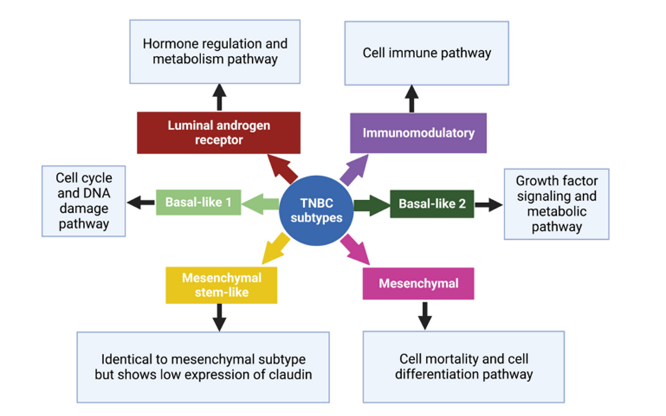
Figure 1. Subtypes of triple negative breast cancer with their characteristic pathways (6)

Treatment
Treatment of TNBC is challenging to the absence of ERs, PRs, and HER2 receptors. Many different therapeutic interventions have been used, including surgery, radiotherapy, hyperthermia, laser therapy and photodynamic therapy. Chemotherapy appears to be the most effective treatment for TNBC. Polychemotherapy is preferred compared to mono-chemotherapy for first-line treatment.(8) Research into the pathological and biological characteristics of TNBC has provided insight into different potential molecular therapeutic targets and therefore targeted therapy treatment option.(1)

Surgery
For early stage breast cancer, breast-conserving therapy in women with TNBC does not appear to have a worse prognosis compared to patients who undergo a mastectomy.(9) When clinically appropriate, breast-conserving surgery followed by radiotherapy should be routinely administered.(10) Both techniques have disadvantages. Modified radical mastectomy can result in decrease in self-esteem, sexuality, attractiveness, and loss of femininity.(11) Breast conserving surgery may result in significant deformations in the body and poor cosmetic results which can occur in almost 2/3 of cases.(12) Prophylactic bilateral mastectomies should be considered for patients with BRCA 1 and 2 mutations as they have a higher risk of ipsilateral recurrence after breast conserving surgery and contralateral breast cancer.
In order to preserve the patients of own tissues in early stages of breast cancer, skin-preserving mastectomy and mastectomy with preservation of the nipple-areolar complex (NAC) are used.(9) Endoscopic or endoscopically-assisted subcutaneous mastectomy has also been proposed, which preserves the skin, nipple areolar complex and the mammary fold.(13) Sentinel lymph node biopsies, without axillary lymph node dissection, are performed for patients with clinically negative lymph nodes.(14) Sentinel lymph node dissection alone for up to two positive sentinel nodes has been shown to be noninferior, in relation to the 10-year overall survival, compared to patients treated with axillary lymph node dissection.(15) Axillary lymph node dissection should be performed in the presence of positive lymph nodes.(16)
The risk of locoregional recurrence is determined by prognostic factors including more than three positive lymph nodes, lymphovascular invasion, age above 40 years and tumour size greater than 2 cm.(17, 18) When radiotherapy was omitted, the five-year risk of locoregional recurrence in the presence of one risk factor was reported at 4.2%, two risk factors at 25.2% and three/ four risk factors at 81%.(18)
Radiation
Radiation therapy is used after surgical excision to damage the DNA of the remaining cancer cells thereby killing those cells. Radiation therapy has been shown to reduce recurrence rates.(19-21) However, rarely it has also been reported that radiation can lead to resistance and relapse in 7–12.6% within 5 years. To prevent this, immunotherapy is commonly used with radiotherapy.(22) Adjuvant radiotherapy has been reported to decrease the frequency of local recurrence and distant metastasis specifically in stage 2 and 3 TNBCs. During a 5-year follow-up the local recurrence was 18.3%, and without radiotherapy at 52.2%. The 5-year follow-up for distant metastases with radiotherapy was 45% and without radiotherapy at 69.1%.(23) The absence of adjuvant radiotherapy is an independent risk factor for recurrence.(24)
Chemotherapy
Chemotherapy containing anthracyclines (e.g., doxorubicin) and taxanes (e.g., paclitaxel) has been the standard of treatment for systemic therapy. Anthracyclines destabilize DNA, whereas taxanes inhibit mitosis, but there are multiple side effects of chemotherapy. The first-line treatment for TNBC is chemotherapy but studies suggest that the decision should be based on tumor size. Stage 2 and 3 TNBCs should have neoadjuvant chemotherapy but stage 1 cancers are variable.(25) Tumors above 1cm should have chemotherapy but less than 1cm may be debatable. Early-stage TNBCs i.e. T1a (tumor sizes ≤0.5cm) or T1b (0.6–1cm) with N0 (no lymph node involvement) generally have a good prognosis without chemotherapy. A retrospective study reported the five-year relapse-free survival (RFS) at 75–88.6% and the five-year distant recurrence-free survival (DRFS) at 95.2% in patients with TNBC that were treated without adjuvant chemotherapy.(26) The findings were similar in a prospective study demonstrating the five-year RFS at 90-98% which were comparable to patients treated with chemotherapy.(27) More prospective data on early stage breast cancer patients with TNBC is required and Gupta et. al. therefore recommends the decision for chemotherapy remains a clinical judgement, especially for T1bN0M0.(28)
Neoadjuvant chemotherapy for TNBC is associated with a higher rate of breast conserving surgery (65%), as compared to adjuvant chemotherapy (49%). Also, neoadjuvant and adjuvant chemotherapy 15-year risk of distant recurrence (38.2% and 38%) and breast cancer mortality (34.2% and 33.7%) were similar.(29) Neoadjuvant chemotherapy has a higher efficacy rate of complete pathomorphological response (23-36%) in TNBC, compared to luminal subtypes, which is associated with decreased recurrence rates.(30, 31) Pathological complete response with neoadjuvant chemotherapy is associated with a 92% 5-year, and 87% 10-year, event-free survival.(32)
In patients where there are detectable residual breast or nodal disease during definitive surgery tend to have a higher risk of recurrence. The residual disease is, however, not a perfect predictor of systemic failure. Liquid biopsy testing for plasma circulating tumor DNA (ctDNA) or circulating tumor cells (CTCs) have been reported to be more significant at predicting recurrence and mortality in TNBC.(33) The application of artificial intelligence (AI) may assist in predicting prognosis and response to therapy.(34) Artificial intelligence models may be able to predict the response to neoadjuvant chemotherapy by examining the prechemotherapy biopsies. The positive predictive value of AI for pathological complete response has been reported at 73.7% and negative predictive value at 76.2% for non-pathological complete response.(35)
Platinum-based chemotherapy
Platinum-based chemotherapy (e.g. cisplatin and carboplatin) has a better response rate in germ-line BRCA1/2 mutations at 54.5% compared to 25.6% in patients with metastatic TNBC.(5) Cisplatin is also preferred for basal-like subtypes of cancer.(36) Platinum-based neoadjuvant chemotherapy has also been shown to have a higher rate of pathological complete response (74% vs 43%) as reported on the GeparSixto trial.(37) This benefit of platinum-based neoadjuvant chemotherapy was especially seen in patients with TIL positive TNBC as shown in the BrighTNess trials.(33, 38)

Immunotherapy
Immune check point inhibitors
TNBCs have been proven to be immunogenic, as evidenced by the presence of stromal and intratumural tumor-infiltrating lymphocytes (TILs). However, cancer cells are able to evade the lymphocytes due to saturation of immune cell signaling. Systemic immunotherapy is therefore a treatment option by using immune checkpoint inhibitors such as Pembrolizumab (since 2020), which inhibits the proteins (checkpoints) from inhibiting the immune cells, thereby allowing the patient’s immune system to eradicate and target neoplastic tissues.(39) The presence of TILs is a prognostic and predictive marker.(1)
The programmed cell death ligand 1 (PD-L1) protein is overexpressed on tumor cells and they bind to T cell receptors programmed cell death proteins 1 (PD-1) which inhibits the functioning of the lymphocytes.(1) By inhibiting the interaction between PD-L1 and PD-1 allows the patient’s immune system to upregulate and kill the abnormal cancer cells. PD-L1 expression should be quantified before the start of first-line treatment. Monoclonal antibodies such as Atezolizumab and avelumab are FDA approved antibodies that targets PD-L1, whereas pembrolizumab targets PD-1.(39) For PD-L1 positive cancers, immune checkpoint inhibitors are typically administered in combination with chemotherapy as shown in the Impassion130, I-SPY 2 and Keynote355 trials.(8)
Antibody-Drug Conjugates
Monoclonal antibodies can act as a drug delivery system by delivering a cytotoxic drug into the cancer cell. Sacituzumab govitecan is an example of a monoclonal antibody (anti-TROP2 antibody) that is combined with chemotherapeutic drug, like irinotecan.(40) The antibody allows internalisation of the complex and thereby allowing delivery the chemotherapeutic agent. The ASCENT trial showed the efficacy of sacituzumab govitecan in TNBC patients who have previously received two or more systemic therapies.(8) Sacituzumab govitecan has received FDA approval since 2021. Another antibody-drug conjugate, Trastuzumab deruxtecan, was also shown to be effective (DESTINY Breast-04 trial) and was approved by the FDA in 2022.(41)
Targeted Therapies
Poly (ADP-ribose) polymerase (PARP) Inhibitors
DNA repair systems are essential for preserving the genome's stability and ensuring its proper structure. The BRCA1/2 genes are essential in homologous recombination repair (HRR) to repair DNA damage and maintain genomic stability. BRCA genes are therefore called tumour suppressor genes. When BRCA1/2 are mutated, cells can grow uncontrollably with tumour formation. PARP inhibitor was approved recently for treating metastatic breast cancer in people with BRCA mutations.(42) PARP inhibitors target HRR defects.(42) Cells with BRCA mutation are sensitive to PARP inhibition due to the synthetic lethality mechanism, resulting in an incapacity for DNA repair.(1) Synthetic lethality is the simultaneous disruption of two or more genes which leads to cell death, while the loss of function of either gene alone does not.(43)
FDA approval has been granted for olaparib (OlympiAD trial)(44) and talazoparib (EMBRACA trial)(45) in BRCA-mutant TNBC in 2018. Unfortunately, the use of PARP inhibitors did not progress for sporadic TNBCs.(41)
Androgen Receptor Antagonists
There are other receptors beside the conventional hormonal receptors. Androgen receptors are expressed in 12-36% in breast cancer patients, including in TNBC patients. Androgen receptors are nuclear hormone receptors that function as transcription factors by binding to specific DNA sequences and regulating the transcription of target genes. Androgen receptors are prognostic and a predictive marker of treatment.(1) Enzalutamide competitively binds to the androgen receptor thereby inhibiting translocation to the nucleus. Enzalutamide is used for treating prostate cancer and is still in clinical trials for treating TNBC.(46)
Epidermal growth factor receptor (EGFR) inhibitors
These receptors are cell surface transmembrane tyrosine kinase receptors. They regulate cell proliferation, differentiation, angiogenesis, invasion and apoptosis. The presence of EGFR is a poor prognostic factor and tends to occur in poorly differentiated large tumours.(47) Direct EGFR blockade by a monoclonal antibody, like cetuximab, inhibits cancer cell growth, proliferation, and survival by preventing ligand binding.(1)
Vascular endothelial growth factors (VEGFs) inhibitors
Tumors stimulate angiogenesis when the VEGF receptors are stimulated. VEGF also stimulates the growth and proliferation of the cancer cells. Higher levels of VEGF in TNBC are associated with poor outcomes. An example of VEGF inhibitor is bevacizumab (monoclonal antibody).(1)
Vaccines
Researchers have been investigating the use of vaccines to treat TNBC. The vaccine will stimulate the patient’s immune system against the neoantigens on the cancer cells. There is currently no approved vaccines available, but there is promising results thus far that have been tested on tumour bearing mice.(48)
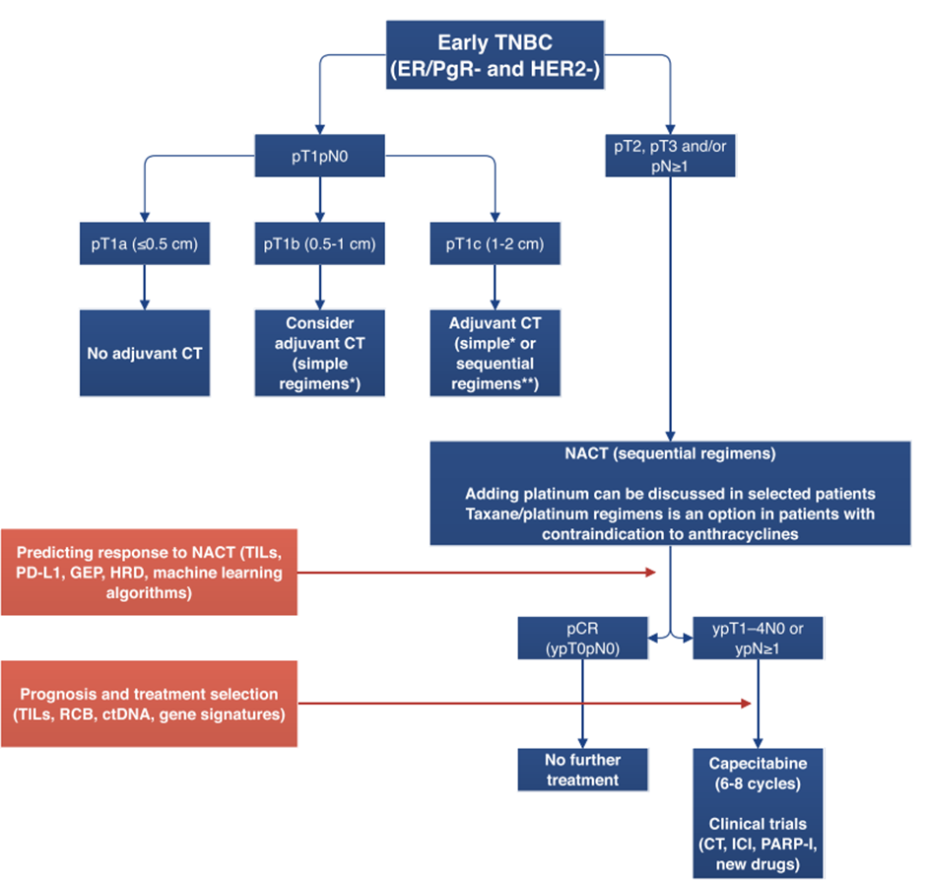
Figure 2. Treatment algorithm for patients with early-stage triple-negative breast cancer(29)
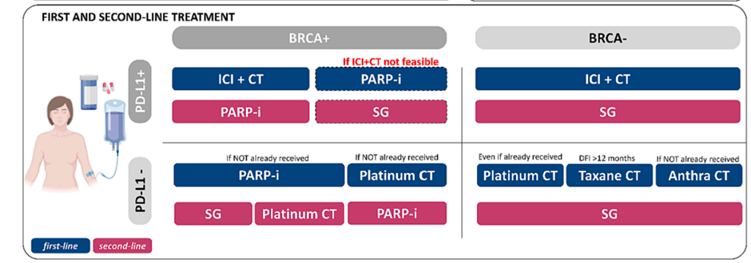
Figure 3. Consensus statements reflecting the Italian Oncology Panel position on diagnostic and staging approach. Abbreviations: PD-L1, programmed death-1 (PD-1) ligand 1; TNBC, triple-negative breast cancer; tx, therapy; DFI, disease-free interval; ICI, immune checkpoint inhibitor; CT, chemotherapy; PARP-I, poly ADP ribose polymerase inhibitor; SG sacituzumab govitecan; mBC, metastatic breast cancer; T-DXd, trastuzumab deruxtecan.(8)

Conclusion
As the understanding of TNBC evolves, different treatments are being discovered. Due to the nature of TNBC, a personalized approach to treatment is crucial to improve patient outcomes, ensuring that patients receive only the necessary therapies. Chemotherapy is still the first line treatment, in most cases, especially in the neoadjuvant setting which has a good response in TNBC. A considerable amount of research has been conducted, and is still ongoing, on targeted therapies which has improved the outcomes of patients with TNBC.

References
1. Obidiro O, Battogtokh G, Akala EO. Triple negative breast cancer treatment options and limitations: future outlook. Pharmaceutics. 2023;15(7):1796.
2. Baranova A, Krasnoselskyi M, Starikov V, Kartashov S, Zhulkevych I, Vlasenko V, et al. Triple-negative breast cancer: current treatment strategies and factors of negative prognosis. J Med Life. 2022;15(2):153-61.
3. Kumar P, Aggarwal R. An overview of triple-negative breast cancer. Archives of gynecology and obstetrics. 2016;293(2):247-69.
4. Alluri P, Newman LA. Basal-like and triple-negative breast cancers: searching for positives among many negatives. Surg Oncol Clin N Am. 2014;23(3):567-77.
5. Collignon J, Lousberg L, Schroeder H, Jerusalem G. Triple-negative breast cancer: treatment challenges and solutions. Breast Cancer (Dove Med Press). 2016;8:93-107.
6. Maqbool M, Bekele F, Fekadu G. Treatment strategies against triple-negative breast cancer: an updated review. Breast Cancer: Targets and Therapy. 2023:15-24.
7. Yin L, Duan J-J, Bian X-W, Yu S-c. Triple-negative breast cancer molecular subtyping and treatment progress. Breast Cancer Research. 2020;22(1):61.
8. Miglietta F, Fabi A, Generali D, Dieci MV, Arpino G, Bianchini G, et al. Optimizing choices and sequences in the diagnostic-therapeutic landscape of advanced triple-negative breast cancer: An Italian consensus paper and critical review. Cancer Treat Rev. 2023;114:102511.
9. Gupta A, Borgen PI. Total skin sparing (nipple sparing) mastectomy: What is the evidence? Surgical Oncology Clinics. 2010;19(3):555-66.
10. Fancellu A, Houssami N, Sanna V, Porcu A, Ninniri C, Marinovich ML. Outcomes after breast-conserving surgery or mastectomy in patients with triple-negative breast cancer: meta-analysis. British Journal of Surgery. 2021;108(7):760-8.
11. Aerts L, Christiaens MR, Enzlin P, Neven P, Amant F. Sexual functioning in women after mastectomy versus breast conserving therapy for early-stage breast cancer: a prospective controlled study. Breast. 2014;23(5):629-36.
12. Urban C, Anselmi KF, Kuroda F, Schwartz J-C. Oncoplasty as the standard of care in breast cancer surgery. Eur Oncol Haematol. 2014;10(1):43-7.
13. Lai H-W, Chen S-T, Chen D-R, Chen S-L, Chang T-W, Kuo S-J, et al. Current trends in and indications for endoscopy-assisted breast surgery for breast cancer: results from a six-year study conducted by the Taiwan Endoscopic Breast Surgery Cooperative Group. PLoS One. 2016;11(3):e0150310.
14. Krag DN, Anderson SJ, Julian TB, Brown AM, Harlow SP, Costantino JP, et al. Sentinel-lymph-node resection compared with conventional axillary-lymph-node dissection in clinically node-negative patients with breast cancer: overall survival findings from the NSABP B-32 randomised phase 3 trial. The Lancet Oncology. 2010;11(10):927-33.
15. Giuliano AE, Ballman KV, McCall L, Beitsch PD, Brennan MB, Kelemen PR, et al. Effect of axillary dissection vs no axillary dissection on 10-year overall survival among women with invasive breast cancer and sentinel node metastasis: the ACOSOG Z0011 (Alliance) randomized clinical trial. Jama. 2017;318(10):918-26.
16. Group EBCTC. Effects of radiotherapy and of differences in the extent of surgery for early breast cancer on local recurrence and 15-year survival: an overview of the randomised trials. The Lancet. 2005;366(9503):2087-106.
17. James M, Dixit A, Robinson B, Frampton C, Davey V. Outcomes for patients with non-metastatic triple-negative breast cancer in New Zealand. Clinical oncology. 2019;31(1):17-24.
18. Chen X, Yu X, Chen J, Zhang Z, Tuan J, Shao Z, et al. Analysis in early stage triple‐negative breast cancer treated with mastectomy without adjuvant radiotherapy: Patterns of failure and prognostic factors. Cancer. 2013;119(13):2366-74.
19. Dragun AE, Pan J, Rai SN, Kruse B, Jain D. Locoregional recurrence in patients with triple-negative breast cancer: preliminary results of a single institution study. American journal of clinical oncology. 2011;34(3):231-7.
20. Abdulkarim BS, Cuartero J, Hanson J, Deschênes J, Lesniak D, Sabri S. Increased risk of locoregional recurrence for women with T1-2N0 triple-negative breast cancer treated with modified radical mastectomy without adjuvant radiation therapy compared with breast-conserving therapy. Journal of Clinical Oncology. 2011;29(21):2852-8.
21. Chen X, Yu X, Chen J, Yang Z, Shao Z, Zhang Z, et al. Radiotherapy Can Improve the Disease‐Free Survival Rate in Triple‐Negative Breast Cancer Patients with T1–T2 Disease and One to Three Positive Lymph Nodes After Mastectomy. The oncologist. 2013;18(2):141-7.
22. Azoury F, Misra S, Barry A, Helou J. Role of radiation therapy in triple negative breast cancer: current state and future directions—a narrative review. Precision Cancer Medicine. 2021;5.
23. Chen X, Xia F, Luo J, Ma J, Yang Z, Zhang L, et al. Postmastectomy radiotherapy reduces locoregional and disease recurrence in patients with stage II–III triple-negative breast cancer treated with neoadjuvant chemotherapy and mastectomy. OncoTargets and therapy. 2018:1973-80.
24. Kümmel A, Kümmel S, Barinoff J, Heitz F, Holtschmidt J, Weikel W, et al. Prognostic factors for local, loco-regional and systemic recurrence in early-stage breast cancer. Geburtshilfe und Frauenheilkunde. 2015;75(07):710-8.
25. Burstein HJ, Curigliano G, Loibl S, Dubsky P, Gnant M, Poortmans P, et al. Estimating the benefits of therapy for early-stage breast cancer: the St. Gallen International Consensus Guidelines for the primary therapy of early breast cancer 2019. Annals of Oncology. 2019;30(10):1541-57.
26. Theriault RL, Litton JK, Mittendorf EA, Chen H, Meric-Bernstam F, Chavez-MacGregor M, et al. Age and Survival Estimates in Patients Who Have Node-Negative T1ab Breast Cancer by Breast Cancer Subtype. Clinical Breast Cancer. 2011;11(5):325-31.
27. Vaz-Luis I, Ottesen RA, Hughes ME, Mamet R, Burstein HJ, Edge SB, et al. Outcomes by Tumor Subtype and Treatment Pattern in Women With Small, Node-Negative Breast Cancer: A Multi-Institutional Study. Journal of Clinical Oncology. 2014;32(20):2142-50.
28. Gupta GK, Collier AL, Lee D, Hoefer RA, Zheleva V, Siewertsz van Reesema LL, et al. Perspectives on Triple-Negative Breast Cancer: Current Treatment Strategies, Unmet Needs, and Potential Targets for Future Therapies. Cancers (Basel). 2020;12(9).
29. Marra A, Curigliano G. Adjuvant and neoadjuvant treatment of triple-negative breast cancer with chemotherapy. The Cancer Journal. 2021;27(1):41-9.
30. Jwa E, Shin KH, Kim JY, Park YH, Jung S-Y, Lee ES, et al. Locoregional Recurrence by Tumor Biology in Breast Cancer Patients after Preoperative Chemotherapy and Breast Conservation Treatment. crt. 2016;48(4):1363-72.
31. Chen VE, Gillespie EF, Zakeri K, Murphy JD, Yashar CM, Lu S, et al. Pathologic response after neoadjuvant chemotherapy predicts locoregional control in patients with triple negative breast cancer. Advances in radiation oncology. 2017;2(2):105-9.
32. Yau C, van der Noordaa M, Wei J, Osdoit M, Reyal F, Hamy A-S, et al. Abstract GS5-01: Residual cancer burden after neoadjuvant therapy and long-term survival outcomes in breast cancer: A multi-center pooled analysis. Cancer Research. 2020;80(4_Supplement):GS5-01-GS5-.
33. Abuhadra N, Stecklein S, Sharma P, Moulder S. Early-stage triple-negative breast cancer: time to optimize personalized strategies. The oncologist. 2022;27(1):30-9.
34. Nagy M, Radakovich N, Nazha A. Machine learning in oncology: what should clinicians know? JCO Clinical Cancer Informatics. 2020;4:799-810.
35. Krishnamurthy S, Jain P, Tripathy D, Basset R, Randhawa R, Muhammad H, et al. Predicting response of triple-negative breast cancer to neoadjuvant chemotherapy using a deep convolutional neural network–based artificial intelligence tool. JCO clinical cancer informatics. 2023;7:e2200181.
36. Lehmann BD, Bauer JA, Chen X, Sanders ME, Chakravarthy AB, Shyr Y, et al. Identification of human triple-negative breast cancer subtypes and preclinical models for selection of targeted therapies. The Journal of clinical investigation. 2011;121(7):2750-67.
37. von Minckwitz G, Schneeweiss A, Loibl S, Salat C, Denkert C, Rezai M, et al. Neoadjuvant carboplatin in patients with triple-negative and HER2-positive early breast cancer (GeparSixto; GBG 66): a randomised phase 2 trial. The Lancet Oncology. 2014;15(7):747-56.
38. Loibl S, O'Shaughnessy J, Untch M, Sikov WM, Rugo HS, McKee MD, et al. Addition of the PARP inhibitor veliparib plus carboplatin or carboplatin alone to standard neoadjuvant chemotherapy in triple-negative breast cancer (BrighTNess): a randomised, phase 3 trial. The Lancet Oncology. 2018;19(4):497-509.
39. Katz H, Alsharedi M. Immunotherapy in triple-negative breast cancer. Medical Oncology. 2017;35(1):13.
40. Bardia A, Mayer IA, Vahdat LT, Tolaney SM, Isakoff SJ, Diamond JR, et al. Sacituzumab Govitecan-hziy in Refractory Metastatic Triple-Negative Breast Cancer. New England Journal of Medicine. 2019;380(8):741-51.
41. Riaz F, Gruber JJ, Telli ML. New Treatment Approaches for Triple-Negative Breast Cancer. American Society of Clinical Oncology Educational Book. 2025;45(3):e481154.
42. Medina MA, Oza G, Sharma A, Arriaga LG, Hernández Hernández JM, Rotello VM, et al. Triple-Negative Breast Cancer: A Review of Conventional and Advanced Therapeutic Strategies. International Journal of Environmental Research and Public Health. 2020;17(6):2078.
43. Lord CJ, Ashworth A. PARP inhibitors: Synthetic lethality in the clinic. Science. 2017;355(6330):1152-8.
44. Robson ME, Tung N, Conte P, Im SA, Senkus E, Xu B, et al. OlympiAD final overall survival and tolerability results: Olaparib versus chemotherapy treatment of physician’s choice in patients with a germline BRCA mutation and HER2-negative metastatic breast cancer. Annals of Oncology. 2019;30(4):558-66.
45. Litton JK, Hurvitz SA, Mina LA, Rugo HS, Lee KH, Gonçalves A, et al. Talazoparib versus chemotherapy in patients with germline BRCA1/2-mutated HER2-negative advanced breast cancer: final overall survival results from the EMBRACA trial. Annals of Oncology. 2020;31(11):1526-35.
46. Chowdhury P, Ghosh U, Samanta K, Jaggi M, Chauhan SC, Yallapu MM. Bioactive nanotherapeutic trends to combat triple negative breast cancer. Bioactive Materials. 2021;6(10):3269-87.
47. Masuda H, Zhang D, Bartholomeusz C, Doihara H, Hortobagyi GN, Ueno NT. Role of epidermal growth factor receptor in breast cancer. Breast Cancer Research and Treatment. 2012;136(2):331-45.
48. Brito Baleeiro R, Liu P, Chard Dunmall LS, Di Gioia C, Nagano A, Cutmore L, et al. Personalized neoantigen viro-immunotherapy platform for triple-negative breast cancer. J Immunother Cancer. 2023;11(8).

PROF S SELAHLE

DR A MOKHTARI

Techniques for protecting the Recurrent Laryngeal Nerve (RLN) and Parathyroid Glands during Thyroid Surgery
Dr. Arian Mokhtari
Dep of Surgery
SMU
The talk outlines the context by describing what the exact problem is from the perspective of an Endocrine Surgeon.
The incidence of both nerve and parathyroid problems during or after thyroid surgery is quoted by reflecting on the current literature available on the topic.
The talk then turns to the important adjuncts used during Thyroid surgery to prevent both RLN and and Superior Laryngeal Nerve injuries , namely intraoperative Nerve Monitoring ( IONM ) and meticulous surgical dissection with knowledge of the detailed anatomy and variations of the normal anatomy.
The talk then turns to the Parathyroid Glands addressing the anatomy and surgical strategies to both routinely identify the glands and preserve them. The presentation then addresses adjuncts used during thyroid surgery to both identify and preserve the glands. This includes intraoperative Serum PTH measurements, intraoperative frozen section, Near-Infrared Autofluorescence (NIRAF) and Indocyanin Green (ICG) imaging. The presenter will share his current experience with those adjuncts and will try to define their place within a busy surgical practice. The talk will then address the current role of those adjuncts and map out current issues affecting the future of endocrine surgery.

PROF Z KOTO

DR N MOKHELE


DR M SCRIBA


University of Pretoria Surgical Controversies Conference 2025
Debate: Longterm Results and Complications of Medical vs Surgical Therapy for GORD
Proposing: Surgery is Best

Dr Matthias Scriba
Upper Gastrointestinal Surgeon, Groote Schuur Hospital, University of Cape Town

Below follows a brief overview of the main literature dealing with the controversial topic of medical versus surgical treatment for gastro-oesophageal reflux disease, with a focus on the points that support surgery as being superior. This information will be presented in a 10-minute oral presentation, hopefully with the appropriate level of energy, unequivocal facts and simple persuasion as part of a debate at the Surgical Controversies conference in October 2025, ensuring that Surgery is indeed the winner on the day.

Introduction
The debate of medical versus surgical therapy for the management of gastro-oesophageal reflux disease (GORD) is long-standing and unresolved. Before one starts looking at the complexities of the debate, one needs to first understand what the true definition of pathological gastro-oesophageal reflux actually is. The Lyon Classification, now updated to the second iteration in 2023, gives clear guidance on what is considered GORD and includes both endoscopic findings (Los Angeles Grade B, C or D oesophagitis, Barrett’s oesophagus or reflux peptic structuring) or, if none of these are present, an acid exposure time of more than 6% should be found on a 24-hour oesophageal pH/impedance test performed off anti-secretory therapy in patients without prior confirmed GORD.¹ When comparing medical vs surgical therapy it is thus vitally important to ensure that true, confirmed pathological GORD is being compared in both groups.

It is further important to also note that “medical” and “surgical” therapies are not binary terms, and both represent a whole host of different treatment options. When talking about medical therapy, proton pump inhibitor (PPI) therapy is usually considered the most effective drug for GORD and most large randomised controlled trials use PPIs (often esomeprazole) as the treatment of choice in the medical arm. However, some studies include adjunctive treatments such as baclofen or neuromodulating agents such as low-dose tricyclic antidepressants, while earlier studies still including H2-receptor antagonists. The medical landscape is further changing as a new class of antisecretory drugs, known as the potassium competitive acid blocker (PCAB), is now available internationally and has already led to changes in international guidelines such as those in Japan (PCABs replacing PPIs).²

Similarly, surgical therapy is generally considered to represent laparoscopic Nissen fundoplication, however there are multiple different fundoplications, including (amongst others) anterior and posterior partial fundoplications, but also other surgical options such as magnetic sphincter augmentation and bariatric/metabolic surgery.³ The waters are being muddied even further with an ever-increasing endoscopic management cohort.³ So the question has to be asked: what exactly is being compared when we ask about medical vs surgical therapy?

Major Trials and Guidelines
Some of the most well-known single randomised controlled trials looking at this include the LOTUS and REFLUX trials, but there are multiple others.^{4,5} Systemic reviews and meta-analyses include a Cochrane review and a paper by McKinley et al, and there are guidelines from multiple gastroenterology societies, including those from the United States of America, Europe and Japan.^{2,6-10} A recent multi-society consensus guideline, incorporating multiple American and European societies, also gives a good account of this debate.³

Efficacy of Surgery over Medical Treatment
The main results and statements from the literature supporting surgery over medical management for GORD are outlined below.

The REFLUX trial (2008) concluded that in the cohort of patients recruited in this trial, who required long-term medication to control symptoms of confirmed GORD, those undergoing surgery had significantly better general and reflux-specific health-related quality of life measures, “at least up to 12 months after surgery”.⁵ The authors also conclude that the more symptomatic the patient, the better the benefit from surgery seems to be. The study also looked at cost-effectiveness and although they showed that surgery was more costly in the short-term, surgery is likely to be the more cost-effective in the longterm.⁵

The LOTUS trial (2011) showed that in a head-to-head comparison between long-term esomeprazole and laparoscopic anti-reflux surgery, the authors conclude that with both medical and surgical management of GORD “most patients achieve and remain in remission at 5 years”, however specific findings showed that at the five-year follow-up surgery showed both reduced heartburn (8% vs 16%, p=0.14), and reduced acid regurgitation (2% vs 13%, p<0.001).⁴ Likely the most recent randomised controlled trial on this topic, authored by Spechler et al, showed that when patients who have actual proven GORD are randomised to surgery or medical therapy, the surgery group has significantly better treatment success than medical therapy. ¹¹

A Cochrane review in 2015, which included four randomised controlled trials with a total of 1180 participants, concluded that short, medium and long-term proportion of people with heartburn and reflux symptoms and short-term GORD—specific quality of life, were all better in the surgery group.⁶ A systematic review and meta-analysis by McKinley et al, similarly showed that compared to medical management, surgery resulted in superior short-term quality of life.⁷

Safety of Surgery

In none of the above-mentioned studies was surgery shown to be associated with an increased mortality risk or indeed major, life-threatening complications compared to PPI therapy. The main adverse effects of surgery are dysphagia and gas-bloat.

Of importance is that these findings arise in trials where participants were given complete (Nissen) fundoplications. It is evident that when partial fundoplications are performed, both dysphagia and gas-bloat can be significantly reduced. This is clearly shown in one of the most recent trials looking at management of Gord by Tade et al.¹² This meta-analysis shows that although a full Nissen fundoplication results in superior reduction in acid exposure time, partial fundoplication, specifically a Toupet (posterior partial fundoplication), results in a better relief score, which is likely due to reduced dysphagia and gas-bloat.¹² This is further supported by statements from the Multi-society consensus guidelines, suggesting that partial fundoplication may be preferred to complete fundoplication.³

Guideline Recommendations

The following guideline recommendations are noted in the literature.
- Society of American Gastrointestinal and Endoscopic Surgeons (SAGES) guidelines on the surgical treatment of GORD (2021)⁸ states:
“1a. The panel suggests managing adult patients with confirmed chronic or chronic refractory gastroesophageal reflux with surgical fundoplication rather than continued medical treatment (conditional recommendation based on very low certainty in the evidence of effects).”
- American College of Gastroenterologists GERD Guidelines (2022)¹⁰ states:
“For patients who have regurgitation as their primary PPI-refractory symptom and who have had abnormal gastroesophageal reflux documented by objective testing, we suggest consideration of anti-reflux surgery or TIF”
- European Association of Endoscopic Surgeons (EAES) (2014)⁹ states:
“Patients with proven GERD, good response to PPI, dependent on PPI, and acceptable quality
of life under adequate PPI therapy may be considered for surgery if she/he so desires.”
- Multi-society consensus conference and guideline on the treatment of GERD (2023)³ states the following questions and recommendations:
  - “2b. Should treatment with MSA versus medical treatment (PPI) be used for patients with GERD? The panel suggests that adult patients with GERD may benefit from MSA over continued PPI use.“
  - “2a. Should treatment with MSA versus fundoplication be used for patients with GERD? The panel suggests that adult patients with GERD may be treated with either MSA or Nissen fundoplication based on surgeon and patient shared decision making”
  - “2d. Should endoscopic treatment with TIF 2.0 versus medical treatment (PPI) be used for patients with GERD? The panel suggests that adult patients with GERD may
benefit from TIF 2.0 over continued PPI”
  - “2c. Should endoscopic treatment with TIF 2.0 versus fundoplication be used for patients with GERD? The panel suggests that adult patients with GERD may
benefit from fundoplication over TIF 2.0.”
  - In summary, this guideline recommends endoscopic treatment over continued PPI use, but recommend surgery (magnetic sphincter augmentation or surgical fundoplication) over endoscopic therapy.
Summary and Conclusion
To summarise the overall findings, although surgery has increased adverse effects, most notably dysphagia and gas-bloat, it is associated with better symptom control (short and long-term), better quality of life, reduced need for medication usage and reduced risk of long-term PPI use. The anti-reflux effects of surgery are durable and are shown to last 20 years or more. Perhaps the most important point is that medication does not correct anatomical abnormalities predisposing to reflux, such as sizable hiatus hernias, and although PPI can reduce the acidity of the refluxate in these patients, it can not adequately manage the volume reflux these patients experience.

In conclusion, in patients with true, confirmed pathological GORD, surgery is the most effective treatment and despite a growing number of medical and endoscopic treatments, none has yet been shown to be more efficacious than surgery.

References

1. Gyawali CP, Yadlapati R, Fass R, et al. Updates to the modern diagnosis of GERD: Lyon consensus 2.0. Gut. Jan 5 2024;73(2):361-371. doi:10.1136/gutjnl-2023-330616
2. Iwakiri K, Fujiwara Y, Manabe N, et al. Evidence-based clinical practice guidelines for gastroesophageal reflux disease 2021. J Gastroenterol. Apr 2022;57(4):267-285. doi:10.1007/s00535-022-01861-z
3. Slater BJ, Collings A, Dirks R, et al. Multi-society consensus conference and guideline on the treatment of gastroesophageal reflux disease (GERD). Surg Endosc. Feb 2023;37(2):781-806. doi:10.1007/s00464-022-09817-3
4. Galmiche JP, Hatlebakk J, Attwood S, et al. Laparoscopic Antireflux Surgery vs Esomeprazole Treatment for Chronic GERD - The LOTUS Randomized Clinical Trial. JAMA. 2011;305(19):1969-1977.
5. Grant A, Wileman S, Ramsay C, et al. The effectiveness and cost-effectiveness of minimal access surgery amongst people with gastro-oesophageal reflux disease – a UK collaborative study. The reflux trial. Health Technology Assessment. 2008;12(31)
6. Garg SK, Gurusamy KS. Laparoscopic fundoplication surgery versus medical management for gastro-oesophageal reflux disease (GORD) in adults. Cochrane Database Syst Rev. Nov 5 2015;2015(11):CD003243. doi:10.1002/14651858.CD003243.pub3
7. McKinley SK, Dirks RC, Walsh D, et al. Surgical treatment of GERD: systematic review and meta-analysis. Surg Endosc. Aug 2021;35(8):4095-4123. doi:10.1007/s00464-021-08358-5
8. Slater BJ, Dirks RC, McKinley SK, et al. SAGES Guidelines:
Guidelines for the Surgical Treatment of Gastroesophageal Reflux (GERD). Surgical Endoscopy. 2021;Sep;35(9):4903-4917.
9. Fuchs KH, Babic B, Breithaupt W, et al. EAES recommendations for the management of gastroesophageal reflux disease. Surg Endosc. Jun 2014;28(6):1753-73. doi:10.1007/s00464-014-3431-z
10. Katz PO, Dunbar KB, Schnoll-Sussman FH, Greer KB, Yadlapati R, Spechler SJ. ACG Clinical Guideline for the Diagnosis and Management of Gastroesophageal Reflux Disease. Am J Gastroenterol. Jan 1 2022;117(1):27-56. doi:10.14309/ajg.0000000000001538
11. Spechler SJ, Hunter JG, Jones KM, et al. Randomized Trial of Medical versus Surgical Treatment for Refractory Heartburn. N Engl J Med. Oct 17 2019;381(16):1513-1523. doi:10.1056/NEJMoa1811424
12. Tade Y, Newman D, Walters RW, Nandipati KC. Fundoplication significantly improves objective and subjective reflux outcomes-a meta-analysis. Surg Endosc. Jul 2025;39(7):4496-4504. doi:10.1007/s00464-025-11856-5

DR L PRODEHL

DR C JOSEPH

Conference Program Summary
Title: Approach to Pharyngeal Diverticula
Presenter: Chris Joseph
Affiliations: Sandton H & N MDT, Pretoria; Hon Assoc Prof, University of Witwatersrand
Date: 2025

Session Overview
This session will cover the historical context, classification, and surgical management of pharyngeal diverticula (lateral, Laimer’s, Killian-Jamieson and Zenker’s) with a focus on Zenker’s diverticulum. Comparative techniques including microlaser and stapling approaches will be discussed, alongside considerations for patient comorbidities and recurrence prevention.

Historical Notes
Ludlow first reported a case in the 18th century; Zenker reported 34 cases in 1877. Mosher introduced the endoscopic approach in 1917. Modern techniques include microlaser (Van Overbeek, 1984) and stapling (Martin-Hirsch/Collard, 1993) and endoscopic mucosa sparing myotomy (2020).

Study Design
A retrospective study of 104 cases of endoscopic microlaser surgery for Zenker’s diverticulum. 59 males and 45 females, majority aged 61–80 (range 42–92). Diverticula classified as small (<3 cm, 35%), medium (3–6 cm, 51%), and large (>6 cm, 14%).

Previous Surgery
18% had failed previous surgery (13 open, 6 endoscopic: 5 staples, 1 laser). Half of recurrences occurred within 12 months.

Comorbidities
58.4% had significant comorbid diseases. Common symptoms included dysphagia (76%), cough (34%), regurgitation (24%), and choking (19%).

Surgical Technique
A thermoplastic nasal splint was moulded to protected teeth. A Hollinger-Benjamin scope introduced to expose the septum. CO2 laser (3W continuous) delivered via micromanipulator under microscope. Cautery used as needed.

Postoperative Protocol
Clear fluids for 24 hours, pureed diet for 3 days, soft diet for 7–10 days. Antibiotics, analgesics, and antacids prescribed. Hospitalisation overnight.

Results
Complications in 3.8%: 2 leaks (1 major, 1 surgical emphysema), 1 small posterior tear abandoned, 1 damaged tooth. Recurrence rate: 8.9% (6 within 12 months). 91% success rate overall.
Recurrence 8.6% (9 patients). 4 successfully revised with microendoscopic laser. 5 patients declined further surgery.

Discussion
Endoscopic microlaser surgery offers magnified view, precision, and low complication rates, making it my preferred treatment for Zenker’s diverticulum. Lateral, Laimer’s and Killian-Jamieson are rare. Open approach is generally recommended for symptomatic patients.

Conclusion
Microlaser diverticulotomy is effective and safe with a low recurrence rate.
DR s MBATHA

University of Pretoria: Surgical controversies 2025
The Biological Basis for Surgical Approach to Management of O.G Junction Tumours
SZ Mbatha: Department of Surgery, University of Pretoria, Hatfield, Pretoria, 0028, South Africa

Introduction
The oesophago-gastric junction (OGJ) is the location where the oesophageal squamous epithelium transitions to the columnar epithelium of the cardiac stomach, marking the separation between the oesophagus and stomach from an anatomical and histological perspective. Histologically, the squamocolumnar junction is the precise position of the OG junction, whereas the cardia is less clear (Rusch, 2004).
Anatomy of the O.G. Junction
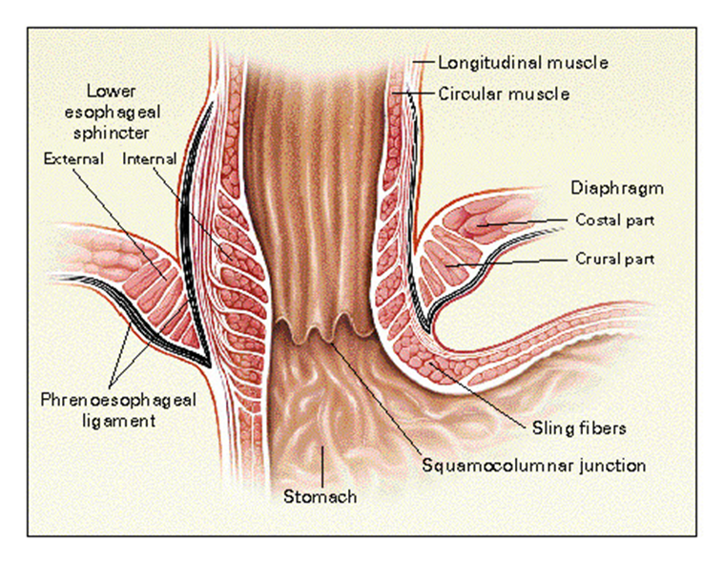
Figure 1: OG junction anatomy: anatomical and histological division of oesophagus and stomach image from (Mittal and Balaban, 1997)
The esophagogastric junction (EGJ) is a distinct anatomical location for cancers. It is a site of adenocarcinomas that are increasingly and progressively being recognized as having distinct biological characteristics from those of genuine gastric and oesophageal cancers. And as such, in terms of treatment and clinical management, deserve to be taken into consideration separately from other nearby sites (such as cranially oesophageal and caudally gastric neoplasms) (Gertler et al., 2011).
Epidemiology and global incidence trends
The incidence of OGJ cancer has risen over the previous four decades and is now comparable to that of distal oesophageal cancer. This is especially true for white male patients and those older than 65 years. Analysis of the SEER Database showed that: “The incidence of OGJ cancer increased significantly over the four decades between 1973 and 2013, 15.7%, 25.3%, 26.9% and 32% (p = 0.001). The rising prevalence was particularly accounted in the patient age cohorts 65-74 years and 75+ years and in white male patients followed by black male patients. The 5-year survival analysis showed a median survival during the four analysed decades of 8, 10, 11, and 14 months, respectively (Log rank test p < 0.001). During the last decades (1993-2002 and 2003-2012) OGJ cancer and distal oesophageal cancer had comparable incidences” (Bartel et al., 2019)
They are typically advanced when diagnosed and have a poor prognosis, with an estimated median 5-year survival of fewer than two years, and are frequently linked to obesity and Barrett's oesophagus, making them an issue of significant public health concern. The management approach is characterized by significant overlap between oesophageal and gastric cancer with arbitrary distinction (Oberoi et al., 2024).
Classification of the O.G. Junction tumours
Oesophagogastric junction (OGJ) tumours vary in their origin and behaviour; the Siewert classification (type I–III), which is based on the tumour epicentre in relation to the gastro-oesophageal junction, is still the most commonly used system to guide the choice of operation because it correlates with patterns of lymphatic drainage and local invasion. Since its proposal in the 1980s, the Siewert classification has been used to plan treatment for gastro-oesophageal junction tumours (Curtis et al., 2014).
Siewert classification: (Rüdiger Siewert et al., 2000)
- Type I: adenocarcinoma of the distal oesophagus, which usually arises from an area with specialized intestinal metaplasia of the oesophagus (i.e., Barrett oesophagus) and may infiltrate the esophagogastric junction from above.
- Type II: true carcinoma of the cardia arising immediately at the esophagogastric junction.
- Type III: subcardial gastric carcinoma that infiltrates the esophagogastric junction and distal oesophagus from below.
The eighth edition of the AJCC guidelines identifies Siewert type I and II tumours as oesophageal and esophagogastric adenocarcinomas, while Siewert III tumours are classified as gastric adenocarcinoma. The NCCN guidelines also group the treatment of Siewert I and II tumours with oesophageal cancer and type III with gastric cancers (Oberoi et al., 2024).
Figure 2: Siewert classification I–III 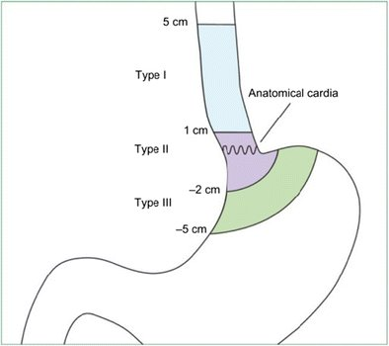
Siewert classification: image from (Brown et al., 2017)

Molecular Characteristics of O.G. Junction Tumours
Traditional view: Siewert Type 1 tumours are oesophageal origin resulting from intestinal metaplasia from squamous to columnar epithelium (Barret’s oesophagus) while type II and III were more gastric
Newer evidence: The Cancer Genome Atlas Research Network conducted a thorough molecular genomic profiling analysis in 2017 and discovered a striking similarity between oesophageal adenocarcinomas and the chromosomally unstable (CIN) variant of gastric cancer. This finding supported the idea that all GE junction adenocarcinomas have a common gastric origin (2017) (Oberoi et al., 2024). According to gene expression analysis, EACs exhibited elevated E-cadherin (CDH1) signalling as well as the ARF6 and FOXA pathways, which control E-cadherin11. On the other hand, ESCCs showed increased expression of the p63, syndecan, and Wnt pathways, the latter being necessary for the differentiation of squamous epithelial cells. These findings imply that EACs and ESCCs progress distinctly due to lineage-specific alterations. When EACs and stomach carcinomas were evaluated together, it was found that they constituted a category that was different from EBV, MSI, or GS tumours. When they examined all gastroesophageal adenocarcinomas (GEAs), they discovered that the prevalence of CIN increased proximally, with 71 out of 72 EACs being identified as CIN (2017). However, despite evidence pointing to a shared gastric origin, malignancies of the GE junction differ significantly from those found further down the stomach. Non-GE junction or distal gastric cancers have a higher prevalence of microsatellite instability, Ebstein-Barr virus infection, Helicobacter pylori infections, and diffuse-type tumour pathology, whereas GE junction cancers have a stronger association with obesity, GERD, and Barrett's oesophagus (Oberoi et al., 2024). The majority of type I tumours arise from Barret’s oesophagus (up to 97% in some series) and are associated with hiatal hernias, whereas in type II and III tumours the association with GERD, hiatal hernias, obesity and intestinal metaplasia becomes less significant with these cancers sharing similarities with gastric cancers (von Rahden et al., 2006).
Management of OGJ tumours – Biological Influences
Current standard of care for OGJ tumours as per multiple international guidelines is multimodality approach including chemotherapy, radiotherapy, immunotherapy, and surgery: the choice of appropriate therapy approach is influenced by the biology of the tumour as discussed below.
Tumour Biology
Histology: as discussed above OG junction adenocarcinomas share molecular features with gastric adenocarcinoma (intestinal/intestinal-type adenocarcinoma) rather than squamous oesophageal cancers and at the same time are distinct from distal gastric tumour. Therefore, both these factors impact the choice of systemic therapy and extent of local surgery.
Biomarkers: HER2 amplification is a significant predictive biomarker in gastroesophageal adenocarcinoma – HER2+ tumours can be treated with trastuzumab. Microsatellite instability (MSI) status, PD-L1 expression, and other immunological biomarkers are increasingly influencing systemic – biomarker positive tumours can be treated with immunotherapy (Immune check point inhibitors) perioperatively or in adjuvant post chemo phase. Knowing the HER2 / MSI / PD-L1 status (and new markers like as ctDNA) helps design neoadjuvant or adjuvant systemic therapies that can affect the timing/extent of surgery (for example, downstaging with effective systemic therapy can lessen the necessity for highly aggressive resections) (Van Cutsem et al., 2015) (Kelly et al., 2021) (André et al., 2023)

Patterns of spread - Lymphatic Spread and Clinical Relevance:
Lymphatic drainage from OGJ tumours is predictable but varies depending on the epicentre and depth of tumour. The involved lymph node basins that may be affected include mediastinal, upper or lower abdominal, celiac, perigastric, and suprapancreatic nodal basins. Siewert-specific patterns have been demonstrated in large series and recent institutional analyses (e.g., more mediastinal nodes for Siewert I, more perigastric node involvement for Siewert II/III) (Tian et al., 2024).
Siewert type I patients the mediastinal LN metastasis risk is considerably higher than Siewert types II and III (Zhang and Nan, 2023)
Siewert II AEG has the highest rate of lymph node metastasis in the upper perigastric + supra-pancreatic region, followed by the lower perigastric + hepatoduodenal, lower mediastinal, middle, and upper mediastinal regions (Tian et al., 2024). Another study found that Siewert type II EGJA was significantly lower in the abdominal lymph nodes and higher in the lower mediastinal lymph nodes (Chen et al., 2020). Furthermore, the distance between the OGJ and the proximal margin of the main tumour (oesophageal invasion) may be a predictor of mediastinal lymph node metastasis in Siewert type II tumours. research found that oesophageal invasion of ≥ 2 cm was linked to a greater probability of mediastinal lymph node metastasis and when oesophageal extension reaches 3 cm, the risk was even higher (Zheng and Zhao, 2022).

Therefore, the choice between a selective and an extensive lymphadenectomy is based on this biological mapping. The nodal fields that need to be cleared and therefore the operative approach and extent of surgery are based on the tumour’s epicentre, T-stage, and preoperative imaging. The surgical approach must be balance oncological benefit (removal of likely involved nodes) against increased morbidity of extended dissections (Tian et al., 2024)
Surgical Planning
The primary objective of surgical resection is total removal of the primary tumour together with its lymphatic drainage, because R0-resection (microscopic complete removal of the tumour), nodal status, and lymph node ratio (number of infiltrating nodes per node removed) are key prognostic markers. Univariate and multivariate analyses have demonstrated that R0 resection with its lymph node are the primary prognostic factors (von Rahden et al., 2006). The 5-year survival rate reduces from 53% to 11% if lymph node metastasis is present. For mediastinal lymph node metastasis, Siewert types I or II tumours invading the oesophagus upwards, infiltration depth, tumour size, and distant metastasis were independent risk factor for poorer prognosis (Zhang and Nan, 2023).
Surgical choices for Type I and III tumours are more straightforward because lymph node spread is easier to locate: Siewert I is managed by oesophagectomy and Siewert III is managed by gastrectomy. Another important factor to consider in surgical planning is the extent and depth of tumour invasion and stage of tumours.
Controversy arises when it comes to the appropriate surgical approach for Siewert II cancers. Another recent controversy is the choice of gastrectomy and reconstruction methods for OGJ tumours. Figure 3 outlines the surgical approaches

Figure 3: Surgical Approach (Zheng and Zhao, 2022)
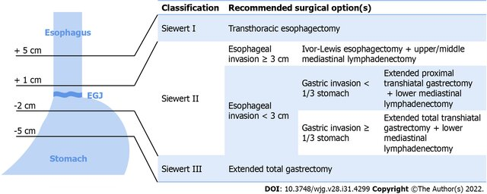
Type I
- Transthoracic oesophagectomy is the first choice since it allows complete nodal dissection Transhiatal oesophagectomy leaves nodal disease behind but can be considered in early-stage tumours with low probability of LN disease and in patients with severe comorbidities where thoracotomy is best avoided. Studies have shown that the postoperative morbidity and mortality between transhiatal and transthoracic is not statistically significant (von Rahden et al., 2006).
Type II
- Patients with more advanced type Ⅱ carcinomas harbour metastases in lymph nodes of paracardial region, lesser and greater curvatures, left gastric artery towards celiac axis, splenic artery, superior border of the pancreas towards the splenic hilum, lower posterior mediastinum, left adrenal gland and left renal vein: Extended trans hiatal gastrectomy seems to offer acceptable results and with transthoracic oesophagectomy for select group of patients with increased extension to oesophagus. The distance of the proximal margin of the cancer from the OG junction appears to be a relevant factor in the decision to pursue a transthoracic or a transabdominal approach (Brown et al., 2017).
- The CARDIA TRIAL is ongoing: it’s a multinational, prospective, randomized, clinical trial comparing transthoracic esophagectomy with transhiatal extended gastrectomy in adenocarcinoma of the gastroesophageal junction (GEJ) type II – will look at postoperative quality of life and pathological and oncological outcomes (Brunner et al., 2022)
Type III
- Extended trans hiatal gastrectomy is the procedure of choice
Proximal resection margins
The recommended proximal (oesophageal) resection margins range from 3-5cm. However, research indicates that the problem of margins cannot be solved with absolute measures but must instead be based on few other factors, such as histological type (longer margins are required for diffuse type), the presence of Barrett's oesophagus, T stage, lymph node metastases, and E-cadherin expression (longer margins are required for negative expression). (Brown et al., 2017).
Types of gastrectomy
Recently proximal gastrectomy has been resurfacing for OGJ tumours. This operation was previously discounted because of poor oncological outcomes and poor post-operative quality of life (Brown et al., 2017). Some centres have restarted using the extended proximal gastrectomy with variable reconstruction techniques aimed at minimizing postoperative complications (i.e., severe reflux, delayed emptying) and improving the quality whilst not compromising the oncological outcomes by reserving it for early tumours (T1-2). See table 1 below (Oberoi et al., 2024).
Table 1: Options for Siewert II and III tumours and reconstruction methods (Oberoi et al., 2024)
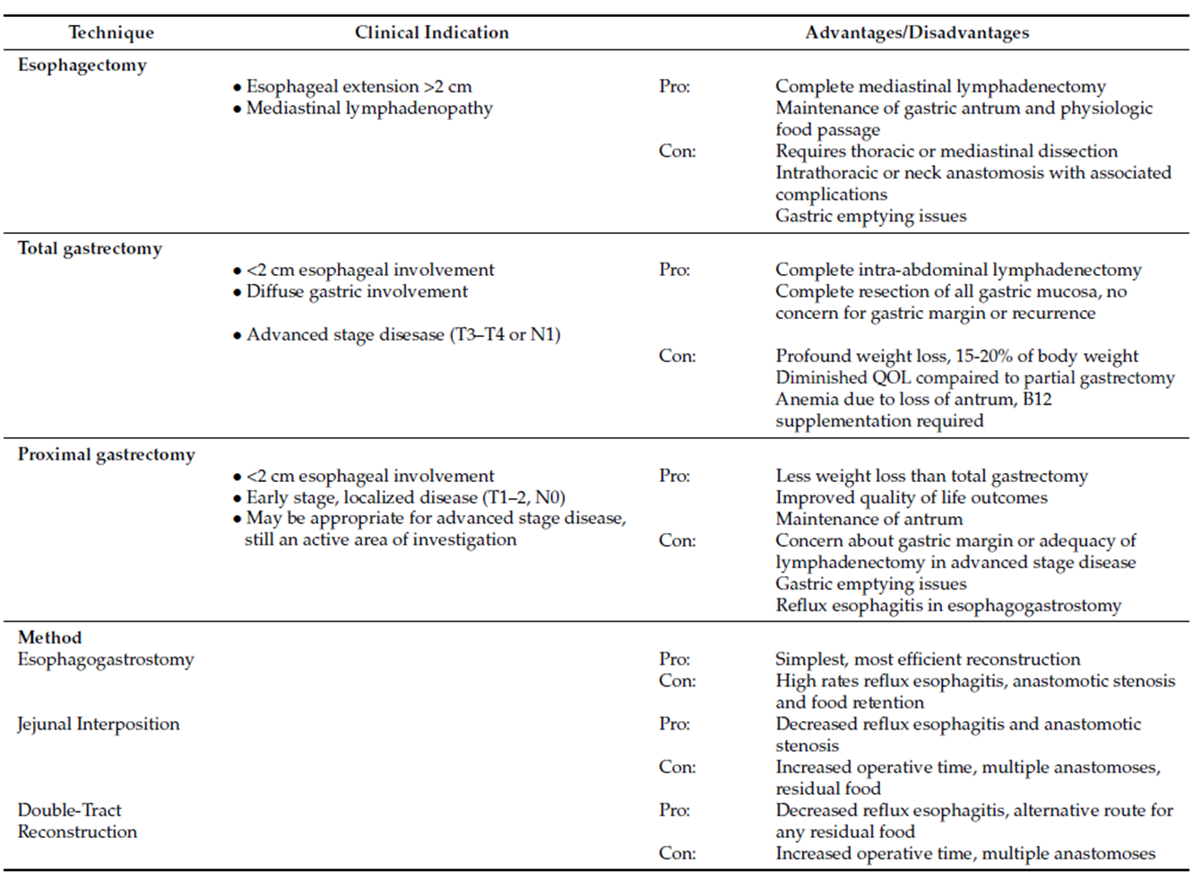

Conclusion
“Any technique chosen for the surgical resection of OGJ tumours should have the same goals: achieving a negative margin, performing an adequate lymphadenectomy, limiting the peri-operative morbidity and mortality of the operation, and attaining optimal patient-centered quality of life.” (Brown et al., 2017).

2017. Integrated genomic characterization of oesophageal carcinoma. Nature, 541, 169-175.
ANDRÉ, T., TOUGERON, D., PIESSEN, G., FOUCHARDIÈRE, C. D. L., LOUVET, C., ADENIS, A., JARY, M., TOURNIGAND, C., APARICIO, T., DESRAME, J., LIÈVRE, A., GARCIA-LARNICOL, M.-L., PUDLARZ, T., COHEN, R., MEMMI, S., VERNEREY, D., HENRIQUES, J., LEFEVRE, J. H. & SVRCEK, M. 2023. Neoadjuvant Nivolumab Plus Ipilimumab and Adjuvant Nivolumab in Localized Deficient Mismatch Repair/Microsatellite Instability–High Gastric or Esophagogastric Junction Adenocarcinoma: The GERCOR NEONIPIGA Phase II Study. Journal of Clinical Oncology, 41, 255-265.
BARTEL, M., BRAHMBHATT, B. & BHURWAL, A. 2019. Incidence of gastroesophageal junction cancer continues to rise: Analysis of Surveillance, Epidemiology, and End Results (SEER) database. Journal of Clinical Oncology, 37, 40-40.
BROWN, A., GIUGLIANO, D., BERGER, A., PUCCI, M. & PALAZZO, F. 2017. Surgical approaches to adenocarcinoma of the gastroesophageal junction: the Siewert II conundrum. Langenbeck's Archives of Surgery, 402.
BRUNNER, S., SCHRÖDER, W., FREBEL, A., DE JONGH, C., RUURDA, J. P., VAN HILLEGERSBERG, R. & BRUNS, C. 2022. The CARDIA Trial. European Journal of Surgical Oncology, 48, e37.
CHEN, X.-D., HE, F.-Q., CHEN, M. & ZHAO, F.-Z. 2020. Incidence of lymph node metastasis at each station in Siewert types Ⅱ/Ⅲ adenocarcinoma of the esophagogastric junction: A systematic review and meta-analysis. Surgical Oncology, 35, 62-70.
CURTIS, N. J., NOBLE, F., BAILEY, I. S., KELLY, J. J., BYRNE, J. P. & UNDERWOOD, T. J. 2014. The relevance of the Siewert classification in the era of multimodal therapy for adenocarcinoma of the gastro-oesophageal junction. J Surg Oncol, 109, 202-7.
GERTLER, R., STEIN, H. J., LOOS, M., LANGER, R., FRIESS, H. & FEITH, M. 2011. How to classify adenocarcinomas of the esophagogastric junction: as esophageal or gastric cancer? Am J Surg Pathol, 35, 1512-22.
KELLY, R. J., AJANI, J. A., KUZDZAL, J., ZANDER, T., CUTSEM, E. V., PIESSEN, G., MENDEZ, G., FELICIANO, J., MOTOYAMA, S., LIÈVRE, A., URONIS, H., ELIMOVA, E., GROOTSCHOLTEN, C., GEBOES, K., ZAFAR, S., SNOW, S., KO, A. H., FEENEY, K., SCHENKER, M., KOCON, P., ZHANG, J., ZHU, L., LEI, M., SINGH, P., KONDO, K., CLEARY, J. M. & MOEHLER, M. 2021. Adjuvant Nivolumab in Resected Esophageal or Gastroesophageal Junction Cancer. New England Journal of Medicine, 384, 1191-1203.
MITTAL, R. K. & BALABAN, D. H. 1997. The esophagogastric junction. N Engl J Med, 336, 924-32.
OBEROI, M., NOOR, M. S. & ABDELFATAH, E. 2024. The Multidisciplinary Approach and Surgical Management of GE Junction Adenocarcinoma. Cancers, 16, 288.
RÜDIGER SIEWERT, J., FEITH, M., WERNER, M. & STEIN, H. J. 2000. Adenocarcinoma of the esophagogastric junction: results of surgical therapy based on anatomical/topographic classification in 1,002 consecutive patients. Ann Surg, 232, 353-61.
RUSCH, V. W. 2004. Are cancers of the esophagus, gastroesophageal junction, and cardia one disease, two, or several? Seminars in Oncology, 31, 444-449.
TIAN, Y., LV, H., WANG, M. & TIAN, Z. 2024. A retrospective analysis of lymph node dissection in Siewert II adenocarcinoma of the esophagogastric junction. J Cardiothorac Surg, 19, 460.
VAN CUTSEM, E., BANG, Y. J., FENG-YI, F., XU, J. M., LEE, K. W., JIAO, S. C., CHONG, J. L., LÓPEZ-SANCHEZ, R. I., PRICE, T., GLADKOV, O., STOSS, O., HILL, J., NG, V., LEHLE, M., THOMAS, M., KIERMAIER, A. & RÜSCHOFF, J. 2015. HER2 screening data from ToGA: targeting HER2 in gastric and gastroesophageal junction cancer. Gastric Cancer, 18, 476-84.
VON RAHDEN, B. H., STEIN, H. J. & SIEWERT, J. R. 2006. Surgical management of esophagogastric junction tumors. World J Gastroenterol, 12, 6608-13.
ZHANG, D. & NAN, Q. 2023. Patterns of the lymph node metastasis and the influencing factors in esophagogastric junction cancers. Asian Journal of Surgery, 46, 3512-3519.
ZHENG, Y. H. & ZHAO, E. H. 2022. Recent advances in multidisciplinary therapy for adenocarcinoma of the esophagus and esophagogastric junction. World J Gastroenterol, 28, 4299-4309.

DR P STEVENS

Management of Short Bowel Syndrome in Children
Dr Paul Stevens
MBChB, MMed PaedSurg (Pret), FCPaedSurg (SA)
Surgical Lead of the Paediatric Intestinal Failure Unit, Midstream Mediclinic, Pretoria.
Introduction
Short Bowel Syndrome (SBS) represents the most common cause of intestinal failure in children. It is characterized by a congenital or acquired loss of functional bowel mass, resulting in inadequate absorption of fluids, electrolytes, and nutrients to maintain health and/ or sustain growth.
Intestinal failure is traditionally defined as the requirement for parenteral nutrition (PN) beyond 42 days post-resection, although in practice, earlier referral to a multidisciplinary team is critical to optimize outcomes.
The management of SBS requires close coordination of a multidisciplinary team of surgeons, gastroenterologists, dieticians, pharmacists, and specialized nursing staff

Causes of Intestinal Failure
The etiologies of SBS and intestinal failure are multiple and often coexist within the same patient. The most common causes in Paediatric practice include:
1. Surgical resection resulting in short bowel length
- Necrotizing enterocolitis (NEC)
- Gastroschisis
- Intestinal atresia
- Midgut volvulus
2. Severe motility disorders
- Hollow visceral myopathy
- Chronic intestinal pseudo-obstruction
3. Congenital mucosal enteropathies
- Microvillus Inclusion Disease
- Tufting enteropathy

The predominant cause in neonates is NEC, while volvulus and atresias are also significant contributors.
Recognition of these causes is essential to anticipate prognosis and therapeutic options.

Pathophysiology
The degree of functional compromise depends on the residual bowel length, the segments preserved, and the presence of key structures such as the ileocaecal (IC) valve and colon. Residual ileum demonstrates superior adaptive potential compared with jejunum due to specialized absorptive capacity (e.g., bile salts, vitamin B12). The colon plays a crucial role in fluid and electrolyte salvage.
The age of the patient at the time of resection is also a major determinant of adaptation potential, with younger patients demonstrating greater capacity for mucosal growth.
Residual small bowel length should be calculated as a percentage of the expected length of small bowel for the child’s height. This varies as children are growing and expected small bowel length therefore changes as the child grows. The following equation represents the most accurate and widely used method for this calculation:
Expected small bowel length -
Ln(SBL) = 6.741 - 80.409 ⁄ height (cm)

Intestinal Adaptation
Following intestinal resection, the remaining bowel undergoes adaptation to maximize absorptive capacity. This process is both structural and functional:
- Villous lengthening
- Crypt deepening
- Increased angiogenesis
- Upregulation of enterocyte transporters
- Dilatation of the residual bowel
- Reduction in motility to prolong transit time
Enteral feeding is the single most important driver of adaptation. Parenteral nutrition sustains growth while the intestine remodels, but advancement of enteral feeds is critical. This phase requires careful balancing to avoid complications such as feeding intolerance, small bowel bacterial overgrowth (SIBO), and dehydration.

Surgical Presentation and Principles
The initial presentation of children with conditions that cause SBS is with an abdominal surgical emergency as a neonate or infant. Surgical decision-making at the index operation significantly influences long-term outcomes.
The guiding principles for surgery in SBS include:
- Preservation of maximal bowel length
- Maintenance of intestinal continuity when feasible (primary anastomosis, clip-and-drop, stoma creation)
- Judicious use of stomas and enteroclysis
- Provision of reliable vascular and enteral feeding access
- Avoidance of procedures that may constrain intestinal adaptation

It is essential that surgeons recognize the importance of staged surgical interventions, being cognizant of how any surgical intervention may influence the long-term prognosis of intestinal autonomy. The overarching goal is to maximize the potential for bowel adaptation and prevent future complications.

Long-Term Management
The management of SBS extends well beyond the index surgery and is centered on intestinal rehabilitation within a multidisciplinary framework. Key components include:
1. Parenteral Nutrition (PN):
- Provide sufficient macro and micronutrients to sustain growth and health while allowing time for adaptation
- Requires durable central venous access
- Risks include intestinal failure-associated liver disease (IFALD), metabolic derangements, and line sepsis
- Cycling of PN and varying PN Lipid formulation strategies help reduce risk of IFALD

2. Enteral Feeding:
- Early initiation, even in trophic amounts, stimulates adaptation
- Feed types include breast milk, elemental or semi-elemental formulas
- Methods include bolus versus continuous infusion,
- Routes include per oral, intragastric and post-pyloric delivery. Often multiple methods may be used in the same patient
- Advancement is titrated according to tolerance and stool output among others
3. Stool and Hydration Monitoring:
- Stool output up to >30–40ml/kg/day may be tolerated if hydration is maintained, and growth is ongoing
- Electrolytes and serum bicarbonate levels guide fluid replacement
4. Enteroclysis:
- Allows for use of the maximum enteral absorptive surface area even in bowel segments that are not in natural continuity.
- Allows for growth of any disconnected bowel segments distal to a diverting enterostomy that ensures adequate calibre and ease of closure when the time comes.
- Assessment of distal bowel function prior to restoration of continuity
- Planning at index surgery is necessary to allow for safe and effective enteroclysis prior to formal restoration of bowel continuity.
5. Prevention of Complications:
- IFALD: mitigated by early enteral feeds, judicious PN use, and avoidance of sepsis
- CLABSI: prevented with strict line care protocols
- Vascular access: strategic planning is of utmost importance to preserve venous sites

Table 1. Prevention of complications in Paediatric SBS
Complication | Risk Factors | Prevention Strategies
IFALD | Prematurity, prolonged PN, sepsis, low enteral feeds | Early enteral feeding, judicious PN formulation choice, PN cycling, sepsis prevention
CLABSI | Prolonged PN, frequent line access, small intestinal bacterial overgrowth (SIBO) | Line care protocols, early sepsis recognition and treatment
Loss of Vascular Access | Multiple line placements, CLABSI | Strategic site selection, US-guided placement, avoid cutdowns, management of CLABSI and mechanical line complications with a view to line salvage

Autologous Intestinal Reconstruction (AIR)
For patients who fail to achieve autonomy with standard rehabilitation, these surgical techniques offer additional options. They aim to redistribute the absorptive surface area, reduce dilatation and gain length. The presence of dilated bowel is a prerequisite for AIR.
The most employed techniques include:
1. LILT (Bianchi): Longitudinal Intestinal length and tailoring
Initial most widely accepted technique described.
2. STEP: Serial Transverse Enteroplasty
Most common procedure performed currently.
3. SILT: Spiral Intestinal lengthening and tailoring
Newer technique.

Table 2. Comparison of Autologous Intestinal Reconstruction techniques
Technique | Advantages | Limitations | Special Considerations
LILT (Bianchi) | Maintains anatomy, orientation preserved | Technically more demanding, risk of ischemic necrosis, higher leak/ contamination risk | Requires longer dilated segment
STEP | Technically easier, repeatable, possible for shorted dilated segments | Alters muscle orientation, re-dilatation risk | Can STEP a previous STEP or a LILT
SILT | Orientation preserved, usable in less dilated bowel | Limited experience, higher leak/ contamination risk | Emerging procedure, not widely used
The Principles for all AIR procedures are similar:
- Adequate adhesiolysis is required to display the full length of residual bowel
- Orientation of the bowel and mesentery is crucial to a successful procedure
- Marking and measuring is necessary to avoid inadvertent worsening of bowel motility/ loss of further bowel segments and creation of diverticula. – Mark twice Cut Once
- Generally avoided early on in an intestinal failure pathway especially within the first year as may worsen intestinal motility and consequently outcomes.
Return of enteral function is usually seen within the first 10 days but trend for weaning of PN usually only after 6 months.

Intestinal Transplantation
Intestinal transplantation is reserved for children with irreversible intestinal failure in whom PN is no longer sustainable due to complications that may include:
- Impending loss of adequate vascular access
- Progressive IFALD
- Recurrent life-threatening CLABSI
- Severe fluid and electrolyte derangements
Transplantation carries substantial risks due to the high immunogenicity of the intestine. Patients require intensive immunosuppression, exposing them to rejection, graft-versus-host disease, post-transplant lymphoproliferative disorders, and infections.
Global intestinal transplantation rates for short bowel syndrome are on the decline. This is due to longer survival on PN, fewer PN-related complications, and success of multidisciplinary intestinal rehabilitation programs worldwide.

Outcomes
The prognosis has improved considerably with specialized multidisciplinary care.
- Mortality of approximately 10–15% at 20 years for intestinal failure
- Enteral autonomy is achieved in 60–80% of children, depending on residual bowel anatomy (time dependent)
- Patients with ≥50cm small bowel length and intact ileum/colon achieve >70% autonomy from PN within 5 years
- Even with residual <20% of expected small bowel length up to 50% may achieve autonomy under the care of expert centres.
These outcomes underscore the importance of integrated surgical and medical management, with early referral to specialized intestinal rehabilitation centres.

Conclusion
Management of Paediatric SBS requires an integrated staged approach encompassing acute surgical care, long-term nutritional support, and prevention of complications. While many patients achieve enteral autonomy through natural adaptation, others benefit from advanced surgical techniques such as autologous intestinal reconstruction. Intestinal transplantation remains a last resort but is lifesaving in selected cases. The key determinant of success lies in timely referral to centres of expertise.

DR ESME LE GRANGE

DR C WARDEN

Advantages of Robotic Surgery for Rectal Cancer Resection

Introduction
Rectal cancer surgery, whether performed openly, laparoscopically, or robotically, requires oncologic precision. The primary aim of this intricate surgery is to complete cancer resection with preservation of patient function. This presents complex surgical challenges within the confines of the bony pelvis. Traditional options such as open and laparoscopic surgery have limitations, especially in confined pelvic anatomy. Robotic surgery offers potential benefits due to improved dexterity and visualization with emerging evidence. This summary examines the key advantages of robotic surgery for rectal cancer resection based on recent clinical evidence.

Enhanced Precision and Visualization
Robotic surgery provides three-dimensional high-definition vision of anatomy with up to 10-fold magnification with excellent stability. This allows surgeons detailed visualization of the rectum and surrounding structures, particularly nerves. The wristed robotic instruments replicate human wrist movement with enhanced dexterity and tremor filtration, facilitating precise dissection in the mesenteric plane. This precision surgery aims for better nerve preservation - critical for urinary and sexual function post-surgery.

Improved Clinical Outcomes
Robotic surgery clearly had a learning curve as initial randomised studies (ROLARR JAMA 2017) showed it did not confer an advantage over laparoscopic surgery. Newer studies (REAL JAMA 2025), however, paint a different picture. Robotic rectal surgery demonstrates lower conversion rates to open surgery compared to laparoscopy, particularly in technically demanding cases such as tumours in a narrow male pelvis or obese patients. Clinical studies report reduced intraoperative blood loss, decreased complication rates, and quicker postoperative recovery (albeit measured in hours). In terms of oncologic outcomes, robotic surgery shows comparable or in newer studies improved rates of negative circumferential resection margins (CRM), disease-free survival, and overall survival.

Minimally Invasive Benefits and Recovery
The minimally invasive nature of robotic surgery leads to smaller incisions, less postoperative pain, reduced blood loss, and lower infection risk. These advantages contribute to shorter hospital stays and faster return to daily activities, improving patients' quality of life. Although these are not unique advantages to robotic surgery as all are offered by laparoscopy too. A major advantage of robotic surgery over laparoscopy is directly offered to the surgeon in ergonomic benefit. The ergonomic setup reduces surgeon fatigue, potentially improving procedural consistency and outcomes. It also allows a tea break while you work.

Challenges and Future Directions
Despite these advantages, robotic surgery often involves longer operative times and significantly higher costs. Important considerations, particularly in resource-constrained environments such as South Africa. These may improve with growing surgical experience and technological innovation (e.g., more uses allowed per robotic instrument). Future advancements in robotic platforms, such as integration with artificial intelligence and augmented reality, may further enhance outcomes and decrease learning curves. More robotic platforms supplied by various companies will improve competition and decrease costs. Ongoing large-scale trials will clarify long-term oncologic and functional benefits.

Conclusion
Robotic surgery for rectal cancer resection offers significant advantages in surgical precision, functional preservation, and patient recovery over older surgical techniques. Current evidence supports its safety and efficacy with comparable or perhaps better oncologic results. While cost and operative time remain prohibitive challenges, growing expertise and technological progress are likely to establish robotic surgery as a central modality in rectal cancer management. Continued research and training are essential to maximize its potential benefits for patients and surgeons and to allow accessibility to all our patients who would benefit.
Key Randomized Controlled Trials:
- Feng Q, Yuan W, Li T, Tang B et al. REAL Study Group. Robotic vs Laparoscopic Surgery for Middle and Low Rectal Cancer: The REAL Randomized Clinical Trial. JAMA. 2025 Jul 8;334(2):136-148.
- Park JS, Lee SM, Choi GS, et al. Comparison of Laparoscopic Versus Robot-Assisted Surgery for Rectal Cancers: The COLRAR Randomized Controlled Trial. Ann Surg. 2023 Jul 1;278(1):31-38.
- Jayne D, Pigazzi A, Marshall H, et al. Effect of Robotic-Assisted vs Conventional Laparoscopic Surgery on Risk of Conversion to Open Laparotomy Among Patients Undergoing Resection for Rectal Cancer: The ROLARR Randomized Clinical Trial. JAMA. 2017 Oct 24;318(16):1569-1580.

PROF D MONTWEDI

NEOADJUVANT THERAPY FOR COLON CANCER
OD Montwedi, Controversies symposium 2025

Colon cancer accounted for nearly 1 million new cases and responsible for over 500 000 death globally (2018). It is the 3rd leading cause of death globally.
Approximately 80% of cancers are localised to colon wall and or regional nodes.
Surgery is the only curative modality for localised colon cancer.
Goal of surgery is complete removal of tumour with its major vascular pedicle and lymphatic drainage basin.
Since 2004 (Mosaic trial) adjuvant chemotherapy has been standard of care for resectable stage 3 disease and controversially for high risk stage 2 cancer. (Addition of FOFOX, Oxaloplatin)
Recently there has been an increasing interest in neoadjuvant therapy for primary colon cancer, however this practice is controversial and at best well suited for patients in a trial situation. There are few randomised trials to inform this practice. The NAC is already accepted therapy for other GIT malignancies like oesophageal, gastric and rectal cancer.
Potential advantages of NAC for locally advanced colon cancer
Includes:
- Earlier eradication of micro metastasis
- Decrease the size/stage of tumour
- Preclude delays in case of post-operative complications
- Tests tumour chemosensitivity and help adapt post-operative treatment
The risk of this approach could be over treatment, unnecessary chemotherapy in case of incorrect radiographic staging. Delaying surgery could result in tumour growth predisposing to obstruction and perforation leading to emergency surgery with all complications of high morbidity and mortality. This delay may even result in cancer metastasis.
Radiographic staging is an integral part of the NAC strategy. Earlier studies showed radiologic staging was accurate for T and N staging in 60% and 62% respectively.
FOXTROT trial assessed accuracy of radiologic staging in their protocol for T3/4 tumour to be 95% and for T1/2 at 50%.MRI and CT colonography have not replaced CT for staging due to their cost.
The earliest retrospective study on neoadjuvant therapy for colon cancer was by Arrendondo et al (2013), analysing 22 patients with stage 3 colon cancer, all patients had volume reduction of 69,5% after neoadjuvant chemotherapy and there was no disease progression preoperatively. Overall survival (OS) was 100% after 14 months, progression free survival was 90%. Additional 43 patients for a total of 65 were evaluated, tumour regression was similar, pathologic complete response occurred in 4.6%.
ELECLA, large randomised phase 2 trial evaluating outcomes of NAC on locally advanced colon cancer was started and is ongoing. Patients are being randomised to NAC, Surgery and AC compared to upfront surgery and AC. The primary aim is to look at 2-years progression free survival (PFS), 3-years PFS and 5-year overall survival. This will likely determine whether NAC induces a clinical and histological tumour response.
The NCCN guidelines (2016) added the option for NAC for T4 lesions. Dehal (2017) reported retrospective analysis of 921 patients. Propensity study matching NAC group with upfront surgery revealed improved OS (74 vs66%).
Netherlands cancer registry (2019) reported a similar study in 149 patients, RO resection was better in adjuvant group (86 vs77%). OS was however not different.
Neoadjuvant chemotherapy
Observational studies showed that preoperative CT is safe and does not worsen outcome. Some RCT demonstrated benefit such as reduced disease recurrence, improved overall survival, other studies failed to show improved DFS or OS over upfront resection.
1.FOXTROT Trial
1053 patients with a CT scan confirmed T3/4 N0 -2 M0, were randomly assigned to preop chemo & upfront surgery.
At 3 years.
Disease recurrence: Low rates of residual or recurrent disease at 2 years (17 vs 22%), in favour of the neoadjuvant group. Addition of immunotherapy for RAS wild type tumour did not show reduction in recurrence or residual disease.
Pathologic response: -4% reduction in both tumour & nodes stage, including complete response was observed in the neoadjuvant group. RO resection was achieved in 94 vs 89% for NAC group of patients. Risk of recurrence was lowest amongst those with significant tumour regression.
Surgical complications- few complication (leak rates, dehiscence, reoperation rate occurred in favour of NAC patients.
DMMR (Deficient mismatch repair) tumour: comparing patients with DMMR to those with MMR-proficient (7 vs 23%). Better response in MMR-Proficient tumours.
2.Optical Trial
752 patients with CT T3,> 3mm invasion beyond muscular propria or T4 cancer were analysed and randomised to 2 arms. AC was given at the discretion of the treating clinician. Follow up was after 48 months.
Neoadjuvant chemotherapy improved OS and demonstrated improved DFS (not statistically significant).
Pathology complete-response was seen in 7% of patients in neoadjuvant group.
DFS: This was high in neoadjuvant group (82 vs 78%) although not statistically significant.
OS: (3yrs) 95 vs 90%). The outcome was all in favour of NAC group.
3.Neocol Trial
Aim: to assess NAC compared to surgery upfront in locally advanced colon cancer. Sample included 125 patients per arm group.
Preliminary results
There was no benefit in DFS or OS over upfront surgery. NAC had favourable outcome in terms of chemotherapy cycles fewer cycles required), post- operative complications were lower and down staging of the tumour was observed.
4.Neoadjuvant immunotherapy (Niche 2 Trial)
Patients with DMMR, Upfront neoadjuvant immunotherapy was found in this trial to be effective in downstaging tumour with DMMR. This seem like an appropriate alternative to NAC in this group of patients.
The Neoprism study also confirmed that in high risk stage 2 and stage 3 DMMR patients use of neoadjuvant immunotherapy resulted in a complete pathological response in the order of 55%.
Chemoradiation:
neoadjuvant CRT for primary colon is limited to isolated case reports & series. This may provide increase complications & toxicity including bowel injuries. Radiotherapy is therefore not recommended for neoadjuvant therapy.

CONCLUSION
Neoadjuvant chemotherapy will most likely find place in the treatment of locally advanced colon cancer as data unfold from ongoing trials. Accurate radiologic staging and molecular characterisation will become critical in selecting the right patients for this treatment and avoiding unnecessary delays in operating those patients who would benefit from upfront surgery.
The use of other targeted therapy, including immunotherapy for DMMR as neoadjuvant therapy in locally advanced colon cancer could prove significant in conferring survival benefit over upfront surgery.
The role of chemoradiotherapy as adjuvant treatment is less defined and cannot be recommended at this stage.

DR M RAMABULANA

Optimum treatment of haemorrhoids today
Dr MM Ramabulana
Colorectal surgeon
FCS (SA), Cert Gastroenterology (SA)

Introduction
Haemorrhoid disease is the fourth leading outpatient gastrointestinal diagnosis, accounting for 3.3 million ambulatory care visits in the United States. Symptomatic haemorrhoid disease is one of the most prevalent ailments associated with both genders. Reported peak incidence from age 45 to 65 years. Notably, Caucasians are affected more frequently than African Americans, and higher socioeconomic status is associated with increased prevalence. Management options for haemorrhoid disease are diverse, ranging from conservative measures to a variety of office and operating-room procedures.
Anatomy and Pathophysiology
Haemorrhoids are clusters of vascular tissues, smooth muscles, and connective tissues that lie along the anal canal in three column- left lateral, right anterior, and right posterior positions. Classical description of haemorrhoids refers to the 3, 7, 11 distributions in relation to the double branched right superior haemorrhoidal artery and the single left haemorrhoidal artery. These cushions are important in maintenance of faecal continence where it was shown that the internal plexuses contribute between 15-20% of resting anal tone.
Pathophysiology of haemorrhoidal disease is still controversial between the vascular theory, in which hyperflow in the haemorrhoidal arteries plays the main role, and the sliding theory, which considers the damage to the supporting connective tissue with the downward displacement of the anal cushions as the key factor. These mechanisms could coexist and both play a role, as confirmed by the numerous surgical procedures introduced in the last 100 years.
It is known fact that the prevalence of haemorrhoids is increased in so called more developed countries in association with a multitude of factors such as sedentary lifestyle, extended periods of abdominal straining; any condition causing increased intra-abdominal pressure which will lead to stretching of the connective tissue support with resultant enlargement/engorgement and thus prolapse of mucosal cushions.
Symptoms associated with haemorrhoids such as discomfort, itching, bleeding, thrombosis and soiling may appear. Pain should not be a symptom of haemorrhoids unless thrombosis or perianal haematoma occurs.
Management of Haemorrhoid Disease
The natural history of most cases of haemorrhoid disease is self-limited. For symptomatic haemorrhoid disease that presents to the clinic or emergency room, treatments range from nonoperative medical interventions and office-based procedures to surgery. One general guiding principle is that the least-invasive approaches should be considered first, except in cases of acute thrombosis. Specific choices of treatments depend on patient’s age, severity of symptoms, and comorbidities.

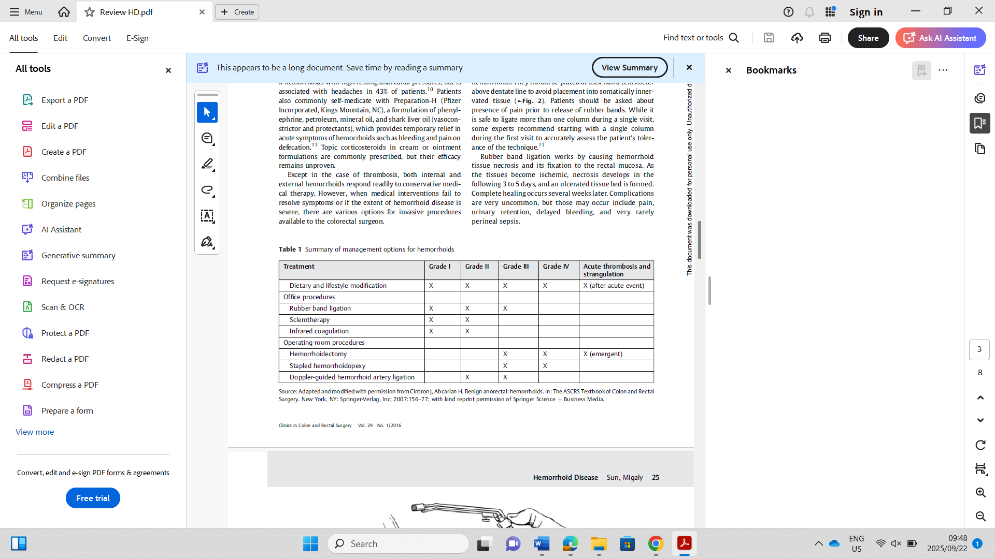
Conservative Medical Treatments
Lifestyle and dietary modification are the mainstays of conservative medical treatment of haemorrhoid disease. Specifically, lifestyle modifications should include increasing oral fluid intake, reducing fat consumptions, avoiding straining, and regular exercise. Diet recommendations should include increasing fiber intake, which decreases the shearing action of passing hard stool. In a meta-analysis of seven randomized trials comparing fiber to nonfiber controls, fiber supplementation (7–20 g/d) reduced risk of persisting symptoms and bleeding by 50%. However, fiber intake did not improve symptoms of prolapse, pain, and itching. Except in the case of thrombosis, both internal and external haemorrhoids respond readily to conservative medical therapy.
Nonsurgical Office-based Procedures
For internal haemorrhoids, rubber band ligation, sclerotherapy,and infrared coagulation are the most common procedures but there is no consensus on optimal treatment.
Rubber Band Ligation
It is the most commonly performed procedure in the office and is indicated for grade II and III internal haemorrhoids. Several platforms are available, but the two most prevalent ligating devices are the McGivney forceps ligator and the suction ligator. Small rubber band rings are deployed tightly around the base of the internal haemorrhoids at least half a centimetre above dentate line to avoid placement into somatically innervated tissue. Overall, banding is a safe, quick, and effective procedure for internal haemorrhoids.
Injection Sclerotherapy
Indicated for patients with grade I and II internal haemorrhoids and may be a good option for patients on anticoagulants. internal haemorrhoids are located and injected with a sclerosant material (typically a solution including phenol in vegetable oil) into the submucosa. It subsequently causes fibrosis, fixation to the anal canal, and eventual obliteration of the redundant haemorrhoidal tissue.
Infrared Coagulation
Refers to direct application of infrared light waves to the hemorrhoidal tissues and can be used for grade I and II internal haemorrhoids. The tip of the infrared coagulation applicator is usually applied to the base of the internal haemorrhoid for two seconds, with three to five treatments per haemorrhoid. It converts infrared light waves to heat, the applicator causes necrosis of the haemorrhoid, visualized as a white, blanched mucosa. Over time, the affected mucosa scars, leading to retraction of the prolapsed haemorrhoid mucosa. it is very safe with only minor pain and bleeding reported.
MacRae and McLeod conducted a meta-analysis of 18 trials and concluded that rubber band ligation was better than sclerotherapy in response to treatment for grade I and III haemorrhoids, with no differences in the complication rate. Patients treated with sclerotherapy or infrared coagulation were more likely to require additional subsequent procedure or therapies in comparison to those treated with rubber band ligation. Finally, although pain was greater after rubber band ligation, recurrent symptoms were less common.
Surgical Procedures
Continued symptoms despite conservative or minimally invasive measures usually require surgical intervention.
For patients who present with thrombosed external haemorrhoids, surgical evaluation and intervention within 72 hours of thrombosis may result in significant relief, as pain and oedema peak at 48 hours. after 48 to 72 hours, organization of the thrombus and amelioration of symptoms generally obviates the need for surgical evacuation.
In the nonemergent setting, popular procedures performed in the operating room include haemorrhoidectomy, stapled haemorrhoidopexy, and Doppler-guided haemorrhoidal artery ligation.
Haemorrhoidectomy
Two major types of haemorrhoidectomies: Ferguson, or closed haemorrhoidectomy and the Milligan–Morgan, or open haemorrhoidectomy have been described. Open haemorrhoidectomy is often the preferred approach to surgically treat severe acute gangrenous haemorrhoids where tissue oedema and necrosis preclude closure of the mucosa.
Despite its relative higher morbidity, surgical haemorrhoidectomy is more effective than band ligation for preventing recurrent symptoms. In a randomized trial among elective cases, there were no differences in open versus closed haemorrhoidectomy. Patients with grade III and IV hemorrhoids benefit the most from surgical haemorrhoidectomy.
Stapled Haemorrhoidopexy
Stapling device is used to resect and fixate the internal haemorrhoid tissues to the rectal wall. Since the staple line is above the dentate line, patients typically experience less pain than those who undergo haemorrhoidectomy. Complications from stapled haemorrhoidopexy include bleeding from the staple line, incontinence for injury of the sphincter muscles, and stenosis from incorporation of excess rectal tissue. There is a risk of recto-vaginal fistula in women due to incorporation of vaginal tissue into the purse-string.
Three systematic reviews concluded that stapled haemorrhoidopexy was less effective than conventional haemorrhoidectomy. Stapled haemorrhoidopexy was associated with a higher long-term risk of haemorrhoid recurrence. Due to need for additional operations, the incidence of prolapse and tenesmus was also higher after stapled haemorrhoidopexy as compared with haemorrhoidectomy.
In a 2010 European multicenter randomized trial of stapled haemorrhoidopexy versus haemorrhoidectomy, both options were shown to be equally effective in preventing recurrence after 1 year. Patients undergoing haemorrhoidectomy were more likely to have symptomatic relief from the haemorrhoids (69 vs. 44%), but had significantly greater postoperative pain.
Overall, stapled haemorrhoidopexy remains a viable alternative to haemorrhoidectomy, and is especially attractive for patients without much external disease. However, while the published complication rates are low, they can be quite severe, and the surgeon must have appropriate training and proceed with great caution, when performing this procedure.
Doppler-guided Haemorrhoidal Artery Ligation
First described by Morinaga et al in 1995, this technique involves use of Doppler ultrasound to identify and ligate the haemorrhoidal arteries. Also referred to as transanal haemorrhoidal dearterialization (THD). The principles include the use of a Doppler probe to identify the six main feeding arteries within the anal canal, ligation of these arteries with absorbable suture and a specialized anoscope, and then plication of redundant haemorrhoidal mucosa. Selective ligation of the haemorrhoidal artery under Doppler guidance (DG-HAL) to reduce the inflow, resulting in gradual shrinkage and fixation of the haemorrhoidal tissue.
The plication is often referred to as recto-anal-repair, mucopexy, or haemorrhoidopexy. Proposed benefits of this procedure are similar to stapled haemorrhoidopexy, with less associated pain due to the suturing being above the dentate line.
Early results of Doppler-guided hemorrhoidal artery ligation (DGHAL)/THD were promising, with lower pain scores than haemorrhoidectomy, and relief of bleeding and tissue prolapse in over 90% of patients. Since then, several randomized clinical trials have been performed with mixed results. Currently, DGHAL/THD remains a viable approach to multicolumn internal haemorrhoids. However, the short-term benefits regarding postoperative pain have recently not been as remarkable as in the earlier studies.
The benefit of Doppler-Guidance (DG) has been debated since, although it allows accurate identification and ligation of the terminal branches. Consequently, artery ligation can be performed without DG, resulting in considerable cost savings. Gupta et al. assessed the benefits of DG-HAL-RAR versus HAL-RAR reporting no significant difference in recurrence rates at 1-year follow-up, but higher postoperative pain in the DG group. A recent meta-analysis of seven RCTs by Roberto et al. did not find superiority of DG-HAL over HAL with or without RAR in reducing postoperative complications and recurrence.
Special Considerations
Crohn Disease
Haemorrhoids should be distinguished from hypertrophic skin tags that are associated with Crohn disease. Skin tags in Crohn disease are often tender and associated with ulceration of the anal canal. Treatment of haemorrhoids should be kept as conservative as possible, with every attempt made to avoid surgery, as these patients can have significant issues with wound healing after haemorrhoidectomy. Haemorrhoidectomy can be performed in a highly selective basis when disease is quiescent, but it is generally discouraged.
Immunosuppression
Patients such as those with acquired immunodeficiency syndrome (AIDS) or those on chronic immunosuppressive medications are at greater risk of sepsis and poor wound healing. Conservative treatments should be exhausted before performing any invasive procedures. However, less-invasive approaches can be undertaken.
Cirrhosis and Portal Hypertension
Contrary to previous teachings, the incidence of haemorrhoid disease in patients with portal hypertension is not different from the general population. Rectal varices, the result of portosystemic communication via the haemorrhoid veins, occur commonly in patients with portal hypertension. However, bleeding from rectal varices is rare, accounting for < 1% of massive bleeding in portal hypertension. When it does occur, it should typically be treated with portal decompression.

Conclusion
Haemorrhoid disease is a common but complex disease. There are a multitude of options for the management of haemorrhoid disease and specific treatment choice should be based on individual patient and clinical factors.
References
- Everhart JE, Ruhl CE. Burden of digestive diseases in the United States part I: overall and upper gastrointestinal diseases. Gastroenterology 2009;136(2):376–386
- Johanson JF, Sonnenberg A. The prevalence of hemorrhoids and chronic constipation. An epidemiologic study. Gastroenterology 1990;98(2):380–386
- Shafik A. Surgical anatomy of hemorrhoids. Surgical Treatment of Hemorrhoids. London: Springer; 2009:7–13
- Banov L Jr, Knoepp LF Jr, Erdman LH, Alia RT. Management of hemorrhoidal disease. J S C Med Assoc 1985;81(7):398–401
- Goenka MK, Kochhar R, Nagi B, Mehta SK. Rectosigmoid varices and other mucosal changes in patients with portal hypertension. Am J Gastroenterol 1991;86(9):1185–1189
- Thomson WH. The nature of haemorrhoids. Br J Surg 1975;62(7):542–552
- Morgado PJ, Suárez JA, Gómez LG,Morgado PJ Jr. Histoclinical basis for a new classification of hemorrhoidal disease. Dis Colon Rectum 1988;31(6):474–480
- Riss S, Weiser FA, Schwameis K, et al. The prevalence of hemorrhoids in adults. Int J Colorectal Dis 2012;27(2):215–220
- Alonso-Coello P, Mills E, Heels-Ansdell D, et al. Fiber for the treatment of hemorrhoids complications: a systematic review and meta-analysis. Am J Gastroenterol 2006;101(1):181– 188
- Tjandra JJ, Tan JJ, Lim JF, Murray-Green C, Kennedy ML, Lubowski DZ. Rectogesic (glyceryl trinitrate 0.2%) ointment relieves symptoms of haemorrhoids associated with high resting anal canal pressures. Colorectal Dis 2007;9(5):457–463
- Sneider EB, Maykel JA. Diagnosis and management of symptomatic hemorrhoids. Surg Clin North Am 2010;90(1):17–32
- Iyer VS, Shrier I, Gordon PH. Long-term outcome of rubber band ligation for symptomatic primary and recurrent internal hemorrhoids.Dis Colon Rectum 2004;47(8):1364–1370
- Buchmann P, Seefeld U. Rubber band ligation for piles can be disastrous in HIV-positive patients. Int J Colorectal Dis 1989;4(1):57–58
- Nelson RS, Ewing BM, Ternent C, Shashidharan M, Blatchford GJ,Thorson AG. Risk of late bleeding following hemorrhoidal banding in patients on antithrombotic prophylaxis. AmJ Surg 2008;196(6):994–999
- Barwell J, Watkins RM, Lloyd-Davies E, Wilkins DC. Life-threatening retroperitoneal sepsis after hemorrhoid injection sclerotherapy:report of a case. Dis Colon Rectum 1999;42(3):421–423
- MacRae HM, McLeod RS. Comparison of hemorrhoidal treatment modalities. A meta-analysis. Dis Colon Rectum 1995;38(7):687–694
- Aigner F, Gruber H, Conrad F, et al. Revised morphology and hemodynamics of the anorectal vascular plexus: impact on the course of hemorrhoidal disease. Int J Colorectal Dis 2009;24(1):105–113
- Greenspon J, Williams SB, Young HA, Orkin BA. Thrombosed external hemorrhoids: outcome after conservative or surgical management. Dis Colon Rectum 2004;47(9):1493–1498
- Pattana-arun J, Wesarachawit W, Tantiphlachiva K, Atithansakul P, Sahakitrungruang C, Rojanasakul A. A comparison of early postoperative results between urgent closed hemorrhoidectomy for prolapsed thrombosed hemorrhoids and elective closed hemorrhoidectomy. J Med Assoc Thai 2009;92(12):1610–1615
- Wesarachawit W, Pattana-arun J. Antibiotics and early post operative complications of closed hemorrhoidectomy: a retrospective matched pair study. J Med Assoc Thai 2007;90(9):1828–1832
- Nienhuijs S, de Hingh I. Conventional versus LigaSure hemorrhoidectomy for patients with symptomatic Hemorrhoids. Cochrane Database Syst Rev 2009;(1):CD006761 Clinics in Colon and Rectal Surgery Vol. 29 No. 1/2016

DR T RAMPAI

Neoadjuvant Therapy for Pancreatic Cancer
Does it make a difference to the outcome?
By TJ Rampai

Introduction
Pancreatic ductal adenocarcinoma (PDAC) remains one of the most lethal malignancies, with a five-year survival rate below 10%. Even in patients diagnosed at an early stage, when the tumour is deemed technically resectable, long-term outcomes remain unsatisfactory due to high rates of local recurrence and distance metastases.
Only approximately 10–20% of PDAC cases are diagnosed at an early stage, wherein treatments such as radiotherapy, chemotherapy, or surgical interventions appear to enhance patient outcomes. Earlier detection greatly improves outcomes. Patients diagnosed at stage I have a 5-year survival rate of about 30–60%, compared to less than 5% for those with metastatic disease.
With a high mortality rate, PDAC ranks 8th most common cancer in women and 10th in men in the US. It shows aa all stage 5-year survival of 12.5% (SEER cancer statistics). Chemotherapy plays a pivotal role in the treatment approach of PDAC, covering adjuvant, neoadjuvant and palliative settings. The management of resectable pancreatic ductal adenocarcinoma (R-PDAC) and borderline resectable pancreatic ductal adenocarcinoma (BR-PDAC) remains a topic of active debate.
Although neoadjuvant therapy (NAT) has shown clinical benefits in BR-PDAC, especially in increasing resectability and achieving higher rates of margin-negative (R0) resections, its role in R-PDAC is less clearly defined. the role of immunotherapy in PDAC is still being explored, with ongoing trials investigating new combinations to overcome the tumour’s immune-resistant microenvironment. PDAC is a medically depressing disease, because improved surgical techniques did not improve the outcome, radiotherapy only good for loco-regional control and chemotherapy did not improve survival.
PDAC is classified into resectable (R-PDAC), borderline (BR-PDAC), and locally advanced (LA-PDAC), according to the NCCN or ESMO, etc Guidelines: Summary below:

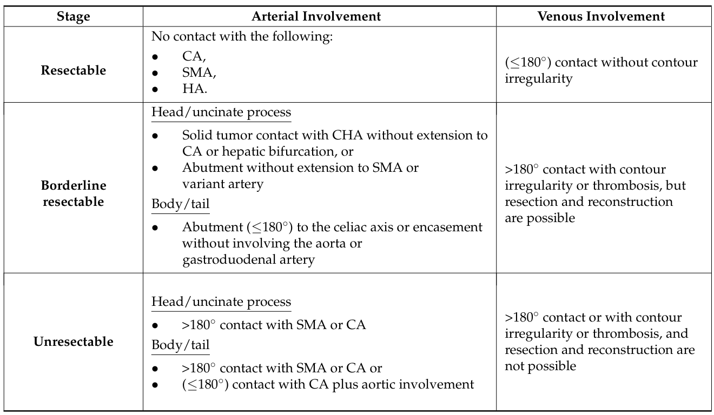

Uses of chemotherapy
PDAC is considered a systemic disease at presentation, due to chances of early micrometastatic disease, which has a poor prognosis and high recurrence rates. Surgery remains the only curative treatment for early disease; chemotherapy plays an important role in the radical management.

Adjuvant chemotherapy: Historical Standard of care
The first clear therapeutic benefit of adjuvant treatment was established after the outcomes of the ESPAC-1 trial. The study demonstrated a significant survival advantage with adjuvant 5-FU plus leucovorin (5-FU+LV) therapy compared to resection alone, thereby establishing 5-FU+LV as the standard adjuvant treatment for resectable PDAC.
After the ESPAC-1 trial, the CONKO-001 trial randomized patients’ post-resection to receive either adjuvant gemcitabine (GEM) or observation. The study reported a significant improvement in recurrence-free survival (RFS) (13.4 months vs. 6.9 months, p = 0.001) in the GEM group. Although initial analysis did not show a statistically significant improvement in OS, long-term follow-up eventually revealed a significant OS benefit as well (22.8 months vs. 20.2 months, p = 0.01). These findings collectively led to the recognition of GEM as an alternative standard adjuvant therapy alongside 5-FU+LV. Summary of other adjuvant trials below:
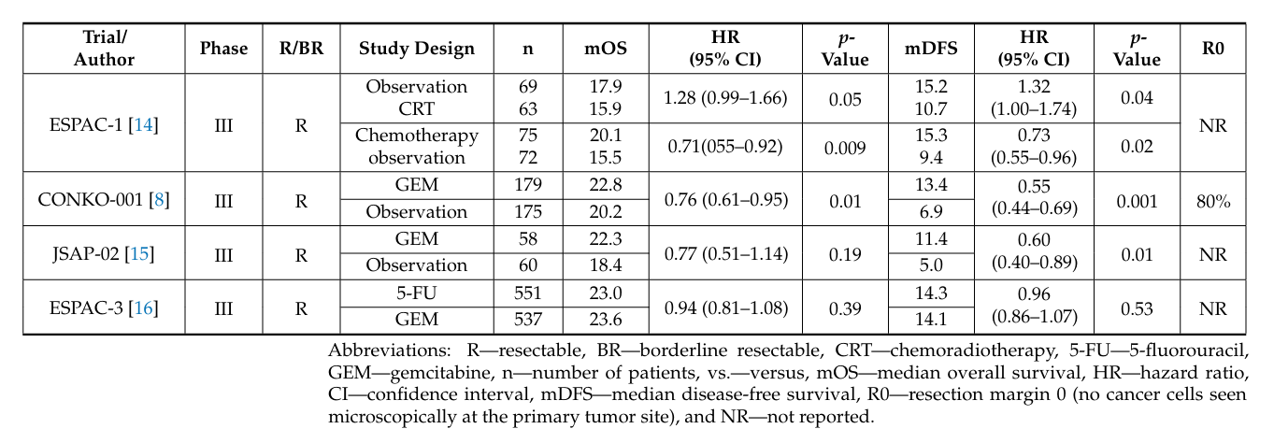

The standard of care for patients with R-PDAC is surgical resection followed by adjuvant therapy with mFOLFIRINOX, as shown by the PRODIGE 24 trial, which showed a significant survival advantage of almost 5 years. Patients were randomized to adjuvant therapy with FOLFIRINOX or gemcitabine. Median DFS was 21.4 months (95% CI, 17.5–26.7) vs. 12.8 months (95% CI, 1.6–15.2) (HR 0.66; 95% CI, 0.54–0.82; p = 0.001),
And median OS was 53.5 months (95% CI, 43.5–58.4) vs. 35.5 months (95% CI, 30.1–40.3) (HR 0.68; 95% CI, 0.54–0.85; p = 0.001) [17]. For patients who cannot receive mFOLFIRINOX due to unfit conditions or other comorbidities, adjuvant treatment with gemcitabine and capecitabine, as shown in the ESPAC-4 trial, is the standard of care.

In summary:
Fit patients receive modified-FOLFIRINOX (Oxaliplatin 85mg/m2, Leucovorin 400mg/m2, irinotecan 150mg/m2, and continuous 5FU 2400mg/m2, without bolus 5FU; every 2 week for 12 cycles)
Unfit patients receive gemcitabine and capecitabine or a single dose regimen.
The European Society for Medical Oncology (ESMO) states that surgical resection remains the standard care for patients with R-PDAC, followed by adjuvant chemotherapy to improve survival outcomes. The regimens include FOLFIRINOX or gemcitabine-based combinations, depending on the patient’s performance status and tolerance.

Neoadjuvant chemotherapy
At least about 50% of patients receive adjuvant therapy, due to post-operative complications or delayed recovery. Neoadjuvant treatment is expected to enable the earlier administration of systemic therapy, potentially increasing the proportion of patients receiving systemic treatment and this will subsequently improve the overall survival of patients. Again, this approach can help to avoid futile surgical interventions in patients with hidden metastases or who rapidly progress to advanced disease. The problem is a significant portion of patients who start neoadjuvant therapy ultimately do not undergo surgical resection.
The main reasons for patients not undergoing surgery after neoadjuvant treatment include disease progression, poor general condition to undergo surgery, or patient’s preference.

Clinical trials for neoadjuvant therapy
Casadei et al. in 2015 demonstrated that neoadjuvant therapy was feasible and safe; however, due to poor accrual, the study was terminated early. And in 2018, Jang et al. did a prospective, randomized phase II/III trial involving 110 patients with BR-PDAC. Patients were randomly assigned to receive neoadjuvant CRT with gemcitabine followed by surgery, or
to undergo surgery followed by CRT. The results showed a benefit in 2-year survival (40.7% vs. 26.1%) and OS (21 months vs. 12 months, p = 0.028) for neoadjuvant gemcitabine-based CRT over upfront surgery in the Intention-to-Treat (ITT) analysis. The study also showed a significantly higher R0 resection rate following neoadjuvant chemotherapy (51.8% vs. 26.1%, p = 0.004).
The Dutch PREOPANC trial (2022) randomized 246 patients with R-PDAC and BR-PDAC to receive either neoadjuvant CRT with GEM followed by surgery and adjuvant GEM, or upfront surgery with subsequent GEM. The results showed improvement in OS in the CRT group compared to the upfront surgery group (15.7 months vs. 14.3 months; HR 0.73; 95% CI, 0.56–0.96, p = 0.025). Furthermore, patients in the neoadjuvant arm achieved higher 5-year OS rates (20.5% vs. 6.5%), and R0 resection rates (71% vs. 49%, p = 0.001). The PREOPANC-2 (2023), a phase III trial, analysed FOLFIRINOX treatment regimen as the neoadjuvant therapy without adjuvant therapy versus gemcitabine with radiotherapy during the second cycle, followed by surgery and adjuvant gemcitabine. Nevertheless, in this study, neoadjuvant with FOLFIRINOX failed to improve OS (21.9 months vs. 21.3 months, respectively; HR 0.87; 95% CI 0.68–1.12, p = 0.28) [28,29].
The NORPACT-1 trial (2024), one of the first randomized controlled trials, compared the role of neoadjuvant FOLFIRINOX with upfront surgery in patients with R-PDAC. The results did not show a significant survival benefit from NAT compared to upfront surgery. The medianOS in the neoadjuvant group was 25.1 months, while in the upfront surgery group, it was 38.5 months (HR 1.52; CI 95% 1.00–2.31, p = 0.050). Additionally, the proportion of patients alive after 18 months was 60% in the neoadjuvant group compared to 73% in the upfront surgery group (p =0.10).
ALLIANCE trial (2022), 126 patients were assigned to compare treatment with neoadjuvant mFOLFIRINOX with or without hypo-fractionated radiation therapy in BR-PDAC. The study reported the mOS of 29.8m (95%CI,21.1–36.6) in arm 1, compared to 17.1mo (95%CI,12.8–24.4) in arm 2, respectively. These findings indicated that treatment with neoadjuvant mFOLFIRINOX alone was associated with improved survival outcomes in patients with BR-PDAC compared to mFOLFIRINOX followed by hypo-fractionated radiotherapy.

Summary of other trials below:
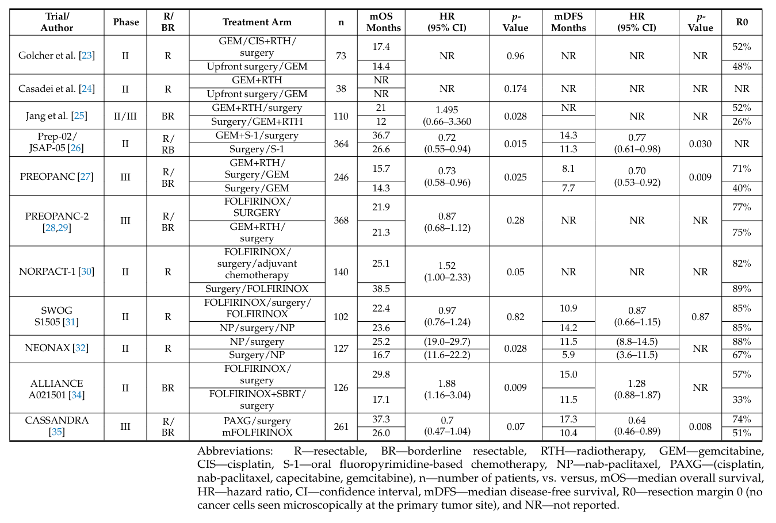

Meta-analysis of clinical trials for neoadjuvant therapy
Since there is no consensus on the integration of neoadjuvant therapy into the standard of care for patients with PC, various authors have conducted meta-analyses.
Aliseda et al. enrolled patients with R-PDAC. The meta-analysis of five prospective randomized clinical trials (Golcher et al., PACT-15, PREP-02/JSAP-05, PRE OPANC, NEONAX) included 625 patients, of whom 272 underwent upfront surgery and 353 received NAT. Among the NAT group, 288 patients received chemotherapy alone, and 65 underwent CRT. The most administered chemotherapy regimen was FOLFIRINOX (n =147), followed by FOLFOX (n = 50), and gemcitabine-based protocols (n = 156). In 625 patients, the mOS of patients in the neoadjuvant and upfront surgery groups was 25.8m (95% CI, 21.4–29.9) and 22.1m (95% CI, 18.3–26.5), respectively. The study indicated no significant difference in the hazard of death between the neoadjuvant and upfront surgery groups (HR: 0.88, 95% Cl 0.72–1.08, p = 0.233).
Summary of other meta-analysis below:
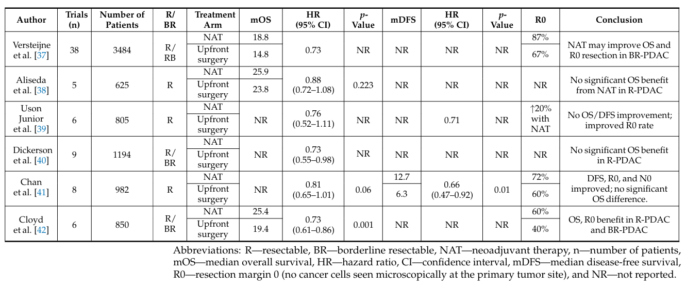

Discussion
Neoadjuvant therapy was introduced to provide potential advantages in tumour downstaging before surgical resection; and now, it is predominantly used to identify patients whose tumour biology indicates a greater benefit from neoadjuvant treatment compared to upfront surgery. This approach has again resulted in an increase in R0 resection rate, which is correlated with improved treatment outcomes. All these factors contribute to a lowering in the risk of recurrence after curative surgery. The determination of resectability in patients with PDAC should be established through a multidisciplinary team.
The NCCN and the ESMO guidelines recommends that patients with R-PDAC should be considered for upfront surgery in the absence of arterial tumour contact with the celiac axis, SMA, or common hepatic artery (CHA), and with no venous involvement or ≤180◦ contact with the superior mesenteric vein (SMV) or portal vein (PV), provided there is no contour irregularity. NCCN 2021:
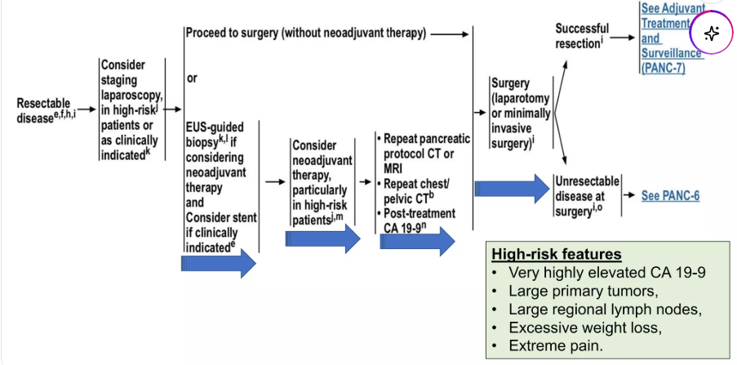

Adjuvant chemotherapy with modified FOLFIRINOX (mFOLFIRINOX) is regarded as the preferred treatment option, whereas the combination of gemcitabine and capecitabine is considered a viable alternative option (PRODIGE 24 TRIAL). And where high-risk features are present, which are markedly elevated CA 19–9 levels, large primary tumours, bulky regional lymph nodes, significant weight loss, or severe pain, neoadjuvant chemotherapy with mFOLFIRINOX should be considered.
For patients with BR-PDAC, the NCCN guidelines recommend neoadjuvant therapy as the first-line treatment approach, even if the tumour appears technically resectable (PREOPANC and Alliance trials).

Summary picture below:
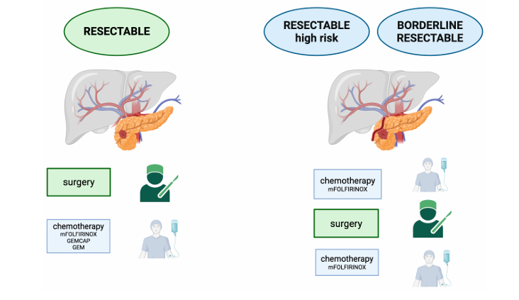

The future of pancreatic cancer management

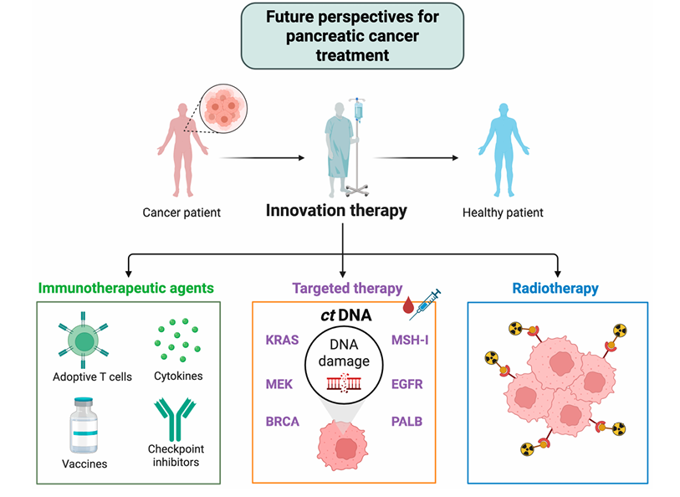

Conclusion
Multidisciplinary discussions are of paramount importance in the treatment of pancreatic cancer. The guidelines increasingly emphasize the role of biological and radiological risk factors, such as elevated Ca 19-9 levels, radiological lymph node involvement, and tumour size ≥ T3, as indicators of more aggressive disease biology.
For high-risk patients, neoadjuvant therapy with FOLFIRINOX may be the best option, while for low-risk patients, upfront surgery remains a valid choice. And the current evidence supports the use of neoadjuvant therapy as the standard of care for BR-PDAC.
Innovative therapy which includes immunotherapeutic agents, targeted therapy and radiotherapy will probably be the standard of care for pancreatic cancer management in the future.

Reference
- Siegel,R.L.; Giaquinto,A.N.; Jemal,A. Cancer statistics,2024. C A CancerJ.Clin.2024,74,12–49.
- Li, T.; Lin, C.; Wang,W. Global,regional,and national burden of pancreatic cancer from 1990 to 2021, its attributable risk factors, and projections to2050: Asystematic analysis of the global burden of disease study 2021. BMC Cancer 2025,25,189.
- Rahib,L.; Smith,B.D.; Aizenberg,R.; Rosenzweig,A.B.; Fleshman,J.M.; Matrisian,L.M.Projectingcancerincidenceanddeaths to2030:
- The unexpected burden of thyroid, liver, and pancreas cancers in the United States. Cancer Res. 2014,74,2913–2921.
- Janssen,Q.P.;O’Reilly,E.M.;vanEijck,C.H.J.; GrootKoerkamp,B.Neoadjuvant Treatment in Patients with Resectable and Borderline Resectable Pancreatic Cancer. Front.Oncol. 2020,10,41.
- Tempero, M.A.; Malafa, M.P.; Al-Hawary, M. Behrman,S .W.;Benson, A.B. ;Cardin,D.B.; Chiorean,E.G.; Chung,V. ; Czito,B.;Del Chiaro,M. Pancreatic Adenocarcinoma, Version 2 .2021, NCCN Clinical Practice Guidelines in Oncology. J.Natl. Compr. Cancer Netw. 2021,19,439–457.
- Jang, J.Y.; Han, Y.; Lee, H.; Kim, S.W.; Kwon, W.; Lee, K.H.; Oh, D.Y.; Chie, E.K.; Lee, J.M.; Heo, J.S.; et al. Oncological Benefits of Neoadjuvant Chemoradiation With Gemcitabine Versus Upfront Surgery in Patients With Borderline Resectable Pancreatic Cancer: A Prospective, Randomized, Open-label, Multicenter Phase 2/3 Trial. Ann. Surg. 2018, 268, 215–222.
- Motoi, F.; Kosuge, T.; Ueno, H.; Yamaue, H.; Satoi, S.; Sho, M.; Honda, G.; Matsumoto, I.; Wada, K.; Furuse, J.; et al. Randomized phase II/III trial of neoadjuvant chemotherapy with gemcitabine and S-1 versus upfront surgery for resectable pancreatic cancer (Prep-02/JSAP05). Jpn. J. Clin. Oncol. 2019, 49, 190–194.
- Versteijne, E.; van Dam, J.L.; Suker, M.; Janssen, Q.P.; Groothuis, K.; Akkermans-Vogelaar, J.M.; Besselink, M.G.; Bonsing, B.A.; Buijsen, J.; Busch, O.R.; et al. Neoadjuvant Chemoradiotherapy Versus Upfront Surgery for Resectable and Borderline Resectable Pancreatic Cancer: Long-Term Results of the Dutch Randomized PREOPANC Trial. J. Clin. Oncol. 2022, 40, 1220–1230.
- Janssen, Q.P.; van Dam, J.L.; Bonsing, B.A.; Bos, H.; Bosscha, K.P.; Coene, P.; van Eijck, C.H.J.; de Hingh, I.; Karsten, T.M.; van der Kolk, M.B.; et al. Total neoadjuvant FOLFIRINOX versus neoadjuvant gemcitabine-based chemoradiotherapy and adjuvant gemcitabine for resectable and borderline resectable pancreatic cancer (PREOPANC-2 trial): Study protocol for a nationwide multicenter randomized controlled trial. BMC Cancer 2021, 21, 300.
- Groot Koerkamp, B.; Janssen, Q.P.; van Dam, J.L.; Bonsing, B.A.; Bos, H.; Bosscha, K.P.; Haberkorn, B.C.M.; de Hingh, I.H.J.T.; Karsten, T.M.; Van der Kolk, M.B.; et al. LBA83 Neoadjuvant chemotherapy with FOLFIRINOX versus neoadjuvant gemcitabine based chemoradiotherapy for borderline resectable and resectable pancreatic cancer (PREOPANC-2): A multicenter randomized controlled trial. Ann. Oncol. 2023, 34, S1323
- Jang, J.Y.; Han, Y.; Lee, H.; Kim, S.W.; Kwon, W.; Lee, K.H.; Oh, D.Y.; Chie, E.K.; Lee, J.M.; Heo, J.S.; et al. Oncological Benefits of Neoadjuvant Chemoradiation With Gemcitabine Versus Upfront Surgery in Patients With Borderline Resectable Pancreatic Cancer: A Prospective, Randomized, Open-label, Multicenter Phase 2/3 Trial. Ann. Surg. 2018, 268, 215–222.
- Motoi, F.; Kosuge, T.; Ueno, H.; Yamaue, H.; Satoi, S.; Sho, M.; Honda, G.; Matsumoto, I.; Wada, K.; Furuse, J.; et al. Randomized phase II/III trial of neoadjuvant chemotherapy with gemcitabine and S-1 versus upfront surgery for resectable pancreatic cancer (Prep-02/JSAP05). Jpn. J. Clin. Oncol. 2019, 49, 190–194.
- Versteijne, E.; van Dam, J.L.; Suker, M.; Janssen, Q.P.; Groothuis, K.; Akkermans-Vogelaar, J.M.; Besselink, M.G.; Bonsing, B.A.; Buijsen, J.; Busch, O.R.; et al. Neoadjuvant Chemoradiotherapy Versus Upfront Surgery for Resectable and Borderline Resectable Pancreatic Cancer: Long-Term Results of the Dutch Randomized PREOPANC Trial. J. Clin. Oncol. 2022, 40, 1220–1230.
- Janssen, Q.P.; van Dam, J.L.; Bonsing, B.A.; Bos, H.; Bosscha, K.P.; Coene, P.; van Eijck, C.H.J.; de Hingh, I.; Karsten, T.M.; van der Kolk, M.B.; et al. Total neoadjuvant FOLFIRINOX versus neoadjuvant gemcitabine-based chemoradiotherapy and adjuvant gemcitabine for resectable and borderline resectable pancreatic cancer (PREOPANC-2 trial): Study protocol for a nationwide multicenter randomized controlled trial. BMC Cancer 2021, 21, 300.
- Groot Koerkamp, B.; Janssen, Q.P.; van Dam, J.L.; Bonsing, B.A.; Bos, H.; Bosscha, K.P.; Haberkorn, B.C.M.; de Hingh, I.H.J.T.; Karsten, T.M.; Van der Kolk, M.B.; et al. LBA83 Neoadjuvant chemotherapy with FOLFIRINOX versus neoadjuvant gemcitabine based chemoradiotherapy for borderline resectable and resectable pancreatic cancer (PREOPANC-2): A multicenter randomized controlled trial. Ann. Oncol. 2023, 34, S1323.

PROF M BRAND

Current Optimal Management Protocols for Hepatocellular Carcinoma

Martin Brand
HCC management has shifted towards a stage-based, multidisciplinary paradigm where curative resection or transplantation remain cornerstones, supported by evolving locoregional and systemic therapies that extend survival and expand treatment eligibility. The BCLC remains the most widely used system guiding the MDT’s.

1. Diagnosis and Staging
- Imaging-based diagnosis: Multiphasic CT or MRI is the standard; biopsy reserved for indeterminate cases.
- Staging system: The Barcelona Clinic Liver Cancer (BCLC) classification integrates tumor burden, liver function (Child–Pugh or MELD), and performance status (ECOG).

2. Curative-Intent Options
- Surgical Resection: First-line in patients with preserved liver function (Child–Pugh A, no significant portal hypertension). Requires adequate future liver remnant. Five-year survival: 50–70%.
- Liver Transplantation: Best for patients within Milan criteria (single lesion ≤5 cm or ≤3 lesions each ≤3 cm, no extrahepatic disease). Downstaging with locoregional therapy possible. Five-year survival >70%.
- Ablation (RFA/MWA): For tumors ≤3 cm when surgery not feasible; outcomes comparable to resection in very-early-stage disease.

3. Locoregional Therapies
- Transarterial Chemoembolization (TACE): Standard for intermediate-stage HCC (BCLC B). Improves survival.
- Transarterial Radioembolization (TARE/Y-90): Option for portal vein thrombosis or TACE-refractory disease.
- External Beam Radiotherapy/SBRT: Emerging for non-surgical candidates or as a bridge to transplant.

4. Systemic Therapy
- First-line: Atezolizumab + Bevacizumab (preferred; superior OS vs sorafenib). Alternative: Durvalumab + Tremelimumab (STRIDE regimen). Sorafenib or Lenvatinib when immunotherapy contraindicated.
- Second-line: Regorafenib, Cabozantinib, Ramucirumab (AFP ≥400 ng/mL). Immunotherapy (nivolumab, pembrolizumab) in select patients.

5. Multidisciplinary and Perioperative Considerations
- MDT approach essential: hepatology, oncology, radiology, surgery, and transplant units.
- Perioperative optimization: Manage portal hypertension, treat viral hepatitis, optimize nutrition.
- Surveillance: Imaging and AFP every 3–6 months post-treatment.

Key Points
- Surgical resection is curative in selected patients with preserved hepatic reserve.
- Transplantation is the gold standard for cirrhotic patients within Milan criteria.
- Locoregional therapies play a bridging or palliative role.
- Systemic therapy now led by immunotherapy + anti-VEGF combinations.
- Multidisciplinary decision-making ensures optimal patient selection and sequencing.

DR S HOFMEYR

DR S BURMEISTER

DR S ODUNZE

DR R KHANYILE

DR S BASSA

DR T MOTHABENG

MANAGEMENT OF MAJOR ABDOMINAL TRAUMA IN PREGNANCY
Mr Thabo Mothabeng

INTRODUCTION
Over the years, trauma has remained a leading cause of non-obstetric maternal mortality, with a significant number of deaths directly related to injuries (kuhlman 1994, Aggarwal, 2018).
In South Africa the leading causes of trauma in pregnant patients are motor vehicle accidents and intimate partner violence; other common causes are falls and parasuicide.
The challenges of managing a pregnant injured patients are exacerbated by physiologic and anatomical changes, effects of radiologic exposure on the foetus and need for a multidisciplinary team and advanced care facilities to manage the these patients.
SCOPE OF PRESENTATION
This presentation briefly discusses an approach to the patient while considering the following points.
- Physiologic and anatomic changes in a pregnant patient.
- Evidence based approach to the management of maternal trauma
- Perimortem caesarean section
- General principles for the primary care giver
SUMMARY
Management of pregnancy trauma patient focuses on initial assessment and resuscitation of the mother according to priorities. The approach should focus on optimal management of the mother in order to ensure foetal wellbeing (Nel, 2018)
This should take into account physiologic and anatomic changes that require modifications of technique. Foetal monitoring throughout resuscitation is crucial.
References
- Richa Aggarwal, Kapil Dev Soni, Anjan Trikha Initial management of a pregnant woman with trauma 2018;8(2): 66-72
- Mattox KL, Goetzl L. Trauma in pregnancy. Critical Care Medicine 2005;33:S385-9
- Nel D. The pregnant trauma patient. South African Journal of Anaesthesia and Analgesia 2018;24(3)(Supplement 1)S21-S24
- Venu Jain, Radha Chari, Sharon Maslovitz, Dan Farine. Guidelines for the management of a pregnant trauma patient. Journal of obstetrics and gynaecology of Canada 2015;37(6):553-571
- Sarah J Kilpatrick. Initial evaluation and management of pregnant women with major trauma 2019 www.uptodate.com

DR M NYEMBE

Management of Septic Endovascular Prosthesis
Dr Musawenkosi Nyembe
28th Annual Controversies & Problems in Surgery

Introduction
Aortic/arterial endograft infection is rare but lethal. Reported mortality ranges from 18–30% overall and much higher with conservative therapy alone (1). Venous stent-graft infections are uncommon but can cause persistent sepsis and requiring complex reconstruction. Early recognition and multidisciplinary team (MDT) planning are critical to limb and life salvage.
Definitions and Diagnostic Framework
Use the Management of Aortic Graft Infection Collaboration (MAGIC) criteria to diagnose Vascular Graft/Endograft Infections (VGEI) (2).
Major categories: clinical, radiological, laboratory. Diagnosis requires at least one major criterion plus any additional criterion from another category.
Radiological imaging: CT angiography (first line), FDG-PET/CT (highly useful when cultures are negative or CT equivocal). Targeted ultrasound for venous graft surveillance (3).
Microbiology
Sampling from surgical wounds or adjacent tissues frequently proves inadequate, as these typically reflect colonising flora. Therefore, obtaining biopsies from the infected graft or adjacent tissues is essential. Aspirating perigraft fluid or abscesses under ultrasound or CT guidance is preferred (4). In addition to direct sampling, blood and wound cultures can yield important information when biopsies or aspirations are not feasible or accessible, however microorganisms identified in blood cultures do not consistently correspond with those present in excised vascular grafts or perigraft tissue cultures in cases of VGEI (4).
Common organisms: Staphylococcus aureus and epidermidis; Gram-negatives; polymicrobial with enteric fistulas; fungi (e.g., Candida) in complex/enteric cases
Clinical risk factors
Dividing early and late graft infections is controversial from a solely time-to-event point of view. European Clinical Practice Guidelines of treatment define early infections as those occurring within the first four months after implantation. Conversely, American Clinical Practice Guidelines suggest setting the threshold at two months. Breach of surgical sterility during intervention and bacterial wound colonization, contiguous spread from surrounding tissues, and bacterial colonization from atherosclerotic plaques or thrombus in the aneurysmal sack might be responsible for the majority of early infections. Clinical risk factors for vascular graft infection are classified into preoperative, intraoperative, postoperative and patient factors by Chakf, et al. and Anagnostopoulos.
Radiological imagine
Ultrasound
The main limitations of ultrasound (US) in thoracic and abdominal VGEIs are its high interrater variability, which leads to low sensitivity. However, experienced practitioners find it easy to perform ultrasound to identify VGEI. Used mainly for postoperative surveillance, duplex ultrasound for graft patency and to monitor for recurrent sepsis
CT Angiography
CT angiography is considered the gold standard for diagnosing VGEI. Reinders Folmer et al. reported in a meta-analysis sensitivity and specificity rates of 90% and 88%, respectively, and even higher rates when combined with single-photon emission computed tomography (SPECT).
FDG-PET/CT
FDG-PET/CT scans have been standardised by the European Association of Nuclear Medicine (EANM) and the Society of Nuclear Medicine and Molecular Imaging (SNMMI) to avoid interhospital discrepancies.
MR Angiography
The use of magnetic resonance angiography is limited to a small number of investigations. Shahidi et al. reported a sensitivity of 68% and a specificity of 98% in 40 patients with suspected abdominal aortic graft infections.
Laboratory investigations
Biopsies should be obtained from the infected graft or the surrounding tissues. Perigraft fluid or abscesses must be aspirated using ultrasound or CT guidance to ensure accurate sampling. Sampling from surgical wounds or neighbouring tissues generally indicates the presence of contaminant flora. The common aetiological organisms associated with VGEI include Staphylococcus aureus, Staphylococcus epidermidis, Gram-negative bacteria, and polymicrobial infections.
Microbiology
Bacteria such as staphylococci can produce biofilms, which hinder antibiotic treatment penetration and delay and decrease host reaction in VGEI. Microorganisms found within biofilm layers have different metabolic characteristics. Bacteria on the surface have an active metabolism and are sensitive to antibiotics, while embedded bacteria exhibit a slow metabolism and decreased sensitivity to antibiotic agents.
Principles of Management
Diagnostic planning
- Make an accurate diagnosis (MAGIC criteria)
- Resuscitation & heamodynamic stabilisation
- Broad-spectrum IV antibiotics (Cover staph and gram negatives)
- Multidisciplinary team (MDT) collaboration
  - Vascular surgery
  - Infectious diseases
  - Radiology/nuclear medicine
  - Anaesthesia/critical care
  - Plastic surgery (for coverage)
  - GI surgery (for enteric fistulas)
  - Dietitian (for nutrition)
- Decide: surgery vs conservative management
Surgical planning
Conservative strategies are reserved for patients unfit for surgery or patients with limited/localised infection amenable to graft preservation and soft tissue coverage. Complete graft explant with debridement is strongly recommended when feasible for cure (5;6)
Surgery
When to Operate (5;6)
- Uncontrolled sepsis or recurrent bacteraemia
- Aorto-enteric fistula or graft-enteric communication
- Mycotic aneurysm or impending rupture
- Purulence around graft, enlarging peri graft collections, pseudoaneurysm, haemorrhage or septic emboli
- Failure of conservative therapy
Operative Strategy
For Arterial Endograft Infections – Aorta (EVAR/TEVAR)
Complete explantation and radical debridement, with or without reconstruction, are necessary for treating arterial endograft infections of the aorta (EVAR/TEVAR). One option for reconstruction involves in-situ use of a rifampicin-bonded, gelatin-sealed Dacron graft, which is effective against staphylococci, accompanied by omental wrapping (5). Another reconstruction alternative is the use of a cryopreserved arterial allograft. In selected cases, autogenous venous conduits may also be employed. An extra-anatomic bypass, such as an axillo-bifemoral bypass, is considered when the operative field is heavily contaminated or when patient factors preclude in-situ reconstruction. Sueda et al. reported a successful TEVAR graft explantation with in-situ rifampicin-bonded Dacron and omental wrapping, with an uneventful follow-up period of 14 months. The literature summarised by Sueda et al. indicates that conservative management is associated with higher mortality; therefore, the consensus supports explantation when feasible.
Adjuncts to surgery, such as muscle flap coverage, can enhance the outcomes of vascular graft infection (VGEI). Graham et al. (2002) conducted a retrospective analysis involving 27 flaps for 24 septic graft sites, predominantly in the groin (86%), and reported a mortality rate of 0% alongside an overall limb salvage rate of 71%. Although this data primarily pertains to open surgical graft prostheses, the principles may be applicable when explanting septic endovascular prostheses. The omental flap is the preferred choice for in-situ aortic reconstruction, as it improves perfusion and provides immune containment (2;3).
Following the complete explant and clean in-situ reconstruction, a course of intravenous (IV) antibiotic therapy lasting approximately six weeks is typically necessary; a brief oral course should be considered thereafter. In some cases, longer courses or chronic suppressive therapy may be required. It is advisable to engage in multidisciplinary team (MDT) discussions with an infectious disease specialist.
Stents implanted in the supra-aortic trunks
Gold standard treatment involves the complete removal of infected prosthetic material, followed by in situ autologous reconstruction, typically using venous grafts. Alternative or adjunctive approaches may include debridement with stent relining and negative pressure wound therapy, combined with tailored antibiotics. Muscle flap coverage is also an option; however, it is infrequently used and generally suggested for particularly challenging cases. Conservative treatment, which relies solely on antibiotics, is rare and typically not recommended due to insufficient evidence (7).
Perini's (2025) meta-analysis indicated that explantation of infected stents was carried out in 18 of 21 cases, often followed by arterial reconstruction to restore blood flow. In some instances, initial endovascular management, such as embolisation, was attempted but frequently necessitated subsequent explantation. Outcomes varied, with some patients remaining alive and infection-free during follow-up, while others succumbed to complications related to the infection (8).
Key Takeaways.
When feasible, complete explantation with radical debridement and well-vascularized coverage offers the best chance of cure for infected endovascular grafts.
Conservative treatment can temporize in non-operative candidates but carries high rates of recurrent sepsis and need for further procedures.
In the groin, muscle flap coverage (sartorius) after debridement supports graft salvage in selected cases with excellent flap survival and limb salvage.
Venous stent-graft infections, though rare, require high suspicion for fistula and often mandate explant and reconstructive venous repair with prolonged antibiotics.
Prognosis depends on host factors (nutrition), hemodynamic status, presence of fistula, organism profile (fungal/resistant), and quality of source control.

References
1. Ulloa J, Moore W. Rutherford’s Vascular Surgery and Endovascular Therapy. In: Carotid body tumours. 7th ed. 1600 John F. Kennedy Blvd. Philadelphia: Elsevier; 2023. p. 1291–301.
2. Wouthuyzen-Bakker M, Van Oosten M, Bierman W, Winter R, Glaudemans A, Slart R, et al. Diagnosis and treatment of vascular graft and endograft infections: a structured clinical approach. Int J Infect Dis. 2023 Jan;126:22–7.
3. Caradu C, Puges M, Cazanave C, Martin G, Ducasse E, Bérard X, et al. Outcomes of patients with aortic vascular graft and endograft infections initially contra-indicated for complete graft explantation. J Vasc Surg. 2022 Nov;76(5):1364-1373.e3.
4. Hemelrijck MV, Sromicki J, Husmann L, Rancic Z, Hasse B, Carrel TP. Vascular graft infections. Vessel Plus. 2022;6:47.
5. Sueda T, Takahashi S, Katayama K, Imai K. Successful treatment of an infected thoracic endovascular stent graft. Gen Thorac Cardiovasc Surg. 2016;64:273–276.
6. Jeng EI, Ortiz D, Khan A, et al. Inferior vena cava stent-graft sepsis. Ann Vasc Surg. 2015;29:1451.e17–1451.e20.
7. Graham RG, Omotoso PO, Hudson DA. The effectiveness of muscle flaps for the treatment of prosthetic graft sepsis. Plast Reconstr Surg. 2002;109:108–116.
8. Perini, P., Wouthuyzen-Bakker, M., Lyons, O. T., Heinola, I., Catasta, A., & Lejay, A. (2025). Systematic review and meta-analysis of occurrence rate, treatments, and outcomes of vascular graft and stent infections in the supra-aortic trunks. European Journal of Vascular and Endovascular Surgery, 70, 377-387. https://doi.org/10.1016/j.ejvs.2025.05.006

DR M SIKHOSANA

Surgery for Post Thrombotic Syndrome
Dr M H Sikhosana

A debilitating and difficult disease to treat, affecting not only the patient’s quality of life, but in severe cases results in significant disfigurement of the leg, Post Thrombotic Syndrome (PTS) is defined as a “set of signs and symptoms of chronic venous disease, due to the impairment of venous outflow in the deep venous system post deep vein thrombosis (DVT).”¹
Typical presentation includes signs of calf pain with compression, varicosities, oedema, and skin changes. Symptoms of venous claudication along with limb fatigue and heaviness are evident. Validated scoring systems such as the Vilalta score and Venous Clinical Society Score (VCSS) have been used to classify not only disease severity, but also severity of quality-of-life impairment for the patient. A score of >15 on the Vilalta score is graded as Severe PTS. ²
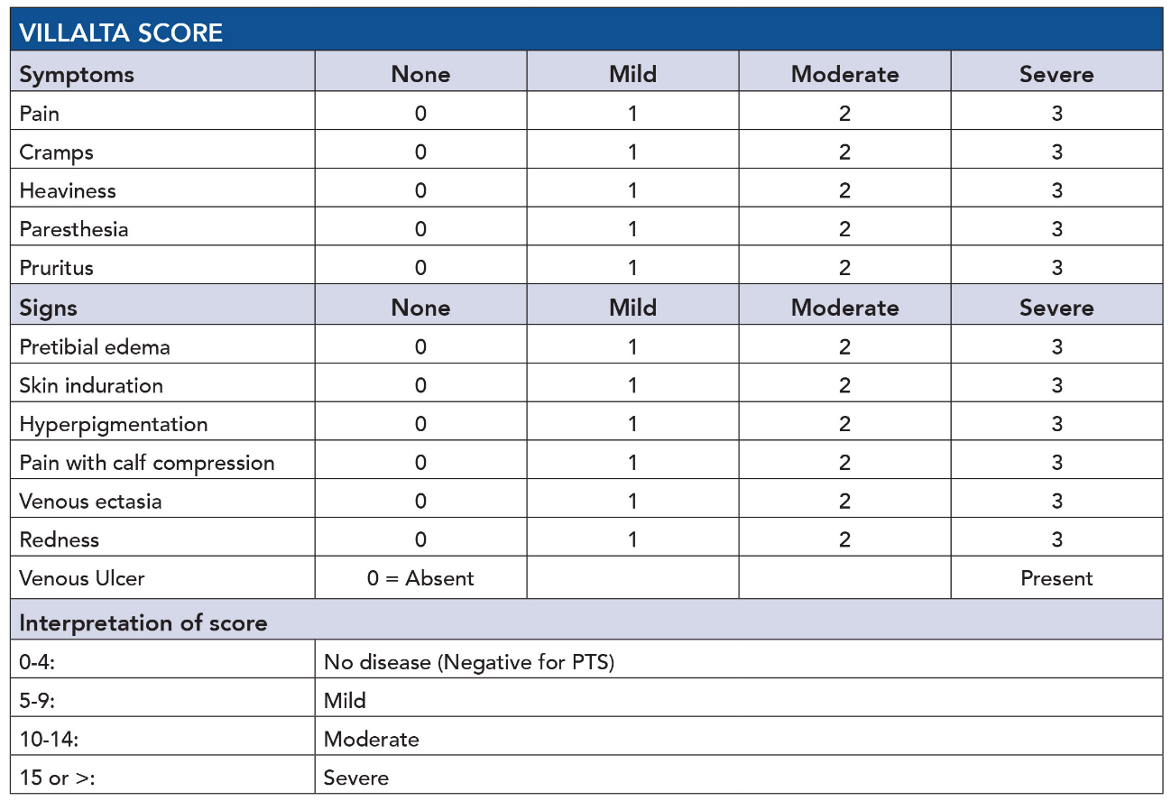

PTS occurs in 20-50% of patients with DVT, with an increased incidence in patients with an upper segment DVT (Ileo-femoral and common femoral vein). 5-10% of patients may develop severe PTS.³
Associated risk factors include: older age, large BMI, smoking, pre-existing disease of the superficial venous incompetence, upper segment DVT, recurrent ipsilateral DVT, residual venous obstruction, sub-therapeutic anticoagulation.³
Conservative management is the mainstay treatment and involves below knee graded elastic compression therapy, supervised exercise therapy to improve the calf pump function and wound care in cases with venous leg ulcers.¹
Surgical approaches for PTS can be divided into 2 groups: Preventing PTS and Treating PTS. ⁴
Preventing PTS:
The aims of these procedures are to not only reduce the thrombus burden, but also maintain vein patency thus correcting venous hypertension. The “Open Vein hypothesis” implies that with early thrombus clearance, and restoration of venous outflow in the proximal venous system, PTS may be prevented.⁵
Endovenous or open surgical options (thrombectomy) may be offered to patients. Endovenous surgical interventions include:
- Pharmaco- mechanical catheter directed thrombolysis +/- aspiration
- Ultrasound assisted/accelerated catheter directed thrombolysis
- Balloon venoplasty
- Venous stenting
A Class IIa recommendation from the ESVS guidelines, “patients with iliac vein outflow obstruction and severe symptoms/signs, endovascular treatment should=d be considered, as a first-choice treatment.”¹
Key points from The Catheter-directed thrombolysis (CDT) for deep Vein Thrombosis (CaVenT) study from 2012, were a significantly lower rate of PTS development in patients who received catheter directed thrombectomy in comparison vs the conservative management group (compression stockings and anticoagulation) at 24 months (41.1% vs. 55.6%, p = 0.047). It is however imperative to mention that there was a higher bleeding rate (22.2%) in the intervention group. A higher rate of iliofemoral patency at 6 months in the CDT arm (65.9% vs. 47.4%, p = 0.012) was identified, with a reduction in PTS in the intervention arm still maintained at 5-years (43% vs. 71% p < 0.0001). Quality of life remained no different between the 2 groups.⁶
The Acute venous Thrombosis: Thrombus Removal with Adjunctive Catheter-directed Thrombolysis (ATTRACT) trial from 2017 was a much larger RCT that looked at catheter directed thrombus removal and thrombolysis along with anticoagulation to prevent the development of PTS. No significant difference was identified in the rate of PTS in the intervention group when compared with the standard therapy group at 6–24 months (46.7% vs. 48.2%, p 0.56). There was also no real difference in disease-specific or quality of life improvement between the two groups at 24 months. the rate of moderate-severe PTS (Villalta score >10), was significantly lower in the intervention group when compared with the standard therapy group (18% vs. 24%, p 0.04).⁷
The Ultrasound-accelerated CAtheter-directed thrombolysis Versus Anticoagulation for the prevention of post-thrombotic syndrome (CAVA) trial from 2020, although underpowered (n=184), noted no reduction of PTS after additional ultrasound‐accelerated catheter‐directed thrombolysis in patients with acute iliofemoral deep vein thrombosis at 1‐year follow‐up (28.6% vs. 34.7%, p 0.42).^{8,9}
It is however important to note that in the intervention group, 41 (53.2%) were a success (restoration of vein patency). There was in improvement in disease-specific (VCSS: 3.50 vs. 4.82, p 0.02) and quality of life scores (EQ5D 40.2 vs. 23.4, p 0.007).⁹
Open surgical thrombectomy has fallen out of practice, since the advancement of endovenous intervention has occurred.

Treating PTS:
Endovenous interventions include the following:
- Balloon venoplasty
- Venous Stenting
Open surgical procedures aimed at improving venous outflow include:
- Venous bypass
- Endophlebectomy
- Patch venoplasty, with creation of an AV fistula to maintain patency
A hybrid approach may be endeavoured. Measures to prevent venous reflux include:
- Segmental vein valve transfer/transposition
- Valvuloplasty (internal or external)
- Neo-valve reconstruction (e.g. Maleti)
There a limited high powered RCTs that look at endovenous intervention in established PTS. A study by Rossi et al, noted that at 6 months, a reduction in VCSS in the iliac stenting arm when compared to the best medical therapy alone arm (18.5 to 11 vs. 15 to 14, p < 0.001) was present. A significant improvement in the VAS pain score and quality of life was also evident. Importantly, it is imperative to mention that this trial had a small number of patient (n=58) and mainly recruited non-thrombotic iliac vein lesions (73.4%), with as few as 16 (27.6%) of participants having PTS.¹⁰
Williams et al, looked at a series of meta-analyses where venous stenting was employed in patients with established chronic lower limb vein occlusion/obstruction or IVC. Symptomatic improvement and venous ulcer healing were identified in 79% and 71% of patients accordingly.¹¹
No RCTs or high-powered, high-quality studies are available for open surgical intervention for PTS.
A review by Bond et al, of 27 publications with moderate-severe PTS (n=317), found that open surgical intervention could be effective where conservative and medical treatments have failed.¹²
PTS is a challenging condition to manage and treat for both the patient and the surgeon. A large body of literature has leaned towards the prevention of PTS. The mainstay of treatment however remains, graduated elastic compression therapy and or anticoagulation where appropriate. Endovenous intervention is a feasible option to assist with symptomatic improvement in the prevention of PTS, but more high-quality research and data is required for open and endovenous management of established PTS.

References:
- European Society for Vascular Surgery (ESVS) 2022 Clinical Practice Guidelines on the Management of Chronic Venous Disease of the Lower Limbs. EUROPEAN JOURNAL OF VASCULAR AND ENDOVASCULAR SURGERY, vol. 63, no. 2, W B Saunders Co LTD, 2022, pp. 184–267.

- Soosainathan, A., Moore, H. M., Gohel, M. S., & Davies, A. H. (2013). Scoring systems for the post-thrombotic syndrome. Journal of Vascular Surgery, 57(1), 254-261

- Khan SR, Comerota AJ, Cushman M. et al. The post thrombotic syndrome: evidence -based prevention, diagnosis, and treatment strategies: a scientific statement from the American Heart Association. Circulation. 2014; 130:1636-61

- Machin, M., Salim, S., Tan, M., Onida, S., Davies, A., & Shalhoub, J. (2021). Surgical and non-surgical approaches in the management of lower limb post-thrombotic syndrome. Expert Review of Cardiovascular Therapy,.19(3), 191–200.

- Li Wenzhu, AU Vedantham, Suresh, AU. Revisiting the Open Vein Hypothesis to Reduce the Postthrombotic Syndrome: Implications for Multidisciplinary Care and Research: A Scientific Statement from the American Heart Association. American Heart Association. 2025; vol 151: 1051-10711

- Haig Y, Enden T, Grøtta O, et al. Post-thrombotic syndrome after catheter-directed thrombolysis for deep vein thrombosis (CaVenT): 5-year follow-up results of an open-label, randomised controlled trial. The Lancet Haematology. Dec. 2020; Feb 1;3(2):64–71

- Vedantham S, Goldhaber SZ, Julian JA, et al. Pharmacomechanical Catheter-Directed Thrombolysis for Deep-Vein Thrombosis. N Engl J Med .2017 Dec;377(23):2240–2252.

- Notten P, Ten Cate-Hoek AJ, Arnoldussen CWKP, et al. Ultrasound-accelerated catheter-directed thrombolysis versus anticoagulation for the prevention of post-thrombotic syndrome (CAVA): a single-blind, multicentre, randomised trial. Lancet Haematol. 2020 Jan 1;7(1):40–9.

- Notten, Pascale, de Smet, André A. E. A, Tick, Lidwine W., van de Poel, Marlène H. W, Wikkeling, Otmar R. M. CAVA (Ultrasound‐Accelerated Catheter‐Directed Thrombolysis on Preventing Post‐Thrombotic Syndrome) Trial: Long‐Term Follow‐Up Results. J American Heart Association. 2021 vol(10), issue 11

- Rossi FH, Kambara AM, Izukawa NM, et al. Randomized double-blinded study comparing medical treatment versus iliac vein stenting in chronic venous disease. J Vasc Surg Venous Lymphat Disord. 2018 Mar 1;6(2):183–191.

- Williams ZF, Dillavou ED. A systematic review of venous stents for iliac and venacaval occlusive disease. Vol. 8, Journal of Vascular Surgery: venous and Lymphatic Disorders. Elsevier Inc. 2020;8(1)145–153.

- Rachel T Bond, Jacqueline M. Cohen, Susan R. Kahn. Systematic Review of the Surgical Treatment of Moderate to Severe Post-Thrombotic Syndrome. Blood. 2010. Vol (116). Issue 21

DR A MTHETHWA

Intravascular lithotripsy for Peripheral Arterial disease
Dr Anele N Mthethwa
Percutaneous angioplasty of heavily calcified peripheral vessels may result in less-than-optimal outcomes for vessel expansion, which can lead to unintended results of either vessel restenosis or dissection, mandating stenting.¹
Over the last decade, intravascular lithotripsy has gained significant strides as being one of the methods for vessel prep in peripheral arterial disease (PAD). It is imperative to note that the indications for surgical intervention in atherosclerotic PAD are:
- Disabling claudication with significant affectation of the patient’s activities of daily living
- Chronic Limb Threatening Ischaemia
In the last decade, a series of trials have looked at the efficacy of intravascular lithotripsy in peripheral arterial disease, in comparison to other commonly performed interventions including, plain old balloon angioplasty (POBA), drug coated balloon angioplasty (DEB) and Atherectomy.
Lithotripsy involves the fragmentation of calcified plaques on the vessel wall with acoustic shockwaves. Lithoplasty involves the addition of multiple emitters on a percutaneous balloon that release pulsatile energy to disrupt plaque, thus aiming to improve vessel patency and limit injury simultaneously.¹
The DISRUPT PAD I trial, was the 1st study to look at the safety and performance of shockwave lithoplasty. Results demonstrated significant stenotic resolution of the calcified femoral-popliteal vessel with minimal vessel trauma. Vessel patency was also noted 6 months post procedure.
The DISRUPT BTK II trial, assessed the efficacy of shockwave lithoplasty in below- the-knee (BTK) calcified arterial vessels in patients with Rutherford 3-5 disease. Outcomes of the study, demonstrated similar results as the DISRUPT PAD I trial, with improved residual stenosis, quality of life and wound healing post intervention. Minimal adverse events were identified 30 days post intervention.²
The DISRUPT PAD III trial, an RCT published in 2022, highlighted the following key findings:³
- Intravascular lithotripsy when compared to angioplasty, was more superior and had procedural success.
- At 1 year post procedure, intravascular lithotripsy was superior for primary patency followed by drug coated balloon treatment (80.5%) vs angioplasty (68.0%)
Previously described for use in coronary arterial disease,^{4,5,6} and although there is a body of evidence to suggest superior early and mid-term outcomes for intravascular lithotripsy treatment in calcified peripheral arterial disease, larger scale longer term studies are required to assess the long-term effects and primary patency rates.⁷

References:
- Brodmann M, Werner M, Brinton T. et al. Safety and Performance of Lithotripsy for Treatment of Calcified Peripheral Artery Lesions. JACC. 2017 Aug, 70(7) 908-910.

- Venita, C, Alexandra J. Lansky, Sameh S, Nicholas W, Shammas, P S, James P. et al. Thirty-day outcomes from the Disrupt PAD BTK II study of the shockwave intravascular lithotripsy system for treatment of calcified below-the-knee peripheral arterial disease. J vasc Surg, Vol 81, Issue 3, 2025, 710-719

- Gunnar T, Brodmann M, Bachinsky W. et al. intravascular Lithotripsy for Peripheral artery calcification: Mid-term outcomes from the randomized Disrupt PAD III trial. JACC Cardiovasc Interv.2021 Jun 28;14(12):1352-1361

- Hill J, Kereiakes D, Shlofmitz R. et al. Intravascular Lithotripsy for Treatment of Severely calcified coronary artery disease. JACC. 2022 Dec, 76 (22) 2653-2646

- Liang B, Gu N. Evaluation of the Safety and Efficacy of Coronary Intravascular Lithotripsy for Treatment of Severely Calcified Coronary Stenoses: Evidence from the serial Disrupt CAD trials. Front Cardiovasc Med. 2021 Aug 19; 8:724481

- Pier Pasquale Leone, Sartori S. et al. Rotational Atherectomy with or without Intravascular Lithotripsy for patients with heavy coronary artery calcification. The American Journal of Cardiology. 2025. 255 (41-48)

- Vasquez Sosa CE, Malik A, Sreenivasan J, Shah A. et al. Intravascular Lithotripsy in Peripheral Artery Disease. Cardiol Rev.2024. Jan-Feb 01;32(1): 71-74

DR H WAIN

University of Pretoria Controversies 2025

Talk: Thromboprophylaxis in Trauma: What are the challenges?

Howard Wain
MBBCh, FCS(SA), MMed (Surgery), Cert Trauma (SA), Ph.D
Netcare St Anne’s Level 1 Trauma Unit
University of KwaZulu Natal Department of Surgery

Definition of the problem

The term venous venous thrombo-embolism (VTE) encompasses both deep vein thrombosis (DVT) and pulmonary embolism (PE). Although both disease process are somewhat distinct, they exist along the same continuum and are therefore frequently spoken of as a single entity, in particular in the realm of prevention. The incidence of VTE in hospitalized trauma patients ranges from 1-75% depending on the exact patient subset, and the degree to which screening in undertaken. The wide variance in this incidence indicates the difficulty in variations in screening practices. Of importance, approximately 7% of VTE is diagnosed within the first 24hours post injury, and 6% of PE in blunt trauma patients occur within 24hours of admission. Significant numbers occur is those with injury severity scores (ISS) <9. This is concerning given that, in general, very few trauma patients receive thromboprophylaxis within 24hours of injury, and lower injury severity has frequently been considered to lower the risk of VTE in trauma.

We can all agree that VTE prophylaxis is a real clinical challenge, has medico-legal implications, is a contentious inter-disciplinary issue, and is certainly a good exam questions from intermediates through to sub-specialist level. Unfortunately, the available literature is unclear, and there is no ‘one size fits all’ approach to the problem.

Trimodal distribution of Trauma Deaths

Trauma deaths are typically described to occur in three stages:
- Deaths on scene, mainly from overwhelming blunt trauma usually from massive head injury or cardiac rupture.
- Exsanguination (within hours) – bleeding/clotting issues
- Organ failure ± sepsis – frequently bleeding/clotting issues.

An imbalance between coagulation and fibrinolysis is often involved in morbidity and mortality post trauma.

VTE risk in trauma

Virchow’s Triad
- Endothelial injury
- Hypercoagulation
- Stasis of flow
All three of these may exist in the trauma patient.

Specific VTE risk factors in Trauma
- Long bone fractures (esp. pelvis and femur)
- Spinal cord injuries
- Traumatic brain injury
- Major surgery
- ICU admission
- Mechanical ventilation
- Delayed mobilization

Acute Traumatic Coagulopathy

ATC was previously referred to as acute coagulopathy of trauma shock, however this was misleading as the patient does not have to be shocked to develop ATC.
ATC develops in approximately 30% of trauma patients. It often starts as a hypercoagulable state, distant to the site of any injury, and frequently starts within an hour of injury. It is not simply a problem of factor dilution or depletion, but is rather promulgated through activated protein C, and seems to have a genetic aspect.

There are two distinct phases seen;
- Early hyperfibrinolysis (as evidence in the findings of CRASH II and CRASH III)
- Later hypercoagulability

Post trauma, some patients will demise, and some will exsanguinate in hospital. They seldom present a challenge on the VTE front. The challenging group are those that survive their trauma (hopefully the majority!), They may cycle through various stages of hypercoagulation, hypocoagulation, become hypercoagulable again, and ultimately return to normal homeostasis. The greatest challenge is the timing of these cycles, and predicting at what stage our patient finds themselves in.

Striking the balance

It is easy to recognize that VTE prophylaxis is a need in trauma patients., however we are equally concerned (and correctly so!) about the risk of bleeding. Getting the timing of VTE prophylaxis right is the dilemma; too early and bleeding is a problem, but too late and thrombosis is a problem. Both can be deadly, and both are medico-legally tricky.

VTE Scores in Trauma

Several VTE risk scores exist, including Wells’ Score, Parkland Protocol, Pradua Score, Caprini Score, Trauma Embolic Scoring System, and the Greenfield Risk Assessment Profile. Scores are attractive as they offer objective measures of a certain metric. Unfortunately, these scores have limited utility in trauma as they mostly rely on pre-test probability assessments, which are flawed in the trauma population, and the influence of ATC further confounds matters.

The Ownership Problem

Trauma is a complex discipline in which several players must co-exist. Conflicting opinions about VTE prophylaxis is a real challenge, There is lack of standardization of protocols, especially in high risk subgroups. Sporadic monitoring of VTE and clexane effects further confuses matters. In essence, nobody wants to take the lead and no one wants to make a decision.

The end result is delay.

VTE Prophylaxis options

Several option exist, in three broad categories.
- Early mobilistaion
- Mechanical prophylaxis
  - Intermittent pneumatic compression
  - Graduated compression stocking (very limited utility in trauma)
- Systemic prophylaxis
  - IV – unfractionated heparin (uncommon)
  - s/c – low molecular weight heparin (enoxaparin)
  - PO – warfarin and DOACs (not in acute trauma)

Early Mobilization

“He’s up and about so let’s stop clexane” is a phrase we’ve all heard.

Mobilization only addresses the stasis aspect of Virchow’s Triad, and is the aspect which seems to have the least impact. Several small studies claimed benefit, although they are not trauma patients and did not have patched cohorts. In several large meta-analyses there is no demonstratable benefit in early mobilization of trauma patients with respect to prevention of VTE.

Early mobilization alone post trauma is not adequate to prevent VTE.

Clexane (enoxaparin)

Clexane is by far the most commonly used agent for VTE in trauma. It works by activating antithrombin III, and thereby indirectly inhibits factor Xa. It has a definitive advantage is limiting both DVT and PE in the trauma population, and its effect is far more predictable than unfractionated heparin.

Despite the initial marketing success of clexane, it has become increasingly clear that its effect is influenced by patient weight, renal function, and disease process (ie trauma vs sepsis vs medical). Of late, many guidelines have promoted the use of anti-factor Xa assays to monitor the effect of clexane in a particular patient, given the variability with which it works.

Both the AAST/ACS and WEST guidelines for VTE prophylaxis in trauma specifically advocate for higher doses of clexane in trauma, although neither strongly suggest anti-factor-Xa monitoring. Blood for this assay is drawn 4hours after the third dose. Whether achieving target anti-Xa levels actually correlates to decreased VTE in the trauma papulation is an area of ongoing study, and is likely the cause of the absence of recommendations for routine monitoring in major guidelines.

Clexane dosing for VTE prophylaxis in trauma is 0.4 to 0.6 mg/kg BD.

VTE Literature challenges

Most studied on VTE in trauma are retrospective. Most prospective observational studies are severely limited by significant inter-facility variations in VTE prophylaxis practices, which limits the utility if the outputs. Randomisation for the purposes of research is notoriously tricky in trauma cohorts, as consent in emergency settings is fraught with legal and ethical hurdles. As a result, most studies are able to suggest correlation, but not demonstrate causation. In addition, some critics cite that increased VTE screening during studies will result in higher VTE detection rates than in the standard clinical situation.

VTE in Traumatic Brain Injury

Clexane is certainly the preferred agent for VTE in the TBI population. The most recent AAST guidelines suggest VTE within 24-72hours of a ‘stable CT’, with reduced VTE rates and no increased rates of intracerebral haemorrhage. The WEST guidelines suggest clexane 24hours post surgical intervention or ‘stable CT’, and advise against VTE prophylaxis beyond 72hours post injury.

Defining ‘stable CT’ is a challenge.

In reality, most centers will use mechanical prophylaxis alone until the end of neuroprotection, at which time clexane is usually commenced.

VTE post Damage Control Surgery
Hypocoagulability usually resolves within 24hours of surgery, after which these patients may become prothrombotic. Platelet and PTT measures are not helpful in determining the resolution of coagulopathy. TEG/ROTEM is the best test to assess coagulation status post DCS.

Most guidelines advocate for the introduction of VTE prophylaxis once ‘stable’ with no signs of active bleeding.

VTE post Blunt Solid Organ Injury

The management of blunt solid organ injuries is becoming increasingly conservative, even in higher grade injuries. The AAST guidelines from 2023 advocate for VTE prophylaxis 24 – 48hours post injury, although there is more evidence for AAST 1-3 injuries. AAST4 or 5 injuries are more contentious. Where injuries have been managed operatively, then VTE prophylaxis is advocated as soon as control is achieved.

What must be remembered is that most guidelines are from the developed world, with easy access to angioembolization services, and so they may not be directly applicable in RSA where we cannot as easily deal with a delayed bleed should one arise. In addition, the applicability of early VTE prophylaxis in a packed liver is debatable.

Ethical issues in VTE prophylaxis

It is easy to say “let’s hold off on clexane for one more day, just to be safe”, and is a phrase we have all used. However VTE related deaths are increasingly being considered as preventable. If we give clexane too early and a patient bleeds we blame ourselves, yet if we delay and then die from a PE, we say something like “well she was very high risk, trauma is bad for you.”

Given the increasing attention that VTE related morbidity and mortality is receiving, trauma practitioners need to seek evidence and develop sound local practices such that VTE prophylaxis is instituted early, at the correct dose, and in the correct patient.

Future directions

The trauma surgeon is ideally situated to lead the charge for proper VTE prophylaxis. It must be an active discussion point between disciplines, and all must consider that a neutral decision is actually a decision to delay.

Weight based dosing of clexane is important, and we should probably be doing more anti-factor-Xa assays than we currently do. In general, clexane within 24hours of injury or ‘stabilization’ is reasonable.

Finally, whilst bleeding is bad, thrombo-embolisms may be even worse!

PROF P NAVSARIA

Contrast-Enhanced Ultrasound (CEUS) in Trauma

Where It Fits Now (and How to Use It)

Pradeep H Navsaria

Trauma Surgeon, Groote Schuur Hospital and University of Cape Town

What is CEUS?
Contrast-enhanced ultrasound (CEUS) is real-time ultrasound performed after a tiny IV bolus of gas-filled microbubbles (most commonly sulphur hexafluoride in a phospholipid shell). These agents remain strictly intravascular, function as pure blood-pool tracers, and wash in and out over arterial, portal/venous, and late phases—letting you “see” perfusion and parenchymal disruptions dynamically, without ionizing radiation and without nephrotoxicity. Modern agents (e.g., Lumason®/SonoVue®) are generally well tolerated; serious hypersensitivity reactions are rare (reported on the order of ~1 per 10,000 administrations), but resuscitation capability is required, and patients are monitored during the first 30 minutes post-injection.

The clinical niche of CEUS in trauma (adults and children)
Why we needed something between FAST and CT.
- FAST/eFAST is fast, portable, and great for detecting free fluid, but it misses many solid-organ injuries—especially when there is no hemoperitoneum. Pooled sensitivity for intra-abdominal free fluid is ~70–76% with specificity ~95–98%; not reliable to rule out injury in stable patients.
- Contrast CT remains the gold standard for comprehensive injury mapping in hemodynamically stable patients, picking up parenchymal, mesenteric, bowel, retroperitoneal, and active bleeding. But CT uses ionizing radiation and iodinated contrast, and in paediatrics we especially want to reduce exposure. Major guidelines continue to place CT as first-line in stable polytrauma; ultrasound (including CEUS) has defined supportive roles.
What CEUS adds.
- Substantially improves US for solid-organ injury detection (liver, spleen, kidney, pancreas) versus grey-scale US—and approaches CT for parenchymal injuries in many studies. A 2017 meta-analysis found CEUS sensitivity ~0.98 for solid-organ injury; a 2023 systematic review concluded CEUS outperforms conventional ultrasound as an initial assessment for blunt abdominal trauma.
- Operative/IR decision support: detects active bleeding signs (contrast extravasation), devascularization, pseudoaneurysm or evolving complications during non-operative management (NOM)—often reducing repeat CT.
- Peadiatrics: growing evidence shows high diagnostic accuracy and safety; CEUS is increasingly used to reduce CT for stable children with suspected solid-organ injury or for NOM follow-up. Recent podiatric meta-analysis and position statements support its use in carefully selected cases.

What CEUS does not replace.
- Polytrauma surveys (e.g., whole-body screening for chest, spine, pelvis, bowel/mesentery) → CT remains necessary in stable patients when mechanism and exam warrant comprehensive evaluation. CEUS is limited in bowel/mesenteric injury and retroperitoneal gas/bowel findings.

Evidence at a glance (selected pooled performance)
- FAST/eFAST (free fluid): Sensitivity ~74–76%; specificity ~95–98% (large 2019 meta-analysis; similar in hypotensive and paediatric subgroups). Not suitable to rule out intra-abdominal injury in stable patients.
- CEUS (solid-organ injury): Meta-analyses and large series report sensitivity ~95–98% and specificity ~94–99% vs reference standards, markedly higher than conventional US and often near CT for parenchymal injuries in stable blunt trauma.
- Contrast CT: Remains the gold standard for stable trauma: detects parenchymal, vascular, mesenteric and bowel injuries and active bleeding; the reference test for grading and NOM planning.

A pragmatic algorithm (adults & peadiatrics; blunt torso trauma)
- Primary survey (ATLS) & hemodynamics
  - Unstable or peri-arrest → eFAST at bedside.
• Positive free fluid/pericardial fluid → Operative/IR as indicated.
• Negative/indeterminate but ongoing shock → manage per clinical picture; do not rely on a negative FAST to exclude injury.
- Stable or stabilized patient (no immediate OR/IR need)
  - Polytrauma/high-energy mechanism or suspicion of bowel/mesenteric/retroperitoneal injury → Contrast CT (portal venous ± arterial phases) as first-line.
  - Isolated blunt abdominal trauma with high suspicion of solid-organ injury, especially paediatrics or when CT access is limited / radiation reduction is a priority:
• Do CEUS to evaluate liver/spleen/kidneys/pancreas.
• If CEUS positive: manage per injury grade; CT if lesion complexity, vascular injury, or multi-territory assessment is needed.
• If CEUS negative but clinical concern persists (pain, mechanism, labs) → CT (or short-interval observation with labs + repeat imaging).
- Non-operative management (NOM) follow-up
  - Use CEUS to monitor laceration evolution, detect delayed bleeding or pseudoaneurysm, and guide mobilization/return-to-activity; reserve CT for equivocal CEUS or when bowel/mesentery/spine/pelvis concerns emerge.
- Safety & logistics
  - Screen for known hypersensitivity (incl. PEG); monitor with resuscitation capability for 30 minutes after injection. Avoid in patients with contraindications on the product label; no renal dosing adjustments needed.

Side-by-side comparison
Feature | FAST / eFAST | CEUS | Contrast CT
Primary role | Rapid detection of free fluid, pericardial effusion, pneumothorax at bedside | Characterize solid-organ injuries & active bleeding in real time without radiation; excellent for NOM follow-up | Comprehensive survey & grading in stable trauma; detects parenchymal, vascular, bowel, mesenteric, retroperitoneal injuries
Typical performance | IA free fluid: Sens ~74–76%; Spec ~95–98% (rule-in, not rule-out) | Solid-organ injury: Sens ~95–98%; Spec ~94–99% vs reference standards | Highest overall diagnostic yield for torso trauma; reference standard in stable polytrauma
Strengths | Immediate, portable, repeatable; guides unstable resuscitations | Near-CT sensitivity for parenchymal injuries; dynamic perfusion; no radiation; kid-friendly; bedside repeatability | Whole-body mapping; shows bowel/mesentery, retroperitoneum, spine; grades injury & shows active extravasation
Limitations | Misses many injuries w/o free fluid; operator dependent | Limited for bowel/mesentery, retroperitoneal gas; needs contrast vial, trained operator, monitoring | Ionizing radiation; iodinated contrast; availability/transport; less ideal for repeated checks
Best fits | Unstable patients to triage to OR/IR; adjunct in stable patients | Stable, isolated blunt solid-organ injury workup or NOM follow-up; radiation-sparing (esp. peds) | Stable polytrauma; suspected bowel/mesentery/retroperitoneal injuries; pre-IR/OR planning
Safety notes | No contrast; no radiation | Microbubble UEA; rare serious reactions (~1/10,000); no nephrotoxicity; monitor 30 min | Radiation; iodinated contrast (AKI risk, allergy)
Sources: FAST/eFAST meta-analysis (2019) for pooled accuracy; CEUS meta-analyses and systematic reviews; guideline statements for CT and the “gold standard” role. PubMedCambridge University Press & AssessmentBioMed CentralACR Search

Bottom line (how to think about it on call)
- If unstable → eFAST to rapidly find treatable bleeding; go to OR/IR when positive or when physiology dictates—do not “clear” the abdomen with a negative FAST.
- If stable polytrauma → CT remains first-line.
- If stable with likely isolated solid-organ injury (especially children) or for NOM follow-up → CEUS is the radiation-sparing, real-time perfusion study that meaningfully upgrades ultrasound and can safely reduce CT utilization—with excellent sensitivity for liver, spleen, and renal injuries.

Key references
- FAST/eFAST accuracy: Netherton et al., 2019 CJEM meta-analysis—abdominal free fluid sensitivity ~74–76%, specificity ~95–98%. PubMedCambridge University Press & Assessment
- CEUS in blunt trauma (adults): Meta-analysis/systematic review showing markedly higher accuracy than conventional US and near-CT detection for solid-organ injury.
- CEUS in pediatrics: Pediatric Radiology meta-analysis and society statements support selective use to reduce CT in stable children. UMB Journal
- CT as gold standard in stable trauma: WSES splenic trauma guideline; ACR Appropriateness Criteria for major blunt trauma. BioMed CentralACR Search
- CEUS agent & safety: FDA Lumason® label and contemporary safety review; rare serious reactions; PEG hypersensitivity contraindication; monitoring recommended. FDA Access Data+1PMC

PROF S MOENG

Chapter: Extracorporeal Membrane Oxygenation in Trauma Care

MS Moeng

Introduction
Extracorporeal Membrane Oxygenation (ECMO) has emerged as a valuable tool in the management of critically injured trauma patients, particularly those with severe respiratory or cardiac failure unresponsive to conventional therapies. Although its roots lie in the support of trauma patients, its use has historically been limited due to concerns around bleeding and contraindications to anticoagulation. Recent advancements in technology and understanding of ECMO physiology have challenged these assumptions, enabling its broader application in both civilian and military trauma settings.
ECMO provides cardiopulmonary support through the temporary external circulation and oxygenation of blood. It is most commonly employed in the venovenous (VV) configuration for respiratory failure and in venoarterial (VA) configuration for cardiac failure or combined cardiopulmonary compromise. The application of ECMO in trauma care demands careful consideration of patient selection, timing of initiation, and management by a multidisciplinary team.
The successful use of ECMO in trauma patients with conditions ranging from acute respiratory distress syndrome (ARDS) to penetrating thoracic injuries and inhalation burns has been documented. As trauma care evolves, ECMO has become an increasingly essential adjunct in centres equipped to manage complex, multisystem injuries.
This chapter outlines the physiological principles of ECMO, different cannulation strategies, key considerations in patient selection and management, and addresses common concerns regarding anticoagulation and neurological injury. Outcomes and special considerations in paediatric trauma are also discussed.

Physiology and configurations of ECMO
The primary indication for ECMO in trauma is refractory hypoxaemic respiratory failure, often due to ARDS. In VV ECMO, deoxygenated blood is removed from the venous system, passed through a membrane oxygenator, and returned to the venous circulation. This configuration is suitable when cardiac function is preserved and serves to provide oxygenation while enabling lung-protective ventilation strategies.
VV ECMO improves gas exchange and reduces pulmonary arterial pressures, indirectly supporting right heart function. It is especially valuable in trauma-induced lung injuries including contusions, aspiration, transfusion-related acute lung injury (TRALI), or resuscitation-associated capillary leak. It has also proven life-saving in cases of tracheobronchial injuries where ventilation is not possible.
Other configurations include veno-pulmonary artery ECMO for right heart support and VA ECMO for cardiogenic shock. VA ECMO returns oxygenated blood to the arterial system, bypassing both heart and lungs, and is used in cases of profound haemodynamic instability. A hybrid approach, venoarterial-venous (VAV) ECMO, can mitigate differential hypoxaemia seen with VA ECMO alone.
Cannulation options vary depending on patient size and clinical condition, ranging from peripheral percutaneous access to central surgical cannulation. The latter may be required when peripheral flow is inadequate or in small children where vessel calibre is limiting.

Indications, contraindications, and patient selection
The decision to initiate ECMO in trauma is complex and requires early multidisciplinary consultation. Indications include severe ARDS unresponsive to lung-protective ventilation and adjuncts (e.g., prone positioning, paralytics, pulmonary vasodilators), refractory hypoxaemia, massive airway injury, and cardiogenic shock.
Trauma-specific challenges include the presence of coagulopathy, active haemorrhage, and brain injuries. Historically, these were considered contraindications due to concerns over systemic anticoagulation. However, modern ECMO circuits and protocols have allowed for anticoagulation-free or minimised-anticoagulation ECMO in select patients, even those with traumatic brain injury (TBI) or active bleeding.
Evidence supports ECMO initiation early in the ARDS trajectory, particularly in patients who cannot undergo conventional adjuncts due to other injuries (e.g., open abdomen or unstable spine precluding proning). It makes sense why the services of Cardiothoracic services (CTS) with ECMO capabilities allows for management of complex traumatic cardiac injuries.
Referral centres often offer mobile ECMO services, enabling cannulation at outlying hospitals and transfer to ECMO-equipped centres. This model has expanded access and improved survival in critically injured patients previously deemed too unstable for transport.
What is emerging currently, is the eCPR concept. Where during CPR, ECMO is inserted to support the respiratory and the cardiac function. It has been shown to improve outcomes of CPR cases. However, the cause of the CPR should always be borne in mind. An acute trauma related CPR has a totally different outcome compared to a medical CPR, with the former associated with poor outcomes. It may be futile to consider such a modality in the former indication for eCPR.

ECMO cannulation, management, and complications
Cannulation for ECMO is a high-stakes procedure and should be performed by trained providers in appropriate settings. Ultrasound-guided percutaneous cannulation is the preferred method for VV ECMO, whereas surgical cutdown or central access may be necessary in complex cases.
Once initiated, ECMO requires meticulous monitoring. Hemodynamic parameters, ventilator settings, circuit flows, and gas exchange metrics must be reviewed continuously. Circuit components are prothrombotic, and even in the absence of anticoagulation, thrombosis risk must be balanced with haemorrhagic complications. Anticoagulation decisions should be individualised, particularly in the trauma setting.
Cannula fixation, prevention of migration, and daily imaging or visual assessment of cannula position are essential. Complications such as oxygenator clotting or pump failure may necessitate circuit exchange, a procedure requiring precise coordination and backup support.
Weaning from ECMO occurs once lung or cardiac recovery is sufficient to sustain adequate oxygen delivery and perfusion. This process must be carefully orchestrated with readiness to reinstitute support if needed.

Special considerations in Paediatric Trauma
Injuries remain the leading cause of death in children, and ECMO has an increasingly recognised role in paediatric trauma, particularly for ARDS and cardiogenic shock. Survival rates for paediatric ECMO in trauma approach 60%, comparable to non-trauma indications.
Cannulation strategies differ from adults due to vessel size. The internal jugular vein with dual-lumen cannula is increasingly preferred for VV ECMO, while jugular-carotid VA ECMO remains an option for cardiac support. Cutdown may be necessary given the small calibre of vessels in children.
Many paediatric ECMO cases occur in adult trauma centres, underscoring the importance of institutional readiness and staff training for managing critically injured children. Centres must ensure that ECMO equipment and personnel are appropriately prepared for paediatric physiology and cannulation techniques.

Outcomes and evolving paradigms
Data increasingly support ECMO use in trauma as safe and effective. Studies demonstrate improved survival in patients with severe ARDS managed with ECMO versus conventional strategies. Military experience, including forward ECMO in combat settings, highlights the feasibility of ECMO even in austere environments.
Importantly, ECMO should not be withheld in patients with TBI or bleeding if benefits outweigh risks. With the advent of heparin-free ECMO strategies and improvements in circuit design, the field has shifted towards more inclusive selection criteria.
The success of ECMO depends on early identification, appropriate patient selection, and management by a cohesive multidisciplinary team. Centres should develop protocols for rapid ECMO consultation, transport logistics, and circuit management, including contingency plans for emergencies.

Conclusion
ECMO represents a life-saving adjunct in the management of critically injured trauma patients with severe respiratory or cardiac failure. Its expanding use reflects growing evidence and improved outcomes, even in previously excluded populations such as those with coagulopathy or head injuries.
With proper team training, technological support, and multidisciplinary coordination, ECMO can be safely employed in both adult and paediatric trauma settings. Trauma clinicians should remain informed and proactive in considering ECMO as a viable intervention in the most severely injured patients.
References:

- Peek G, Mugford M, Tiruvoipati R. Efficiency and economic assessment of conventional ventilation support versus extracorporeal membrane oxygenation for severe adult respiratory failure. A multicentre randomised controlled Trial (CESAR). Lancet 2009;374:1351-1363
- Combes A, Hajage D, Capellier G, et al. Extracorporeal Membrane oxygenation for Severe Acute Respiratory Distress Syndrome (EOLIA). NEJM 2018;378:1965-1975
- Zhang Y, Zang L, Huang X, et al. ECMO in adult patient with severe trauma: a systematic review and meta-analysis
- Tonna J, Johnson N, Greenwood J, etc al. Practice and Characteristics of Emergency Department extracorporeal cardiopulmonary resuscitation (eCPR) programs in the United States. The Current state of the art of Emergency Department extracorporeal membrane oxygenation (ED ECMO), Rescuscitation;2016:38-46
- Lenazi A, Akjanoubi M, JYeung, etc al. Variability in patient selection criteria across extracorporeal cardiopulmonary resuscitation (ECPR) system: A systematic review. Doi:org/10.1016/j.resuscitation.2024.110403 accessed 18 June 2025

DR M TALATALA

ETHICAL CONCERNS OF ARTIFICIAL INTELLIGENCE IN THE PRACTICE OF MEDICINE
Author: Dr Mvuyiso Talatala
Introduction
Humanity is experiencing an era of rapidly improving artificial intelligence (AI) systems. AI is the technology that is composed of machines that are intended to mimic human intelligence. Medicine has not been spared from this AI revolution with AI arguably going to be better than a doctor’s brain in the future as it has the capacity to learn rapidly, store large amount of information and retrieve it when required.¹ Unlike AI, a doctor needs training over many years to master the required knowledge and the skills of practising medicine. Already there are areas of medicine where AI is better than human clinicians in diagnosis and treatment of patients. AI therefore does possess the capacity to acquire the factual knowledge of medicine and the required clinical skills. Despite this admirable capacity of AI to practise medicine there is a concern that it may lack the human touch that is critical in the ethical practice of medicine.² Consequently, there are ethical concerns about the use of AI in the field of medicine. To explore these ethical concerns, a brief description of some uses of AI in medicine will be provided as well as the associated ethical concerns and possible ways of dealing with these ethical concerns.
Brief overview of the uses of AI in Medicine
The uses of AI in medicine are vast and rapidly evolving. A detailed description of AI and its uses is beyond the scope of this chapter. However, a brief overview of the uses of AI in medicine is being provided as a background that is going to be used when exploring the ethical concerns.
AI has found use in public health and in many areas of medicine.³ In public health AI has found use in the management of outbreaks of diseases with functions that range from detection of outbreaks to contact tracing. In medicine AI is used for assessment and treatment of patients. AI can assist with taking history, formulating a diagnosis, suggesting investigations, providing a prescription, creating a code for the reimbursement of services, writing clinical notes and later providing a clinical report should this be necessary. AI can be used in fields such as dermatology, radiology, oncology and ophthalmology where image analysis is key to diagnosis.⁴
Several robots have been developed to provide AI driven clinical work. In surgery there are autonomous and semiautonomous robots that can perform surgical operations.⁵ These robots are introducing improved surgical skills and a potential for better outcomes. The ability of AI to analyse data may be used in surgery to plan for procedures, reduce theatre time and “furnish surgeons with real-time data, predictive analytics and decision-support mechanisms throughout intricate surgical operations”.²
Hospitals, medical schemes, and governments may use AI to assess doctors' performance to boost efficiency and cut costs.
For AI to be able to perform these vast and dynamic functions described above it must obtain confidential information from patients which it analyses and provide diagnosis, treatment or any other clinical utility that may be required from AI. AI also shares the information about patients with other AI systems in order for AI systems to learn, improve their skills and reduce bias. Each patient’s information therefore gets distributed and shared downstream by big data in. While data sharing by AI is important and may reduce some ethical concerns such as bias, it raises many other ethical such as informed consent, data security and privacy.⁶
Some ethical concerns of artificial intelligence in medicine
AI has been in development for many decades with the term AI having been “coined by John McCarthy in 1956”.¹ The recent evolution of AI has brought to the fore ethical concerns, some of which are worthy of consideration. However, like any new technology, there are concerns that with time will prove not have necessitated any serious concern. For instance, when fast trains came into operation there was a concern that the trains were too fast for the soul.⁷ Obviously, this moral concern about the effect of fast trains on one’s soul needs not be taken seriously anymore. The arrival of digital technology raised fear that it would destroy industries that make photographic film, cassette tapes, or vinyl records. These industries have indeed been destroyed by the digital technology. However, it is doubtful that there are people who miss cassette tapes as digital technologies have improved human lives.
While some ethical concerns with new technologies may be unusual and likely to have an effect on human lives, there are concerns that ought to be taken seriously. For instance, the arrival of motor vehicles improved the mobility of human beings, but it brought along some ethical concerns such as motor vehicle accidents and the environmental ethical concerns such as pollution.
With regards to AI, one ethical concern that is likely to persist but may with time prove not to have been necessary is our fear that AI poses an existential to medicine. It is argued that with advances in AI there will come a stage where there will be no need for doctors as AI will assume all duties of a doctor and be more efficient and more liked by patients. It is thought that in future there will be hospitals that are fully operated by AI. This concern is expressed even for fields like psychiatry where soft skills of medicine are required. In psychiatry, the therapeutic relationship is one of the healing ingredients and yet it is argued that AI will master this skill.⁸ It is argued that AI can in the future provide individualised care and continuity of care from primary health care services to quaternary which is impossible with human clinician. With AI fully operational there will be no fragmented healthcare services from one level of care to the next. “Over time then, patients’ trust could be earned and maintained, rather than being repeatedly fractured with every handover. Thus, people may well find AI-led care to be paradoxically more humane than the status quo of [medicine] today; in their desire to be understood and treated to the best of scientific understanding, they will willingly choose AI over its flesh-and-blood alternative”.⁸ Human beings will find it easy to express themselves to a machine that may not be judgemental like a human doctor.
This argument that AI will result in the extinction of medicine as we know it is countered by the belief that patients will still need a human touch as AI will have difficulty mastering the nuanced approach of human doctors.⁸ As AI masters human intelligence, it will also acquire the imperfections of human beings. Patients will start realising that AI is as fallible as their human doctors and yet not as accountable as human doctors for unethical conduct. This will then demand that there be a doctor who takes responsibility and accountability for the actions of AI. Besides the issue of accountability, AI still has a long way to travel before it overcomes other challenges such as data bias, dealing with uncommon patterns and dealing with new tasks that have never been encountered by human beings.⁸
Besides this ethical concern of the existential risk of medicine which should not be taken seriously, there are several ethical concerns that have been raised regarding AI. These ethical concerns include bias, data security, confidentiality, consent, respect for autonomy, privacy, discrimination, fairness, responsibility and many others. With regards to surgical disciplines Rad (2025) explores the following ethical considerations with regard to AI:²
- Decision making authority - The ethical consideration in decision making authority is whether the surgical decision on patient management should be made by the treating surgeon or the AI system. If the decision-making authority is AI, the difficult ethical question we are left with is who is accountable for the decisions made by AI in the management of a patient.
- Data privacy and security - Protection of personal and confidential information is important in healthcare. However, AI needs to share information with other AI systems as part of its training and to reduce bias. This downstream sharing of information on big data may compromise patient confidentiality, privacy and data security.
- Bias and fairness - There is ongoing concern about bias within AI systems based on the population the AI system use for training. Rad (2025) argues that “an additional ethical concern is the potential for intrinsic biases within AI algorithms. The impartiality of AI systems is contingent upon the neutrality of the training data. Should these data embody historical prejudices, such biases may be replicated in surgical advisories”. This argument is applicable to other fields of medicine where race, language, socioeconomic status and other demographic factors need to be incorporated in the training of AI.
- Justice and fairness could be compromised if equitable access to AI across different populations is not ensured. We may find a situation where populations from low-income countries may be left behind on the advances in AI.
- Equitable access may not be ensured amongst different countries and between different income groups within a country.
- Surgeon training and education - With regards to the use of AI for training and education there is a risk “that over-reliance on AI simulations could reduce essential hands-on experience needed for real-world skills” (Rad). Rad suggests that in training doctors there should be a combination of training that is based on humans and AI driven training.
- Legal and ethical frameworks – ethical and legal responsibilities are of concern in the use of AI in medicine. Rad (2025) cautions about the risk of “a robotic surgery system autonomously modif[ying] a surgical technique during a procedure and this lead[ing] to a complication. In that scenario “the delineation of accountability becomes blurred”.

Dealing with some of the ethical concerns about AI in surgery
The medical profession must embrace AI while cognisant of the ethical concerns. The profession of medicine will not go extinct because of AI, and this has been argued above. Ethics in AI must be a concern for designers of AI, the AI system itself and the end users of AI. Ethical thinking must be incorporated in the entire value chain of AI. The views of patients and the communities should also be considered.² AI must be trained in different populations of patients in order to reduce bias.
Governments, professional bodies of doctors and the Health Professions Council of South Africa (HPCSA) should provide guidance to the profession of medicine with regards to legal and ethical issues that are related to AI. Such guidance should be in the form of ethical codes and guidelines as well as the development of law that is keeping up with the evolution of AI. In 2024 HPCSA published Booklet 20 which provides an ethical guideline on the use of AI in medicine. This guideline does provide guidance to the profession on some of the ethical concerns that have been raised in this chapter.
To deal with issues of patients’ consent newer ways of obtaining consent should be explored. The consent obtained from a patient should explicitly state the extent to which the information of the patient can be used within an AI system. The patient should also be made aware about the downstream sharing of information by AI. Informed consent in AI extends from the consent to use AI for a specific consultation to the use of that information downstream. The patient must have an option to decline the use of AI in the consultation as well as sharing of their information. Even if the patient does provide consent, such a consent should state the extent to which it is applicable in that consultation. For instance, there could be an option for the patient to give permission for the use of their information downstream without requiring the patient to provide further consent. However, a more dynamic approach where the patient is asked to provide consent each time their information is being used is also an option Savulescu J (2024).⁶
Conclusion
We are in interesting times with regards to technology. AI is offering a multitude of opportunities for medicine that could improve efficiency, reduce cost and improve outcomes in clinical care. It is also an opportunity for all stakeholders in patient care including the ethicists and patient themselves to debate the ethics in AI.

References
- Mintz Y, Brodie R. Introduction to artificial intelligence in medicine. Minimally Invasive Therapy & Allied Technologies. 2019 Mar 4;28(2):73-81.
- Arjomandi Rad A, Vardanyan R, Athanasiou T, Maessen J, Sardari Nia P. The ethical considerations of integrating artificial intelligence into surgery: a review. Interdisciplinary CardioVascular and Thoracic Surgery. 2025 Mar;40(3):ivae192.
- Haug CJ, Drazen JM. Artificial intelligence and machine learning in clinical medicine, 2023. New England Journal of Medicine. 2023 Mar 30;388(13):1201-8.
- Ray A, Bhardwaj A, Malik YK, Singh S, Gupta R. Artificial intelligence and Psychiatry: An overview. Asian Journal of Psychiatry. 2022 Apr 1;70:103021.
- Shademan A, Decker RS, Opfermann JD, Leonard S, Krieger A, Kim PC. Supervised autonomous robotic soft tissue surgery. Sci Transl Med 2016;8:337ra64.
- Savulescu J, Giubilini A, Vandersluis R, Mishra A.Ethics of artificial intelligence in medicine. Singapore Med J 2024;65:150-8.
- Müller, V. C. (2020). Ethics of artificial intelligence and robotics.
- Brown C, Story GW, Mourão-Miranda J, Baker JT. Will artificial intelligence eventually replace psychiatrists?. The British Journal of Psychiatry. 2021 Mar;218(3):131-4.

DR R PILLAY

