**Frequently asked questions PhD AQA**

**What makes a PhD different from a master's?**

The jump from master's level thinking to doctoral level can be large. At the master's level, you just had to demonstrate that you can do a research project, but at the doctoral level, you have to contribute new knowledge to your field. Ask yourself: *Am I generating innovation and change in my field by conducting this study?* We strongly recommend that you know what **intervention/innovation** you want to contribute to your field **before** registering. Please discuss your ideas with your supervisor and write your proposal before registering.

**When can I apply?**

Applications open yearly in April and close end of August. Students are selected once a year for the following year.

**What can I do to improve my chances of being selected?**

We choose students who have secured a supervisor, have written a feasible proposal, and have research topics that fit our staff's fields of specialisation.

Just so you know, you need to have an appropriate topic and proposal ready, preferably one you have talked about with your supervisor before applying.

**How can I find a potential supervisor?**

You can visit our faculty website to find potential supervisors. If you want to apply for an PhD in the Science, Maths and Technology education department, please see our research focus areas: <https://www.up.ac.za/science-mathematics-technology-education/article/49577/research-focus-areas>

Suppose no supervisors specialise in your topic at the University of Pretoria. In that case, we recommend you look at other universities as they may have the right person and apply at that University. Finding the right supervisor that fits your topic and approach is your responsibility, and you should take this seriously.

**What sort of topics have students recently utilised for AQA PhD studies?**

You can use our library website to find previous theses: <https://www.library.up.ac.za/home>

Click on Search → UP Space Institutional Repository → Education → Science, Maths and Technology Education → Theses and Dissertations → Type → Dissertation.

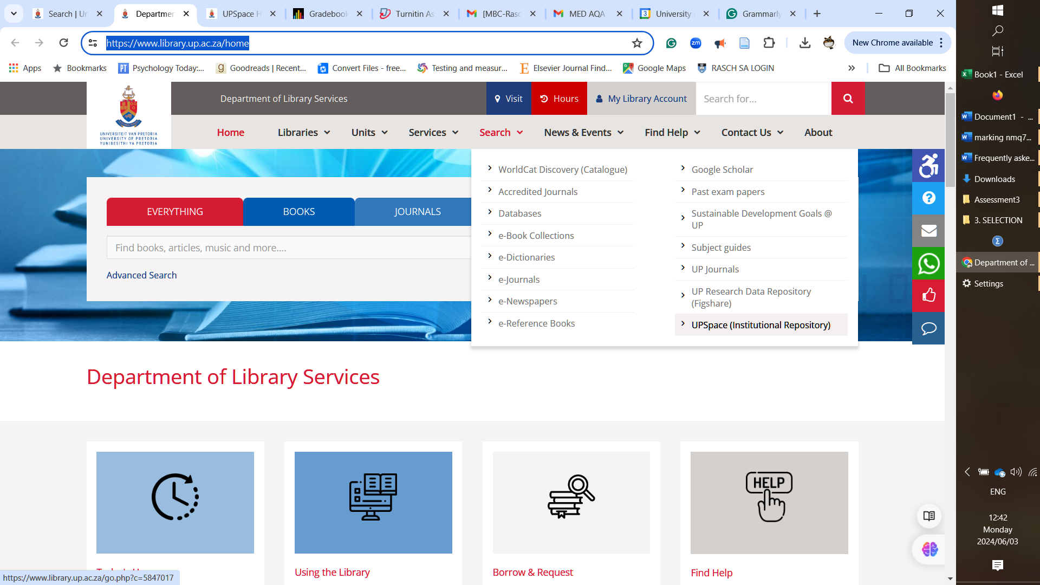

**How should I approach a potential supervisor?**

Send an email to potential supervisor(s) specialising in your topic. Start by being clear on your topic and ask if they would be willing to consider you as a student for the next intake**.** Ask if they would be willing to meet with you to discuss your study and topic in person or online. Have a topic and research questions ready when meeting with a potential supervisor(s). Have a draft version of your proposal ready and send this to the potential supervisor before scheduling a meeting.

**Do I need to have a proposal ready?**

Yes, the fact that you are applying for a PhD implies that you have your ideas in order. This means that you must have written a good draft proposal which feasible to execute, and clearly highlights the contribution your study will make. A potential supervisor will expect to see the proposal so that they can evaluate the practicality and appropriateness of your study before they agree to supervise you.

**How do I select a topic?**

Finding a topic depends on you and your long-term career goals. We recommend that you choose a topic that aligns with your interests and professional goals.

**Budget – What will it cost me to complete a doctoral degree?**

Just so you know, you must register annually, and there is an R12 500 registration fee. There are also yearly student fees - please check the website for the latest costs: <https://www.up.ac.za/student-fees/article/2735935/postgraduate-tuition-fees-per-faculty>). Please plan for the registration fee, annual fees, and indirect costs such as language editing, technical editing, and data collection for 3 - 4 years. We recommend you create a budget before applying and make sure you can afford your studies.

**What funding opportunities exist?**

Please visit <https://www.up.ac.za/faq> and <https://www.up.ac.za/funding> to learn more about UP-funded scholarships and other bursaries and loans available. You can also talk about funding opportunities with your supervisor.

**Online versus face-to-face?**

The PhD is academic; there are no classes to attend. There are support sessions three times a year which we strongly recommend you attend. Meetings with supervisor(s) can be arranged online. But please keep in mind that we find occasional in-person meetings are more beneficial than online meetings, and your supervisor may request a contact meeting.

**Full-time or part-time?**

We do not distinguish between full-time or part-time; technically, we consider the degree full-time. However, you can work while completing the degree, but please keep in mind that you must find a way to balance work and studies in such a case. You only have 2.5 years from registration to complete the proposal, defence, ethics application and thesis.

**Are there modules or coursework?**

No, you must conduct innovative research and write a thesis. There are no classes or coursework.

**How much time do I have to complete the degree?**

You have 2.5 years from registration to complete the thesis. If you have made significant progress, you can apply for an extension if you reach the end of the third year and have not submitted your manuscript. The faculty decides whether you will be granted an extension.

**What type of job can I do with a doctorate?**

As with most social science degrees, people tend to follow divergent paths. Many of our students remain in the teaching profession. Students who seek employment other than teaching work in various fields such as business, training institutions, higher education, and many others. In a volatile job market, the seeker must be very flexible, promote themselves, and use their networks to obtain employment.

Please also keep in mind that if you want to obtain the qualification for employment related reasons, the responsibility lies with you to find out what career opportunities exist or if you will be promoted in your current job once you attain the degree. We recommend you do your job research before deciding to register.

**What are the recommended timelines for completing a doctoral study?**

Below are the ideal timelines, but your study may take longer.

Year 1 Write proposal and defend by June

Year 1 Ethical clearance by August

Year 1 Chapters 1, 2 and 3 written

Year 2 Data collection and analysis

Year 2 Revisions of Chapters 1 - 3

Year 2 Chapters 4 and 5 written

Year 3 Revisions of all chapters

Year 3 Language and technical editing

Year 3 Manuscript finalised and submitted by August

Year 3 Article written and submitted to a journal

Year 3 Examiner feedback, refinement and final submission

Year 4 Graduate in April

**If I studied outside of South Africa, would I be accepted at UP?**

If your master's qualification was not obtained in South Africa, then a SAQA certificate at the appropriate NFQ level (9) is required. You can visit the SAQA website to find out the processes you need to follow to get the certificate. Our university is not involved in this process. Please deal directly with SAQA but ensure the certificate is ready before applying, the responsibility lies with you.

# **Concept note – what should I include?**

The concept note is a mini version of your proposal. The central text may not exceed 5 pages, excluding front matter, references, and appendices. See guidelines for length below.

**Title** - approximately 14 words in length, on front page

**Introduction, problem statement & research questions** – 1.5 page maximum

**Literature review** – 1.5 pages maximum

**Framework** - 0.5 page maximum

**Methodology** - 1 page maximum

**Timelines & Budget** - 0.5 page maximum

**Other Instructions for concept note**

1. Please use **EndNote** or **Zotero** to manage your references.
2. Please use **Grammarly** to check your writing.
3. Please use **Headings in Word.**
4. Please use **UK English** (make sure this is set when working in Word).