**Frequently asked questions MEd AQA**

# **When can I apply?**

Applications open yearly in April and close at the end of August. Students are selected once a year for the following year.

# **What can I do to improve my chances of being selected?**

We receive many applications every year. We can only accommodate a few students due to supervisory capacity. We choose students with higher marks, feasible proposals, and research topics that fit our staff's fields of specialisation. Please note that you need to have an appropriate topic ready, preferably one you have discussed with your potential supervisor.

Two of our programmes are excessively full: *Assessment and Quality Assurance (AQA)* and *Computer Integrated Education (CIE)*. The other programmes are less full and may offer you a more specialised degree. Please also consider applying for one of these if you qualify:

·         Life Sciences Education (09250009)

·         Mathematics Education (09250013)

·         Physical Sciences Education (09250014)

·         Technology Education (09250015)

**How can I find a potential supervisor?**

You can visit our faculty website to find potential supervisors. If you want to apply for an MEd in the Science, Maths and Technology education department, please see our research focus areas:

<https://www.up.ac.za/science-mathematics-technology-education/article/49577/research-focus-areas>.

Suppose no supervisors specialise in your topic at the University of Pretoria. In that case, we recommend that you look at other universities as they may have the right person. Just so you know, only two full-time staff members are supervising in the AQA programme: Dr Karen Roux and Dr Celeste Combrinck.

# **How should I approach a potential supervisor?**

Send an email to potential supervisor(s) specialising in your topic area. Start by being clear on your topic and ask if they would be willing to consider you as a student for the next intake.Ask if they would be willing to meet with you to discuss your study and topic in person or online. Have a topic and research questions ready when meeting with a potential supervisor(s).

**What sort of topics have students recently utilised for AQA PhD studies?**

You can use our library website to find previous theses: <https://www.library.up.ac.za/home>

Click on Search → UP Space Institutional Repository → Education → Science, Maths and Technology Education → Theses and Dissertations → Type → Dissertation

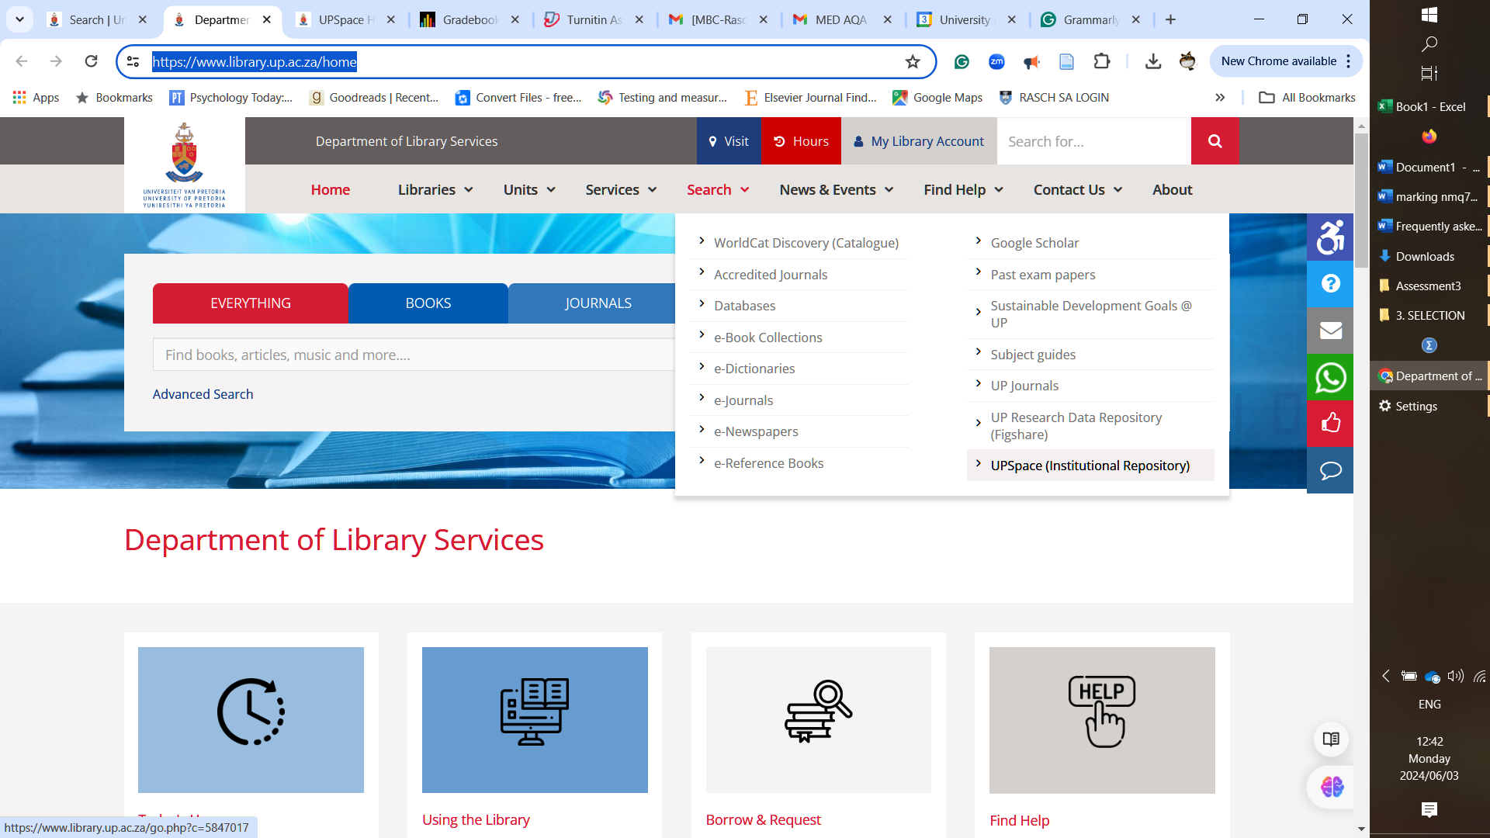

# **Do I need to have a topic ready?**

Yes, it would be best to have an appropriate topic ready before applying and contacting potential supervisors. Finding a topic depends on you and your long-term career goals. We would recommend that you choose a topic that aligns with your interests and professional goals.

# **Budget – What will it cost me to study for a master's?**

Please note that you must register annually.

There is an **R12 5000** registration fee. There are also **yearly student fees** - please check the website for the latest costs: <https://www.up.ac.za/student-fees/article/2735935/postgraduate-tuition-fees-per-faculty>).

Please plan for the registration fee, annual fees, and indirect costs such as language editing, data collection and so forth for 2 – 3 years. We recommend you create a budget of at least **R30 000** per year.

**NB: Foreign national students, please take note that your fees may be higher, and you need to budget accordingly**, please investigate the fees at https://www.up.ac.za/student-fees/article/2746297/international-student-fees

# **What funding opportunities exist?**

Please visit:

<https://www.up.ac.za/faq>

<https://www.up.ac.za/funding> to learn more about UP-funded scholarships and other bursaries and loans available.

Please note that though there are bursaries available, there is a limited number, and there is no guarantee that you will receive one, or you might get a bursary one year but not the next. Please plan for the full amount rather than assuming a bursary will be allotted. The bursary would not include the registration fee.

# **Online versus face-to-face?**

The MEd is an academic master's, i.e. a masters by dissertation; there are no classes to attend. There are support sessions (once a term online) that we strongly recommend you attend. Meetings with supervisor(s) can be arranged online. But please keep in mind that we find occasional in-person meetings are more helpful than online meetings, and your supervisor may ask for a contact meeting.

# **Full-time or part-time?**

We do not distinguish between full-time or part-time. Masters and PhD students are considered to be full-time students. You can actually work while completing the degree, but please keep in mind that you have to find a way to balance work and studies in such a case and the university will still view you as a full-time student. You only have **18 months** from registration to complete the thesis.

# **What if I live outside of South Africa?**

If you live in another country, you can study with us; many of our students are from neighbouring countries. Ensure you have the appropriate SAQA certificate if your honours degree was not completed in South Africa.

# **Are there modules or coursework?**

No, you must conduct primary research and write a dissertation. There are no classes or coursework.

# **How much time do I have to complete the degree?**

You have 18 months from registration to complete the thesis. Still, if you have made significant progress, you can apply for an extension at the end of the second year. The faculty decides whether you will be granted an extension.

# **What type of job can I do with a master’s degree?**

As with most social science degrees, people tend to follow divergent paths. Many of our students remain in the teaching profession. Students who seek employment other than teaching work in various fields such as business, training institutions, higher education, and many others. In a volatile job market, the seeker must be very flexible, promote themselves, and use their networks to obtain employment.

Please note that if you want to obtain the qualification for reasons other than professional development, the responsibility lies with you to find out what career opportunities exist. We think you should do your job research before deciding to register.

# **What are the timelines for completing a master study?**

Below are the ideal timelines, but your study may take longer to complete.

Year 1 Write proposal and defend by June

Year 1 Ethical clearance by August

Year 1 Chapters 1, 2 and 3 written

Year 2 Data collected

Year 2 Chapters 4 and 5 written

Year 2 Manuscript finalised and submitted by August

Year 2 Examiner feedback, refinement and final submission

Next year: Graduate in April

# **What are the requirements to be accepted?**

1. Honours research modules have marks above 65%
2. Research methodology and research questions feasible for masters
3. Topic aligned to potential supervisor interests (preferably discussed with supervisor before application)
4. If your honours qualification was not obtained in South Africa, then a SAQA certificate at the appropriate level is required.

# **If I studied outside of South Africa, would I be accepted at UP?**

A SAQA certificate at the appropriate NFQ level (8) is required if your honours qualification was not obtained in South Africa. Please visit the SAQA website to learn the processes you must follow to obtain the certificate. Our university is not involved in this process; please deal directly with SAQA but ensure you have the certificate ready before applying.

# **Concept note – what should I include?**

The concept note is a mini version of your proposal. The central text may not exceed 5 pages, excluding front matter, references, and appendices. See guidelines for length below.

**Title** - approximately 14 words in length, on front page

**Introduction, problem statement & research questions** – 1.5 page maximum

**Literature review** – 1.5 pages maximum

**Framework** - 0.5 page maximum

**Methodology** - 1 page maximum

**Timelines & Budget** - 0.5 page maximum

**Other Instructions for concept note**

1. Please use **EndNote** or **Zotero** to manage your references.
2. Please use **Grammarly** to check your writing.
3. Please use **Headings in Word.**
4. Please use **UK English** (make sure this is set when working in Word).