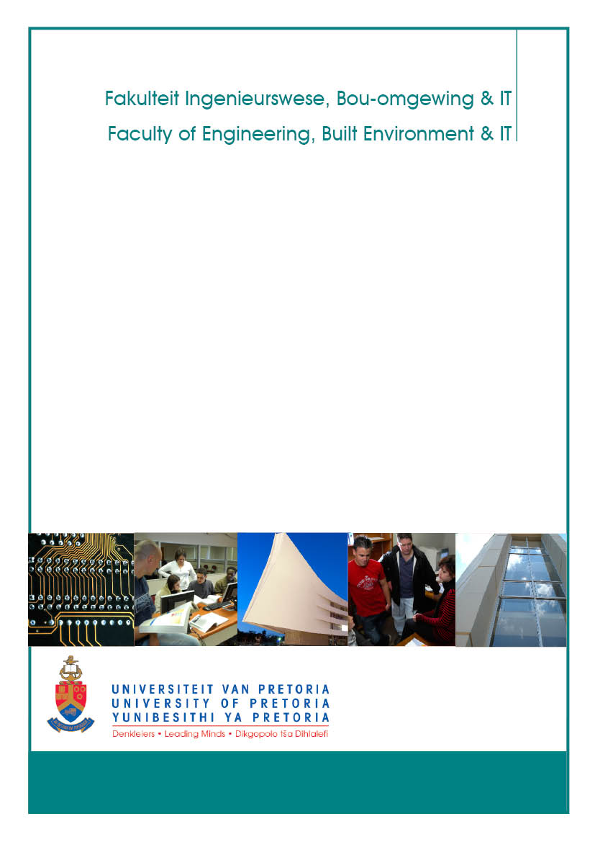

School of Engineering

Department of Materials Science and Metallurgical Engineering

Industrial Training NPY 316
Revision 1
January 2014
Dr DR Groot

Table of contents

ORGANISATIONAL COMPONENT 1
1. General Premise and Educational Approach 1
2. MODULE Coordinators and Consulting Hours 1
3. Rules of Assessment 1
STUDY COMPONENT 2
1. Module Objectives, Articulation and Learning Outcomes 2
1.1 General objectives 2
1.2 Prerequisite learning and articulation with other modules 2
1.3 ECSA Outcomes addressed in this module 2
2. ECSA Documents 3

ORGANISATIONAL COMPONENT
1. General Premise and Educational Approach
During or at the end of the second year of study, students undergo at least six weeks of prescribed training in industry. A satisfactory report on the practical training must be submitted to the Department of Materials Science and Metallurgical Engineering within one week of registration.
2. MODULE Coordinators and Consulting Hours
Module coordinator: Wynand Roux
Room 3-40 Mineral Sciences
Tel: 012 420 3192
e-mail: wynand.roux@up.ac.za
Lecture times and venues: No formal lectures

3. Rules of Assessment
All students must submit a satisfactory report on their practical training to the University at the start of the next academic year. The report must be concise and to the point, focusing on the project which the student handled (rather than giving a general description of the plant where they worked).

The report must be approved by the direct supervisor of the student. In addition, the submission must include the appended forms to be completed by the direct supervisor of the student.
- The direct supervisor’s report on the appended form must be favourable;
- The module coordinator must approve the report as regards overall quality and compliance with the ECSA DLO’s.

The outcome of assessment will be a grade of “attendance satisfactory” or “attendance unsatisfactory” after the report and employer’s report form have been assessed.

The written report should address the following:
- The student must demonstrate in the written report awareness that mathematical techniques, knowledge from the natural sciences and engineering knowledge need to be applied correctly in understanding and solving engineering problems, as appropriate to the project(s) executed. (ECSA DLO 2)
- The student must demonstrate in the written report:
1. an awareness of the use of the tools for information retrieval,
2. competence to use engineering methods, skills and tools as appropriate to the project(s) executed,
3. an awareness of the safety, health and environmental issues appropriate to the project(s) executed,
4. basic project management skills.
(ECSA DLO 5)
- The student must demonstrate in the written report the ability to effectively formulate and communicate information about:
1. the technical environment in which the project was carried out;
2. the technical background to the project;
3. the aim(s) of the project;
4. the results obtained; and
5. any relevant conclusions and suggestions for further work.
(ECSA DLO 6)
- The student must demonstrate in the written report an appropriate level of critical awareness of the impact of engineering activity on the social, industrial and physical environment as appropriate to the project(s) executed.
(ECSA DLO 7).

project COMPONENT
1. Module Objectives, Articulation and Learning Outcomes
1.1 General objectives
During or at the end of the second year of study, students undergo at least six weeks of prescribed training in industry. A satisfactory report on the practical training must be submitted to the Department of Materials Science and Metallurgical Engineering within one week of registration. We regard vacation training as an integral part of the training of students in Metallurgical Engineering. The vacation work serves to cover that part of the training which, for practical reasons, cannot be offered at the university. We hence rely on the industry to provide sensible exposure of students to industry practice.
We expect that this period be considered to be part of a formal training programme, which means that serious attention needs to be given to the formulation of an appropriate programme of work for each vacation work student.
The aim of vacation training can be summarised as follows:
- To familiarise students with the industrial environment; this requires exposure to the organisational, human and economic facets of production.
- To familiarise students with technical aspects – the operation of equipment, processes, and plants.
- To give students the opportunity to apply in industry the theoretical knowledge and experimental skills which they have gained at university.
Ideally, each student should be entrusted with a vacation work project which engages all three of these aspects. It is essential that the nature of the project ensures a degree of responsibility and involvement in the plant, rather than passive observation.
Students who have completed their second year have limited technological knowledge. Of their metallurgical modules, they have completed two modules on materials science (basic physical metallurgy), and one on process thermodynamics (mass and energy balances, and reaction equilibria). Hence they should be entrusted with tasks dealing with those aspects of the plant which illustrate basic physical and chemical principles. Typical examples include evaluation of new or existing analytical and test methods, testing new equipment, collecting and analysing data on a process or plant.
1.2 Prerequisite learning and articulation with other modules
The module articulates with Industrial Training NPY 416.
1.3 ECSA Outcomes addressed in this module

Development-level outcome 2: application of scientific and engineering knowledge
Beginning to apply knowledge of mathematics, natural sciences, engineering fundamentals and an engineering speciality to solve simple engineering problems.
Level descriptor: knowledge of mathematics, natural sciences and engineering sciences is characterized by:
• a systematic, theory-based understanding of the natural sciences applicable to the discipline;
• engineering specialist knowledge that provides theoretical frameworks and bodies of knowledge for the accepted practice areas in the engineering discipline; much is at the forefront of the discipline.
Mathematics, natural science and engineering sciences are applied for reasoning about and conceptualizing engineering problems.

Criteria of assessment
The student must demonstrate in the written report awareness that mathematical techniques, knowledge from the natural sciences and engineering knowledge need to be applied correctly in understanding and solving engineering problems, as appropriate to the project(s) executed.

Development-level outcome 5: engineering methods, skills and tools, including information technology
Beginning to demonstrate competence to use appropriate engineering methods, skills and tools, including those based on information technology.

Range statement: a range of methods, skills and tools appropriate to the disciplinary designation of the program including:
1. Computers and networks and information infrastructures for accessing, processing, managing, and storing information to enhance personal productivity and teamwork;
2. Basic techniques from economics, business management;
3. Health, safety and environmental protection appropriate to the discipline;
4. Project management.

Criteria of assessment
The student must demonstrate in the written report:
1. an awareness of the use of the tools for information retrieval,
2. competence to use engineering methods, skills and tools as appropriate to the project(s) executed,
3. an awareness of the safety, health and environmental issues appropriate to the project(s) executed,
4. basic project management skills.

Development-level outcome 6: professional and technical communication
Beginning to demonstrate competence to communicate effectively in writing with engineering audiences.

Range statement: material to be communicated is in an academic or simulated professional context. Audiences range from engineering peers, and management, using appropriate academic or professional discourse. Written reports are short (300-1000 word plus tables diagrams). Methods of providing information include the conventional methods of the discipline, for example engineering drawings, as well as subject-specific methods.

Criteria of assessment
The student must demonstrate in the written report the ability to effectively formulate and communicate information about: 1. the technical environment in which the project was carried out;
2. the technical background to the project;
3. the aim(s) of the project;
4. the results obtained; and
5. any relevant conclusions and suggestions for further work.

Development-level outcome 7: impact of engineering activity
Beginning to demonstrate critical awareness of the impact of engineering activity on the social, industrial and physical environment.
Range statement: the combination of social, workplace (industrial) and physical environmental factors must be appropriate to the discipline or other designation of the qualification. Development of comprehension of the role of engineering in society and identified issues in engineering practice in the discipline: ethics and the professional responsibility of an engineer to public safety; the impacts of engineering activity: economic, social, cultural, environmental and sustainability.

Criteria of assessment
The student must demonstrate in the written report an appropriate level of critical awareness of the impact of engineering activity on the social, industrial and physical environment as appropriate to the project(s) executed.
2. Supervisor’s report

This document must be fully completed (2 pages) and signed by the direct supervisor of the student. The completed document must show whether the student has completed the tasks in a satisfactory manner or not. It must be handed in with the written report as stated under Rules of assessment.

Universiteit van Pretoria  Skool vir Ingenieurswese  Verslag oor vakansiewerk:  Metallurgiese Ingenieurswese |  |  |  |  | University of Pretoria  School of Engineering  Report on vacation training:  Metallurgical Engineering
Naam van student:
Name of student:
Student(e)no: |  |  |  |  | Merk asb:  Please tick: | NPY316 |  |  | NPY416
Naam en adres
van werkgewer:
Name and address
of employer:
Tydperk van werk:
Period of work:
Werk verrig / Tasks performed |  |  |  |  |  |  |  | Aantal dae  Number of days |  | Paraaf van toesighouer  Initials of supervisor
Opmerkings van toesighouer:
Remarks by supervisor:
Datum:  Date: |  |  |  | Handtekening van werkgewer:  Signature of employer

Universiteit van Pretoria  Skool vir Ingenieurswese  Verslag oor vakansiewerk:  Metallurgiese Ingenieurswese |  |  | University of Pretoria  School of Engineering  Report on vacation training:  Metallurgical Engineering
Naam van student:
Name of student:
Student(e)no: |  |  | Merk asb:  Please tick: | NPY316 |  | NPY416
Naam
van toesighouer:
Name
of supervisor:
ECSA uitkoms  ECSA outcome | OVU beskrywing  DLO description |  |  |  | Ontwikkelingsvlak behaal Ja/Nee  Development Level accomplished Yes/No
OVU/DLO 2 | The student has demonstrated awareness that mathematical techniques, knowledge from the natural sciences and engineering knowledge need to be applied correctly in understanding and solving engineering problems, as appropriate to the project(s) executed.
OVU/DLO 5 | The student has demonstrated in the written report:  - awareness of the use of the tools for information retrieval,  - competence to use engineering methods, skills and tools as appropriate to the project(s) executed,  - awareness of the safety, health and environmental issues appropriate to the project(s) executed,  - basic project management skills.
OVU/DLO 6 | The student has demonstrated the ability to effectively formulate and communicate information about:  - the technical environment in which the project was carried out;  - the technical background to the project;  - the aim(s) of the project;  - the results obtained; and  - any relevant conclusions and suggestions for further work.
OVU/DLO 7 | The student has demonstrated an appropriate level of critical awareness of the impact of engineering activity on the social, industrial and physical environment appropriate to the project(s) executed.
Opmerkings deur toesighouer oor bostaande

Comments by supervisor regarding above

