CLASS GUARDIANS 2022
DEPARTMENT MECHANICAL AND AERONAUTICAL ENGINEERING
1ST YEAR OF STUDIES
Dr Helen Inglis - (012) 420 3125 helen.inglis@up.ac.za  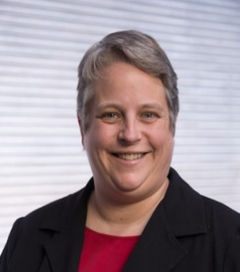 | Prof Nico Wilke - (012) 420 2861 nico.wilke@up.ac.za  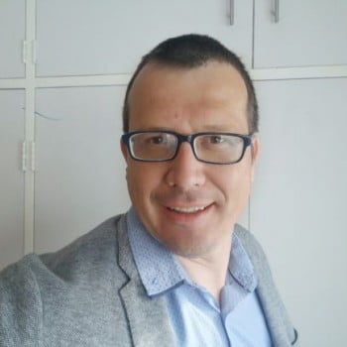 | Dr Bradley Bock - (012) 420 2195 bradley.bock@up.ac.za
2ND YEAR OF STUDIES
Prof Schalk Els - (012) 420 2045 schalk.els@up.ac.za  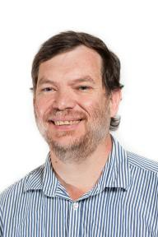 | Dr Barbara Barbieri Huyssen - (012) 420 6316 barbara.huyssen@up.ac.za | Dr Mostafa Mahdavi -(012) 420 3111  mostafa.mahdavi@up.ac.za  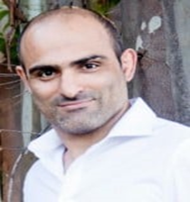
3RD YEAR OF STUDIES
Mr Isaac Setshedi - (012) 420 2014 isaac.setshedi@up.ac.za  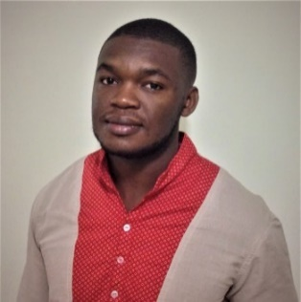 | Dr Marlize Everts- (012) 420 6891 marlize.everts@up.ac.za  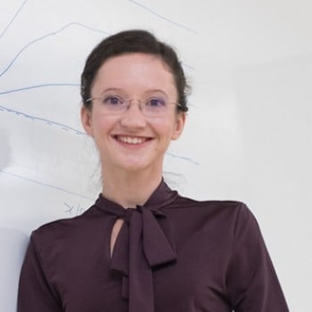 | Prof Jaco Dirker - (012) 420 2465 jaco.dirker@up.ac.za  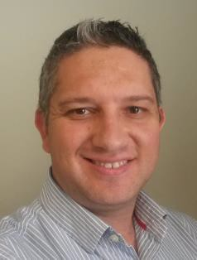
FINAL YEAR OF STUDIES
Prof Ken Craig - (012) 420 3515 ken.craig@up.ac.za | Ms Dineo Ramatlo - (012) 420 2462 dineo.ramatlo@up.ac.za  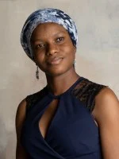 | Mr Riaan Meeser - (012) 420 2194 riaan.meeser@up.ac.za  