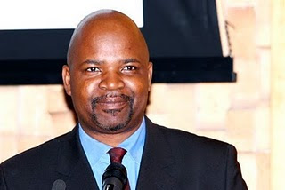

**Abstract**

Of all the markers of identity in 20th and 21st century Africa, religion is proving to be one of the most enduring. This is not to minimise the importance of other signifiers of identity such as ethnicity, race, gender, class and political affiliation. Indeed, these markers of identity do not exist in isolation but form a web of networks within, across and between groups and individuals. In this paper I will attempt an analysis of how faith continues, for better and for worse, to be an important marker and signifier of identity.

**Brief Bio**

Tinyiko Maluleke is advisor to the Principal and Vice Chancellor at the University of Pretoria. Amongst others, he is an elected member of the Academy of Science for South Africa, an NRF rated researcher, a member of the Board of Khulumani NGO and a member of the NRF Board. He has held various executive management positions at various South African universities, including, Dean of Faculty, Executive Director for Research, Deputy Registrar and Deputy Vice Chancellor.

He has supervised 11 PhD students to completion and published more than 80 peer reviewed articles. As a regular columnist for the Mail & Guardian and the Sunday Independant, Maluleke has published dozens of popular articles on socio-political issues.

Recent Publications:

'The Search for a More Human Face for Nelson Mandela' - HTS, 2015.

'Between Pretoria and Goerge Goch Hostel'. God in South Africa in 2015 - New Agenda, 2015.

'Desmond Tutu's Earliest Notions and Visions of Church, Community and Humanity' - Ecumenical Review, 2015

'Christian Mission Under the Shadow of the Challenges of Poverty, Unemployment and Inequality' in (Mari Pontinen (editor) *Mission and Money.* 2016, Masterdam: Brill