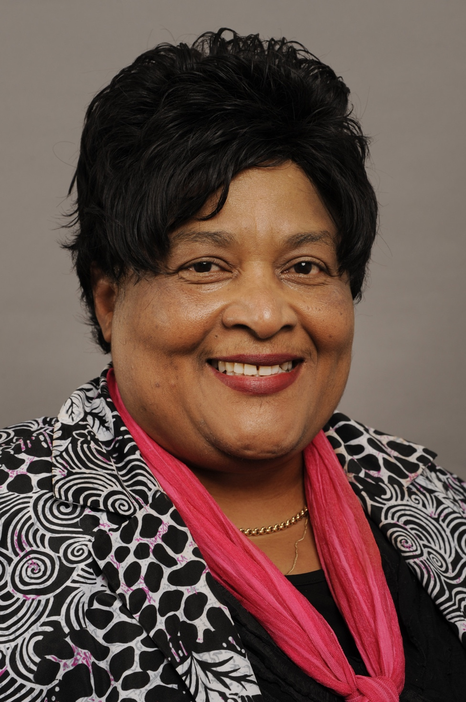

**Faith and cultural realities in South Africa**

**Prof MA Plaatjies van Huffel**

**Abstract**

Twenty years after the death of apartheid the country is still struggling with racism at large and an upsurge of the discourse on cultural social identities are being seen. South Africa is largely a racial divided country. The culturally structured set of assumptions (including values and commitments/allegiances) underlies how people from different cultural and racial backgrounds perceive and respond to each other as well as the presuppositions upon which people base their lives. Attention will be given in the paper to the fact that multiculturalism is currently being overshadowed by the reverse tendency toward ethnocentrism and ideological fundamentalism, suspicion of “the others” and the anti-multiculturalist politics of integration. Multiculturalism has shown its conceptual failures. Assimilation of different races (multiculturalism) is being juxtaposed in this paper with cultural transmission from the dominant culture to the other cultures and *vice versa*. My premise is that account should be taken of in the discourse on racism in South Africa of the following *inter alia* mono-cultural perspective, multiculturalism, interculturalism, transculturalism, as well the role faith communities can play in this regard.

**Publications**

**Prof MA Plaatjies van Huffel**

1. **Chapters in Academic Books**
   1. A Chronology of the Political and Theological Activity at the University of Western Cape during the Heyday of the Struggle against Apartheid In *Contested Relations Protestantism between Southern Africa and Germany from the 1930s to the Apartheid Era.* Edited by Hanss Lessing, Tilman Dedering, Jürgen Kampmann, and Dirkie Smit, 2015.
   2. The relevance of Reformed church polity principles: Revisiting the concept In *Protestant**Church polity in Changing Contexts 1* (Editors: Leo Koffeman en Allan Janssen) LIT 2014
   3. *The quest for identity. A gender perspective* in The Quest for identity in (so-called) mainline churches in South Africa (Ed. Ernest Conradie). Sun media, 2014
   4. Reading the Belhar Confession - as historical text. In *Reformed Churches in South Africa and the struggle for justice - Remembering 1960-1990* (Editors MA Plaatjies van Huffel and RR Vosloo), Sun media, 2013.
   5. Response to: Empowering Those Who Suffer Domestic Violence: The Necessity of Different Theological Imagery by Anne-Claire Mulder. In *Fragile Dignity, Inter-contextual Conversations on Scriptures, Family, and Violence*. Society of Biblical Literature, 2013.
   6. Dirk Smith – An Apologist for confessionin *Living Theology (*Editors: Len Hansen, Nico Koopman, and Robert Vosloo). Bible Media, 2011.
   7. About the empowerment of women in post-apartheid South Africa: A post-structural approachIn *From our Side Emerging perspectives on Development and ethics.* (Editors: Steve de Gruchy, Nico Koopman, Syste Strijbos (ed.) 2008.
   8. Women in the theological anthropology of Oom Beyers Naude. In  *Oom Bey for the future*. Beyers Naude Centre Series on Public Theology Stellenbosch: SUN Press, 2008.
2. **Articles in accredited journals** 
   1. The remarkable career of Christina Landman, pioneer feminist theologian, rooted in the Reformed tradition in *Studia Historicae Ecclesiasticae* August/Augustus 2014 Volume XL Supplement<http://www.unisa.ac.za/contents/faculties/theology/chssa/docs/Abstracts,_SHE_XL,_Supplement,_August_2014.pdf>
   2. *The Belhar Confession - as historical text.* NGTT [*Vol 55, No 1-2 (2014)*](http://ngtt.journals.ac.za/pub/issue/view/28) <http://ngtt.journals.ac.za/pub/issue/view>
   3. The search for a common understanding with regard to ecology   and justice in the Uniting Reformed Church in Southern Africa   *Studia Historicae Ecclesiasticae* XXXIX(2), Desember 2013.
   4. The URCSA’s engagement on legal matters in South *Africa* *NGTT* Deel 54 Supplementum 4, 2013 p101-113. <http://ngtt.journals.ac.za/pub/article/view/294>
   5. The Belhar Confession: Born in the struggle against apartheid in Southern Africa, guiding light today *Studia Historicae Ecclesiasticae* 2013. p. 1-11 http://wwwuir.unisa.ac.za/bitstream/handle/10500/9977/
   6. Michel Foucault se historiografiese benadering as lens in historiese ondersoeke *Acta Theologica* Jaargang 32 No 1 June 2012 <http://www.ajol.info/index.php/actat/article/viewFile/78839/69161>
   7. Die stryd om die aard en omvang van die tugreg by die Nederduitse Gereformeerde Sendingkerk (1881−1994)’, *HTS Teologiese Studies/Theological Studies* 68(1) 2012, <http://www.hts.org.za/index.php/HTS/article/view/1007>
   8. Die reis met kerkeenwording tussen die Verenigende Gereformeerde Kerk in Suider-Afrika en die Nederduitse Gereformeerde Kerk in Afrika<http://www.ve.org.za/index.php/VE/article/viewFile/724/1138>
   9. Patriarchy as empire: a theological reflection Studia *Historicae Ecclesiasticae*, December/Desember 2011, Volume XXXVII. Supplement.
   10. Control, secede, vested rights and ecclesiastical property. *Studia Historicae Ecclesiasticae* Vol 37 (2), September 2011. <http://uir.unisa.ac.za/handle/10500/5126>
   11. The Institutionalization of Christian women’s organizations: from docile recipients to agents of change   in *Studia Historicae Ecclesiasticae* Vol 37 (1) May/Mei 2011. <http://uir.unisa.ac.za/handle/10500/4616>
   12. Die kerkreg en kerkregering van die Nederduitse Gereformeerde Sendingkerk (1881-1915*)* in   *NGTT* 2011. (p194-204). <http://ngtt.journals.ac.za/pub/article/download/17/16>