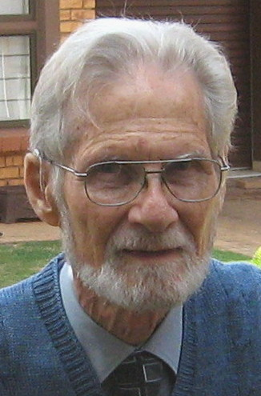

**The power of the impotent: Christian faith and the approaching economic-ecological crisis**

Prof Klaus Nürnberger

**Abstract**

The South African economy is embedded in a relentlessly globalising system based on competition for economic power, profit and pleasure, producing winners and losers at ever greater scales.

Its operation depends on the continued growth of market demand (thus rising expectations of growing populations), of market supply (thus enhanced productive power through technological innovation) and of natural resources (thus a growing ecological impact).

The consequences are (a) the growing concentration of economic power at the top of the social pyramid and the economic marginalisation of large sections of the population at the bottom and (b) the growing destructive impact on the natural world, which is its indispensable resource base.

Since the collapse of the Marxist-Leninist system it is widely accepted as the only viable alternative. Neo-liberal economics, its theoretical underpinning, displays the characteristics of a legitimating ideology, rather than a burning concern for the future welfare of humanity and the planet. Social democracy, a successful alternative, is being undermined by a culture of avarice and entitlement.

For some decades now perceptive analysts have warned that humankind is heading towards an economic-ecological disaster of unprecedented proportions. However, the appeal to the human base instincts of wealth, status and power has sapped the political will to make significant changes across the social spectrum.

In view of the contemporary character and capacity of the Christian community of believers (spirituality, devotional life, expertise, composition, and social location) the probability that it will make a meaningful difference is rather minute. However, it is tasked to proclaim, enact and embody the ‘Word of God’, which in biblical times functioned as the redemptive response of God to human needs, predicaments and depravities.

The unsurpassable catastrophe of the cross of Christ became the seed of a transformative process. It can serve as the prototype that reflects God’s sacrificial benevolence in all aspects of natural, social and spiritual reality. The failure of our powers (even at the cost of a global crisis) may thus open up the way for the creative and redemptive power of God.

**Some of his Publications**

For a full list visit: <http://www.klaus-nurnberger.com>

1. 1998 *Beyond Marx and market: Outcomes of a century of economic experimentation.* Pietermaritzburg: Cluster Publications / London: Zed Books (274 p).

2. 1999 *Prosperity, poverty and pollution: Managing the approaching crisis.* Pietermaritzburg: Cluster Publications / London: Zed Books.

3.  2004 *Biblical Theology in outline: The vitality of the Word of God.* Pietermaritzburg: Cluster Publications.

4.  2005 *Martin Luther's message for us today: A perspective from the South.* Pietermaritzburg: Cluster Publications.

5.  2007 *The living dead and the living God: Christ and the ancestors in a changing Africa.* Pietermaritzburg*:* Cluster Publications.

6. 2010 *Richard Dawkins’ God Delusion: A repentant refutation.* London: Xlibris Corporation / Pietermaritzburg*:* Cluster Publications..

7. 2011 *Regaining sanity for the earth: Why science needs ‘best faith’ to be responsible, why faith needs ‘best science’ to be credible.* London: Xlibris Corporation / Pietermaritzburg: Cluster Publications.

8. 2013 *Informed by science, involved by Christ: How science can update, enrich and empower the Christian faith.* London: Xlibris Corporation / Pietermaritzburg: Cluster Publications.

9. Forthcoming: *Faith in Christ: Invitation to Systematic Theology*. Volumes I and II. London: Xlibris Corporation / Pietermaritzburg: Cluster Publications.